J.A.N. Enterprises Inc.

Product Description
Glasses to alert the driver
The glasses look like any other glasses, but the advantage of alerting the driver when he/she is sleepy or unfocused on the road. Using sensors, the glasses track the driver’s eye movement and alerts the driver using a speaker in the frame. This alarm is triggered by actions such as eyes being closed for too long or looking away from the road.

Value Proposition
What if you owned glasses that would ensure your safety and the people driving with you? If there was a product that can alert you when you have your eyes off the road for too long or they get closed from being too drowsy. A product that will keep a driver on a long road trip awake, and keep the driver focused.
These glasses track your eye movement using small sensors and alert the driver when their eyes close or turn away from the road for too long keeping the driver alert on the road, ensuring a safe arrival to wherever you may go.

Customer Survey
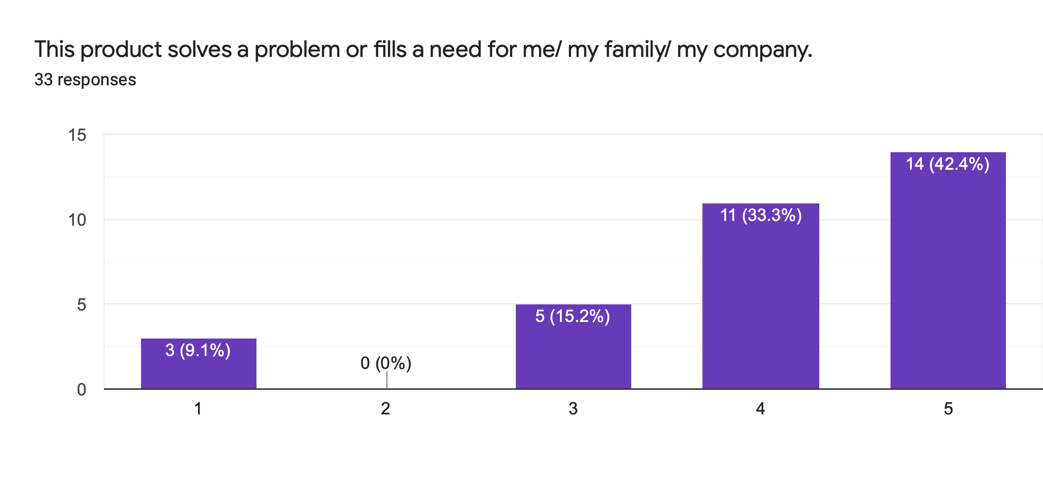
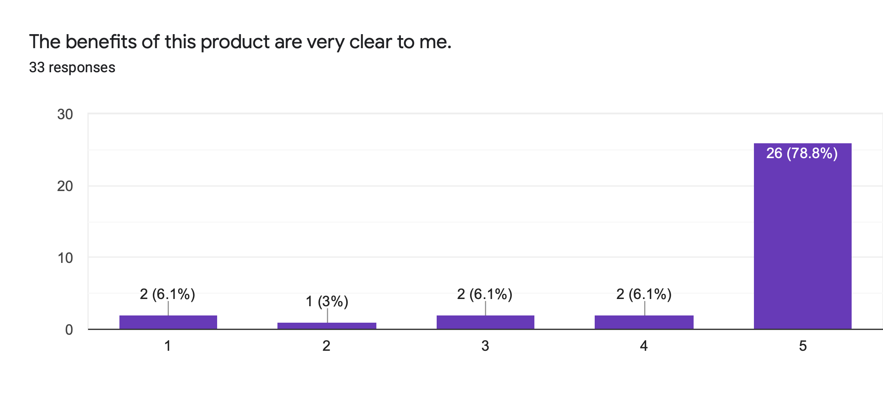
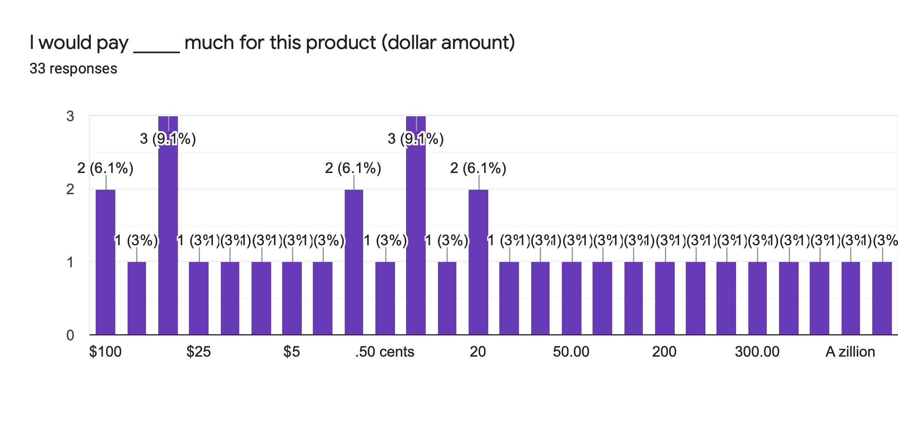
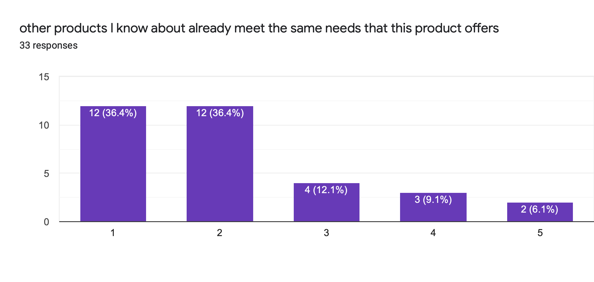
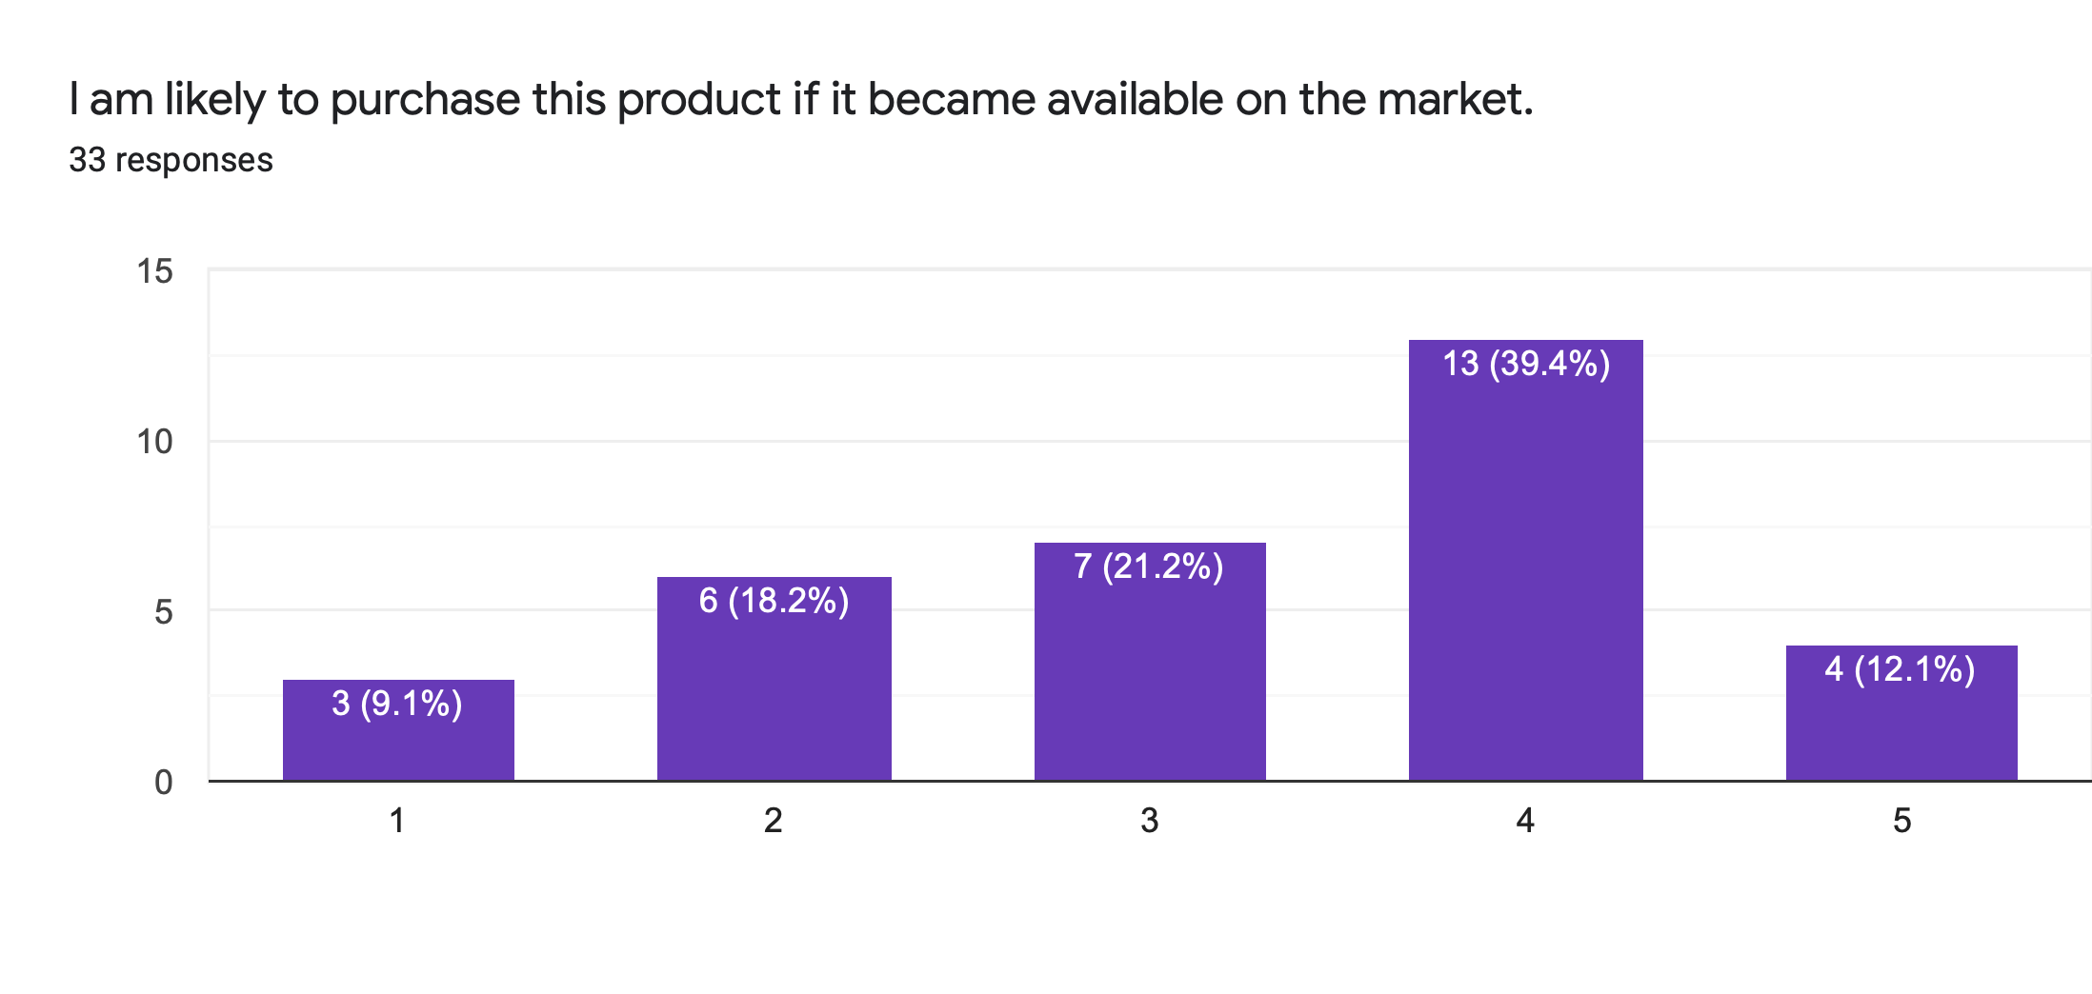
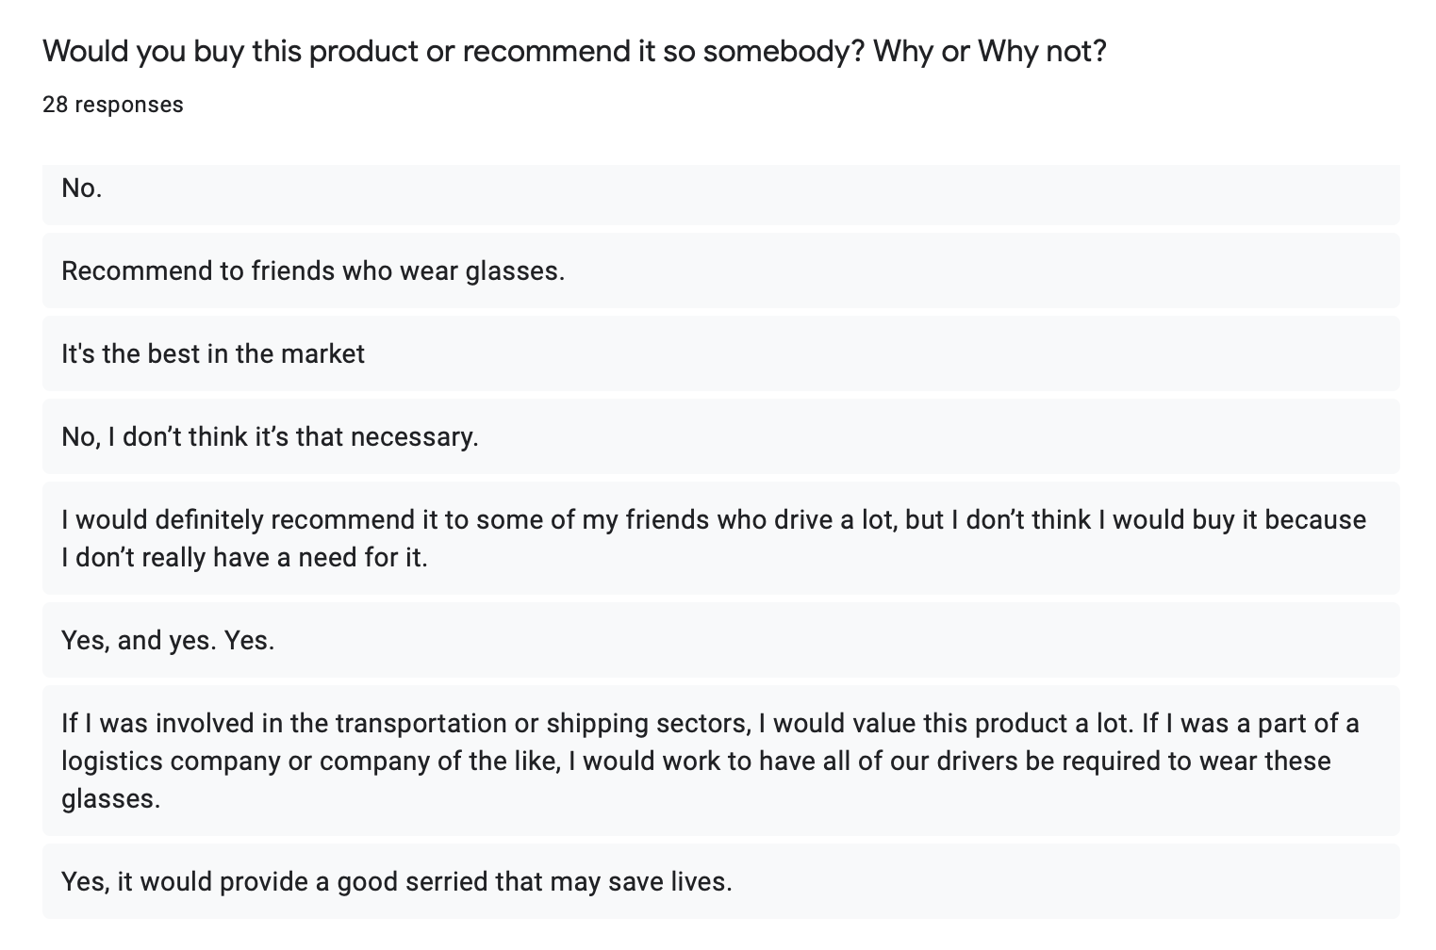
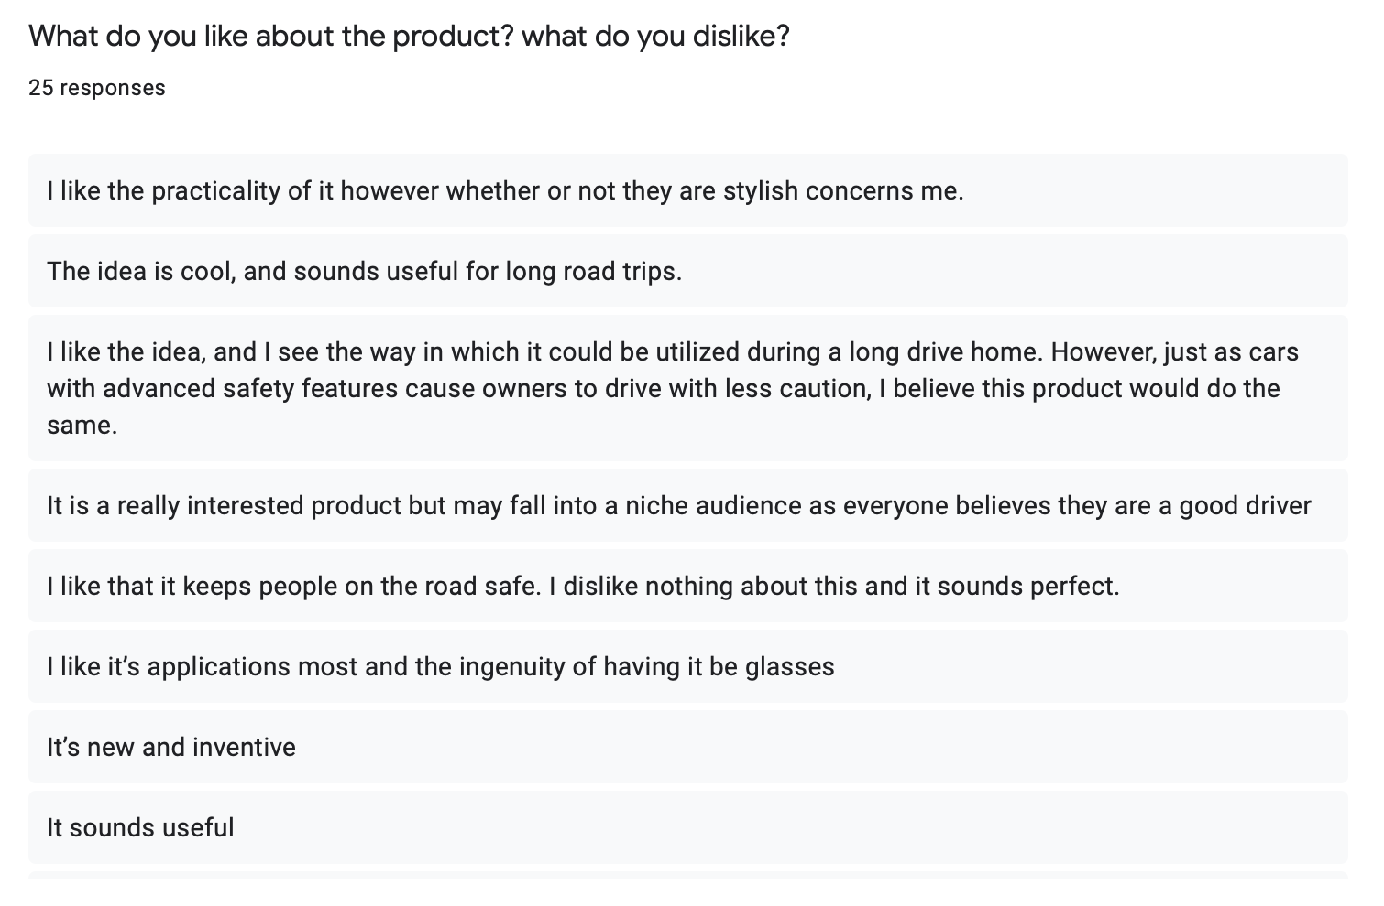
Analysis

To test the perceived value of this product to the public, a survey was created and given to a random group of people inquiring about different aspects of the potential product and whether or not this would be a product that they would be interested in buying. In this survey participants were asked to answer numerous types of questions ranging from, “How interested the person is with the product?” to “How much would they pay for a product like this?” The goal of this survey was to gain an understanding of how the market would react to our product and what would be the best way to market and whether or not any changes needed to be made to fit the needs of the consumer more effectively. To do that participants were asked both quantitative and qualitative questions about a potential product that could be on the market. The results of the survey are shown above, with this information the company was able to gain invaluable information about how the market views this product. From the results in the survey it seems like the majority of the participants do understand the need for a product like this. Based on this we can assume that driver safety is still a large concern and customers are looking for new and better ways to be safe on the road. ALong with this, the value of the product was easily translatable to the customer. This tells us that education of the product is not a big priority when it comes to the marketing strategy. Educating the public on a new product and its value is a very costly and risky endeavor for a growing product. After establishing that there is a need and a perceived value on this product it was necessary to measure just how much value is to be placed on it. When consumers were asked to place a price on this potential product, many answers varied but a certain trend was seen. Most of the answers given ranged from $50 to $200 with the most popular answers being in between 40 to 75 and 150 to 200. This shows that customers can either see this as a useful accessory item that is rather inexpensive or it can be marketed as a luxury safety item for the car with a premium price placed on it for the name of safety in style. The biggest issue in any business venture is the outside environment and most importantly, the competition. With this product however, it seems to be ahead of the curve when it comes to that aspect and the consumer seems to think so also. When asked if other products fulfill the same needs as this one, the general consensus between the group was that there was none. This tells us that either there is no competition to this product at the moment, giving us a first-mover advantage on the market, or that potential competition have failed to market themselves to the extent they could have and the market does not know they exist. Both of these outcomes speak well for the success of this product. Finally, in the survey consumers were asked to explain their feelings about the product, only a sample of the responses are shown above however, for the majority of the answers the consumers seem to either be on board with the product for themselves or a friend of theirs that believes they need it. While some consumers don’t want to admit they would need aid in their driving it is reassuring to hear that for those people a potential friend who believes otherwise is willing to refer them to our product and open their eyes to the value of this new aspect of safety.

Segmentation

Segmentation variable | Does it make sense to use that basis why or why not? | Potential segments/groups
Benefit | Yes. To protect them when they're driving | Safety Conscious Individuals
Usage | Help anyone whether be on long drives, late nights, new drivers, etc. | Professionals  Road trip enthusiast  Automotive based occupations  Safety oriented families  Learning Drivers  Elderly Drivers
Lifestyle | Those who spend a large amount of time on the road. | Truck drivers  Taxi drivers  Commuters

 | Segment 1 | Segment 2
Segment | Family/ Learning/ Elderly Drivers | Automotive Occupations
Benefit Marketed | Allows the family to ensure that their members whether they be a parent, the learning teenager who just started driving, or the elderly grandparent who can doze off at any moment are staying alert on the road and safe. | For professionals that spend groggy morning and tired nights coming to and from work making sure they get home safe.  Allow and added benefit of protection from the sun and added safety of themselves and the services they are committed to completing. Whether it be late night taxi rides or cross country trips in a semi truck.

Target Market Selection
Based on the survey, and the initial vision for this product. Our company feels that the best course of action in order to instill ourselves into this market is to separate our marketing strategy into three segmented groups based on the different lifestyles of the potential consumer and the benefits given to each of those lifestyles. For the first and projected largest market is the family unit. Whether it be to attract the stressed out parent who is constantly on the road taking kids to school, going to the grocery store, or going on long road trips with the whole family. Life gets too fast and it is essential to stay focused and stay safe in these stressful times. On the other hand it can be marketed for the young teen who is learning how to drive or just got their license and their parents want to make sure that their child is staying safe and focused on this new frontier that they have been thrust into. This product can help older people just as much as young people, when an elderly person who may be more a risk on the road this product will help ensure that their undivided attention stays on the road.
The next market to be targeted would be the professional market, whether the consumer is a professional that must commute an hour to and from work day in and day out in early morning and late nights, or they work in an automotive driven industry such as a truck or taxi driver and must be on the road 12 hours a day. It can be a very tiring experience and one wrong move or one moment of lack of focus could be someones last. These glasses offer a functionality of sunglasses allowing the driver to be protected by the sun as well as staying safe for the long trips on the road while allowing you to maximize your opportunity by giving the driver more time of being focused on the task at hand, therefore either saving or making money for the driver. These glasses could be one of the best investments that a professional could make for themselves.

