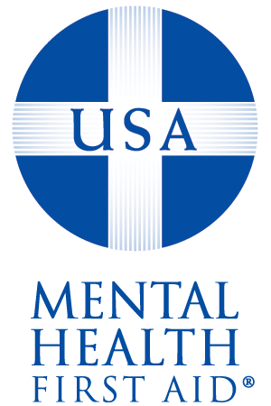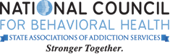

National Council for Behavioral Health operates Mental Health First Aid in the USA. The National Council for Behavioral Health, the Maryland Department of Health and Mental Hygiene, and the Missouri Department of Mental Health founded Mental Health First Aid USA.

**Fred Schmid**

Instructor

**Tracy Daniels**

Instructor

Mental Health

First Aid USA

Date

This certificate expires on: 3/25/2022

Date

This certificate became effective on: 3/25/2019

Has completed the 8-hour course and is now certified in

Adult

Mental Health First Aid USA

And has been trained to provide initial help to people experiencing

problems such as depression, anxiety disorders, psychosis, and substance use disorders.

