CHARACTER ANALYSIS ESSAY 40 point
via Literary Analysis and Critical Theories
In this Character Analysis Essay, you will be projecting your critical reading/thinking skills and your knowledge of Critical Theories by analyzing 3 female characters from 3 different works.
How to Start?
- Consider the provided list of the characters from the works we discussed in our class

- You SHOULD use Mrs. Hutchinson (from the story “The Lottery”) and CHOOSE 2 other characters
(1 male and 1 female) from 2 other works we discussed in class. So you will be analyzing 3 characters.

* To make your choice easy, consider the provided list of characters when deciding on your 2 characters.

- After choosing the characters, consider their character type for Literary Analysis:

a) Character Traits: state if each of your characters is a static or dynamic; flat or round character and explain briefly referring to the texts. You may also consider Characterization: Direct or Indirect Characterization Are your characters described directly/ explicitly in the story or are we (the readers) form the image and personality of the character based on his/her action, thoughts, interactions with others (indirectly characterized)

- Choose 2 theories or themes*

So, you will be writing an analysis essay where you will be using the theories/ themes to analyze each
of the 3 characters and compare with each other.
You will be analyzing the 3 characters via Literary and Theoretical Analysis: which means, you will analyze the characters based on their character type and through 2 theoretical themes.

*Here are some themes to choose from / Choose any 2 (or 3) of these Theories/ Themes:
- Semiotics: Denotative/Connotative/ Symbolic meaning (De Saussure’s and Pierce’s theories)

Irony: if any meaning is used ironically

When analyzing the characters from the semiotic perspective, consider the meaning of their names, and how that meaning can be associated with their personality, actions, interactions with others, etc.

You may also consider any sign, word, position title (profession) used to identify that character in the work and how the meaning of that relates to the character. Also, if the title of the work can be related to the character you are analyzing, you may consider that too and explain how the meaning of the title relates to the character. (Ex. Mrs. Louise Mallard from ‘” Story of an Hour” had a heart trouble and died from “joy that kills”– so when analyzing her character, you will consider the possible meanings of her full name and the denotative and connotative meanings of either the title of the story or “heart trouble” or “death” or the “cause of her death” /the phrase “the joy that kills” and how these meanings may relate to her character/ personality/ actions.
  - Ideologies/ Power, Privilege, Control gained through certain beliefs/ traditions, through social status and/or education, knowledge, or certain skills (Marx’s theory)

Capitalism: Competition, American Dream, Hero Motif, Commodification; Colonial Subject

When analyzing the characters from this perspective, you may consider if the characters hold any power and have certain privilege among others based on their social status, educational level, knowledge or any skill that the characters possess. You may also consider if the characters can be related to any type of capitalist ideologies, and if the character is colonial subject or a colonizer.
  - ISA/RSA: control via ideologies and repression (Althusser’s theory)
When analyzing the characters from this perspective, you may consider if your characters are acting as the “state apparatus” meaning if they are the ones imposing ideologies, rules, beliefs or are using any type of punishment methods upon others/ “the disobedient.” Or are your characters the obedient / are they the one following the pre-set ideologies, rules, or are being punished for not following/deviating from those expectations?

  - Gender expectations in Patriarchal society and/or from Feminist perspectives (Gender Theory handout)

When analyzing the characters from this perspective, you may consider if your characters abide with any expected gender roles.

You may consider their lifestyle, profession, appearance, behavior, actions, interactions with others that re-affirm their gender role/prototype expected by the society they represent.

Altruism and/or Narcissism:

When analyzing the characters from the perspective of these terms, you may consider if your chosen characters are selfless or
self-centered; how much do they care about others.

* Remember, you need to choose only 2 of the above mentioned theories/terms. ** You may choose 3 for extra credit!

How to Structure your Paper?
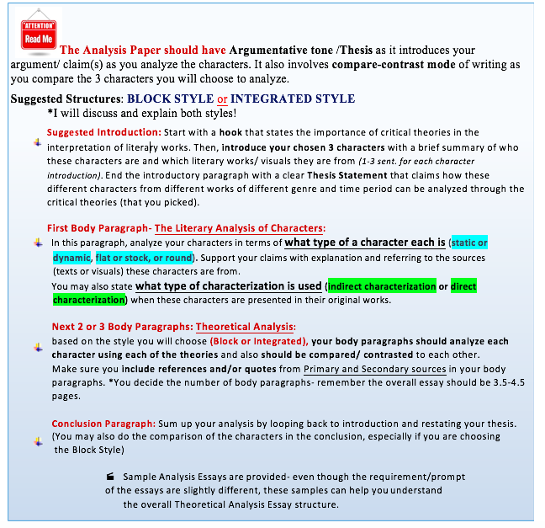

The Analysis Essay:
- Should have an academic essay structure: introduction, body paragraphs, and a conclusion

Should be 3.5- 4.5 pages typed/ double spaced/ Times New Roman 12 font (not including the Works Cited page, which will be attached to the back of your paper.)
- Should mention at least one of the theorists we discussed in class.
(Refer to/mention the theorist, whose theory you will be using in your analysis essay.)
- Should refer to the Primary Sources/ the works from where your characters are coming: It should have supporting information, quotes, examples/references from the sources considered for the analysis.
- Should also have at least 2 (max 3) Secondary Sources that you will research to support your claims The secondary sources may include:
  - Credible texts / electronic sources such as an article, book, journal, scholar essay, encyclopedia, etc. (* At least 2 credible sources)

* Use Google Scholar, or Academic databases of LAVC.
  - Our course materials (example Theory Handouts, PowerPoints, lecture notes)
*Please note that our course handouts will not be considered as the use of the secondary credible source.
  - but no more than 1 website information searched via regular search engines
- It should use MLA format for in-text citations and a Works Cited page.
*I will provide some information and handout on MLA Works Cited page.

___________________________________ __________________________________

*We will have Zoom sessions to discuss the questions you may have while drafting your essay and the MLA citation. Also, for questions, advice, help, guidance consider the LAVC Writing Center Zoom hours to see a tutor.

How to Structure your Paper?

The Analysis Paper should have Argumentative tone /Thesis as it introduces your argument/ claim(s) as you analyze the female characters. It also involves compare-contrast mode of writing as you compare the 3 characters.
Suggested Structures: BLOCK STYLE or INTEGRATED STYLE

I will discuss and explain both styles in-class!
Suggested Introduction: Start with a hook that states the importance of critical theories in the interpretation of literary works. Then, introduce your 3 characters with a brief summary of who these characters are and which literary works/ visuals they are from (1-3 sent. for each character introduction). End the introductory paragraph with a clear Thesis Statement that claims how these different female characters from different works of different genre and time period can be analyzed through the same critical theories (the 2 theories that you picked).

. Body Paragraphs: based on the style you will choose (Block or Integrated), your body paragraphs
should analyze each character using each of the theories and also should compare/ contrast to the
other characters (so you will analyze each character in terms of your chosen 2 theories, and then you
will compare the character with each other)

Make sure you include references and/or quotes from Primary sources (quotes and references from the works these characters are picked from) and from Secondary sources ( the 2 sources you will research and use as a support)
You decide the number of body paragraphs- remember the overall essay should be 3.5-4 pages.

Conclusion Paragraph: Sum up your analysis by looping back to introduction and restating your thesis.
You may also summarize the comparison of the characters in terms of your selected theories.

  - Sample Analysis Essays may be provided- even though the requirement/prompt of the essays are slightly different, these samples can help you understand the overall Theoretical Analysis Essay structure.

  - Use the Writing Center services to get feedback on your draft and formatting.

*For Citation / Works Cited page of the Primary sources consider my MLA Citation Handout Details
provided separately on the the weebly site

* Here are some brief notes on Theories and Theorists:
- Language derives its meaning from the relation of Signifier and Signified (De Saussure)
- The meaning of signs is created through Icon, Index, and Symbolism (Peirce)
- The theory of power and knowledge is used for social control
Ideology of Power resides in the ruling ideas: the ruling class is the ruling intellectual force (Marx)

- Ideological State Apparatus (ISA) and Repressive State Apparatus (RSA) (Althusser)
Power is exercised through ideologies and repression (ISA and RSA)

- Self-Identification is an unending process that starts from the Mirror stage! We identify us through symbolic language and through “the Other.” We always strive for Individual Identity and the Wholeness of Self. (Lacan)

- These are the three parts of the psychic apparatus where the interaction of our mental life is described: Id is the set of uncoordinated human basic instinctual drives; Super-Ego reflects the internalization of cultural rules; Ego is the organized, realistic part that mediates between the desires of the id and the super-ego. (Freud)

- Gender is constructed and defined by the society. (Judith Butler)

GRADING RUBRIC / What to Consider when revising / finalizing the paper:

Analysis Paper Structure and Length

Paper Requirements (3 characters/ 1 being Emily and 2 Theories)

Brief Summary of the works the characters are picked from and brief character analysis-

Referring to/ mentioning a Theorist

Referring/ Quoting from the Primary Sources

Secondary source in-text citation

Format and Works Coted Page

Mechanical: Grammar, spelling, punctuation

