9ABiochemical Connections: Law

Who Owns Your Genes?
“There is a gene in your body’s cells that plays a key role in early spinal cord development. It belongs to Harvard University. Incyte Corporation, based in Wilmington, Del., has patented the gene for a receptor for histamine, the compound released by cells during the hay fever season. About half of all the genes known to be involved in cancer are patented.” Following the explosion in information that came from the Human Genome Project (see Biochemical Connections 9B), commercial firms, universities, and even government agencies began to look for patents on genes, which began a long philosophical and legal battle that continues to this day. Human cells have about genes, which are the blueprint for the trillion cells in our body. About percent of the human genome has been patented. As of 2006, Incyte Corporation owned about percent of all known human genes.
So the question that comes to mind is, “how can a company patent a biological entity?” Well, clearly they cannot actually patent you or your genes, at least not the ones you carry around. What can be patented is purified DNA containing the sequence of the gene and techniques that allow the study of the genes. The idea of patenting information began with a landmark case in 1972 when Ananda M. Chakrabarty, a General Electric engineer, filed for a patent on a strain of Pseudomonas bacteria that could break down oil slicks more efficiently. He experimented with the bacteria, getting them to take up DNA from plasmids that conferred the clean-up ability. The patent office rejected the patent on the grounds that products of nature and live organisms cannot be patented. However, the battle was not over, and in 1980 the Supreme Court heard the appeal in the same year that the techniques of molecular biology and recombinant DNA technology really began to take off. Chief Justice Warren Burger declared arguments against patenting life irrelevant by stating, “anything under the sun that is made by man” could be patented. The ruling was close, only in favor of Chakrabarty, and the ramifications continue to this day. Patents have been issued for gene sequences, whole organisms such as specific bacteria, and cell types like stem cells. A patent on a clone gene or the protein it produces gives the owner exclusivity in marketing the protein, such as insulin or erythropoietin. As of 2005, the largest holder of scientific patents was the University of California, with more than patents. The U.S. government was second with , and the first commercial enterprise on the list, Sanofi Aventis, came in third at (Figure 9.7).
Figure 9.7
This map of the chromosomes offers an indication of how often genes have been patented in the United States. Each colored bar represents the number of patents in a given segment of a chromosome, which can contain several genes. Patents can claim multiple genes, and one gene may receive multiple patents. As a result, the number of patents indicated for each chromosome does not necessarily match the sum of the values represented by the colored bars.
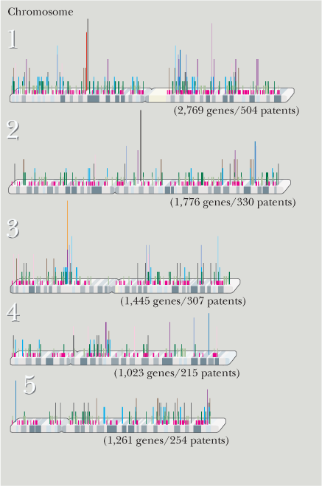
(Laurie Grace)
There are many issues stirring the controversy. Proponents for the patent system point out that it takes money to drive research. Companies will not want to invest hundreds of thousands to millions of dollars in research if they cannot get a tangible gain. Allowing them to patent a product means they can eventually recover their investment. Opponents believe a patent on what amounts to information stifles more research and even prevents the advancement of medicine. If a company holds the patent to a gene known to be involved in a disease, then others cannot study it effectively and perhaps come up with better or cheaper treatments. The latter point of view has come under intense scrutiny recently because patents on diagnostic genes inhibit both research and clinical medicine. At the heart of the conflict are patents for two genes related to breast cancer, BRCA 1 and BRCA 2, both owned by Myriad Genetics, Inc., of Salt Lake City. In 2009 a group of patients, doctors, and research professionals brought a suit to invalidate those patents. They argued that the two genes are “products of nature” and should never have been patented in the first place. The long-term effects of such a suit are important enough that the American Civil Liberties Union has joined the plaintiffs.
Opponents of gene patents claimed a big victory in March 2010 when Federal Court Judge Robert Sweet ruled against Myriad in the suit of BRCA 1 and BRCA 2, stating the human genes cannot be patented. So who owns your genes? At the moment, you do. See the Hot Topic on breast cancer at the end of this chapter for more about BRCA 1 and 2.

