CHAPTER 1: INTRODUCTION
1.1. Research Overview
This chapter sketches the background and significance of this thesis.
The OECD Benchmark Definition of Foreign Direct Investment elucidates FDI as an investment that establishes “a lasting interest by a resident enterprise in one economy (direct investor) in an enterprise (direct investment enterprise) that is resident in an economy other than that of the direct investor”. A lasting interest implies that a long- term relationship is established between the direct investor and the direct investment enterprise, whereby the direct investor has a significant amount of influence over the management of the enterprise. For this relationship to exist, a direct investor in one economy needs to directly or indirectly own 10% or more of the voting power of the direct investment enterprise in another economy. There are arguments that 10% is too trivial to have any influence, and that, in other cases, a share less than 10% can hold substantial power in managerial discussions and decisions, and ultimately, over management. Nonetheless, for statistical consistence and coherence worldwide, the figure used is 10%. (OECD, 2008)
Correspondingly, Foreign Direct Investment in Namibia is defined as “any proposed investment by a foreign national of assets with not less than 10% of the total share capital of a venture or that the foreign national holds a management interest in the day to day running of the business concern”. (Foreign Investment Act, 1990)
Table 1 Source: UNCTAD (2019)
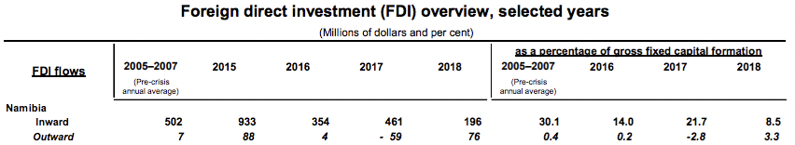
5
According to UNCTAD (see Table 1 above), inward FDI flows were 30.1% (pre-global financial crisis annual average) from 2005 to 2007 and 14.0%, 21.7%, and 8.5% from 2016 to 2018 respectively, as a percentage of gross fixed capital formation. (2019) On the other hand, FDI stock as a percentage of gross domestic product ranged from a significant 48.7% to 54.3% from 1995 to 2018. Outward flows were comparatively, very low in both cases – ranging from 0.4% to 6.9%.
UNCTAD’s World Investment Report reports that FDI flows to Sub-Saharan Africa increased by 13% to $32 billion after consecutive contractions in the two preceding years. Southern Africa saw the biggest recovery of $4.2 billion after a net divestment of $925 million the year before. (2019)
Furthermore, the Bank of Namibia’s quarterly bulletin at the end of 2018 conveys that direct investment declined from N$4.1 billion and N$3.1 billion both on an annual and quarterly basis, to N$1.9 billion during the third quarter of 2018. The reduction in capital inflows in this case occurred due to “lower profits made by foreign direct investment enterprises in the form of reinvestment of earnings”.
Equally important, the Namibian government has made efforts, such as the Investment Promotion Act, tax incentives for registered manufacturing enterprises (provided that certain criteria are met), capital allowances, the Special Economic Zones (SEZs)1, and the Namibian Investment Centre (NIC) which was established in 1990 under the Foreign Investment Act No.27 of 1990 (currently under review), with the “major responsibility of promoting FDI”. (MITSMED, 2019)
Given these points, FDI plays a significant role in the Namibian economy.
1SEZ enterprises “qualify for total relief from income tax, VAT, customs and excise duties, stamp duty and transfer duty (but not employee related tax and WHT), given certain requirements”. (Deloitte, 2018)
6
1.2. Research Aim and Objectives
Research Aim: This project aims to be an in-depth analysis of Foreign Direct Investment (FDI) flowing into Namibia and whether it carries benefits or not.
Objectives
1. The impact of FDI in Namibia
- ! What are the inflows and to which sectors do they go?
- ! What is the resultant economic impact?
2. Policies pertaining to FDI in Namibia
1.3. Research Rationale
! Are the policies adequate and efficient at achieving their task?
There is limited amount of research in this area, which has proven to be significant especially recently.
Namibia finds itself in a situation where the Ministry of Mines and Energy and the Ministry of Finance are both expressing their contention towards FDI agreements that have been made with regard to mines, stating that they do not believe they have been structured in a win-win manner, but more in a win-lose manner, whereby the country is losing because it only receives a minimal percentage of the profit through domestic shareholding and royalties, for example. This provides one angle of an interesting business case because the Bank of Namibia, the country’s reserve bank, reports that direct investment by sector has been dominated by mining and quarrying in both 2017 and 2018, when the percentages shares were 64.6% and 65.5% respectively. (2019)
Beyond that, there has been tremendous public concern, rhetoric, and allegations regarding how the Chinese seem to be “taking over” Namibia. This is not only because of the growing numbers of the Chinese population in the country (which is partially owed to FDI entities), but also due to the growing amount of Chinese debt that the
7
country has on its back (the Minister of Finance has addressed these allegations publicly to try and do away with public fears and concerns). Moreover, from a direct investment point of view, the Bank of Namibia has reported that the People’s Republic of China is dominant in this case, with percentage shares of direct investment by country, of 40.4% in 2017, and 39.3% in 2018. (see Appendix 11) Not to mention, Chinese firms are known for employing Chinese laborers and importing most materials including cement from China for their Namibian projects, which takes away the benefits that are supposed to be afforded to Namibians. (Windhoek Observer, 2018)
There has also been public disagreement towards government tenders for road construction being awarded to South African companies, for example. This comes as no surprise, with South Africa coming in second place after China; having a percentage share of direct investment by country of 31.4% and 30.4% during 2017 and 2018 respectively. Other countries on the list all have a percentage share below 10%. (Bank of Namibia, 2019)
Correspondingly, the president of the Republic of Namibia has voiced that western companies operating in China invest on Chinese terms and Namibia can learn from this, further adding that Namibia should not blame the Chinese, but themselves. These statements and reality of the above-mentioned matters once again provides an important business case, because, clearly, the Namibian government is dealing with FDI issues and has no clear-cut cohesion regarding said issues.
Moving on, from a more personal perspective, FDI is a matter which needs to be addressed urgently, seeing to it that issues related to it have already become of major public concern, to the extent that ministers and the president need to address it publicly in order to avoid any uproars which might occur due to this matter. Not only that, with the current global trend of countries trying to attract as much FDI as they can because it is believed to be a driver of economic development, and a highly sought after financing option or capital provider, which it undoubtedly is, the pros and cons thereof need to be evaluated carefully in order to determine how policies that are
8
enacted to attract and manage FDI, as well as FDI agreements, are structured to equally and optimally benefit both/all parties involved.
1.4. Research Context
Namibia is a country in South West Africa, neighboring South Africa, Botswana, Angola, Zimbabwe, and Zambia. It comprises large desert areas, ranchland, and a long coastline bordering the South Atlantic. The World Bank has classified the country as an upper-middle-income country because of its mineral riches and a tiny population of about 2.5 million in 2016. (2019) Moreover, the country is politically stable and has reliable economic management. These noteworthy characteristics have however not resulted in job creation, and extreme socio-economic inequalities which were inherited from the years when the country had an apartheid system whilst under South Africa’s colonial rule, continue to prevail, regardless of generous public spending on social programs.
The economy contracted by 0.4% in 2018, and by 0.9% in 2017. The continuation of fiscal consolidation can be seen as one of the reasons why the country is now in a depressed economic state, along with a decreased demand for Namibian exports from the country’s neighbors, due to sluggish growth in those respective economies as well. By the same token, aforementioned fiscal consolidation, which commenced in the middle of the 2016/17 financial year due to extreme fiscal spending in the previous financial years, continued into the 2018/19 financial year, but with a slower pace.
The mining and construction industry were the strongest parts of the economy; encouraging recovery, as mining activity expanded by 11% in 2018 as a result of increased uranium production particularly owing to increased Uranium production by the Husab mine, and construction activity grew by 10% after a 25% contraction in the previous two years. The boost in construction activity primarily came from the private sector.
In addition, economic growth is believed to continue increasing in 2019, up to 2% over the medium-term, mainly because of mining activity, the revival of the construction
9
sector (which will also be supported by the “planned infrastructural projects financed by the African Development Bank”), the recovery of domestic demand and regional trading partners which could lead to a stronger services sector, and positive agricultural activity because of expected favorable weather conditions. (World Bank, 2019)
Poverty has decreased from 69.3% of the population living below the national poverty line, to 17.4% in 2015/2016. In addition, as previously mentioned, the country is still largely plagued by inequality. The consumption Gini index decreased from 64.6% in 1993/94, to only 57.6% in 2015. Regardless of steady economic growth since independence in 1990 (not taking the economic depression from 2016 into consideration), poverty, inequality, and unemployment have remained persistent, with unemployment sitting at 34%, up from 27.9% in 2014. Hence, the majority rely on subsistence farming or social grants and other transfers, instead of employment income. Sluggish economic growth which results partially from continuous fiscal consolidation, along with slow recovery of regional trading partners, is expected to further limit job creation. (Deloitte, 2017)
1.5. Research Outline of Chapters
Chapter 2: Provides a comprehensive review of the literature of the study, as well as a discussion of the models and theories related to the topical issues.
Chapter 3: Presents how the research was designed, which parties were involved, which research philosophy, approach and strategy were used, as well as how data was collected, along with ethical considerations and research reliability and viability.
Chapter 4: A brief explanation of how the data was collected and a discussion in terms of the research questions and the literature review.
Chapter 5: Explains the overall conclusion drawn from the research findings and analysis of the collected data. In addition, it proposes recommendations to the main 10 findings, discusses the theoretical and managerial implications thereof, explains the limitations of the study, and suggests the direction for further research.

CHAPTER 2: LITERATURE REVIEW
The 1970s to 1990s saw the proliferation of capital outflows from Namibia and respective Southern African countries, as colonialization by Western countries came to an end. Namibia, in particular, gained independence from South African rule on the 21st of March 1990. With decreased capital inflows after independence, the country had to look at alternative sources of capital inflows to drive much-needed fundamental development and industrialization. This saw then president, and Namibia’s founding father, Dr. Sam Nujoma, travelling around the world to promote the country’s lucrative investment opportunities. Investment conditions were favorable as well. FDI to the country surged, arriving in the types and modes explained later on. It has however now seen sluggish growth, if not a decline. Investors seem to no longer view it as a safe haven to invest in.
Although a number of studies around FDI in Namibia have been conducted, the benefits and challenges thereof remain inconclusive, with the country still making sub- optimal use of FDI, FDI being concentrated in the mining sector – yet with debatable and questionable agreements, and generally just no induction of an ideal amount of FDI.
In the following chapter, a critical review of the literature surrounding the objectives stated in Chapter 1 is presented, with a detailed focus on the following: FDI and economic growth, FDI in developing countries, FDI in Southern Africa, FDI in the extractive industries, the determinants of FDI, and FDI and policy implications.
2.1. Definitions and importance of FDI
Along with the definitions provided in Chapter 1, a significant number of literature classify FDI as a form of Foreign Capital Inflows (FCIs). Other forms of FCIs are personal remittance (PR), official development assistance (ODA) and foreign portfolio investment (FPI), of which FDI, PR, and ODA tend to be the most important sources of FCIs in numerous African countries.
12
To accentuate its importance, FDI is regarded as one of the most significant contributors to economic growth worldwide. FDI flows have increased dramatically in the past quarter century, especially with the sweep of globalization in the early 1990s. Moreover, UNCTAD maintains that FDI remains the largest external source of finance for developing economies. It makes up 39 percent of total incoming finance in developing economies as a group, but less than a quarter in the Less-Developed Countries (LDCs), with a declining trend since 2012. (UNCTAD, 2018)
UNCTAD further breaks down FDI into:
• Equity capital – the foreign direct investor’s purchase of shares of an enterprise in a country other than its own
- Reinvested earnings – the direct investor’s share (in proportion to direct equity participation) of earnings not distributed as dividends by affiliates, or earnings not remitted to the direct investor. The retained profits are reinvested in this case
- Intra-company loans or intra-company debt – short- or long-term borrowing and lending of funds between direct investors (parent enterprises) and affiliate enterprises
(UNCTAD, 2007)
2.1.1. Types of FDI
UNCTAD (1998) identifies 4 types of FDI:
• Market-seeking – allured to markets because of their size and/or growth capacity
• Efficiency-seeking – investment that looks for locations where cost (e.g. labor costs, administrative costs, etc.) is low and productivity is high (most likely firms that compete on price rather than differentiation)
13
• Resource-seeking – seeks to exploit the extraction of natural or other resources
• Strategic-asset seeking – oriented towards man-made assets, such as a workforce with relevant qualifications and expertise, knowledge-intensive assets and learning experiences. Simply, assets which are beneficial in achieving strategic objectives
Beyond that, Protsenko (2003) distinguishes two other distinctive types of FDI.
- Vertical FDI – investments that multinationals make to set up each production stage in a different country in order to take advantage of the “differences in relative factor costs”
- Horizontal FDI – investments that a multinational makes into different countries to set up separate plants in every local market in order to specially produce for and serve each unique market
2.1.2. Modes of FDI
Gorynia, Nowak, and Wolniak (2005) pinpoint 3 main modes of FDI:
- Mergers and acquisitions (M&A) – using the firm’s funds to combine and integrate two firms’ operations or to purchase and take over an already existing operation
- Green-field investment (New Plant) – “an investment of a firm that uses its funds to set up an entirely new economic entity by constructing a new facility”.
- Joint Venture – “combining assets in a common and separate organization by two or more firms who share ownership and control over the use and fruits of these assets”
14
2.2. FDI and economic growth
The OECD imparts that FDI plays a noteworthy role in building international economic integration; further highlighting that FDI can present financial stability, drive economic development, and elevate the well-being of societies.
Furthermore, neoclassical and endogenous growth models which have been widely used to study the relationship between FDI and economic growth (EG), as well as the theoretical benefits of FDI, convey that FDI plays a role in promoting growth. A study of that kind is one by Chowdury and Mavrotas (2005) which outlines the determinants of growth, the role of multinational firms in host countries, the determinants of FDI, the direction of causality between the two variables, and the determinants of FDI, as the four main channels through which FDI promotes growth. Other authors, namely De Mello (1997), Tiwari (2011), and Adusah-Poku (2016) all support this positive relationship. They however are of the opinion that this relationship can only exist and thrive provided that financial market regulations and banking systems, necessary human capital in the host countries, relatively open economies (especially those being invested in), and existing trade regimes, are in place to support it.
Nevertheless, on the other hand, Hein (1992) and Khan (2007) suggest that developing countries should drive economic growth without putting great emphasis on and being heavily reliant on FDI, adding that if developing countries cannot improve and develop their structures so that they become fully-fledged modernizations, they remain trapped in the world’s inherent capitalist system. To counter this, however, whilst still reaping the possible and obvious benefits of FDI, the authors suggest that developing countries should create the appropriate economic environment for adequately and efficiently absorbing FDI.
All things considered, as displayed below (Table 2), according to Mowlaei’s research, several empirical studies further prove that FDI has a positive impact on economic growth, of course, given an ideal and political-economic environment. (2018) Table 3, which exhibits a compilation of the research surrounding the general FDI – EG
15
relationship from 1999 to 2012 by Almfraji and Almsafir (2013), also emphasizes this positive impact, as the positive effect results prevail distinctly over those with contrasting results. It is however important to note that the results vary because of the sample selection (developed versus developing countries), the estimation techniques chosen (OLS, Granger Causality, Cointegration, Error correction, etc.), the estimation methodology, the selected time period, and so forth.
Table 2: Empirical Studies of FDI on Economic Growth Source: Mowlaei (2018)
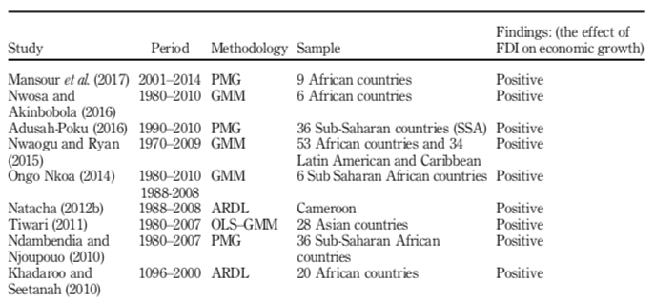
16
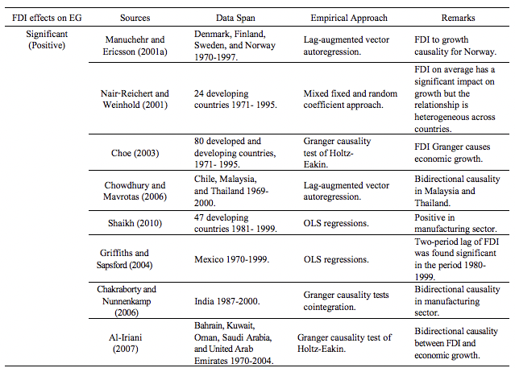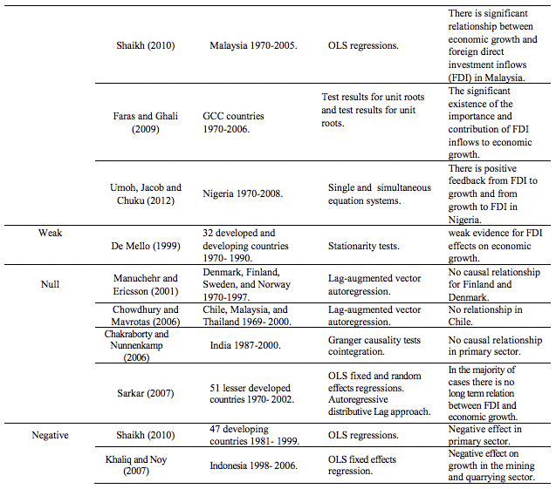
Table 3: Relationship between FDI and Economic Growth Source: Almfraji and Almsafir (2013)
17
2.3. FDI in Developing Countries
Loungani and Razin (2001), under the IMF, posit that in contrast to other forms of private capital flows such as portfolio equity and debt flows, foreign direct investment, has remained more resilient during financial crises. Examples are East Asian countries which maintained a stable level of FDI during the global financial crises of 1997-1998 and the Mexican crisis of 1994-95, as well as the Latin American debt crisis during the 1980s through which FDI also remained buoyant. (2001) What this means is that it is understandable why developing countries would prefer FDI over other forms of capital inflows; advancing a global (and especially an emerging market) trend which sees capital inflows shifting away from bank loans towards FDI and portfolio investment, as revealed by Table 4 below.
*Estimate or projection by the IMF, World Economic Outlook
Table 4 Source: Deutsche Bundesbank (2003)
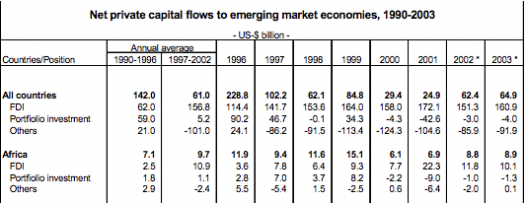
18
Feldstein (2000) and Razin and Sadka (1999) thus outline that developing host countries can benefit from FDI in the forms of:
- Human capital development when employees are trained with specific skills and know-how that the new establishment requires, and perhaps offered educational opportunities before or during their employment.
- Contributing to and stimulating competition in the domestic input market (and thus accelerating productivity growth in domestic firms).
- Enabling technological transfers/spillovers – which is achieved by capital inputs other than those that are of a financial or trading nature.
- Increased corporate tax revenue2
- FDI cannot be extracted from the host country easily or immediately at the first
sign of trouble. Direct investments are revalued with immediate effect when a crisis occurs, as opposed to short-term debt, for example.
By the same token, Bosworth and Collins (1999) confirm that an increase in FDI results in an almost equally corresponding increase in domestic investment, after conducting an extensive study that comprises 58 developing countries from 1978 to 1995, including Latin American, Asian, and numerous African countries. 18 of these countries were emerging economies. (see Figure 1)
Goldstein (2004) and Odenthal (2001) also reveal additional benefits such as narrowing the gap between capital needs and domestic savings, new employment opportunities with higher value addition and salaries than the domestic economy, augmented world market access through TNCs (transnational corporations) (and thus a possible entry into global supply chain networks), restructuring the domestic industry and increasing its competitiveness, and hence increasing rates of R&D and innovation (especially when a foreign company acquires or merges with a local company).
2 That is, if corporate taxes are applicable in that specific FDI agreement. An example where taxes might not apply are Economic Processing Zones (EPZs), which will be elaborated on later in the paper, or other efforts that cut or do away with corporate taxes in order to attract FDI.
19
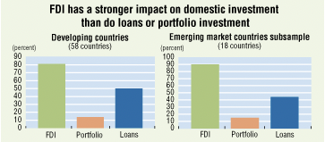
Figure 1 Source: Bosworth and Collins (1999)
*The height of each bar represents the estimated impact of the indicated capital flow on domestic investment. For example, in the left-hand panel covering developing countries, every dollar of FDI increases domestic investment by an average of 80 cents, that is, by 80% of the amount of FDI.
Given these points, there are strong arguments for FDI, ones that might make it worthwhile to advocate for markets to unrestrictedly be able to invest directly across the borders of developing countries. It however goes without saying, that FDI can also have – in all the above-mentioned areas – negative impacts.
Hausmann and Fernández-Arias (2000) believe that a substantial amount of FDI as a share of total capital inflows might be an indication of the host country’s weakness, rather than its strength. There is evidence that FDI flows are higher in riskier countries (where risk is computed by the respective countries’ credit ratings for sovereign debt or by other measures of country risk) (see Figure 2), and in countries where the quality of institutions is lower. One possible explanation behind this reality is that FDI, more than other forms of capital flows, will be the preferred method of investment in countries with missing or inefficient markets because there is little confidence and thus low reliance on local financial markets, legal arrangements, or suppliers, to name a few. Albuquerque goes on to postulate that these developing countries, if trying to gain more access to international capital markets, should, instead of trying to attain more and more FDI, focus on creating reliable and dependable enforcement systems first. (2000)
20
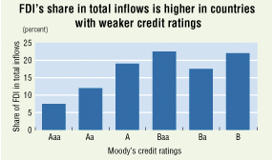
Figure 2 Source: Albuquerque (2000)
Similarly, Hausmann and Fernández-Arias further agree that if developing countries focus on ameliorating their investment climates and upgrade the functionality of markets, they are more odds-on to benefit through increasingly efficient overall investment, coupled with more capital inflows, amongst them, FDI. Although it is observable that FDI is higher in some countries, as a share of capital inflows, due to the deficiency of domestic policies and institutions, this cannot quite be the reason for disapproval towards FDI, as the host countries could be much worse off without it. In addition, in some cases, FDI enables foreign investors to have control over host country firms. This transfer of control is not always advantageous, because of the circumstances under which it transpires, problems of adverse selection, or maybe excessive leverage. (2000)
Krugman elaborates on this by questioning whether under the circumstance of a crisis, for example, foreign entities take over domestic enterprises because they possess particular unique and superior competencies and can thus administer these firms better, or straightforwardly because they have the necessary (financial) capital, and the locals do not? Additionally, do these inferior sales then burden the afflicted countries more than the crisis itself? (1998)
Beyond that, with regard to above-mentioned adverse selection, Razin, Sadka, and Yuen maintain that FDI gives foreign investors access to significant inside information around the productivity of the enterprises under their control.
21
This affords them an “informational advantage” over “uninformed” domestic savers who are not in possession of any control, even if they might own shares in the domestic establishments. Having this pivotal information at hand, foreign direct investors are in a privileged position where they can hold on to high-productivity companies that they own, and sell low-productivity firms to the unknowledgeable savers. (1999) Ordinarily, this could lead to overinvestment by foreign direct investors.
Thirdly, the earnings from FDI can be limited if the capital used to finance the project is largely obtained through excessive borrowing from the domestic credit market by foreign-owned firms, instead of employing foreign savings, which is often the case. (Loungani and Razin, 2001)
Loungani and Razin further note that although there is investment in fixed capital, which makes it difficult for FDI to be withdrawn from the host country suddenly, transactions of a financial nature can sometimes effectuate a “reversal of FDI”. For instance, the foreign subsisdiary can borrow money by using its domestic assets as collateral, and lend this money back to the parent company. Correspondingly, “because a significant portion of FDI is intercompany debt, the parent company can quickly recall it.” (2001)
Another challenge of FDI is when it is aimed at servicing local markets that are guarded by high tariffs or non-tariff barriers. Such being the case, FDI could prolong the poor allocation of resources through the fortification of lobbying attempts. Not to mention, domestic competition can also be reduced or lost completely in the event of “foreign acquisitions leading to a consolidation of domestic producers, through either takeovers or corporate failures,” and domestic investment can be crowded out. (Loungani and Razin, 2001) Figlio and Blonigen (2000) also argue that FDI might cause a surge in wage inequality, negatively affect the performance of several productive local firms, and weaken the connection between location advantages and ownership advantages, amongst others. Moreover, Moran adivses that FDI could, through profit repatriation, reduce, rather than raise domestic savings and investments (as well as twist balance of payments), increase demands for foreign exchange, buttress local oligopolies and be anti-competitive, distort local politics and thwart
22
regulation, produce instability by increasing financial volatility, and seek to protect technology rents by refusing to transfer and share much-anticipated and hoped for technological knowledge.
2.4. FDI in Southern Africa
Southern Africa is characterized by SADC, which is the acronym for Southern African
3
Development Community . It comprises 16 member states, namely Angola,
Botswana, Comoros, Eswatini, the Democratic Republic of Congo, Lesotho, Madagascar, Malawi, Mauritius, Mozambique, Namibia, Seychelles, South Africa, Tanzania, Zambia, and Zimbabwe.
According to Goldstein, theoretically, all these respective economies are open to FDI. The majority have special schemes, imperative incentive mechanisms, and/or specialized organizations in place to captivate foreign investors. (2004)
UNCTAD reports that FDI flows to Sub-Saharan Africa surged by 13% to $32 billion, after experiencing declines in the two preceding consecutive years. Southern Africa gained most of this growth recovery; securing flows of $4.2 billion after having endured a net divestment of $925 million the previous year. South Africa dominated as per usual, garnering most of this growth, with FDI doubling to $5.3 billion, owing mainly to intracompany transfers by established investors, while Angola saw negative FDI growth (-$5.7 billion), as oil and gas entities relocated funds to parent companies via intracompany loans. (UNCTAD, 2019) SADC has received investment interest and attention from the international business community since the beginning of the 1990s, but stills lags behind other developing regions in FDI performance. (Odenthal, 2001) Nevertheless, Anyanwu asserts that East and Southern African countries attract higher levels of FDI than countries in other African sub-regions. (2018)
3 SADC is a free trade area with the aim of promoting regional integration, development and economic growth (and thus investment attractiveness), peace and security, whilst alleviating poverty, supporting the socially disadvantaged, building on democratic principles and equitable, and sustainable development, and enhancing the standard and quality of life of the peoples of Southern Africa. (SADC, 2019)
23
Goldstein imparts that an uninviting macroeconomic environment, unreliable and sluggish efforts towards trade liberalization, privatization and additional systemic amendments, a poorly trained workforce and insufficient skills, poor infrastructure, a small market size (in some countries), meager GDPs, belligerent climates, price and currency instability, as well as incompetent and unacceptable governance (corruption included) have, in one way or another, discouraged the movement of FDI to the African continent, and to its southern region, in particular. Fortunately, however, strong property rights, which play a critical role, exist. (2004)
In this light, Goldstein goes on to underscore that for most SADC countries, excluding the Democratic Republic of Congo (DRC), and Zimbabwe, for instance, a substandard macroeconomic environment has not deterred FDI to a large extent. (2004) A case in point is Angola, which has attracted significant FDI inflows (it has often been the second-largest recipient of FDI in SADC), regardless of its (then and to a certain degree, current) outrageous governance. It is however important to stress again that even so, a few countries have managed to fascinate international investors by bettering their domestic business environments. (Morisset, 2000)
Furthermore, apart from South Africa, which has the most diversified economy in Southern Africa, Goldstein conveys that most SADC countries (with Lesotho, Mozambique, and Swaziland being the few exceptions) attract most of their FDI to the exploitation of extractive industries, as the region has a diverse, abundant supply of precious and base minerals. (2004) This fact poses a serious predicament due to the negative consequences that result from an excessive dependence on natural resources. It will be addressed and expanded on in the subsequent section.
2.5. FDI in the extractive industries
In the 2019 African Economic Outlook, the African Development Bank (AfDB) announced that African economic growth is fueled by plentiful agricultural, mineral, and other, natural resources, due to a lack of industrialization and value addition (73 % of the continent’s exports in 2008 were natural resources – the highest amongst all
24
continents) (WTR). Not only that, African countries have in fact deindustrialized (which is a feared effect that can occur when natural resources crowd out the production of potentially dynamically-beneficial non-commodity tradable goods). (AfDB, 2019)
The World Trade Report (WTR) defines natural resources as “stocks of materials that exist in the natural environment, that are both scarce and economically useful in production or consumption, either in their raw state or after a minimal amount of processing.” (2010)
There is a clear linkage between FDI and natural resources on the continent, with Asiedu (2006) and Morisset (2000) contending that natural resources do in fact correlate positively with FDI inflows. Interestingly, Asiedu and Lien also point out that in countries with superior natural resource exports, a higher level of democracy will have a negative effect on the amount of FDI inflows, whilst it will have a positive one on those countries with less natural resource exports. (2011)
In the same fashion, Asiedu (2013) documents that resource-rich countries are more
likely to attract an amount of FDI inflows less than the optimum and required amount
45 they can attract, and are thus most likely to fall victims to the natural resource curse. ’
4 The Natural Resource Curse or the Paradox of Plenty, is a counter-intuitive, paradoxical phenomenon whereby oil, natural gas, or other valuable mineral deposits or natural resources do not automatically confer economic success, with casual observation confirming that countries endowed with copious natural resources, such as Nigeria, Mexico, the Democratic Republic of Congo, and Venezuela, to name a few, not having exhibited robust, vibrant, and sustainable economic growth, high quality of life, and high per capita income, while contrastingly, those with no valuable natural resources (e.g. Japan, Singapore, and Hong Kong), have. (Frankel, 2010)
5 Arguments for the cause of the resource curse constitute: 1) High commodity price volatility, 2) Crowding out of the manufacturing sector (i.e. deindustrialization), 3) Civil war caused by mineral riches, 4) Corruption, inequality, class structure, chronic power struggles, and the absence of rule of law and property rights as a result of “point source” commodities (e.g. oil, minerals, and some crops), 5) The Dutch Disease, which manifests when a currency appreciates, and government spending rises as a reaction to a commodity boom. This in turn results in “the expansion of nontraded goods and service sectors such as housing, and surrenders uncompetitive non-commodity export sectors such as manufacturing. If and when world commodity prices go back down, adjustment is difficult due to the legacy of bloated government spending and debt and a shrunken manufacturing sector.” (Frankel, 2010)
25
The Resource Curse is also supported by Sachs and Warner (2001) and Ross (2001), especially concerning oil resources.
In like manner, as previously hinted at, Poelhekke and Van der Ploeg (2010) affirm that natural resources derail aggregate FDI from the non-resource sector, into the resource sector. Even so, despite the aforementioned, they concede that “a doubling of the natural resources leads to a decline in aggregate FDI flow”.
On the other hand, the common inference that natural resources are a worrying impediment to economic growth has been challenged, and very well so. Larsen (2005, 2006) points out that Norway, for instance, prevails in terms of governance and economic performance whilst being a recognizable oil-producer. Similarly, Botswana and the Democratic Republic of Congo (DRC) are both generously blessed with diamonds, but Botswana lies far ahead, even continentally, considering income growth, stability, and democracy. (Iimi, 2006; Engelbert, 2000) Additional statistical studies that have found no evidence of the natural resource curse have been conducted by Herb (2005), Maloney (2002), and Davis (1995). It is thus imperative to stress that to succeed, resource-rich countries need to have certain systems and channels in place (e.g. strong institutions that produce good, sound macroeconomic and microeconomic policies) to ensure that they achieve a Botswana rather than a Venezuela, and a Norway rather than a Congo. (Frankel, 2010)
Furthermore, World Development Indicators (WDI) emphasize that the marvelous growth that stems from dependence on the extractive industries in numerous African countries is not sustainable, and that countries should focus on investing in assets that will be instrumental in provoking economic growth in the long run, e.g. human capital. Equally fundamental, they highlight that natural resources need to be managed prudently, since, after all, high economic growth is correspondent with the depletion of natural capital, such as forests and minerals. (2013)
Long, Stretesky, and Lynch also propound a correspondent, yet enlightening advancement to the aforementioned reasonings and conclusions. They confirm both their hypotheses (Hypothesis 1: Annual increases in FDI will lead to annual increases
26
in natural resource depletion within countries; Hypothesis 2: Annual increases in FDI will lead to annual increases in natural resource rents within countries), and find that increases in FDI stocks in LDCs are commensurate with increases in all forms of natural resource depletion and natural resource rents6, except energy rents. This validly demonstrates that FDI aggravates natural resource depletion. Not only that, since resource rents grow with FDI, LDCs become increasingly dependent on their natural resource sectors, “pushing them toward environmentally unsustainable behavior ... and ecological disorganization.” (2017)
2.6. Determinants of FDI
As conveyed in the previous chapters, determinants play a vital role in the induction of FDI inflows. The latter chapter, however, has substantiated that sometimes they do not, especially in the extractive industries. In this section, I briefly outline some of the determinants that are necessary in inviting FDI.
By making use of comprehensive survey data from the European Round Table of Industrialists, together with traditional sources such as World Bank data, on investment conditions in 28 developing countries since the late 1980s, Nunnenkamp posits that traditional market-related determinants still play a superior role in the distribution of FDI. Moreover, he also affirms that non-traditional determinants, “though mostly revealing the expected correlation with FDI, have typically not become more important with proceeding globalization”. He mentions that the population of host countries (which is a representation of market size) and the access thereto, GDP per capita in host countries, GDP growth of host countries, administrative bottlenecks, entry restrictions, and risk factors (of which one representation is the country’s credit rating) are considered traditional determinants.
In contrast, non-traditional factors are local inputs and complementary factors
6 Resource rents are the total value that can be generated from the extraction of the natural resource, less the cost of extracting the resource (including a normal return on investment to the extractive entity). (SESRIC, 2019)
27
necessary for internationally competitive production, the availability of sufficiently qualified labor, cost factors in terms of taxes, employment conditions, labor market regulations, the leverage of trade unions, restrictions on foreign trade (openness to trade), and the change in trade shares. Factors that aren’t classified as one of the two are multi-faceted, post-entry restrictions (e.g. performance requirements), and technology-related regulations. (2002)
Global Investment Competitiveness
Furthermore, the World Bank, in one of its recent
Reports, adds a few other determinants, namely (in order of decreasing importance) political stability and security, macroeconomic stability and a favorable exchange rate, good physical infrastructure, financing in the domestic market, and access to land or real estate. (WBG, 2017)
2.7. FDI and policy implications
This section draws extensively on the United Nations Conference on Trade and Development (UNCTAD), World Investment Report 2018: Investment and New Industrial Policies (New York, Delhi, Tokyo, and Geneva: United Nations).
Considering that FDI has become highly sought after in an increasingly globalized world, developing countries like Namibia are constantly told to “get the policies right”. But as we have observed in the preceding chapters, sometimes the policies matter, but other times not, especially when natural resources are involved. Hence, there are a number of caveats that exist in this case, because dancing to the tunes of foreign investors and their advocates, and “getting the policies right” specifically as per their demand, often does away with the much-anticipated benefits of FDI, if not being inimical to a specific country’s economy altogether. The opposite of the foregoing undeniably also holds true. Unquestionably, it is thus the domestic policy framework that is crucial in terms of whether or not the net effects of FDI are positive (UNCTAD, 2018). And it is thus largely in the hands of domestic policymakers to make the best out of FDI.
28
This section is a review of some of the policies that have an impact on FDI or vice versa (and that might specially have been enacted with FDI in mind), and what their potential impact can be.
Firstly, it is important to convey that new national investment policies worldwide are geared primarily towards investment liberalization – a trend that once again calls for caution. (UNCTAD, 2018)
UNCTAD data reveals that “in 2017, 65 countries and economies adopted at least 126 investment policy measures affecting foreign investment – the highest numbers of countries and policy changes over the past decade. Of these measures, 93 related to the liberalization and promotion of investment, while 18 introduced restrictions or regulations (the remaining 15 measures were neutral). Liberalization and promotion thus accounted for 84 per cent of investment policy changes.” (2018) (see Figure 3)
Encouraging investment entailed simplifying administrative procedures, providing incentives, and creating new special economic zones. On the other hand, restrictions and regulations were put in place on the basis of national security and foreign ownership of land and natural resources.
29
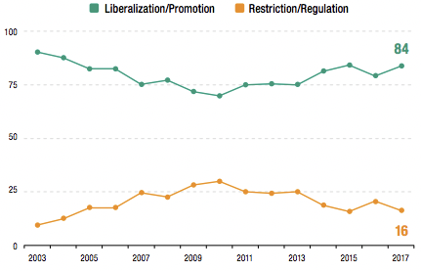
Figure 3: Changes in national investment policies, 2003-2017 Source: UNCTAD (2018)
Furthermore, more than 80% of investment policy measures that have been introduced since 2010, are aimed at driving industrialization (manufacturing, complementary services, and industrial infrastructure), of which half distinctly serve an industrial policy purpose, and with most being cross-industry. (UNCTAD, 2018) Hence, because industrial policy is growing rapidly, and becoming the most prevailing part of development strategy, “new industrial policies need to make more effective use of investment policy instruments, and investment policies need to modernize in line with new industrial development strategies.” (UNCTAD, 2018)
A majority of investment policies have arisen in the form of incentives, special economic zones/incubators, investment promotion and facilitation, performance requirements, and investment screening procedures. (see Figure 4 below)
30
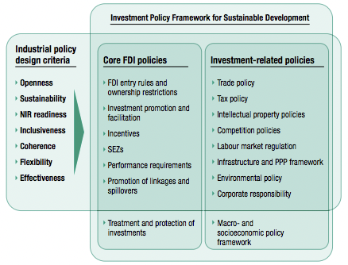
Figure 4 Source: UNCTAD (2018)
Figure 5: Investment policy measures for industrial policy purposes, by type, 2010-2017 (Percent of total, n = 387)
Source: UNCTAD (2018)
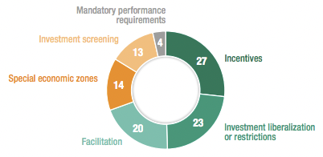
31
2.7.1. Incentives
Incentives remain the most commonly used investment policy, as exhibited by Figure 5 above. Progress has been made to make incentives more effective, with schemes specifically targeting multiple or specific industries, and defined activities such as research and development (R&D). In this case, financial or fiscal incentives used to entice investors, are only incorporated into investors’ location decisions when the economic determinants have been fulfilled. (Malampally and Sauvant, 1999)
2.7.2. Special Economic Zones/Incubators (SEZs)
There has been an increase in SEZs worldwide, but more on a value addition basis rather than a pure export processing basis, as this is more beneficial to the host country. Moreover, industrial development and Global Value Chain (GVC) integration has been supported by “targeted strategies to attract specific industries and link multiple zones [in] some countries that have adopted build-up7 and catch-up8 industrial policies, although enclave risks remain”. High-tech zones or industrial parks have also become a prominent instrument for NIR-driven9 industrial policies. (UNCTAD, 2018)
It is imperative to accentuate that in order for SEZs to bear fruitful results in the long run, overall investment conditions in the country need to be parallel with special conditions offered to investors in such zones, in order to avoid “footloose enterprises10 that have little contact with the rest of the economy and which will leave the country again as soon as another zone
7 entail horizontal measures to enhance competitiveness
8 champion innovation and the adoption of new technologies
9 New Industrial Revolution (NIR)-based policies use build-up techniques for new industries
10 These are enterprises that can move around their operations from location to location as they wish, because they are not affected by factors such as resources or transport. The costs of their products do usually not change, regardless of where the product is assembled.
32
elsewhere offers better conditions”. Therefore, lasting linkages with the domestic economy beyond the SEZs need to be instituted through determined incentives. (Odenthal, 2001)
2.7.3. Investment Promotion and Facilitation
Numerous developing countries have started to make use of investment facilitation as one of their key investment policies, along with targeted investment promotion efforts (besides incentives and SEZs) carried out by most investment promotion agencies, in order to define priority sectors for investment promotion, with three quarters of these agencies having promotional schemes to advance technology in industry. In addition, modern industrial policies have also “boosted investment facilitation, which until recently played a secondary role in investment policy frameworks”. (UNCTAD, 2019) In this case, after-investment services also play a vital role to foster reinvestment by present-day investors, who, if pleased, deliver publicity for the host country, sparking further investment. (Malampally and Sauvant, 1999)
2.7.4. Performance Requirements
These are mostly conditions attached to incentives. They are used to “maximize MNE contributions to industrial development”, but UNCTAD reports that “much of their functionality could be achieved by better designed, cost-based incentive mechanisms”.
2.7.5. Investment Screening Procedures
In contrast to the removal and relaxation of foreign ownership restrictions that has emerged over the last decade and become commonplace, these processes or requirements have particularly come into being to enforce restrictions to foreign ownership, for instance. Uniquely, it is not common
33
for manufacturing sectors to be affected by complete restrictions on foreign ownership.
(UNCTAD, 2018)
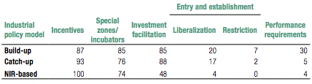
Table 5: Investment policy tools in industrial development strategies, by type (Percent of sample)
Source: UNCTAD (2018)
UNCTAD urges investment policy to be steered by the design criteria reflected in Figure 4, and that different investment policy tools should target respective modern industrial policies (build-up, catch-up, and NIR-based) (see Table 5 above) which are fitting for sequential phases of development, as well as “focus on different sectors, economic activities and mechanisms to maximize the contribution of investment to the development of industrial capabilities”. It is also imperative to recognize that the “investment policy toolkit evolves with industrial policy models and stages of development.” Thus, UNCTAD strongly instructs countries to keep their investment policy instruments up-to-date by “reorienting investment incentives, modernizing SEZs, retooling investment promotion and facilitation, and crafting smart foreign investment screening and monitoring mechanisms. The new industrial revolution, in particular, requires a strategic review of investment policies for industrial development.” (2018)
Incidentally, for sustainable development to materialize through contemporary industrial policies, “policymakers need to enhance their coherence with national and
34
international investment policies and other policy areas, including social and environmental policies.” This means that, to build synergy, the whole government needs to work together cohesively, comprehensively, and holistically. They also need to achieve a perfect equilibrium between the market and the State to strike the ideal balance of regulation. Finally, they need to embrace a collaborative modus operandi that does not inhibit international productive-capacity cooperation, and sidestep beggar-thy-neighbor11 aftermaths. (UNCTAD, 2018)
Finally, Odenthal (2001) goes on to valuably and insightfully add that as countries upgrade investment conditions, they should:
a) Streamline and simplify bureaucratic processes
This, for instance, could entail converting Investment Promotion Agencies (IPAs) into effective “one-stop shops” where an investor is thoroughly assisted with all bureaucratic paperwork required to start operation in the country, along with minimizing the requirements imposed on prospective investors. IPAs are sometimes plagued with too many duties and little resources which prevent them from adequately fulfilling their role.
b) Improve the overall promotion strategy
In this case, the countries’ competitive advantages are kept in mind in order to efficiently allocate scarce resources to a small number of lucrative industrial sectors. Nonetheless, resources are utilized more for service delivery rather than regulation enforcement, coupled with strategic cooperation with other institutions, e.g. partnering with other promotion agencies to undertake mutual interests, and IPAs working hand-in-hand with “local private sector associations or banks to make them ambassadors for their country”, as was implemented in Uganda.
11 In economics, beggar-thy-neighbor policies are those which a country employs to cure their economic problems, at the expense of other countries’ economic health and interests.
35
c) Design and implement specific promotion measures
As implied before, incentive packages should be tailor-made to the needs of specific industries. Hence, it is paramount that companies that fit into the overall targeting strategy are strongly supported, after being defined as eligible by pre- set criteria. Co-ordination between domestic agencies that oversee different incentive packages is also of great importance, as is the practical and periodic assessment and oversight process of all incentive programmes.
36
CHAPTER 3: RESEARCH METHODOLOGY
The selected methodology for this study was based on the inductive, qualitative approach whereby interviews, questionnaires, an analysis of archival data, along with observations were used.
Respondents for the interviews were selected from the financial services sector, as well as financial and economic planning organs of government. This is in line with the scope of the objectives in Chapter 1, that seek to understand the effects of FDI flows into Namibia, and the policies that come into play. This shall be expanded on in Chapter 3.
This chapter draws extensively on Research Methods for Business Students by Saunders, Lewis, and Thornhill (2009), Fifth Edition (Harlow).
Figure 6: The Research ‘Onion’ Source: Saunders, Lewis, and Thornhill (2009)
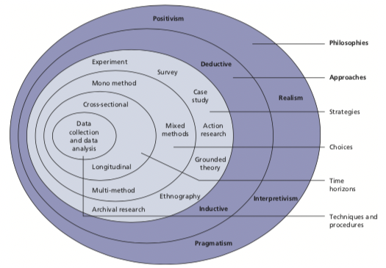
37
3.1. Definition and importance
Mishra and Alok define research methodology as the approach in which research troubles are solved thoroughly. It is the science of studying how research is conducted systematically. In this field, the researcher explains themselves with the different steps, that is, the specific procedures or techniques, along with methods, materials and tools generally employed to study a research problem, and identifies, selects, collects, processes, and analyzes information about that problem. Hence, the scientific approach which is adopted for conducting a research is called methodology. (2017)
Research methodology is essential and fundamental because it substantiates and allows the critical evaluation of a study’s overall validity, reliability, and relevance.
3.2. Research Philosophy
Research philosophy is the overarching fundamental that relates to how knowledge is developed and the nature of that knowledge, as well as its purpose. (see Figure 6) It is highly affected by our perspectives of the world and the assumptions that result therefrom. These assumptions bear our research strategy and the methods we select as part of that strategy. Johnson and Clark (2006) observe that business and management researchers need to constantly be cognizant of the philosophical devotions we make through our preference and selection of a research strategy, as this has a consequential impact on how we carry out our research, and on our comprehension of what we are investigating. Practical and contextual issues will however also have an effect on the philosophy espoused, and on the choice of strategies and methods, along with what is important and applicable.
Therefore, each research philosophy is more efficacious, depending on the research question(s) in play.
Four research philosophies exist, namely pragmatism, positivism, realism, and interpretivism.
38
Pragmatism argues that the research question determines the epistemology, ontology, and axiology that you accede to. Moreover, if the research question does not immediately identify with either the positivist or interpretivist philosophy, pragmatism’s consideration that variations or mixtures in your epistemology, ontology, and axiology are a possibility, is supported. Tashakkori and Teddlie (1999) maintain that pragmatism affords the researcher the opportunity to study what interests them and is of value to them, using different routes that they deem fit, thus garnering results with true value.
Positivism is usually classified as the philosophical standpoint of a natural scientist. Hence, only observable happenings/social reality are believed to produce credible data. A research strategy in this case will most probably draw from existing theory to develop hypotheses which will wholly or partially be confirmed or repudiated after being tested, leading to the further expansion of theory that can also be tested by additional research. Moreover, facts play a crucial role. The researcher is completely independent from the research, especially in terms of feelings and (personal) values, and is more concerned with the resources involved to test the hypotheses.
Realism puts emphasis on the senses – asserting that the truth is what we are shown by the senses. Hence, objects have an existence independent of the human mind. It takes on a scientific approach with regard to the development of knowledge, similar to positivism. To elaborate, two types of realism exist: direct and critical.
Direct realism affirms that our experience through our senses portray the world accurately.
On the other hand, critical realism advocates that we experience sensations, and hence only images and representations of things in the real world, not the things themselves.
Interpretivism upholds that it is imperative for the researcher to comprehend differences between humans’ roles as social actors. Moreover, it accentuates the conduction of research among people rather than objects such as cars and tables. The term ‘social actors’ plays a crucial role, along with the researcher’s interpretation
39
of the actors’ actions, according to their (the researcher’s) own set of meanings. Equally important, the researcher has to embrace an empathetic outlook, which means they need to understand the perspectives of the research subjects. This, in itself, can be a challenge. Many argue that this approach is most appropriate for business and management research because business situations are complex and unique; encompassing the intersection and interaction of a particular set of circumstances and individuals at one specific time.
For this study, the researcher believed that the interpretivist philosophy was most appropriate because she was trying to empathetically interpret and analyze the real effects of FDI on not only the Namibian economy simply as a GDP number, but on various other factors and social actors that could be affected. This is because FDI does not operate in a vacuum, but interacts with the broader economy and its numerous components. It is a quintessential example of a complex business and economics topic. Nonetheless, the researcher is fully Namibian, having spent the first 19 years of her life in the country, which makes her part of what is being researched, as required by the aforementioned philosophy.
3.3. Research Approach
Research approaches are classified as either inductive or deductive, of which the collection of quantitative data falls more under the deductive approach, and qualitative data under the inductive approach.
Deduction is used more for scientific research because it develops a theory (through the deduction of a hypothesis) that is subject to rigorous, structured testing. A relationship between variables is studied and the facts need to be able to be measured quantitatively. It is however not impossible for a deductive approach to use qualitative data.
40
For clarity, quantitative data is structured and numerical in nature, representing measures of values or counts and comprising numerical variables – it defines. Conversely, qualitative data is unstructured and non-numerical in nature, a measure of types, and it approximates or characterizes but does not measure – it describes observable but unmeasurable phenomena with natural language descriptions (and not numbers).
Furthermore, with induction, the researcher collects data in a relatively unstructured or flexible manner, and develops a theory based on the data garnered and the analysis thereof. Moreover, as opposed to deduction, it allows alternative explanations of events. Qualitative data is often collected in such cases because researchers try to establish different perceptions of phenomena.
Concerning this study, the researcher used the inductive, qualitative approach, because she was trying to get a wider understanding of FDI in the Namibian context, instead of starting off with a set of hypotheses that had to be tested. Equally important, as justified in the previous section, the researcher was not trying to numerically measure the impact of FDI on the Namibian economy, which, in most cases, is proxied by its GDP figure, but to measure and garner knowledge of the effects of FDI on the Namibian ground. This required her to flexibly research how people understood and felt about the visible, and sometimes tangible, effects of FDI.
3.4. Research Strategy
There are 8 main types of research strategies, that is, experiments, surveys, case studies, action research, grounded theory, ethnography, and archival research.
Experiments (see Figure 7) test whether there is a causal relationship between variables, with more advanced experiments being able to incorporate more than two variables and determine the relative importance and size of change of the variables. They are used often in the natural sciences.
41
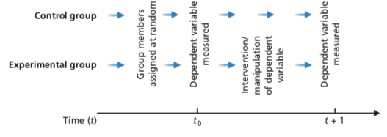
Figure 7: Elaboration on experiments Source: Saunders, Lewis, and Thornhill (2009)
Surveys are usually employed by the deductive researcher, and are more commonly used to answer who, what, where, how much, and how many queries. Data is often collected through a standard questionnaire that is answered by a sample. They allow the efficient and economical collection of a large amount of data from a reasonably- sized population. Their drawback, however, is that the data collected is limited and not wide-ranging, in contrast to data collected from semi-structured interviews, for example.
Other data collection techniques that fall under the survey strategy are structured observations and structured interviews.
Robson (2002) defines case studies as “a strategy for doing research and which involves an empirical investigation of a particular contemporary phenomenon within its real-life context using multiple sources of evidence”. Data collection techniques in this case entail interviews, observations, documentary analyses, and questionnaires. Numerous techniques can be used in combination with one another.
By the same token, triangulation plays a pivotal role in case studies. Triangulation is
42
the collection of data using different techniques, or two or more independent sources of data to ensure the accurate interpretation of the data collected, through corroboration.
As illustrated by Figure 8 below, action research facilitates changes while the research is being conducted – there is an intense focus on proactive, changemaking action. Thus, the researcher is part of the organization where the research and change are taking place, or there is very strong collaboration between the two parties, as opposed to typical research where the employees, for instance, are merely subjects or objects of the study. Nonetheless, it is imperative to accentuate the iterative nature of the strategy, which develops after the context and purpose have been clearly and specifically identified. Also, the results obtained could inform other contexts.
Figure 8: Action Research Source: Saunders, Lewis, and Thornhill (2009)
Concerning grounded theory, there is no formation of an initial theoretical framework. Theory is built up from observations, and the data generated from the observations is
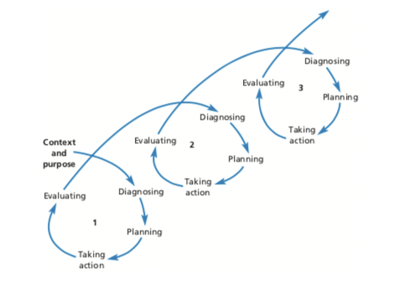
43
used to formulate predictions which are then again tested by additional observations that confirm or refute the predictions. It is however not the ignorance of existing literature or theory. In addition, it is an interpretive, immensely creative undertaking, that is extremely challenging to implement, to say the least.
Ethnography encapsulates the inductive approach. It requires the complete immersion of the researcher in the social world being studied in order to attain insights and fully understand the perspectives of those in that particular social setting. Because the researcher’s patterns of thought are constantly being altered, depending on the observations made, the research process needs to be agile.
Lastly, archival research principally uses data obtained from administrative records and recent or historical documents. It is however important not to confuse it with secondary data analysis, although “all research that makes use of data contained in administrative records is inevitably secondary data analysis”. The difference is that with archival research, these data are used because they are a realistic representation of daily activities, rather than solely being data collected with the initial purpose of research.
The main component of the adopted research strategy is a case study because the country case in discussion is Namibia. This best suits the study because the researcher was studying the effects of FDI specifically in a Namibian setting.
This strategy was used together with the archival research strategy, because archival data from the Bank of Namibia (the country’s central bank), for instance, had to be analyzed to gauge in which sectors FDI is concentrated, the magnitude of FDI inflows against Gross Domestic Product (GDP), and so forth.
Nevertheless, because the case study strategy necessitates the use of triangulation, data was collected using four different techniques. That is, interviews, archival research, personal and interviewee observations, and questionnaires, to ensure the accurate interpretation of the data collected.
44
3.5. Data Collection Methods
Primary data collection methods mainly span from observations to interviews and questionnaires, especially in qualitative data collection cases.
Saunders, Lewis, and Thornhill define observation as the systematic procedure of recording, describing, analyzing, and interpreting people’s behavior. (2009) Two types exist: participant observation – which is qualitative, and structured observation – which is quantitative.
With participant observation, the researcher immerses themselves fully in the daily lives and activities of the research subjects, becoming a part of them. Three types of data can be generated in this manner: primary (noting occurrences or discussions), secondary (statements by observers of occurrences or what was said – involves observers’ interpretations), and experiential data (perceptions and feelings experienced throughout the research process).
On the other hand, structured observation is systematic and its structure is highly predetermined. Additionally, it takes on a more disconnected stance and aims to quantify behavior rather than describe it.
Moving on, interviews are purposeful discussions between two or more people and can be categorized as either structured, semi-structured, or unstructured/in-depth. Structured interviews are interviewer-administered questionnaires because they use a fixed, standard set of questions for each interview. Comparatively, semi-structured interviews (also called qualitative interviews) are not standardized, and the direction of the interview is based on certain themes and questions, whereby some questions are added or omitted, taking the organizational context and progression of the conversation into consideration.
Unstructured interviews are informal and are used to gather in-depth data. Although there is an idea of the aspects being investigated, there is no predetermined list of questions and the interviewee is given the opportunity to talk unrestrictedly.
45
Lastly, questionnaires are generally “all techniques of data collection in which each person is asked to respond to the same set of questions in a predetermined order,” (deVaus, 2002)
For this research, all primary data collection methods were used, because valuable data could be collected from all of them for the substantiation and reinforcement of this qualitative study.
Semi-structured interviews were held with individuals from the private financial sector, ranging from asset and wealth management firms, insurance firms, SME- financing firms, investment consultancy firms, private equity firms, and the Social Security Commission (a government parastatal).
In each firm, the managing director/CEO/CFO/investment manager/portfolio manager, or anyone in a relevant financial/economic position was interviewed. This approach was chosen because individuals who have broad knowledge and expertise in relation to investments were needed, as they would be able to insightfully and prudently criticize FDI in the Namibian setting, taking their financial/economic backgrounds, and relative observations, into consideration. In addition, key employees in specific organs of government that are directly affiliated with FDI, were interviewed (i.e. the Ministry of Finance (MoF), the Ministry of Industrialization, Trade, and SME Development (MISTMED), the Ministry of Economic Planning (National Planning Commission (NPC)), and the Ministry of Mines and Energy (MME). (see Appendix for specific individual details)
Semi-structured interviews were used in order to probe answers, get in-depth explanations or elaborations of respondents’ answers, and in order to understand the deeper meaning of what participants were trying to convey, whilst still keeping the interview along the lines of the benefits and challenges of FDI. This added tremendous value and richness to the study, and is particularly important when adopting an interpretivist epistemology.
Equally important, with some institutions, such as the Ministry of Finance, the Bank of Namibia (to discuss the answers to their questionnaire), and IJG Securities (a prominent private equity firm), group interviews were conducted because the
46
researcher felt that she could learn a great deal by getting many differing (or maybe similar) opinions from these specific, information-rich individuals, who come from completely different economic functions.
Furthermore, different questionnaires were administered to key employees at the Namibian Investment Centre (NIC)12, and to the Bank of Namibia (BoN)13 because detailed information was required from these two institutions who deal directly with foreign investors and FDI numerical data respectively.
It is imperative to highlight that not all interview and questionnaire questions were focused on FDI. Specific questions (especially the initial ones) had the purpose of priming the interviewee to think in terms of the broader investment discipline, and to accumulate data that could be used to potentially provide broader capital-need solutions and policy suggestions that reach beyond immediate FDI. (see Appendix 5 for Interview Guide)
Lastly, the researcher used primary and secondary observations, coupled with experiential data, because they very well explained what was really transpiring in some social situations, they intensified the researcher’s awareness, and because virtually, all data collected in this manner tend to be useful. Moreover, they afforded the researcher the opportunity to fully experience the interviewees’ emotions towards FDI.
3.6. Ethical Considerations
Ethical issues that needed consideration were anonymity, confidentiality, and reassurances. These were considered to avoid the researcher putting the participants in a situation where they might be at risk of harm as a result of their participation. (Trochim, 2002) To grant anonymity to the interviewee, he/she was given a statement
12 The Namibian Investment Centre (NIC) was established in 1990 with the major responsibility of promoting FDI. The NIC is the first port of call for investors, local and foreign.
13 The Bank of Namibia is the bank’s central bank, that has the duty of
development, acting as fiscal advisor and banker to Government, promoting price stability, managing
supporting economic growth and
reserves and currency, ensuring a sound financial system, and conducting economic research.
47
of informed consent (see Appendix 4) to endorse their signature before the interview could commence; indicating that they are willing to participate. This statement gave the interviewee the option to remain anonymous, if communicated to the researcher, which then resulted in the use of pseudonyms.
Confidentiality was not a major factor because all the archival data analyzed was public data. In cases where it was, the data-provider had an option to communicate whether they would prefer the data to remain confidential. Similarly, interviewees had an option to convey whether some of the data being requested through interview questions is confidential and can therefore not be provided to the researcher. Once again, all these issues were assured by the statement of informed consent, and by the formal introductory phrase at the beginning of every interview (see Interview Guide in Appendix). Beyond that, requests for access and cooperation were clear, specific, and polite. (see Interview Cover/Introductory Letter in Appendix)
3.7. Research Reliability and Validity
Research reliability ensures that the manner in which the data was collected and analyzed is consistent and transparent, whereas research validity is concerned with whether the findings are a true representation of what they wish to convey – whether the relationship between two variables, for instance, is in fact a causal relationship – whether the research performed is sound and solid.
Measures to achieve reliability were the use of publicly published data (ensures transparency), a large, broad, and representative number of interviewees (to ensure that data collected is somewhat consistent and cohesive across the board), and a questionnaire administered to specifically relevant parties where detailed data was required. Nonetheless, the findings were analyzed and shared with all interested parties to ensure transparency, accuracy, and accountability.
On the other hand, measures to realize validity comprise conducting research on the ground in Namibia to collect current, relevant data, interviewing appropriate
48
candidates (i.e. those who have a financial/economic background and can thus scrutinize FDI accurately), obtaining archival data from significant stakeholders such as the Bank of Namibia (the central bank) and the Namibian Investment Centre, the researcher having lived in Namibia for 19 years as a citizen and observing the effects of FDI over the years at first hand, as well as learning from the observations of aforementioned interviewees who observe the effects of FDI on a daily – to date, and are therefore able to adequately analyze it from an economic point of view.
Overall, the researcher made sure that all data collection and reporting procedures were honest, that no research results were falsified or misrepresented, and that the multimedia recorder used to record the interviews, along with the questionnaires, were kept in a safe area for a period of no longer than 4 months to allow for completion of the study, after which the completed questionnaires and memory card used in the multimedia recorder were destroyed.

