Opioid Pain Control Facts:  01 Opioid addiction can happen to anyone, often before they even realize it. While not everyone who uses opioids will get addicted, every user is at risk.  02 We can think of opioid abuse as a medical illness that is governed by things inside of us and outside of us.  03 It takes a couple of weeks to become physically dependent on an opioid, but that varies by individual.  04 Opiates are highly addictive and give the brain a false sense of euphoria. And if opiates are misused or taken for an extended period of time, the body is able to build up a tolerance, needing more and more of the drug in order to get that high or pain relief. | Potential dangers and side effects  - Drowsiness  - Confusion  - Nausea  - Constipation  - Respiratory Depression  - Uncontrollable Cravings  - Weight Loss  - Frequent Flu-Like Symptoms  - Changes in Sleep Habits  - Isolation from Family/Friends  - New Financial Difficulties  Alternative Pain Control Measures:  - Cold and Heat  - Exercise  - Physical/Occupational Therapy  - Yoga  - Therapeutic Massage  - Music Therapy | Opioid Crisis

Outside Educational Resources:  - www.prevention.org  - www.operationprevention.com  - www.cdc.gov  - www.who.int  Safe Opioid Use:  Tell all of your providers about all of the drugs you're taking.  Order all your medications through the same pharmacy whenever possible.  Read the instructions and warnings on the drug safety information sheet stapled to your prescription.  Report side effects to your doctor right away.  Check the expiration date on your pill bottle. |  | 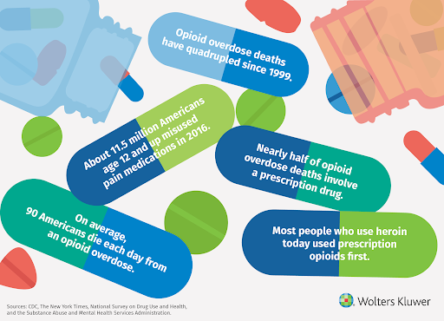
"Addiction is a disease that makes you too selfish to see the havoc you created or care about the people whose lives you have shattered.”  \\ |  |  |  | Get lowest effective dosage Establish realistic treatment goals  Sign agreement papers for long-term opioid medication usage Get help minimizing withdrawals when stopped usage  