Wk1: Marketing Research Process & Ethical Principles
Marketing research
- The systematic, identification, collection, analysis, dissemination and use of information.
- Conducted for the purpose of improving decision making related to the identification and solution of problems, and opportunities in marketing.

Function of marketing research:
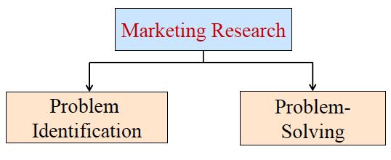
- Problem- deification: Research undertaken to help identify problems, which are not necessarily apparent on the surface and yet exist or are likely arise in the future.
- Problem- Solving: research undertaken to help splve specific marketing problems.

When selecting your targeting market, you might like to know:
- Who would be interested in our product or service?
- Who have already bought from us?
- Are we making inappropriate assumptions (i.e. people’s consumption preference) about the market?

When you se the price for your product, you might like to know:
- How much are customer willing to pay for our products?
- Will the customers be willing to pay more for our products?
- Should we bundle our products for a single price?
- Should we give discount to get people to buy our products?

Marketing Research Process:
- Step1: Definding the problem
- Step2: Developing an Approach to the problem
- Step3: Formulating a Research design
- Step4: Collecting data
- Step5: Preparing and analyzing data
- Step6: Preparing and presenting the report

  - Step1: Definding the problem
- 1) Discussion with decision maker(s)
- Understand the nature of the problem decision maker facing and what they hope to learn from research
- Decision marker needs to understand the capabilities and limitation of research
- 2) Interviews with experts
- Normally use unstructured personal interview
- Experts can be found inside and outside the firm
- 3) Secondary data analysis
- Data collected for some purpose other than the problem at hand
- Include sources from government report, commercial marketing research firm, and computerized database.
- An economical and quick source of background information
- 4) Qualitative research (gather non-numerical data)
- Providing valuable insights to the problem and its underlying factors
- It’s unstructured, exploratory in nature, based on small samples.
- 5) Environmental context of the problem
- Past information and forecasts (i.e. Past sales, market share)
- Competitive environment
- Resources and constraints (i.e. cost, time, research skills)
- Objective (i.e. organization objective)
- Buyer behavior (i.e. preference. Price sensitivity)
- Legal environment (i.e. low)
- Economic Environment (i.e. disposable income, saving)
- Marketing and technological skills (i.e. Technology advancement)
- Marketing research questions:
- a) What criteria do households use when selecting department stores?
- b) Who are the customers? What are their demographic and psychographic characteristics? Does it differ from the profile of customers of competing stores?
- What is the market share of Coles and its competitors for specific product categories?
- Are customers loyal to Coles? What is the extent of brand loyalty?

  - Step2: Developing an Approach to the problem
- 1) Objective/theoretical framework
- 2) Specification of the information needed

  - Step3: Formulating a Research design
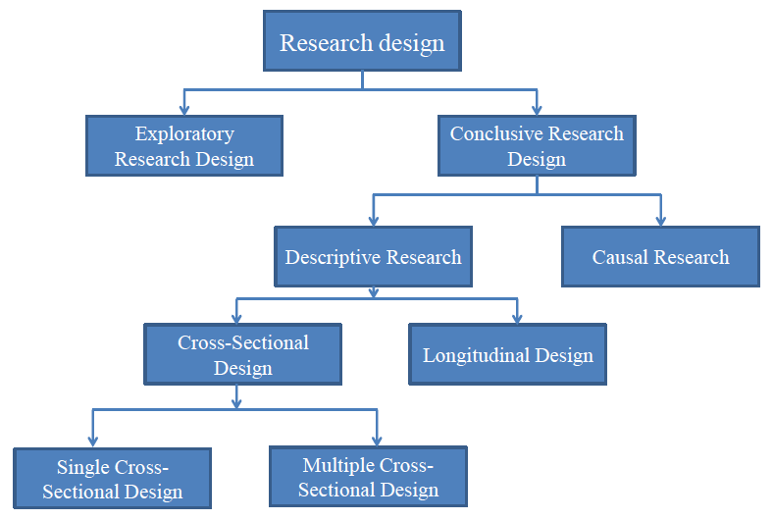
- 1) Exploratory Research
- Merely to explore the research question and does NOT intend to offer final/ conclusive solution to existing problems
- This type of research is usually conducted to study a problem that has not been clearly defined yet
- 2) Descriptive Research
- Describe the characteristics of relevant group (i.e. consumer, salespeople, organization, market areas)
- 3) Cross- sectional design
- Collection of information from any given sample of population elements only ONCE
- 4) Longitudinal Design
- A fixed sample (or samples) of population elements is measured repeatedly on the same variables.
- 5) Casual research
- To understand which variables are the cause (independent variables), and which variable are the effect (dependent variables) of a phenomenon.

  - Step4: Collecting data
- 1) Primary data
- Originated by a researcher for the specific purpose of addressing the problem at hand
- 2) Secondary data
- Data that have already been collected for purpose other than the problem at hand.
- These data can be located quickly and inexpensively

  - Step5: Preparing and analyzing data
- Example:
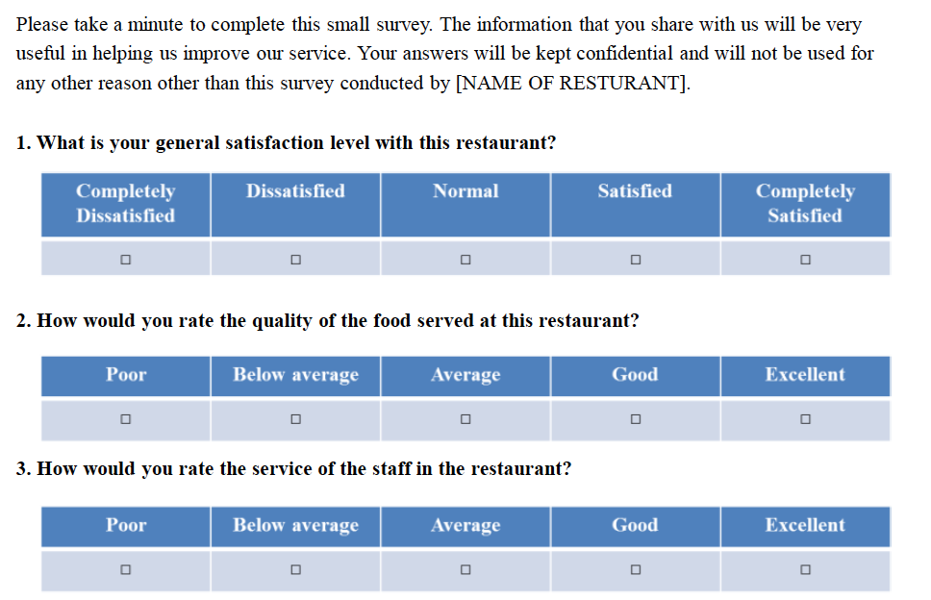
- Veriable view of restaurant survey:
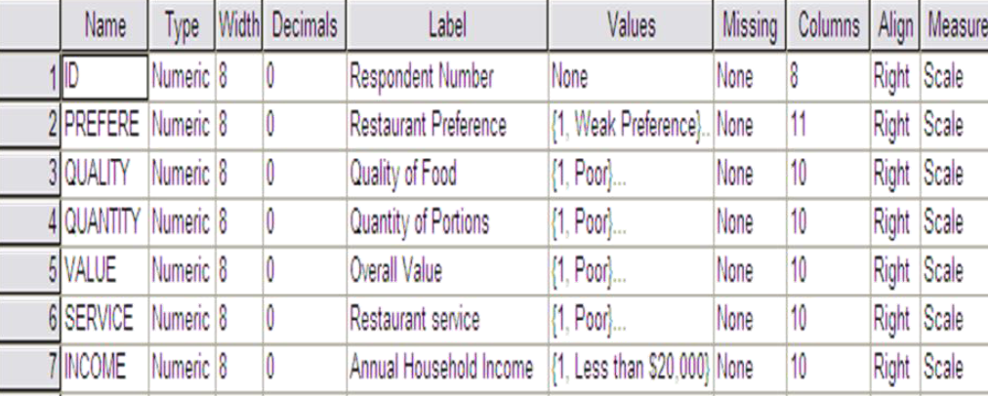
- Veriable view of restaurant survey:
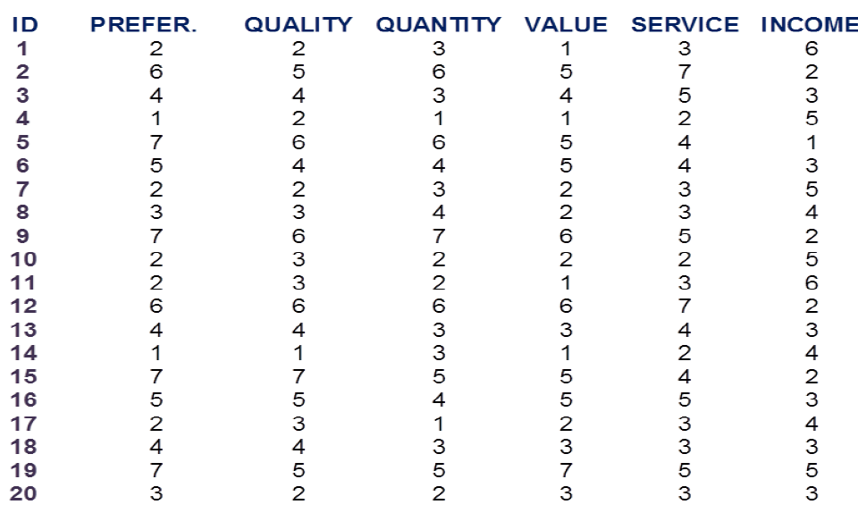
- Analysing data
- Characteristics of the data
- Techniques
- Background and philosophy of the researcher

  - Step6: Preparing and presenting the report
- A report is written/ oral presentation of the research process, result, recommendations, and/or conclusion to a specific audience
- Management decision are duide by the report and the presentation
- Management's decision to undertake marketing research in the future or to use the particular research supplier again will be influenced by the perceived usefulness of the report and the presentation.
- Presenting report:
- Easy to follow
- Creative communication
- Presentable and professional appearance
- Reinforce text with table and graphs

Ethical Princiales
Fall into 4 main areas, need to:
- 1) Avoid harm to participants (and producing benefits)
- 2) Ensure informed consent同意 of participants
- 3) Respect the privacy of participants
- 4) Avoid the use of deception欺骗

  - 1) Avoid harm to participants (and producing benefits)
- Research will be considered harmful if it cause a participant to be embarrassed/ belittled轻视/ anxious焦虑/ stressed

  - 2) Ensure informed consent同意 of participants
Researcher should provide information on
- The aims of the research.
- Who will be undertaking it.
- Who is being asked to participate.
- What kind of information is being sought.
- How much of the participant’s time is required
- That participation in the study is voluntary.
- That responding to all questions is voluntary.
- Who will have access to the data once it is collected. 资料收集后,谁将有权取得资料。
- How anonymity匿名者 of respondents调查对象 will be preserved保存.
- Who should it be returned to and by when

  - 3) Respect the privacy of participants
- Respondents must give informed consent知情同意
- Respondents have the right to withfraw提出申诉 at any time
- Data(in electronic and manual forms) must be kept securely

  - 4) Avoid the use of deception欺骗
Best achieved by being open and transparent about the research including:
- Its objestive
- Methods
- Uses
- Role of respondent, including time and any other commitments

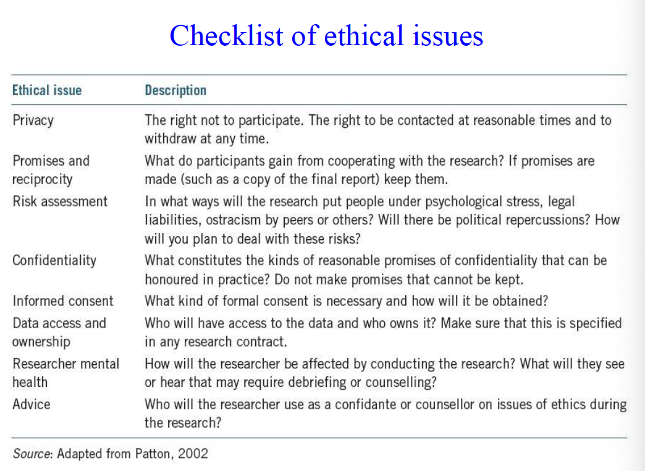

Wk2: Research Design: Quantitative, Qualitative, and Mixed Methods

Research Design
- Overarching首要的 for the collection, measurement and analysis data

Two Research Methods
- Quantitative research:
- Explaining phenomena by collecting numerical data that are analyzed using mathematically based methods (statistics).
- Qualitative research:
- Seeks to answer questions about why & how people behave in the way that they do. It provides in-depth information about human behavior.

Operationally Define variable
- Gives meaning to a construct结构 or a veriable by seeting out the activities or “operations” that are necessary to measure it

Operationalise Variables：
- 1) Efficient Customer Service
- Easy, simple, Fast, error free, reducing the amount of wasted inputs
- I.e. how long does it take for customer to complete the order?
- i.e. how long does it takes for the cusntomer to receive order?
- 2) Friendly Customer Service
- Kind, pleasant
- i.e. Are customer service staff taking time to understan my need?
- i.e. Are customer service staff helpful when I have question or require special service?
- 3) Customer Staisfacitona
- Actual performance of product > Expection of product performance
- i.e. Does the actual performance of berger king meet my expectation?

Independent, Dependent, Madiating, and Modering Variables
- 1) independent variable (IV): Why even occu.
- 2) Dependent variable (DV): resulting effect.
- 3) Mediating variable : variable that cause mediation in the IV and DV. It’s explain the replationship between the IV and DV,
- 4) Moderating Variable调节变量: variable that effect the strength of the relationship between a IV and DV. 影响IV和DV之间关系强度的变量。

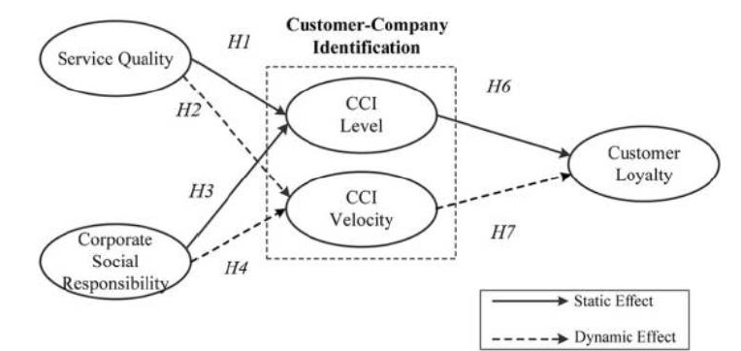

A Hypothesis
- A speculative statement of the relation b/t two or more variables.
- Describes a research question in a testable format which predict the nature of the answer
- Example:
- H1. Job demands have significant positive impacts on burnout.
- H2. Job resources have significant negative impacts on burnout

Validity
- McBurney and White (2009) : using a measurement of hat size to determine intelligence (measure someone’s hat size, every hour and always comes up with the same result, which means Reliable ), however, it’s not valid, because hat size has nothing to do with what is being measured.
- To ensure validity, a research instrument must measure what is was intended to measure (i.e. the research instrument subject area and operationally defined subject area must exactly match)

Reliaility
- The overall consistency or stability of a measure.
- A measure have high reliability if it produce similar results under consistent conditions.
- Internal Reliability : measured by Cronbach’s alpha test, which calculates the average of all split- half reliability coefficients.
- 0 ≤ Alpha coefficients ≤ 1
- Alpha coefficients = 1 ➡ Perfect internal Reliability
- Alpha coefficients = 0 ➡ No Internal Reliability
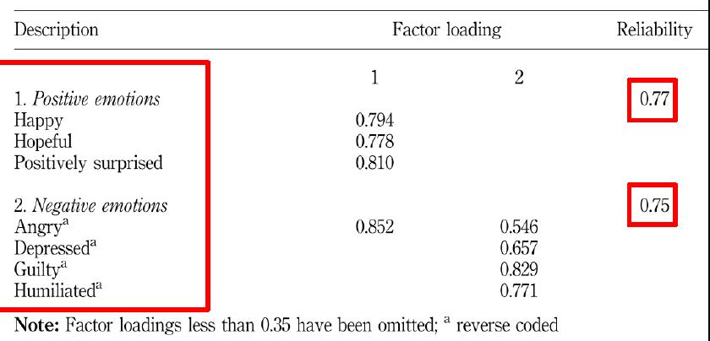

Service climate
- Describes the shared process of collective sensemaking about the quality of service delivery. It encourages staff to provide quality service and satisfy customers.
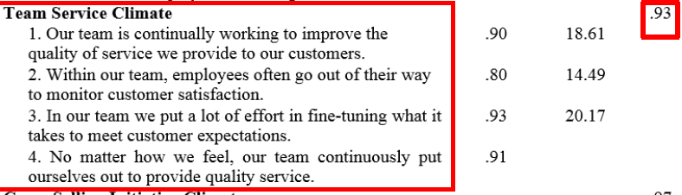

Qualitative Research
- 1) role of reaearcher: gain a deep, intense强烈的 and “holistic”整体 overview of the context under study.
- 2) The types of data gathering tools & resources used by researchers, including:
- Semi-structured interview
- Observation
- Focus group
- Analysis of material: i.e. Document, Phoptgraphs, video recordings, and other media
- 3) Characteristics of Qualitative Research:
- Conducted through intense contact within a ‘field’ or real life setting. (通过在“领域”或现实生活环境中的紧密接触进行)
- Qualitative research has advantages over quantitative research: researchers are closer to the fields or settings they are trying to research. 研究人员更接近他们试图研究的领域或环境
- Themes that emerge from the data are often reviewed with informants for verification从数据中产生的主题经常被检举人审查以进行验证
- 4) Collecting/ source of Qualitative Data:
- a) Interviews
- b) Obseravtions: Observational data is primarily descriptive of settings, people, events and the meanings that participants assign to them.
- c) Photographs and other visual data (i.e. Video, film recording): stimulate刺激 an interview or encourage a participant to produce a narrative叙述 to accompany and expand upon the photographic evidence.
- d) Unobtrusive Data: data in the form of documents.i.e. company reports, business plans, written statements.

- 5) Criticisms/ disadvantage of Qualitative Research
- a) Unscientific: Lacks of reproducibility可重复性 the research is so based in one context
- b) lacks of generalizability普遍性/概括性: lack of extent research findings that can be applied to settings other than originally tested.
- c) Personal to the researcher: another researcher might use the same data to come to radically different conclusions.

  - Designing Qualitative Research
- 1) Allow other researchers to inspect检查 the procedures through which the research has been conducted.
- 2) Use individual cases to build working hypotheses that can be tested in subsequent cases through the use of multiple case studies.
- e.g., as more similar or contrasting cases are used, we can justify through replication重复证明, the stability of the findings. Rather than generalize泛化, we can see if the findings from Context A can be transferred to Context B.
- 3) In most qualitative approaches: reliability is improved by triangulation三角测量 (i.e. gathering info. from multiple sources or by using multiple data gathering tools.)
- 4) For interview data: increasing reliability through the training of interviewers and use of standardized interview schedules.
- 5) For observations: researchers also need to be trained before they enter the field. improving Reliability through the use of pre designed observation schedules.
- 6) Use thick descriptions深厚描述 to provide evidence for making judgements about similarities between cases.

Mixed Method
- Include At Least One Quantitative Method and One Qualitative Method
- Collection/ analysis of both quantitative and qualitative data in a single study, the data collected concurrently同时 or sequentially依次.
- Mixed methods approaches can be based upon different types of research question, sampling procedures, data collection methods or approaches to data analysis.

  - Benefit of mixed Method Designs
- 1) Triangulation:
- combines quantitative and qualitative methods can focus on a single case , same people complete a questionnaire and are also interviewed . The answers from both data sets are combined and compared.
- 2) Complementarity
- Combined to measure overlapping but also different elements of a phenomenon.
- 3) Development
- the result of one method are used to inform the development of the second,
- 4) Initiation
- uses mixed methods to uncover new perspectives观点 and contradictions矛盾 .
- 5) Expansion
- broaden and widen the range of a study.

  - Cost of Mixed method research
- 1) Collecting both quantitative and qualitative data can be expensive and time consuming .
- 2) still have considerable confusion concerning how mixed methods findings can be integrated整合.

  - Types of Mixed Method Design
- 1) Qualitative then Quantitative
- a) occurs when the result of Qualitative study, are used to inform the Quantitative research定性研究的结果用于定量研究阶段时发生。
- b) This design is used when relatively little or nothing is known about the research problems.
- 2) Quantitative then Qualitative
- a) Occurs when the findings of a quantitative study are used to develop the qualitative stage.
- b) use quantitative study to identify important themes, then use qualitative fieldwork to gain an in depth understanding of the themes.
- 3) Quantitative & Qualitative Concurrently
- Mixed designs do not always have to be interdependent.
- Conducted independently, not in any particular order, they could be carried out concurrently.
- Different methods could be used to address the same research question or focus on different aspects of the research.

Wk3: Secondary Data Analysis

