Quality, Process and Location Analysis
Joan Zimmerman:
Southern New Hampshire University:
May 28, 2020:

Quality, Process and Location analysis
Question A
Steps of TOC process
The goal of every profit-making organization is to maximize sales and reduce costs. The TOC process is crucial to organizations since it allows them to make identification of all the factors that limit them from achieving their set goals and objectives. The following are the five steps that Nissan should use to identify their limitations:
Step 1: Identification of the limitations
This entails making identification of all the shortcomings and limitations that affect various operations in the company. At this step, the company should make identification of all the causes of tailbacks in the supply chain (Bauer, Vargas, Sellitto, Souza & Vaccaro, 2019).
Step 2: Coming up with a sound plan to overcome the limitations
This is the second step and it is very crucial to the company. Basically, the management of the company should exploit all the limitations and try as much as possible to overcome these limitations. The company can make the use of buffer or drum systems to overcome the bottlenecks. The identification of the less productive factories should be done in this stage.
Step 3: Channeling the resources towards the fight to eliminate or overcome the limitations

This is the third major step. After identification of the bottlenecks, strategies should be implemented on how to overcome all the shortcomings or limitations. One of these strategies is focusing the funds towards the fighting the bottlenecks (Dahlgaard-Park, Reyes & Chen, 2018). Nissan can simply add some employees and other experts to the factory at discussion. Also, more machines can be directed to the factory to help solve the problems.
Step 4: Reduction of the effects of the limitations
This is the fourth step in the TOC process. It basically entails solving the problem by either expanding the capacity of the company to deal with the work limit or offloading work. The company can reduce the effects of the limitations by sharing some of the operations with other workstations.
Step 5: Starting all over again with another limitation after solving the first one.
This is the final step. The TOC process is a continuous one. It is apparent that after one constraint or bottleneck has been solved, the entire process starts all over again now with a new constraint. The steps are repeated again from step one to step five. Application of the TOC to the processes is advantageous for the company since it could help reduce the bottlenecks affecting performance and different operations.
Question B
Principles of TQM
There are various tools and principles that the Nissan company can make use of to improve quality and performance. The various principles of TQM that the company could implement include establishing leadership, making efforts to involve and engage all stakeholders, creation of processes to enhance efficiency and effectiveness, creating a relationship with the suppliers that are mutual and continually working towards improvement. It is paramount that through centralization at Nissan, there is a uniform structure within the organization which promotes quality.
Outwardly, the creation of different processes throughout the organization enhances efficiency and effectiveness in the company. Nissan should also always work towards improvement which will promote the effectiveness and efficiency of various operations. Also, it is important to ensure that different stakeholders are involved not only in decision-making processes but in other operations within the organization. This will help to enhance quality as well (Dahlgaard-Park, Reyes & Chen, 2018).
Date Analysis
Cause-effect diagram
The supply chain is very crucial within any organization. It is apparent that when an organization has limitations in the supply chain, various operations and processes are affected. It is through the supply chain that an organization develops a good relationship with the suppliers as well as their customers. The following is a cause-effect diagram that simply illustrates why some partners of the company have some struggles in the implementation of some materials developed by the organization (Bauer, Vargas, Sellitto, Souza & Vaccaro, 2019).
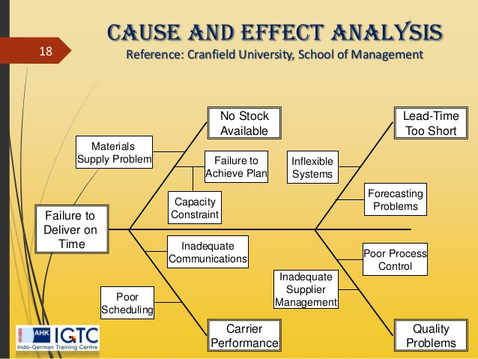
Basically, when the suppliers of an organization are not reliable enough, they lead to some adverse effects that may affect the company. For instance, this results in delays that are unexpected which really affects the entire production process (Kemppinen, Korpela, Elfvengren & Polkko, 2017). It is also paramount that when accountability is poor, communication issues arise causing gaps in various processes especially in times where new products or processes are implemented.

Time function Map
Promotion  Nissan dealer launches model and observes response  1 Day | → | Analysis  Dealer analyzes potential demand and places order  Day 2
 |  | ↓
Supply Chain  Order received by nearest factory  3 Days | ← | Manufacturing  Order prepared and sent for delivery  6 Days
↓
Dealership  Vehicle received, cleaned and checked  7 Days | → | Sales  Vehicle is put on sale officially by the dealer  8 Days

It is possible to do the measurement of time spent or consumed at every phase of the entire process at the company through the use of visual representation. As the operation manager of the company, I would make identification of all the bottlenecks at each process and use the steps in the TOC process to overcome them. This will help minimize both cost and time at each process. For instance, the days used in manufacturing may be caused by the bottlenecks in the operations which can be eliminated.
Question C
To determine the location of the new manufacturing plant that Nissan should establish, various factors are put into consideration. The best location should be favorable in terms of productivity. Also, the best location should favor different activities that will stimulate the productivity and profitability of the company.
Factor | Weight | Columbia | Mexico | Columbia impact | Mexico Impact
Political risk | 0.25 | 80 | 70 | 20 | 17.5
Transportation costs | 0.20 | 90 | 40 | 18 | 8
Labor productivity | 0.20 | 75 | 85 | 15 | 17
Rental costs | 0.15 | 55 | 90 | 8.25 | 13.5
Labor costs | 0.10 | 50 | 80 | 5 | 8
Taxes | 0.10 | 50 | 90 | 5 | 9
Total impact |  |  |  | 71.25 | 73

All these factors are crucial in determining the best location between Mexico and Columbia. In Columbia, the political risk is slightly higher than that of Mexico. The difference between the two locations is huge when considering the costs of transport. The transportation cost at Columbia is much higher than that in Mexico. It is also apparent that different costs such as taxes, labor costs, and rental costs are higher in Mexico City when compared to the city of Columbia. These are the costs that tend to rely on the production. The higher the production, the higher the costs (Kemppinen, Korpela, Elfvengren & Polkko, 2017). This makes Columbia to be the most feasible option. It is imprudent to rely on the political risks since this is a factor that can change suddenly with time. Also, the costs associated with transport can change any time based on political factors. As such, Columbia is the best location.

References
Bauer, J. M., Vargas, A., Sellitto, M. A., Souza, M. C., & Vaccaro, G. L. (2019). The thinking
process of the theory of constraints applied to public healthcare. Business Process
Management Journal.
Dahlgaard-Park, S. M., Reyes, L., & Chen, C. K. (2018). The evolution and convergence of total
quality management and management theories. Total Quality Management & Business
Excellence, 29(9-10), 1108-1128.
Kemppinen, J., Korpela, J., Elfvengren, K., & Polkko, J. (2017). Improving the productivity and
efficiency of an integrated mental and addiction care–an application of the theory of
constraints and five-focusing step to evaluation of adult ADHD patients. Finnish Journal
of eHealth and welfare, 9(1), 18-30.

