Disability Weights Used in Burden of Disease Study
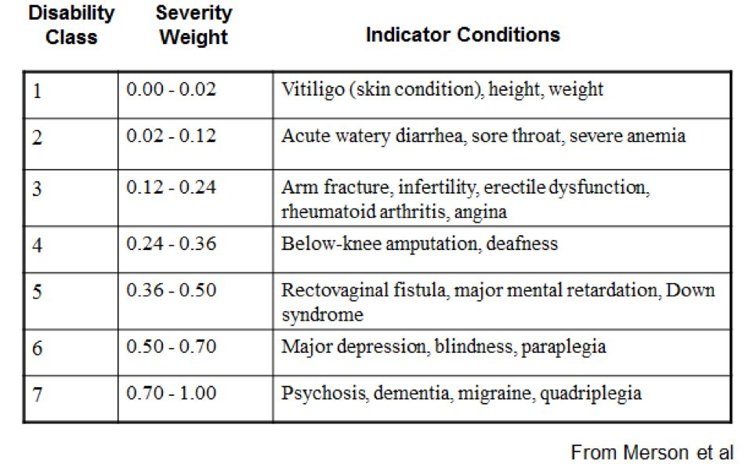

Mortality and disease burden by category
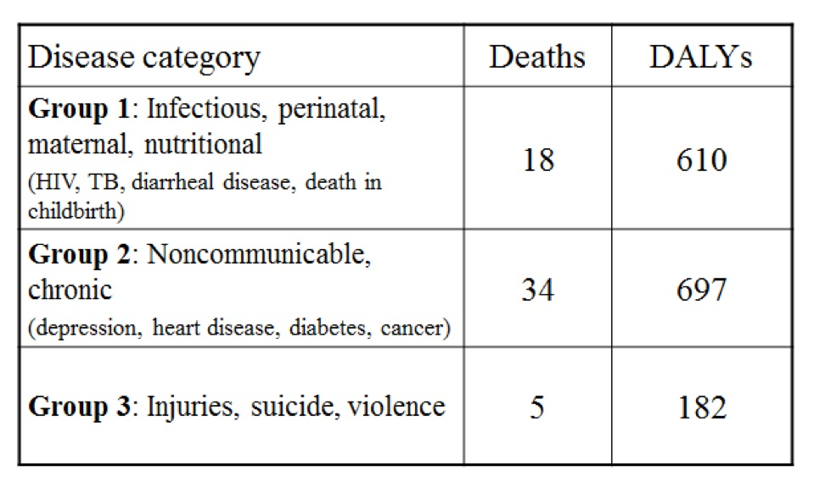

What’s Worse?
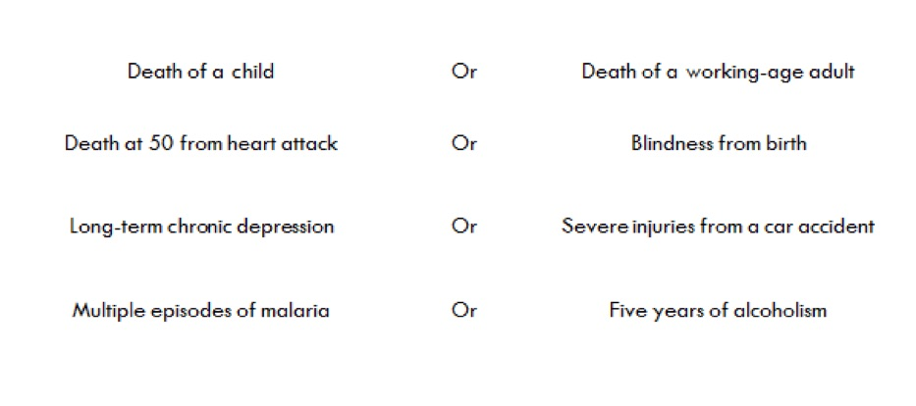
After completing the readings and listening to the videos, review the above tables, “Disability weights used in Burden of Disease study” and “Mortality and disease burden by category”. Then discuss all the questions under “What’s Worse?”. Support your argument by citing and referencing examples from the readings, or other resources, in APA style.

