Week 5 Lesson: Poetry
Table of Contents

Introduction
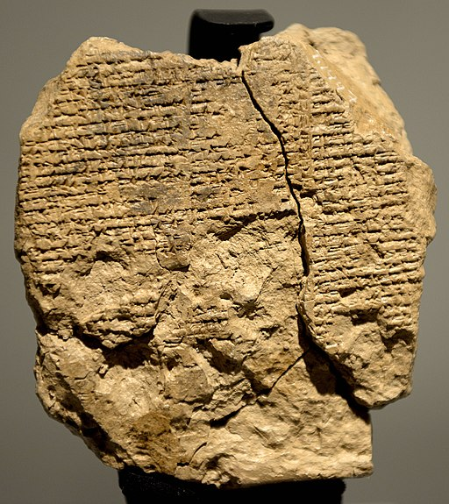Reverse side of the newly discovered tablet V of the Epic of Gilgamesh, 2003-1595 BCE. (CC BY-SA 4.0)
A poem is a literary work characterized by the expression of feelings and ideas and the use of distinct style and rhythm. Poetry uses these qualities of language to convey meanings other than the literal meaning.
The history of poetry dates back to prehistoric times with the earliest written poetry discovered to date being from the 25th century BCE in Africa. The Epic of Gilgamesh was written in Sumerian between the 13th and the 10th centuries BCE and is considered to be the oldest surviving work of great literature.
The Ancient Greeks attempted to describe poetry by focusing on the use of language in drama, song, speech, and comedy whereas other cultures focused on repetition, verse, and rhyme and other devices that distinguished poetry from prose.
Aristotle's Poetics describes three genres of poetry: the epic, the comic, and the tragic. Later philosophers identified the three genres as dramatic, lyric, and epic, with comedy and tragedy falling within the dramatic category.
Today, poetry can be divided into many genres, including epic, narrative, lyric, satirical, or prose. Click on the following tabs for a brief description of each:

- Epic
- Narrative
- Lyric
- Satirical
- Prose
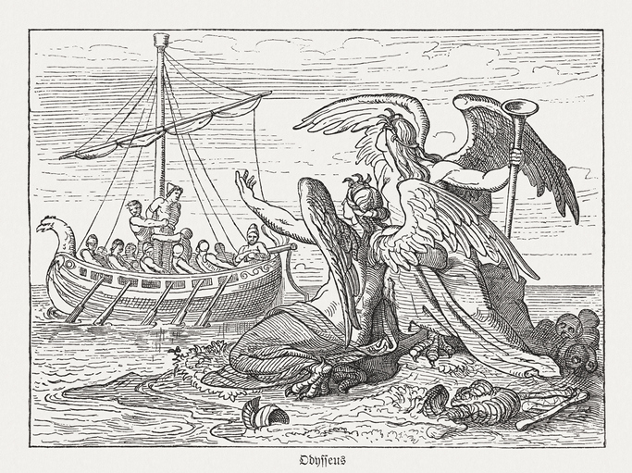
Epic poetry is often defined as long narrative poems detailing the events of a hero or an event important to the culture of the time. Examples of epic poems are Homer’s Iliad and the Odyssey. Epic poems decreased in popularity in the Western world after the early 20th century.

Watch the following video on William Carlos Williams and the trend of Modernist poetry towards prose poetry with a focus on natural speech rhythms and simplified language. The video also addresses the connection of his poetry to art.
Rhythms in Poetry: William Carlos Williams (7:12)
Poetry attempts to use forms and conventions to evoke emotional responses and suggest a different interpretation of words. Poetry uses literary devices such as ambiguity, assonance, alliteration, onomatopoeia, rhythm, symbolism, and irony. Poetry also used figures of speech such as metaphor, simile, and hyperbole to create meanings and form connections that might not normally be made (Brooks, 1988).

Rhythm, Meter, and Metrical Patterns
Prosody is the patterns in a poem – this is made up of meter, rhythm, and sound. Rhythm is a repeated pattern of sound and is determined by the ear and the mind. You cannot have poetry without rhythm. Prose may have rhythm but not necessarily in an organized manner. Rhythm in a poem increases the emotional response of the reader or listener.
Meter, on the other hand, is the method of organizing the rhythm of a poem. Rhythm is expressed through stressed and unstressed syllables in poetry. Different types of poetry use different meters (or beats). The most common types of meter are iamb, trochee, spondee, anapest, and dactyl, with the most well-known meter being iambic pentameter. An iamb is made up of one unstressed syllable and then a stressed syllable; therefore, iambic pentameter (penta = 5) consists of five iambs (unstressed – stressed / unstressed – stressed / unstressed – stressed / unstressed – stressed / unstressed – stressed).
Let's look at this example by Alfred, Lord Tennyson - the last two lines in his poem "Ulysses":
Made weak / by time / and fate, / but strong / in will
To strive, / to seek, / to find, / and not / to yield
(Tennyson, 1842/2019, lines 69-70)
While most of the poem is written in iambic pentameter, Tennyson changes the meter in some places. Line 69, for example, starts with two stressed syllables (a spondee) and continues with iambs. The final line is iambic pentameter.
Let's practice with the first two lines of the same poem. The following lines are broken up into syllables.
Let's now look at the opposite of the iamb - the trochee - in this example from Edgar Allan Poe's "The Raven." The trochee has a stressed – unstressed pattern.
And the / Ra - ven, / ne - ver / flit - ing, / still is / sitt - ing, / still is / sitt - ing
On the / pal - lid / bust of / Pal - las / just a - bove my / cham- ber door; (Poe, 1845, lines 103-104)
The trochee creates a falling rhythm versus a rising rhythm, which is seen in the iamb. The second line ends with a stress syllable as it is easier to rhyme stressed syllables. The trochee is often used for darker subjects such as death (LitCharts, n.d.).
Let's practice with these lines from MacBeth. As before, the lines are broken up into syllables.

Literary Devices
Rhyme, alliteration, assonance and consonance are literary devices that create patterns of sound.
- Rhyme occurs when the sound between words or the endings of words correspond.
- Alliteration is the repetition of letters or letter-sounds at the beginning of two or more following each other.
- Assonance is similar to alliteration, although assonance occurs when sounds are similar within several words following each other.
- Consonance is defined as a consonant sound repeated in a sentence, but the consonant sound doesn't necessarily have to be at the beginning of a word.
Watch the following performance and think about how rhyme is used, specifically slant rhyme, which uses alliteration and assonance to create sounds that sound similar but are not exactly the same.
The Power of Performance: Crystal Tennille Irby (5:01)

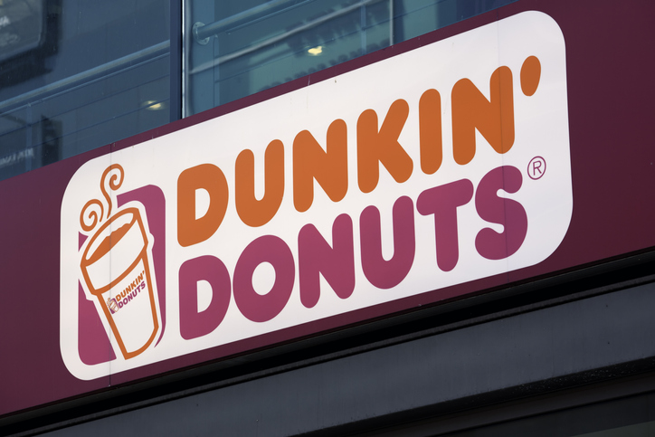
The patterns of sound help make lines or phrases memorable. We see this in our everyday lives with the use of alliteration: Dunkin' Donuts, Bed Bath & Beyond, Coca-Cola, and so on. It is also used in prose to connect words and ideas and to make a strong impact: "Four score and seven years ago our fathers brought forth on this continent a new nation..." (Lincoln, 1863/2018, para. 4). Think about how you can use these devices beyond poetry and music lyrics.

Is Rap Music Poetry?
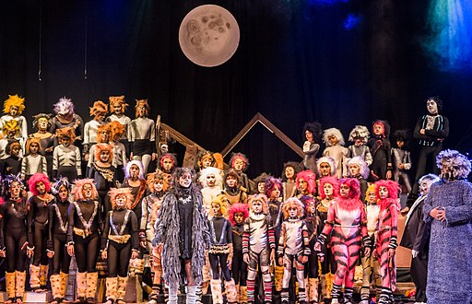Cats the Musical, Bangalore, India, 2014. (CC BY 2.0)
Andrew Lloyd Webber, the famous English composer and theater producer, declared in 2014 that T.S. Eliot may be the father of rap music. He stated in an interview that he "came to the conclusion, having read Eliot again, that maybe he was the inventor of rap. His metre for the Rum Tum Tugger is so wonderful... it raps" (Webber qtd. in Clark, 2014, para. 4).
Webber demonstrated his point by quoting the opening lines to the poem: "The Rum Tum Tugger is a curious cat; / If you offer him pheasant he would rather have grouse. / If you put him in a flat then he'd rather have a house" (Eliot qtd. in Clark, 2014, para. 5).
Webber's renowned musical Cats was originally based on Eliot's "Old Possum's Book of Practical Cats" (originally published in 1939), and it first premiered in 1981 in London's West End. Cats was the longest running show in Broadway history from 1997 until 2006. It was rereleased in a updated version in 2014 with a strong hip-hop vibe. The Rum Tum Tugger poem was turned into a rap in the new production, and the character was played as a "rapping 'street cat'" rather than a "rock rebel" (Singh, 2014, para. 6).
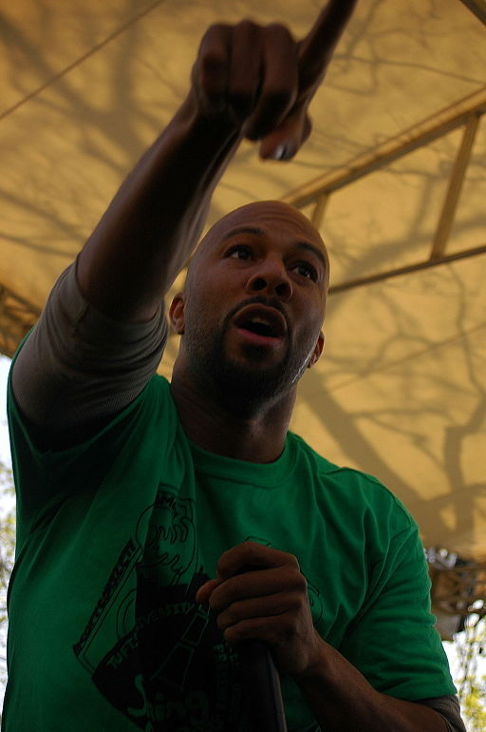Common, Tufts University, 2008. (CC BY-SA 3.0)
Maya Angelou is another who has influenced the rap and hip hop genre, and she is called the "godmother of hip hop" by many. Angelou was one of the first to see a connection between hip hop and poetry, and she has collaborated with and influenced many hip hop artists over the years, including Kanye West, Q-Tip, Tupac Shakur and Common. In 2011, Maya Angelou and Common collaborated together on his track "The Dreamer," during which Angelou recited a poem she had written. Conduct a Google search for Common & Maya Angelou The Dreamer to view the recording.
Something that both rap and poetry have in common is rhythm. W. B. Yeats, the famous Irish poet, stated that poetry is "an elaboration of the rhythms of common speech and their association with profound feeling" (Yeats, 1936, p. 2). Without rhythm, the lyrics in rap and the lines of poetry would simply be short stories. Through rhythm, the rappers and poets create a mood that communicates their message.
Imagery is also used in both rap and poetry. When an author uses imagery well, readers or listeners are able to immerse themselves in the world that the author is trying to create. A great example of the use of imagery is from Kanye West's song "Flashing Lights": "First class with the seat back, I still see ya / In my past, you on the other side of my memory's museum" (West, 2019, lines 36-37).
From these lines, the listener understands that, although West lives a life of luxury, he is still haunted by the memory of his ex-girlfriend. In the second part, West seems to be stating that he still thinks of her but feels separated from her. When an artist skillfully uses imagery, the listener is able to enter into the world of the speaker and feel everything that the speaker is feeling.
A relatively new sub-genre of rap is "socially conscious" hip hop. This sub-genre of music "question[s] the dominant cultural, political, philosophical and economic consensus" (Smolcic, 2016, para. 2). Some examples of socially conscious hip hop artists that are part of this movement are Kendrick Lamar, Common, Jay Z, and Public Enemy. These artists and others are calling attention to issues such as police brutality, prejudice, violence and injustice in their lyrics.
It is important to remember that using literary devices such as rhythm, rhyme, metaphor, and imagery does not necessarily make a rap into poetry. For a rap to be considered poetry, it needs express feelings in a way that is imaginative and creative with a distinct style and rhythm, and the lyrics must be complicated and multifaceted.
Watch the following video on "To Prisoners" (originally published in 1981) by Gwendolyn Brooks, a major influence on many socially conscious rap artists, as scholars and former prisoners reflect on the words and meaning. Think about generalization and specificity in the poem. How does the poem paint a specific picture? How does it remain timeless and relevant today?
To Prisoners: Gwendolyn Brooks (10:00)

References
Amin, O. S. M. (2011, August 17). Reverse side of the newly discovered tablet V of the Epic of Gilgamesh [Photograph of tablet]. Retrieved from https://commons.wikimedia.org/w/index.php?curid=61612783
Bell, K. M. (2008, April). Common at Tufts [Image file]. Retrieved from https://commons.wikimedia.org/w/index.php?curid=4390278
Brooks, C., & Warren, R. P. (1988). Understanding poetry (4th ed.). Boston: Wadsworth, Cengage Learning.
Clark, N. (2014, July 7). Andrew Lloyd Webber hails T.S. Eliot as the father of rap as Cats returns to the West End. Retrieved from https://www.independent.co.uk/arts-entertainment/art/news/andrew-lloyd-webber-hails-ts-eliot-as-the-father-of-rap-as-cats-returns-to-the-west-end-9590475.html
Izadi, E. (2018). How Maya Angelou became the godmother of hip hop. The Washington Post. Retrieved from https://www.washingtonpost.com/news/arts-and-entertainment/wp/2018/04/04/how-maya-angelou-became-the-godmother-of-hip-hop/?utm_term=.1d77015be053
L'Epicier, R. (Producer). (2003). Rhythms in poetry [Video file]. Annenberg Learner. Retrieved from Academic Video Online: Premium database.
Lincoln, A. (2018). The Gettysburg Address. Retrieved from http://www.abrahamlincolnonline.org/lincoln/speeches/gettysburg.htm (Original work published 1863)
LitCharts. (n.d.). Trochee. Retrieved from https://www.litcharts.com/literary-devices-and-terms/trochee
New, E. (Director), & Reis-Dennis, L. (Producer). (2017). To prisoners [Video file]. Public Broadcasting Service. Retrieved from Academic Video Online: Premium database.
Poe, E. A. (2019). The raven. Retrieved from https://www.poetryfoundation.org/poems/48860/the-raven (Original work published 1845)
Prince, M. (2014, November 29). Cats the musical [Image file]. Retrieved from https://commons.wikimedia.org/w/index.php?curid=79434040
Sayer, H. M. (2010). Discovering the humanities. Upper Saddle River, NJ: Prentice Hall.
Seligman, J. (Director), & Blaetz, P., & Rattner, L. (Producers). (2008). Poetry lounge 3: The power of performance [Video file]. Choices, Inc. Retrieved from Academic Video Online: Premium database.
Shakespeare, W. (2019). The tragedy of Macbeth. Retrieved from http://www.opensourceshakespeare.org/views/plays/play_view.php?WorkID=macbeth&Act=4&Scene=1&Scope=scene (Original work published 1606)
Singh, A. (2014, July 7). Cats: classic musical to feature a rapping cat. Retrieved from https://www.telegraph.co.uk/culture/theatre/theatre-news/10951867/Cats-classic-musical-to-feature-a-rapping-cat.html
Smolcic, A. (2016). Is rap music poetry? The Bowen Street Press. https://www.thebowenstreetpress.com/bsp-blog/?offset=1475469958140
Tennyson, A. (2019). Ulysses. Retrieved from https://www.poetryfoundation.org/poems/45392/ulysses (Original work published 1842)
West, K. (2019). Flashing lights. Retrieved from https://www.azlyrics.com/lyrics/kanyewest/flashinglights.html (Original work published 2007)
Yeats, W. B. (1936). The Oxford book of modern verse 1892-1935. London: Oxford University Press.

