External Resource

01 View the Visual Artwork: Self-portrait on the Borderline Between Mexico and the United States by Frida Kahlo

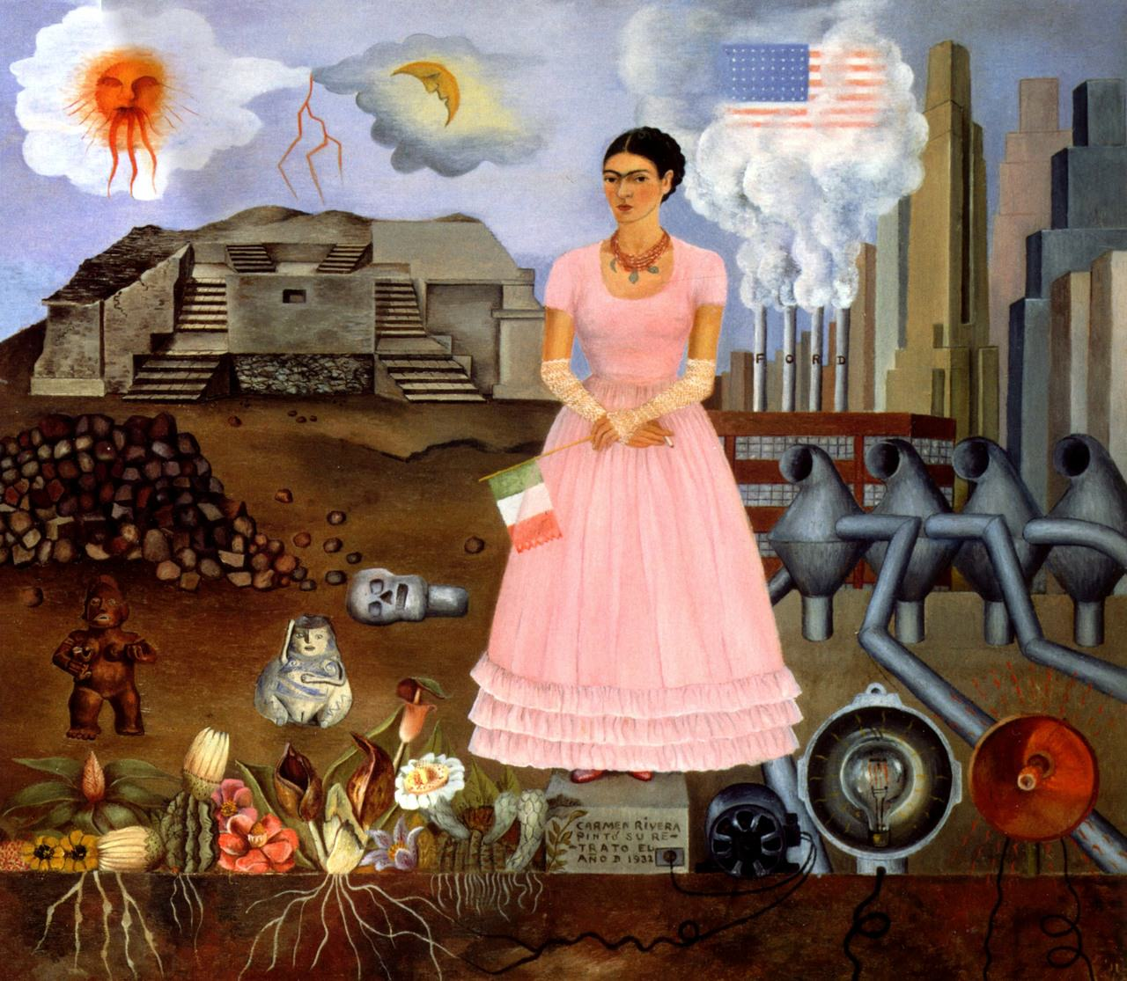

External Resource
02 Explore the Artist's Biography: Frida Kahlo
https://www.biography.com/artist/frida-kahlo
External Resource
03 Explore Details Inside the Painting: Frida Kahlo's Works of Art
http://www.pbs.org/weta/fridakahlo/worksofart/borderline.html

