Annotated Bibliography of Pocahontas
Name
Institution Affiliation

Annotated Bibliography of Pocahontas
Buescher, D. T., & Ono, K. A. (1996). Civilized colonialism: Pocahontas as neocolonial rhetoric. Women's Studies in Communication, 19(2), 127-153.
In this article, the authors contend that Pocahontas, an animated film from Disney, is neocolonialist writing that echoes the American history of colonial events with the Indigenous Americans, substituting the antique of the massacre with an engaging narrative that endeavors to justify and civilize colonialism. This narrative ascertains how the romantic tale of the film adopts the current social issues of human autonomy, environmentalism, and feminism to make the ethnic dominion look pure and innocent. The plot of the film cannot be separated from the cultural hegemony of imperialism. Despite being an exciting narrative for the children, the film also sheds essential insights into light-hearted adults.
Wood, C. (2017). Pocahontas. Quest, 189, 25-34.
According to this source, Pocahontas has been described by numerous narratives, and her legend has played essential roles for many years, most of them at excellent dubious value from the current day's viewpoint. She did not choose how to live her adult life as this was done by others, but she selected a path of honor rather than consent. She did all that she could not only for her family but for her people under the new circumstances. She could not alter the sequence of events, motivated by greed and arrogance, covered in a purportedly loving religion. However, she portrays a path filled with hope, living life, which was a tie between individuals, miserably terminated.
Shifflett, M. (2008). MATOAKA: Pocahontas in the Age of Identity.
This article describes the labors of judgment and research that inspired and enlightened the work in a play with Three Acts, Matoaka. The article particularly assesses the historical enigmas encircling the life of Pocahontas and supports the choice made in embellishing her life in the play, as mentioned earlier. The non-fiction writings of the last four centuries are referenced and the famous dramatic acts of the 19th century. These works are keenly evaluated to disclose the Pocahontas narrative as a bridge between many parallel social discussions.
Fromm, J. (2011). The Woman, the Myth, the Legend: Tracing Pocahontas Through History. Williams Prize.
The image of Pocahontas is portrayed in most of the parts in the country. For instance, it is erected as a figurehead on a ship's stern or a child's television as a singing cartoon. Pocahontas has turned out to be one of the prominent historical personnel in the current era. Even though her story is almost known to everyone, her portrayal has often been adjusted, covering the Powhatan princess in a haze of anonymous. The paintings grounded on the work of the young Indian, singing into the standards of the society to please the listeners and make the immigrant females relatable.
Lewis, J. J. (2019). Did Pocahontas Really Save Captain John Smith? ThoughtCo. https://www.thoughtco.com/pocahontas-saves-captain-john-smith-3529836

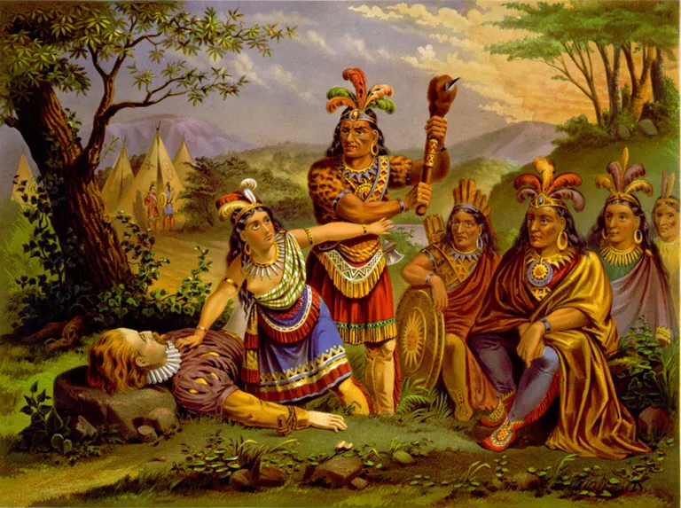

The painting “A picturesque story: Captain John Smith” shows the event when Captain smith is captured by the Indian chief. He is pinned on the ground, his head placed on a rock, and the warriors are ready to hit him to death. Within no time, Pocahontas shows up and puts herself in front of the soldiers, risking her own life. The chief concedes and frees Smith. Pocahontas continues and establishes the friendship ties with Smith and his cohorts. This played an essential role in the survival of the English colony in the early years. This artwork shows that Pocahontas was compassionate towards strangers.
Finally, the peer-reviewed sources were located in various scholarly journals, while the primary source was acquired from internet sources. The main challenges that were encountered includes finding the relevant sources to use in this project. Numerous sources focus on this topic. Nevertheless, it is only a few which are relevant to the topic of study. Additionally, locating recent journal articles was a real struggle as most of them were written some decades ago.

