Hello Class
Behavior analysis is a fascinating and effective approach. It's not a surprise that part of this discussion requires you to answer if behavior shapes personality or vice versa. I look forward to hearing your thoughts on this and evidence to support it. Consider this image:
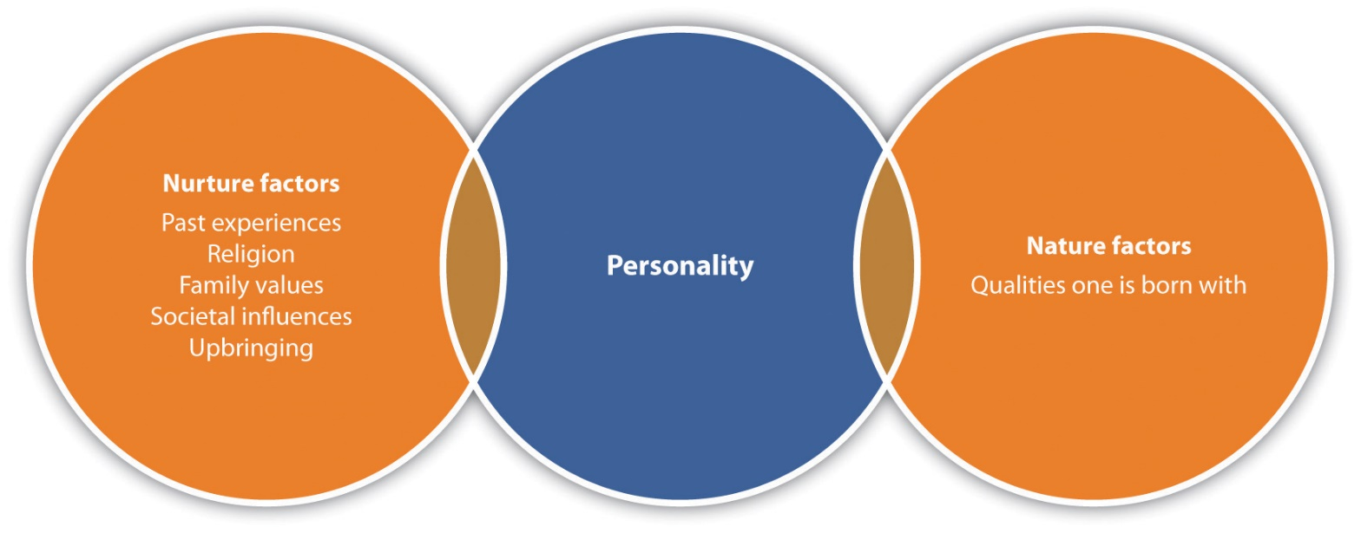

How does this diagram speak to the above question? Which theorists/theories fall into nurture category? Nature category?
Dr.K

