Week 2 Lesson: Defining and Discussing Art
Table of Contents

Defining Art
Art has many definitions. Consider the following common definitions:
- "The expression or application of human creative skill and imagination, typically in a visual form such as painting or sculpture, producing works to be appreciated primarily for their beauty or emotional power" (Oxford Dictionaries, 2018, Def. 1).
- "Skill acquired by experience, study, or observation" (Merriam Webster, 2018, Def. 1).
- "The conscious use of skill and creative imagination especially in the production of aesthetic objects" (Merriam Webster, 2018, Def. 4a).
- "Decorative or illustrative elements in printed matter" (Merriam Webster, 2018, Def. 6).
- "The making or doing of something whose purpose is to bring pleasure to people through their enjoyment of what is beautiful and interesting, or things often made for this purpose, such as paintings, drawings, or sculptures" (Cambridge Dictionary, 2018, Def. 1).
Does one of these come close to what you think art is?
Art is a term applied to a complex network of aesthetic styles. The rules vary so much from genre to genre that it would be nearly impossible in the limited scope of this lecture to explain all of them. There is, however, one common thread. Across the centuries and numerous genres, art can always be counted upon as a unique and creative form of human expression.
Art seeks to communicate, and it often communicates ideas that are invaluable to the study of man's intellectual evolution. Over the course of history, we have developed methods of self-expression that traverse symbolic and verbal language, which have been categorized (sometimes loosely) as art. Even in this complicated web of subjective expression, there must be some objective measures to determine what constitutes a work of art.
Simply speaking, creativity as it applies to art is the act of generating new ways of communicating ideas. Artists apply their styles and techniques to communicate with the viewers. Originality is the key in any creative endeavor. Although the idea that the artist seeks to communicate might not necessarily be original, the way in which it is communicated should be unique in order for the final product to be considered art. So how does the creative process work? There is no singular creative process. In fact, from a psychological perspective, it is really unknown. Artists appear to use a variety of approaches, and as far as we know, creativity may not be duplicated. In other words, there may be other artists who are deemed as talented as Michelangelo (a subjective determination in and of itself), but there will never be another Michelangelo. The process of creativity may still be mysterious, yet "nonetheless, something happens in which humankind takes chaos, formlessness, vagueness, and the unknown, and crystallizes them into form, design, inventions[,] and ideas" (Sporre, 2004, p. 15).
One thing that is known is that creativity is an intuitive act. Artists simply follow their instincts to arrive at the finished work. Certainly, many of the most revered artists studied techniques, but without the artistic intuition – creativity – the work is not art. Again, art must be an original expression. This leads to a great, long-raging debate over what constitutes art. Christo and Jeanne-Claude are among the vast cast of artists whose works have not always been accepted among the artistic community as art. Their ephemeral installations are no doubt beautiful, but are they art? In order to be considered so, we must evaluate what they are attempting to communicate.

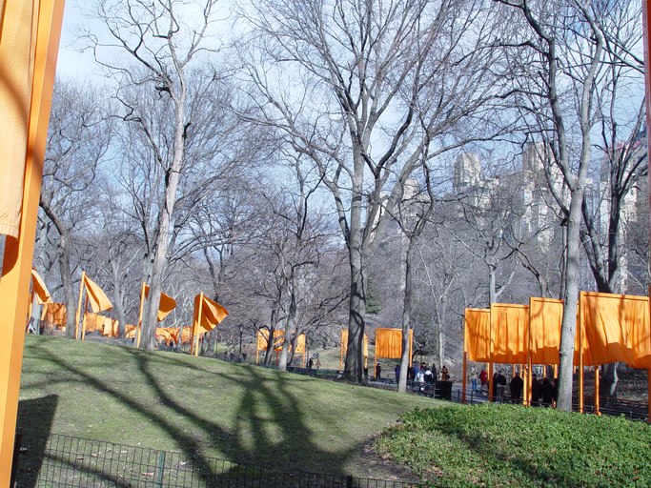Christo and Jeanne-Claude, The Gates, 1979-2005. Central Park, New York City.The Gates (2005 installation) sparked yet another debate over whether Christo and Jean Claude's work is indeed art. Some critics view their work as architectural in nature, but they do not necessarily believe it possesses the spark of creative and original genius. Supporters find their work innovative in its attempt to assert an extraordinary perspective in an ordinary setting.

Art, at its core, is a refined form of communication that is referred to as aesthetics. Aesthetics is the study of beauty, but this is not to say that all art is beautiful. Some art may be intentionally grotesque or may deal with subjects (e.g., death, war, etc.) that would not be defined as beautiful, but as the antithesis of beauty, such subjects are still considered under the umbrella of aesthetics. The study of aesthetics is one of the five classical philosophical fields of inquiry. Immanuel Kant is considered one of the innovators of aesthetic study. His Critique of Judgment (1790) asserted that art is not simply a matter of the appreciation of beauty but a process of judgment as well. In other words, art may still be a subjective category of study, but the only way to judge art is in an informed manner.
In order to define art, you must also recognize the difference between fine and applied art. Fine art is created with the express purpose of aesthetics; fine art has an express emotional purpose. Sculpture, painting, dance, music, and so forth are all examples of fine art. Applied art may include such categories as architecture, interior design, pottery, textiles, furniture, and so on. The applied, or decorative, arts refer to works that may be created with aesthetics in mind, but the purpose of the end products is most often functional in nature.
Practice your understanding of fine and applied arts in the following interactive. Drag the images to the correct category.

