Week 3 Lesson 1: The Beginnings of Culture
Table of Contents

Why Do Humans Create?

The object of the artist is the creation of the beautiful. What the beautiful is is another question. (Joyce, 1916/2017, Chapter 5)

Humans have known that ancient people drew on cave walls since the late nineteenth century. Throughout history, humans have always felt the impulse and drive to create art. Some say that the creation of art, this display of creativity and skill, aids a human in finding a mate, therefore ensuring reproductive success. This seems to be too simple of an explanation especially considering that not all people who create art are looking for a mate. One characteristic to note about prehistoric art is that it centered around the central problems and fears of people: finding food, being prosperous and safe, and preventing illness and harm. It is possible that participating in the work of communal art gave people a sense of community in difficult times, so that even if a hunt was unsuccessful or some people came to harm, the artwork helped the group cope with these problems.
There are other theories as to why prehistoric people painted animals on cave walls.
- They wanted to make the cave beautiful, and animals were very important to them.
- They may have thought that these depictions could bring good luck for the hunters which in turn would feed the community.
- Early people were daydreaming and painting how they wished things would be. They could have been painting these animals in hope of increasing the herd's numbers.
- Art could also have been used as a way to problem solve and communicate with others and serve as a form of therapy.
- Art produces emotional effects in the community, and people take pleasure from creating something beautiful on a cave wall or embellishing the handle of a tool. Seeing something beautiful strikes an emotional response with the viewer and makes people feel connected.
Click on the arrows to see some examples of the early creative impulse. Keep these in mind as you plan your own creation for this week. What will be your intent? How are the materials you use important?

Previous
The Great Sphinx of Giza, c. 2558–2532 BCE.
Monumental Sculpture
The Western tradition of sculpture began in ancient Greece. Greece is traditionally seen as producing the great masterpieces of the Classical period. One of the most common purposes of sculpture involves some type of religion. The ancient Greeks, Egyptians, Hindus, and Buddhists all devoted large monumental sculptures to their deities. The ability to create a monumental sculpture by a talented sculptor and the transporting heavy materials in order to create the sculpture are considered to be the mark of a relatively advanced ancient culture. For example, the recent discovery of ancient Chinese Bronze Age figures some more than twice human size have changed many of the widely held ideas about early Chinese civilization. The use of very large sculpture to impress the power of a rule on the viewer goes back at least 4500 years ago to the creation of the Great Sphinx. The Egyptians created massive architectural structures dedicated to their gods.
Think about how we mark important events or people in modern times. How does power play a role in memorialization?
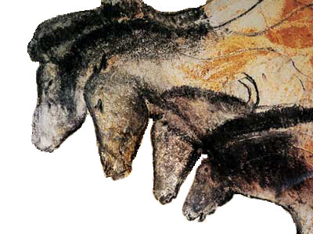Cave painting of horses, c. 30,000 BCE. Grotte Chauvet, Ardèche, France. (Public Domain)
Cave Painting
Many caves have been discovered over the years that have contained prehistoric drawings, but the most exciting discovery was that of the Chauvet Cave in the Ardéche gorge in France. These drawings were the most sophisticated discovery to date and thought to have been created over 30,000 BCE.
The cave paintings suggest that these areas were centers of culture as many as 30,000 years BCE. Since they were discovered, scholars have marveled at the skill of the drawings, especially at Chauvet, and have questioned why these early people created the cave drawings. The artists at Chauvet used color and seemed to understand perspectival, or three-dimensional, drawing. This leads us to the conclusion that from the earliest of times, humans have been capable of representing the world in naturalistic terms.
Think about how perspective has changed in two-dimensional art throughout history. How do artists show depth and distance?
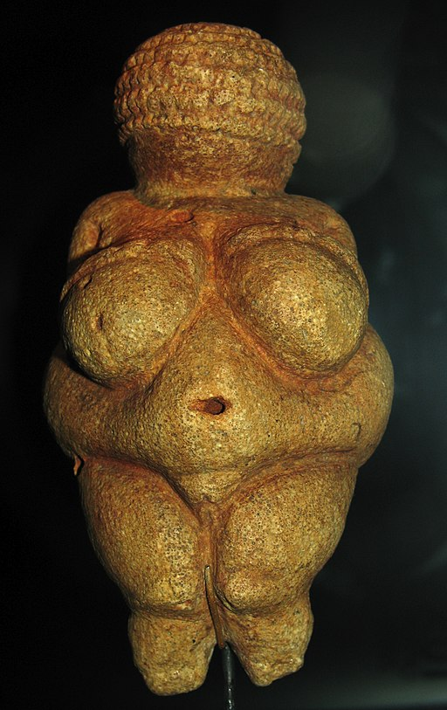Venus of Willendorf, c. 28,000-25,000 BCE. Limestone and red ochre. (CC-SA 3.0)
Sculpture
During the Paleolithic Era, or "Old Stone Age," the cultures of Europe lived a nomadic lifestyle and survived on game and wild plants. The tools developed during the Paleolithic period were carved from stone and more sophisticated than those of their ancestors. Paleolithic tools included cleavers, chisels, grinders, hand axes, and arrows and spearheads made with flint. In addition to tools, Paleolithic humans carved small sculptures and painted on cave walls, which we now call one of the first attempts to create art.
Among the most remarkable sculptures discovered across Europe were female figures. The most remarkable and famous sculpture is a woman carved out of limestone that was discovered at Willendorf. The sculpture dates back to 22,000 to 21,000 BCE and is known as the Venus of Willendorf. This figure depicts a female with exaggerated breasts and belly and clearly defined genitals, which could suggest a connection to fertility and child bearing. The fact that female figures greatly outnumber male figures discovered from the Paleolithic period suggests that women may have played a central role in Paleolithic culture. Paleolithic culture may have been matrilineal, in which descent is determined by the female, and matrilocal, meaning that children resided with the female's tribe (Sayre, 2010).
Think about how art reflects culture. How have depictions of women changed throughout history? How have those depictions reflected their role in society?

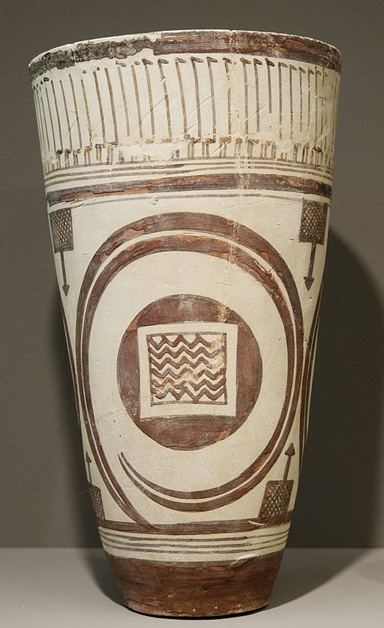Bushel with ibex motifs, c. 4200-3500 BCE. (Public Domain-US)
Pottery
Around 10,000 BCE, when the ice began to melt in the Northern Hemisphere, agriculture began to develop, and this led to an end to the nomadic lifestyle. This new era was called the Neolithic Era or "New Stone Age." In the river valleys of the Middle East and Asia, groups of people began to form civilizations. People at this time created myths and legends to explain the world around them and the evidence remains in the form of cave paintings and small sculptures. Around 4000 BCE, humans learned to separate metal from ore, and metal tools replaced the stone and bone tools of the past, ushering in the Bronze Age.
The transition from a hunter-gatherer society to one of agriculture led to the increased need for pottery vessels to carry food, store water, and prepare some types of food. Fragile ceramic vessels would not have been practical for hunter-gatherers, but a culture that did not move from place to place could find great use for such vessels.
The transition from a hunter-gatherer society to one of agriculture led to the increased need for pottery vessels to carry food, store water, and prepare some types of food. Fragile ceramic vessels would not have been practical for hunter-gatherers, but a culture that did not move from place to place could find great use for such vessels. Some of the most notable works of Neolithic pottery came from Susa on the Iranian plateau, such as this baked clay vessel painted with an ibex and long-necked birds. It stands 11.3 inches tall.
Think about aesthetics and function. Why are we concerned with the appearance of useful objects?
The Great Sphinx of Giza, c. 2558–2532 BCE.
Monumental Sculpture
The Western tradition of sculpture began in ancient Greece. Greece is traditionally seen as producing the great masterpieces of the Classical period. One of the most common purposes of sculpture involves some type of religion. The ancient Greeks, Egyptians, Hindus, and Buddhists all devoted large monumental sculptures to their deities. The ability to create a monumental sculpture by a talented sculptor and the transporting heavy materials in order to create the sculpture are considered to be the mark of a relatively advanced ancient culture. For example, the recent discovery of ancient Chinese Bronze Age figures some more than twice human size have changed many of the widely held ideas about early Chinese civilization. The use of very large sculpture to impress the power of a rule on the viewer goes back at least 4500 years ago to the creation of the Great Sphinx. The Egyptians created massive architectural structures dedicated to their gods.
Think about how we mark important events or people in modern times. How does power play a role in memorialization?
Cave painting of horses, c. 30,000 BCE. Grotte Chauvet, Ardèche, France. (Public Domain)
Cave Painting
Many caves have been discovered over the years that have contained prehistoric drawings, but the most exciting discovery was that of the Chauvet Cave in the Ardéche gorge in France. These drawings were the most sophisticated discovery to date and thought to have been created over 30,000 BCE.
The cave paintings suggest that these areas were centers of culture as many as 30,000 years BCE. Since they were discovered, scholars have marveled at the skill of the drawings, especially at Chauvet, and have questioned why these early people created the cave drawings. The artists at Chauvet used color and seemed to understand perspectival, or three-dimensional, drawing. This leads us to the conclusion that from the earliest of times, humans have been capable of representing the world in naturalistic terms.
Think about how perspective has changed in two-dimensional art throughout history. How do artists show depth and distance?
Next
- 1
- 2
- 3
- 4

References

Bushel with ibex motifs. (c. 4200-3500 BCE). Retrieved from https://en.wikipedia.org/wiki/Bushel_with_ibex_motifs#/media/File:Bushel_ibex_Louvre_Sb14276.jpg
Cave Painting of Horses. (c. 30,000 BCE). Retrieved from https://en.wikipedia.org/wiki/Chauvet_Cave#/media/File:Chauvethorses.jpg
Hitchcock, D. (2008). Venus of Willendorf [Image file]. Retrieved from https://commons.wikimedia.org/wiki/File:Willendorf-Venus-1468.jpg (Original work completed c. 28,000 BCE – 25,000 BCE)
Joyce, J. (2017). A portrait of the artist as a young man. Retrieved from https://www.gutenberg.org/files/4217/4217-h/4217-h.htm (Original work published 1916)
Sayer, Henry M. (2010). Discovering the humanities. Upper Saddle River, NJ: Prentice Hall.

