Week 3 Lesson 2: Ancient Roman Architecture
Table of Contents

Roman Cities
When the Romans conquered Greece in the 3rd century BCE, not only were they impressed with the ornate architecture of the region, but they also adopted the spiritual practices of the Greeks. Prior to their invasion of Greece, the Roman style of architecture was quite plain and emphasis was placed on functionality. The Roman invasion of Greece marked a turning point in Greco-Roman history.
Click through the slides to learn more:
Click on the plus signs to learn more about the interior space of the Pantheon.
Inspired by the Greeks and Etruscans, ancient Roman architecture flourished after Rome became a world power. The Romans also employed city planning on a more extensive basis than the Greeks, who divided their cities among the sacred and secular. Roman city planning emphasized the continuous whole. Major streets provided the hub of activity and were divided by smaller streets, creating a grid-like pattern of city blocks that were divided into districts, a system that still influences Western city planning today.
Roman cities were characterized by forums placed in the center of the city where the two main roads intersected. Under Julius and Augustus Caesar (Octavian), temples were added, followed by a basilica (law court). Flanked by shops and religious and civic buildings, the forum was the primary meeting place in the city. Eventually, cities grew to the point that they adopted several fora (plural of forum) to absorb the population. Roman fora were the precursors to modern city centers and malls.
In the following map, the Roman Forum (noted as Forum) is at the center of several other structures, including the Basilica Julia, a public meeting place on the south side of the forum. Notice the additional fora to the north: Forum Iulium (Forum of Ceasar), Forum Augustum (Forum of Augustus), Forum Taiani (Trajan's Forum).

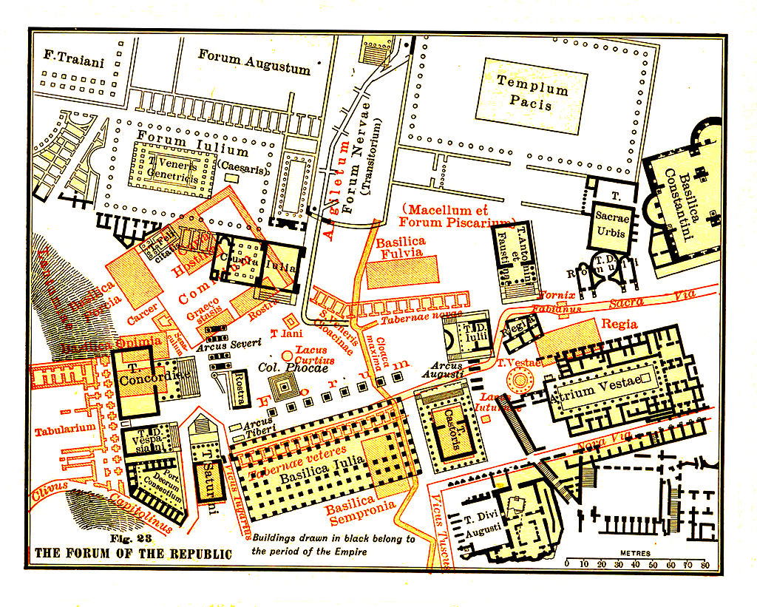Map of Roman Forum. (Public Domain)

Greco-Roman Influence
The Greco-Roman influence is among the strongest on the modern world today. The Greeks and the Romans constructed incredible civilizations that thrived for thousands of years before eventually succumbing to countless outside forces, such as invasions, epidemics, and economic, religious, moral, and administrative calamities. After the fall of these civilizations, people returned to a barbaric and savage society until around 1400 CE, when they gradually began to readopt the ideas of the Greeks and Romans.
The influence of Greco-Roman architecture can be seen throughout America. Click through the following slides to learn more:
In conclusion, many American cities boast monuments that emulate the architecture of the Romans, some overtly and some in more subtle ways.

References

Drawing of Pantheon. (1908). Retrieved from https://commons.wikimedia.org/wiki/File:Pantheon.drawing.jpg
Highet, G. (1949). The classical tradition: Greek and Roman influences on western literature. New York, NY: Oxford University Press.
Highsmith, C. M. (2011). Kimbell Art Museum in Fort Worth, Texas [Image file]. Retrieved from https://www.loc.gov/pictures/item/2011631403/
L’Enfant, P.C. (n.d.). L’Enfant-McMillan Plan of Washington, DC [Image file]. Retrieved from http://www.loc.gov/pictures/item/dc0776.sheet.00002a/
MacDonald, W. (2002). The Pantheon: Design, meaning, and progeny (2nd ed.). Cambridge, MA: Harvard University Press.
Partridge, W. T. (1930). Design of the federal city: Chart no. 5, L'Enfant plan of Washington superimposed on the rectangular system from which he worked. In National capital park and planning commission, reports and plans, Washington region: Supplementary and technical data to accompany annual report. Government Printing Office. Retrieved from https://commons.wikimedia.org/wiki/File:L%27Enfant_Plan_of_Washington_Superimposed_on_the_Rectangular_System_from_which_He_Worked.jpg
Platner, S. B. (2008). Map of Roman forum. In The topography and monuments of ancient Rome. Retrieved from https://commons.wikimedia.org/wiki/File:Platner-forum-republic-96_recontructed_color.jpg (Original work published 1908)
Sayer, Henry M. (2010). Discovering the Humanities. Upper Saddle River, NJ: Prentice Hall.

