Cause/Spread
Zika virus is caused from a mosquito from the Aedes species
It can be spread through a bite from this mosquito, blood transfusion (rare), via pregnancy and sexual contact (CDC, 2019)

Zika Virus: An Emerging Virus

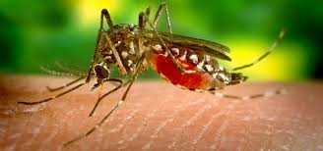
(photo courtesy CDC, 2019)
Statistics and History
-first identified in 1947
-1952 first human case of Zika virus
-associated with incidences of Guillian- Barre and microcephaly
-Most cases found in Africa
(WHO, 2020)
-
Zika Virus is identified through serum identification of the viral nucleic acid (definitive diagnosis) and detection of IgM antibodies
(Petersen, Jamieson, Powers, & Honein, 2016)

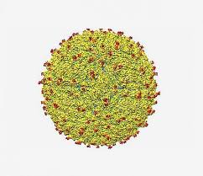
Treatment
Symptomatic only/no vaccine
Prevention
Using mosquito repellent permethrin
Provide for unprotected sex
Eliminate breeding sites through insecticides
(Petersen, Jamieson, Powers, & Honein, 2016)

Zika Virus
(photo courtesy of NIH, n.d.)
References:
Center for Disease Control and Prevention, 2019. Zika Virus. Retrieved from:https://www.cdc.gov/zika/about/overview.html

Petersen, L.R., Jamieson, D.J., Powers, A.M. & Honein, M.A. (2016). Zika virus. New England Journal of Medicine, 374, 1552-1563, DOI: 10.1056/NEJMra1602113

World Health Organization( (2020). The history of Zika virus. Retrieved from: https://www.who.int/emergencies/zika-virus/timeline/en/

