NETWORK RESEARCH PAPER
Student Name
Name of College

(Words highlighted in yellow without comments indicate a spelling or grammar issue)

Research outline

- PURPOSE OF VIRTUAL STORAGE TECHNOLOGIES

- The creation of a virtual storage system to facilitate the physical architecture allows for the increase of storage facilities depending on demand.
- The technologies permit the manipulation of the storage without tampering with the storage devices when adding or reducing storage space.
- DATA RECOVERY PLAN

- There are challenges to virtual storage for some possible loss of data due to the SAN mismanagement.

- INTRODUCTION
Storage virtualization is a technique that enables the physical information organization of hardware through its logical representation(define). The method allows users not to worry about the location of their data because it can easily be identified using a logical path (define). It enables the use of different hardware, which can be accessed using a single logical file system(define). There are various types of storage visualization, but two of the widely used include Storage Area Network and the Network Attached Storage [1]. SANs (which stands for storage area network) allows the integration of hardware contained in different networks and data locations into a single logical view(define). This statement implies that every partition or device contains logical units(define) which are referenced through reasonable unit numbers (define) within the SAN system. A SAN system has disks (which are physical gadgets used to storing data) grouped separately on a network then managed in an array, where the server can access the array in a similar way to a local storage device. NAS (Network Attached Storage) allows the storage system to be accessed by network devices, usually done by installing a NAS device onto a Local Area Network. Virtual Storage is a technology which involves the abstraction of physical devices through the creation of logical units which are location independent (define). This technology helps in reducing administration costs of managing SANs by creating a flexible environment that allows for secure backup, archive, and recovery of data [1]. A secure backup is created through the use of virtual storage which is not affected by the various risks which influence physical storage(What risks?). The NAS technology is sophisticated as compared to SAN because it contains unique protocols (like the transport and IP protocols) such as fibre channel(which is a high-speed data transmission system). Info band(a set of predefined range of frequencies), and iSCSI(Internet Small Computer Systems Interface and facilitates communication across the TCP/IP protocol). (You seem to be missing quite a few in-text citations. Your Introduction seems a little too much technical detail for an Introduction. Why not discuss in more detail the SAN and NAS in Part II, rather than in the Introduction?)
- PURPOSE OF VIRTUAL STORAGE TECHNOLOGIES
Virtual Storage, which is a technology for abstracting physical devices into logical units allows for the increase of storage capacity depending on demand. This technology can be combined with server visualization (which defines abstracting the physical servers through the adoption of logical architecture) to permit the creation of disk pools(define) whose storage capacity can be increased depending on application needs. Before the advent of the abstraction of the physical gadgets into logical spaces and network storage technologies, the host system had its storage that was a waste to the unused or excess storage capacity, meaning that the workplace had created excess storage systems which in turn failed to help it to promote the day to day functions [2]. Network storage technologies avail (as mentioned in the previous section (NAS and SAN)) storage capacity on-demand based on the growing requirements of the workplace in the context. It facilitates applications that are part of the host system that required ample storage to use it appropriately according to the demands arising on the day to day basis hence guaranteeing efficiency. Virtual Storage and network storage technologies promote data location independence. This means that the data is not confined to a single position and can be accessed across the entire network by abstracting the data's location; by replacing physical with the virtual environment from the logical representation. (virtual environment) used to access data. The virtualization system creates logical entities, such as virtual storage units, usually known as volumes to boost efficiency in access and storage that facilitate the mapping of the capacity to the exact location of the physical data. This ensures that the virtual and physical storage are linked. The technology creates Metadata (information that defined the data stored) because the mapping can range from a section of the physical disk to a single full disk. Mapping usually involves ensuring that the devices are connected within the same network and is essential since it ensures consistency in data storage and access. Also, the above act improves the efficiency as compared to traditional storage arrays. According to [2], virtual storage can increase storage efficiency by up to 70%. This can employ the Jumbo frame, which is a high data transfer channels, a high-performance network that can help improve the SAN system's performance. The jumbo frame is an Ethernet link (Ethernet channel with over 1 Gbps transfer speeds) that encouraged overcoming congestion (reduced efficiency in data transmission) on the SAN resulting from IP (source IP address) traffic. The figure below shows the configuration of a Jumbo Frame within a VLAN(define).
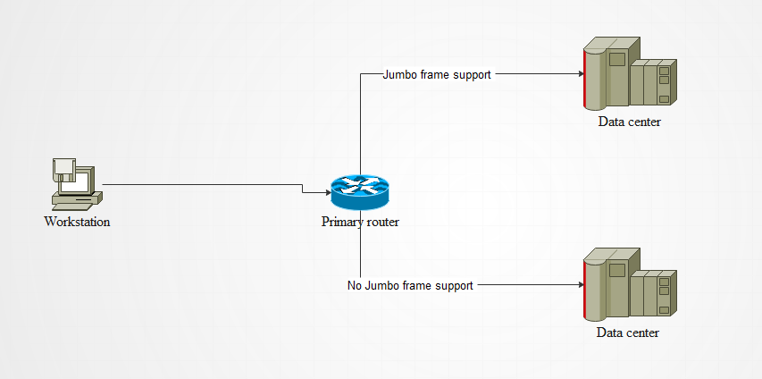
Figure 1. Jumbo configuration in a VLAN. (reference?)
From the figure above, the connection with Jumbo Ethernet has over 8-times faster data transfers as compared to the other hence beneficial in the configuration to improve data transfers. (reference?)
The technologies permit the manipulation of the storage without affecting performance with the storage devices when adding or reducing storage space. The host computers in a network, known as Host Systems, are no longer used in storage management and shielded from data changes such as data upgrades since they perform core functions within the network [2]. It has enabled the simplification of data protection methods because assigning storage classes for application (categories of storage systems) has been made easier by the technology. For instance, data migration from older arrays to new devices can be done without interfering with application access. Remote offices have embraced storage visualization because it facilitates access to cloud storage that is not physically accessible and available from the branches but depends on local servers for data.
- DATA RECOVERY PLAN
There are challenges to virtual storage (the creation of logical storage units) for some possible loss of data due to the SAN mismanagement, like unauthorized access. (Is that always mismanagement? How does that relate to loss of data? Is mismanagement the only way data can be lost?) It is, therefore, critical to the data recovery plan to help in the resumption of the standard functionality of the system as soon as possible. A data recovery plan is a set of steps which should be followed when an incident affecting the integrity of information occurs to restore the corporate systems to a previous state before the occurrence of such an incident. The plan contains regulations, guidelines and stakeholders involved in the process of recovering and restoring data. Lack of such a solution may affect the normal operations of a company should an incident resulting in data loss may arise. Some of the cost recovery options include the hot site, cold site, and warm site. A hot site is a parallel data centre to the production environment that takes the place of the impacted site in case of an outage [3]. A cold site is data centre space without any installed servers, but will only require instalment of servers to be functional. A warm site contains servers ready for installation in case there is an outage to the data centre [2]. The selection of either of the options is influenced by the nature of the incident reported. A warm site can be used for parallel operations to ensure speedy business operations restoration. (reference? How soon can a cold, warm, or hot site be expected to be operational? How does an organization know which type of site they need? What is an RPO/RTO?) SAN and NAS may not be used in this case since they are configured within the facility(Could this be done at a mirror site?). The continuity of the operations, which is essentially the ability of a company to continue its operations after an incident happens, depends on the availability, and the time is taken for specific features of a network system to be availed for continued normal functioning. (new paragraph) Some systems are designed for high availability, which means they include features such as load balancing (which is a configuration involving two devices which operate in parallel such that if one fails, the other one takes over), redundant hardware. The recovery from a possible loss of data in the data centre should be supported by a backup [3]. There are various types of backups, such as full, differential, or incremental backup, depending on the user's priorities (such as the types of operations carried out among others). The network system should have a low mean time to repair (MTTR). MTTR is crucial for a data centre that is used as a backup since it helps to regulate the operation. Therefore promoting efficiency, proper measures, such as regular backing up and cloud storage, should be taken to ensure that there is a small MTTR. (reference?)

- CONCLUSION
Virtualization and network-based storage technologies are various elements that need to be considered for proper functionality. A virtual-based storage system is crucial in the management of volume because it facilitates data location independence by abstracting the location of the data from the logical representation used to access data. Although they enhance the efficiency of application systems, they can encounter challenges such as possible loss of data. In averting such problems, there needs to be a data recovery plan to ensure that operations are not brought to a standstill. Data recovery encompasses several aspects that are vital to the management of data centres. On the same note, NAS has been used to provide extensions to the storage systems and configurations used in a network. This technology only improves the available local storage as opposed to focusing on virtualization. Hence, when considering backup and recovery planning, companies look for solutions which will facilitate cloud interventions as opposed to installing local and physical units.

REFERENCES (A little light on references)
[1]M. Agrawal and N. Vani, "Server Virtualization using Cloud Environment for Data Storage & Backup," International Journal of Science and Research (IJSR), vol. 5, no. 6, pp. 449-452, 2016. Available: 10.21275/v5i6.nov164021.
[2]S. Patil and K. Honwadkar, "Unified Virtual Storage: Virtualization of Distributed Storage in a Network," International Journal of Computer Applications, vol. 1, no. 22, pp. 30-33, 2010. Available: 10.5120/447-681.
[3]C. Tankard, "Streamlining data discovery," Network Security, vol. 2018, no. 6, p. 20, 2018. Available: 10.1016/s1353-4858(18)30059-x.

