December 10, 2020
Theme: Individuals, Groups, and Institutions
Question 1: To what extent is America a stratified society?

Question 2: Examine the three bar graphs and write in the document where you either summarize the main idea and ask a question of the data.
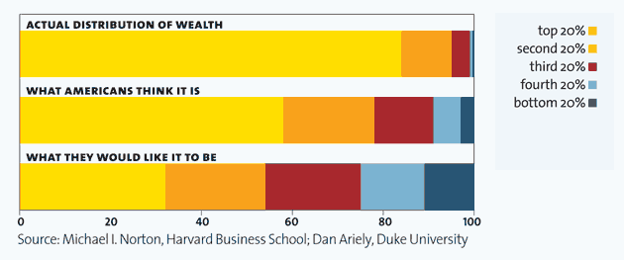
Question 2 Answer:

Question 3: Why does the distribution of wealth actually matter?

Directions:
- Write down observations about the statistics presented and consider how economics influence stratification for the data charts below.
- Write down two comments in the lecture notes for things that stand out or resonate to you.

Data Charts:
- Income Distribution: NYC v. United States (2014)
- Geographic Distribution of Median Income by Quintile in NYC (2010)

Lecture Notes:
- Social inequality describes a condition in which members of a society have different amount of wealth, prestige, or power.
- Stratification is a structured ranking of entire groups of people that perpetuates unequal economic rewards and power in a society.
- Ascribed status is a social position assigned to a person by society without regard for that person’s unique talents or characteristics.
- Achieved status is a social position attained by a person largely through his or her own efforts.
- Income refers to salaries and wages.
- Wealth is an inclusive term encompassing all of a person’s material assets, including land, stocks, and other types of property.
Comments:

Systems of Stratification
- Slavery: a system of enforced servitude in which enslaved individuals are owned by other people, who treat them as property.
- Slaves in Ancient Greece were captives of war or piracy, but their status was not
necessarily permanent or passed on to the next generation.
- In the United States, slavery was an ascribed status, and racial and legal barriers prevented them from being freed.
- Castes: Hereditary system of rank usually religiously dictated. Example: four major castes, or varnas, in India. In 1950, India adopted a new constitution that formally outlawed the caste system.
- Social Classes: A social ranking based primarily on economic position in which achieved status can affect or influence social mobility. Leads to income inequality.
- Daniel Rossides's (1997) five-class model (Upper class (2%), Upper-middle class (10-15%), lower-middle class (30-35%), working class (40-45%), lower class (20-25%).
- Income data released by the U.S. Census Bureau show that 2017 median household income was the highest on record at $61,372. Pew defines the middle class as those earning between two-thirds and double the median household income. This means that the category of middle-income is made up of people making somewhere between $40,500 and $122,000. Those making less than $39,500 make up the lower-income bracket. Those making more than $118,000 make up the upper-income bracket. Easy, right? Just take your household income and see where you fit given these numbers.
  - The problem is that your $61,372 probably doesn't buy you the same kind of life as your cousin’s $61,372 in another part of the country. The lives of families making the median income look very different given the vastly different cost-of-living levels across the U.S.
- 3 New Ways to Look at Class in America (Cultural, Social, and Economic Capital)
  - Social capital is your connections: It's whom you know, whom you socialize with, who's in your circle. It's "group membership," according to Bourdieu. If you've ever heard someone say "it's not what you know, it's who you know," you're familiar with the idea of social capital.
  - Cultural capital is a little less concrete, but it's basically someone's cultural literacy. This includes education level, skills, cultural knowledge and taste, ways of behaving, speaking and dressing. It's the way that you communicate, through your behavior, that you are of a certain social status.
- Class is Relative: Inequality and its Effects
  - Elizabeth Kolbert discusses this by describing the findings of psychologist Keith Payne, a UNC professor and the author of "The Broken Ladder: How Inequality Affects the Way We Think, Live, and Die." According to Payne, she writes, "...what's really damaging about being poor...is the subjective experience of feeling poor." This subjective experience of feeling less privileged compared to those around us has implications for behavior, as "people who see themselves as poor make different decisions, and, generally, worse ones."

Summary (in 6 or more sentences): What is economic inequality? Is it a major problem in America today? Why or why not?

Question 4: Assuming that we could equally divide all the world’s wealth and assets among everyone, why would stratification soon be evident among societies again?

