Students Name
Course Name
Research Topic:

Mock Dissertation Title
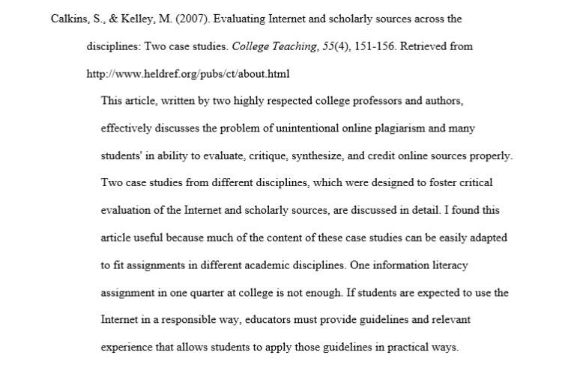
Annotated Bibliography

Excerpt copied from https://guides.rasmussen.edu/apa/annotatedbib

