NAME

Module 1: SLP#1 Disaster Preparedness

NRF/NIMS

HSL501: Introduction to Homeland Security

PROFESSOR

DATE

Disaster Preparedness
Site Description: Rose Bowl Stadium
The Rose Bowl Stadium started their operations in 1922 and the Rose Bowl Stadium has 92,542 seats available for the public. At first, the stadium could only hold up to 56,000 spectators and was made in a horseshoe design. In 1928, the stadium was redesigned and had a larger portion for seating, and the shape was also modified. Various additional renovations were created during the years, which have been vital in providing more for the seating space. The stadium is located in Pasadena, California. The City of Pasadena are the ones that own the stadium. It is controlled and managed by the Rose Bowl Operating Company. They are considered a non-profit organization that involves a group of governors specifically handpicked by the council of the city of Pasadena. The stadium utilizes a local law enforcement to offer security and traffic control during special events.
Events Planned for the Month of September
- On September 13th, the stadium will present the Rose Bowl Flea Market event. The event will start at 7:00 am and will finish at 4:30 pm. After people reporting at the venue, people going to the event are to first check-in at the yellow tent based at Gate A.
- September 25th, the stadium will present the Rose Bowl Public tours. Two different type of sessions will be provided. Starting out the day with the first group session which would start are 10:30 am. The second group session would wait and commence their portion at 12:30 pm. All the individuals will be put into a specific group led by a tour guide who will take the people around the stadium.

Hospital Profile
Huntington Hospital is located close to the stadium. There are three different routes one can go through. One can head towards via CA-710, which is an estimate of 2.8 miles, the Rosemount Ave and Orange Grove Blvd route, which is 2.3 miles. Lastly, the Linda Vista Ave and CA-710 is 3.1 miles. The hospital nearly 619 bed availability in the hospital. It is a non-profit run by a board of directors. Private security is what the hospital uses to provide security to the facility. Huntington is a level II trauma center but is looking to join with Cedars Sinai Medical Center, a level one trauma facility at the hospital that is found LA. Cedars-Sinai is also a non-profit hospital with a 958 bed availability. It is monitored and taken care by executive members and directors. They are also manned by private security.
Map and Photos of the Locale. The Venue, and Nearest Hospitals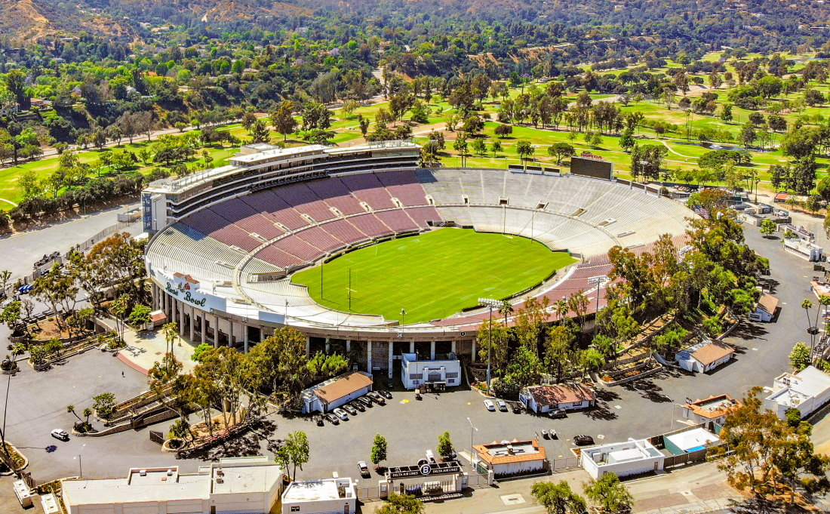
Figure 1: Rose Bowl Stadium (Eytan, 2020).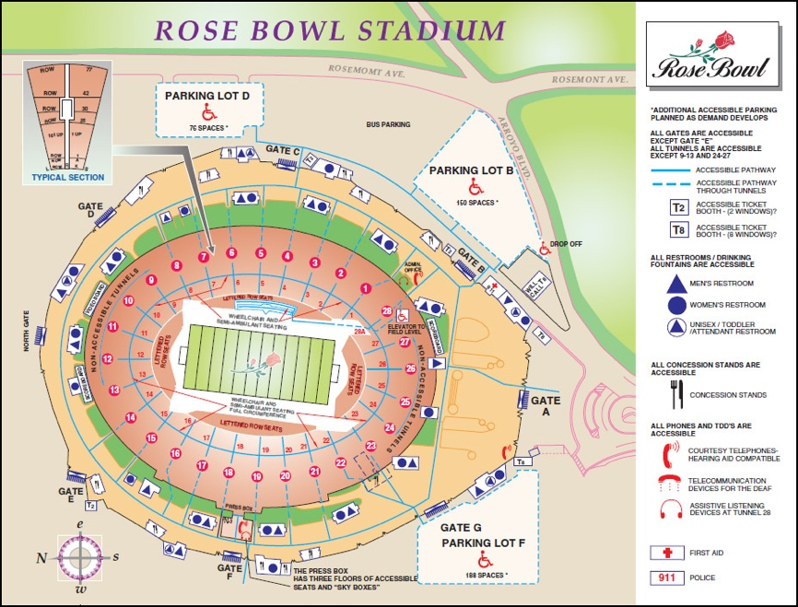
Figure 2: Rose Bowl Stadium Map (MLS, Inc., 2020).
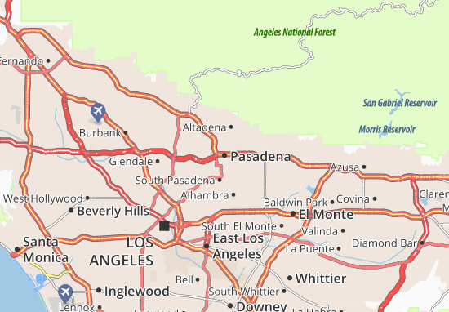
Figure 3: Map of Pasadena (Google.Map, 2020).
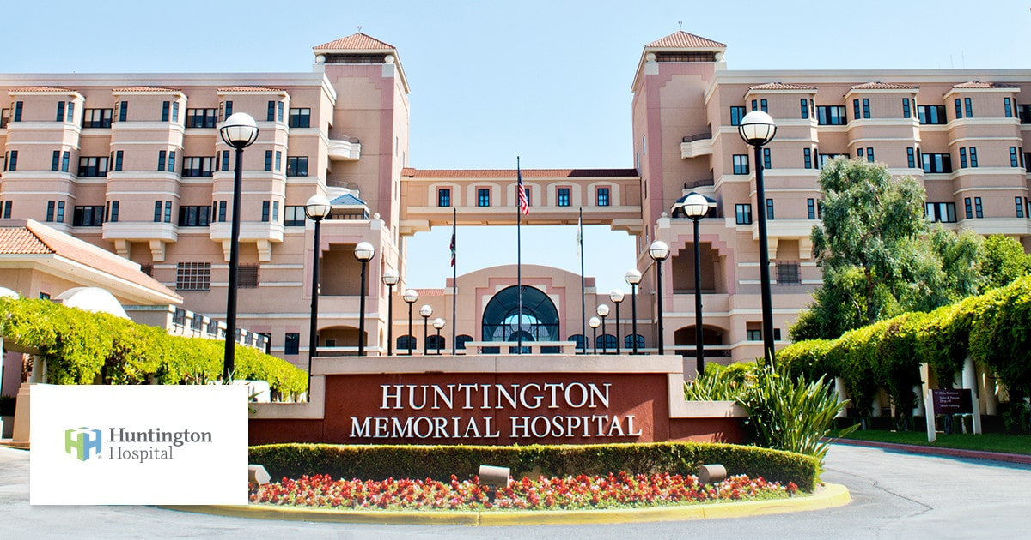
Figure 4: Huntington Hospital (Huntington Hospital, 2020).
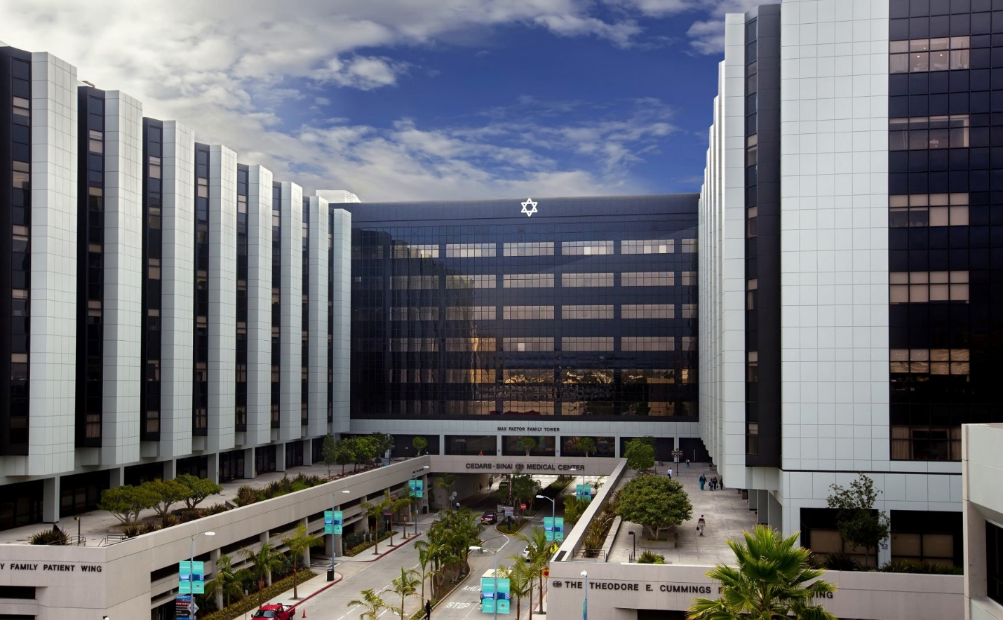
Figure 5: Cedars-Sinai Hospital (Cedars-Sinai, 2020).
Law Enforcement Agency, Fire Department, and EMS Services that Respond to Events in the Rose Bowl Stadium
The lawful agency that is placed there to serve and protect should initiate for every critical or minor response for every incident in the Los Angeles Police Department. The agency responds to any minor or violent criminal activities around the location. Their main role is to make sure there is a proper security around the location. The department sometimes determines whether or not to request the FBI assistance or to take over specific cases if the threat is more than what they can handle. They also work with bomb squads when there is a bomb-related threat in the location. Special Weapons and Tactics (SWAT) is also one of their special response team. Los Angeles Police Department is a public agency owned by the government.
Another response team would be the Los Angeles Fire Department who also responds to situations in the Stadium. Los Angeles Fire Department’s main role is to respond to events where there is a risk of someone’s life or property. The Los Angeles Fire Department The local government also owns the Los Angeles Fire Department.
Finally, The Los Angeles Emergency Management Department is tasked with responding to events in the local or entire region. This agency is also owned by the local government. Its primary role is to provide and serve to all emergency services to people during emergencies in the region. An prime example of this situation is that if a terrorist attack were to occur somewhere outside the area or inside the Stadium, the LA Emergency Management Department would help provide first aid assistance to the injured. LA Emergency Management would also assist in transporting them to the nearest hospital.
Preparedness
When preparing for the disaster, I will mainly use the NIMS cycles. The NIMS cycle has five stages. The Stages would be:
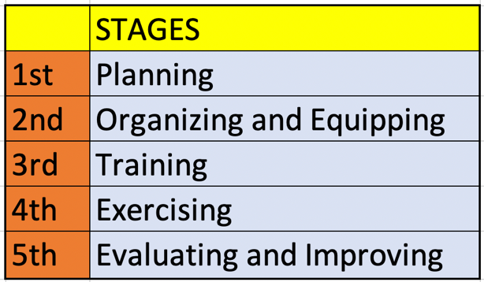
(National preparedness cycle, 2015).
There is not a necessity to comprehend the type of threat one is getting ready for in the planning stage (Carli & Telion, 2018). In this case, I have to plan and get ready for a terrorist attack in the Rose Bowl Stadium and another in the Huntington Hospital. During the planning stage, I will mainly assess the venue and the hospital to determine the impact the incident will have if it were to happen. I will also examine the venue and the hospital's strengths because these are the things that the team and the agencies to be involved in the process will exploit to better respond to the incident. Other than the strengths, I will analyze the weaknesses of both locations. The weaknesses are what the terrorists will exploit when attacking both the venue and the hospital. After Identifying the weaknesses, I will look for ways on how to eliminate these weaknesses.
When preparing for the event, I will include the agencies that will respond to the event. These include local law enforcement, the bomb squad, the FBI, the fire department, and emergency services. These agencies have to prepare for a tiered response, so they will have to send one team to the hospital and another team to the venue. Emergency services will only be deployed to the venue since the hospital already has staff that can care for emergency patients. As part of the preparation, these agencies will need to ensure that they have enough resources to prevent or respond to the attack. As part of the critical response, there is a necessity to start a joint task force between the agencies that respond to the event. Each agency will have a representative in the task force. One individual will head the task force. Doing so will guarantee a unified command during the event, thereby lead to better coordination between the agencies in handling the event. The representative in the task force will be the person leading their team during the event.
In both the venue and the hospital, there is a need to place an additional security checkup area. For the venue, there will be specific entrance areas. At each spot, each law enforcement agency responding to the event will deploy manpower. These individuals will check the people and clear them before they enter the venue. For each entrance point, there will be two security checkup areas that one needs to go through. The parking area will also contain officers who will examine each car. On the day before the event, the bomb squad will make rounds throughout the venue to determine whether a bomb has already been implanted. Prior to the event starting, specifically on the day the occasion, the bomb squad will also do a security sweep. The hospitals will also be checked for bombs before the event at the Stadium.
During the event, the officers will make rounds throughout the venue, looking for suspicious individuals who may be the suicide bombers. In case they spot an individual, they should carefully approach them and gently request them to accompany the officer outside the venue where they will be checked. It is not advisable to check the person while they are among the audience since this might raise the alarm. In case they spot a suicide bomber ready to detonate, excessive force may be applied as the officers evacuate the people.
The people who will respond to the event will get trained on how they will do it (National Incident Management System, 2017). They will also have to exercise what they have been trained about. The officers will get trained on how to check the spectators before they enter the venue. They also have to familiarize themselves with the policies of the venue and the hospital. For example, there are things that spectators are not to carry inside the arena. The exercise will occur at both the venue and hospital because they need to familiarize themselves with the environment on which they will operate (Goralnick, Van Trimpont, & Carli, 2017). Knowing the environment will make it easy for them to navigate through during the event. Finally, there are two events in September, according to the event calendar of the Rose Bowl stadium; these guidelines will be followed during each event. Finally, after the first event, there is a need to evaluate the procedures followed to locate areas of improvement.

References
Carli, P., & Telion, C. (2018). Paris City Disaster: Response to the Recent Terror Attacks and Lessons Learned. Current Trauma Reports, 4(2), 96-102.
Cedars-Sinai. (2020). Cedars-Sinai Hospital. Retrieved from Google: https://www.google.com/search?q=Cedars-Sinai+Hospital&sxsrf=ALeKk03Ayd41W18DZDYIHnfEA2h0Qbpa-g:1598486885418&source=lnms&tbm=isch&sa=X&ved=2ahUKEwjh0O7Xi7rrAhVOUt8KHZ1QBhQQ_AUoA3oECBAQBQ&biw=1572&bih=875
Eytan, T. (2020). Rose Bowl Stadium. Retrieved from The Stadium Guide: https://www.stadiumguide.com/rose-bowl-stadium/
Google.Map. (2020). Map of Pasadena. Retrieved from Google: https://www.google.com/search?q=Map+of+Pasadena&client=safari&rls=en&sxsrf=ALeKk02jopf6IddBHqIniMNsGt_zmCh2wg:1598486664407&tbm=isch&source=iu&ictx=1&fir=L5NrGoM_7ikonM%252C-_zni9uLMLX2SM%252C_&vet=1&usg=AI4_-kTighbYkOZRjtXnuTTeSw3DRp_YIw&sa=X&ved=2ahUKEw
Goralnick, E., Van Trimpont, F., & Carli, P. (2017). Preparing for the next terrorism attack: lessons from Paris, Brussels, and Boston. JAMA surgery, 152(5), 419-420.
Huntington Hospital. (2020). Huntington Hospital. Retrieved from Google: https://www.google.com/search?q=Huntington+Hospital&sxsrf=ALeKk02sKyIhJ0pgHWQmYKxdkId_e9_LIg:1598486766385&source=lnms&tbm=isch&sa=X&ved=2ahUKEwiTto2fi7rrAhXiQ98KHaQ1DZAQ_AUoA3oECCIQBQ&biw=1572&bih=875#imgrc=rSDwW3dxAp4plM
MLS, Inc. (2020). ROSE BOWL: STADIUM MAPS. Retrieved from L.A. Galaxy: https://www.lagalaxy.com/content/rose-bowl-stadium-maps
National Incident Management System. (2017). 3rd. Ed., FEMA. Retrieved from https://www.fema.gov/media-library-data/1508151197...
National preparedness cycle. (2015, March 2). Retrieved from https://www.coehsem.com/emergency-management-cycle/

