Focus is on the interventions you are planning at Leukemia and Lymphoma society. Think about the broad goals - what you hope to accomplish – with this intervention. Describe the target population and the additional stakeholders you may have. Now think about how this planned intervention fits with the theory you chose last week.

An example intervention that we do now is going out to different hospitals and provide people with information regarding what LLS has to offer. Here is the website.. https://www.lls.org/ (I guess this post is asking for a different intervention)

Include the following in this weeks discussion assignment:
- List the health intervention that you plan to implement within your CBSL site/community.
- Briefly discuss/list the target population of this health intervention.
- Develop 1 project intervention goal using the SMART format:
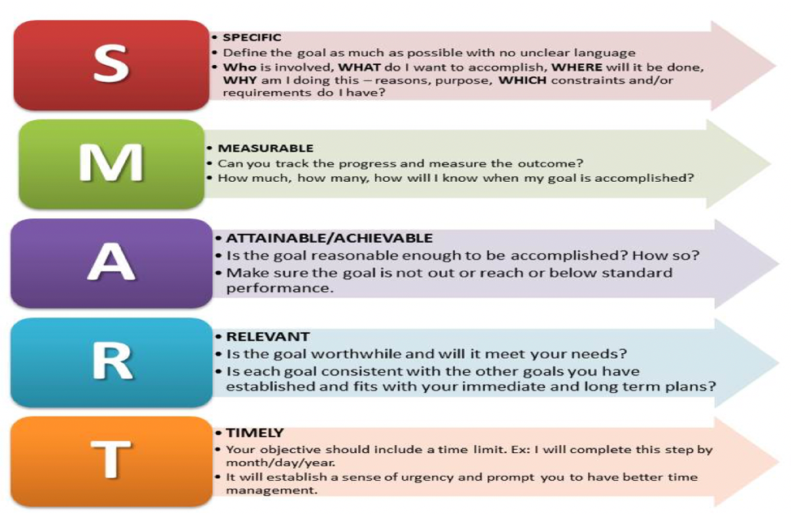
Here is the theory we chose last week to help with this post:
Gordan’s Functional Health Patterns
Gordan’s Functional Health Patterns is rooted in looking at the entire person and all aspects of their life in order to better assess their needs and health care plan. This theory is divided into 11 categories or patterns that aid in organizing the patient’s data and improve the overall assessment (Rentfro, 2018, p. 493). Our CBSL site, Leukemia and Lymphoma Society (LLS), focuses primarily on the Functional Health Patterns Health Perception – Health Management Pattern, Self-perception – Self-concept Pattern and Coping – Stress Tolerance Pattern. Health Perception-Health Management pattern is defined as aiding in perceived health and how this is managed (Rentfro, 2018, p. 495). LLS touches on this health pattern through providing vast resources to their patients including explanations of each blood cancer, money management and communication with the patient’s provider. Per training with LLS, a core component is ensuring the patient understands their diagnosis and how to move forward with their diagnosis (LLS, 2015-a). These resources are available online, in person at LLS volunteer sites and can be mailed if the information center is contacted free of charge. In addition, LLS focuses on self-perception-health management pattern and Coping-Stress Tolerance pattern. A cancer diagnosis can take a huge toll on the individual themselves. Through support groups and a support line, LLS strives to ensure all patients feel support throughout their journey (LLS, 2015-b).
LLS attempts to touch on all areas of health through providing resources and support to patients for all areas of an individual's health status. This directly aligns with the vision of Gordon’s Functional Health Patterns in order to make health care easier to navigate, more accessible and more affordable. Our planned health intervention is to aid in expanding where LLS materials and services are visible to ensure more people can have the resources they provide. While LLS has a wonderful mission and dedication to Gordan’s Functional Health Patterns they can only take this mission so far without access to certain community areas. We plan to expand their network by facilitating communication with hospitals they have not yet been able to contact and by distributing flyers in areas they currently do not reach out to. As a group we strongly believe LLS is dedicated to ensuring planned intervention based on the person’s individual needs as seen in Gordan’s Functional Health Patterns. We strive to carry this out by expanding their mission to new areas.

