JUST, Inc.: Clean Meat and the Future o? Protein Alternatives

Rosh Tetrick, founder an quietly rehearsing his spJel for the board of directors meeting. He reviewed the bulleted list of ta *ng points, ironing out areas of uncertainty, hoping that a strong prese the board’s confidence in him. 3UST’s board was becoming increasingly apprehensive given the company’s ongoing challenges with the Food and Drug Administration (FDA) and the Securities and Exchange Comrr’ sion (SEC). But the company was doing well and growing, despite these hurdles with US agencies.

Amid his pacing and mumbling, Tetrick (ooked out his window and noticed a family ordering from the hot dog stand across the street. He watched as the parents handed steaming hot dogs to two excited children who were likely unaware of the negative impact of eating that meal. Tetrick felt a familiar twinge of frustration. Despite his work for the past six years to revolutionize the plant-based alternatives market, this family’s lunch purchase seemed to illustrate how far the world still had to go to ensure that everyone was eating well. He felt that food was cultural, part of our identities, and if anything should be a basic right, it should be eating well. He believed the world could be made better, to be less cruel, to even taste better, but not enough was being done.' Though the plant-based alternatives industry was growing quickly, especially with 3UST’s strong positioning in that space and continued drive for innovation, Tetrick felt that it was capable of so much more.

He had been mulling several concepts for flUST‘s future. As of 2017, the six-year old company still had a lot of gr identified several opportunities that MUST could pursue. The first was to focus on aggressively expanding its presence in the plant-based alternatives space, further diversifying its product offerings to solidify itself as a market leader. However, Tetrick had found several new and enticing opportunities in the alternative meat space. He had narrowed the likely markets in this sector to plant- based meat, clean meat, and insect-based proteins. This could be a radical shift away from the products
Published by ROI Publishing, a division of the William Oavidson Institute (ROI) at the University of Michigan.
* 2020 Eva Collins-Carey, Pared DeGroat, Thomas 0nsJ, and Nisha Patel. This case was written by UnJversJty of MJchJgan undergraduate students Eva Collins-Carey, Pared DeGroat, Thomas Onsi, and Nisha Patel, under the supervision of Andrew Hoffman, Holcim (US) Professor of Sustainable Enterprise, a position that holds joint appointments at the University of f4ichigan’s Ross School of Business and School for Environment and Sustainability. The case was prepared as the basis for class discussion rather than to illustrate either effective or ineffective handling of a situation. The case should not be considered criticism or endorsement and should not be used as a primary data. Rosh Tetrick is a real person, but the events depicted in the case introduction are fictional. Some developments mentioned In the case occurred or were reported on or after the tJmJng of Tetrick‘s decision on what to recommend to the board, but
have been included to provide full context to the case reader.

MUST, Inc.: Clean Pleat and the Future of Protein Alternatives W27C49

MUST was founded to develop, but the potential to drastically improve access to healthy and sust a ly- produced food was more than tempting to Tetrick.

He knew that any decision he made would warrant heavy scrutiny from the board. H nee t absolutely sure where he would take the company before walking into that meeting. Shout MUST en the meat alternatives space and, if so, which market should it enter? Tetrick looked back at his otes, eval ated his options, and resumed his pacing.

JUST, Inc., History
MUST was a Silicon Valley-based food manufacturing company focused on revolutionizing both the inputs and the production processes that dominated global food systems. It was founded in 2011 by entrepreneur Tetrick and his childhood friend Rosh Balk, who at the t“ a> nior director of food policy for the Farm and Animal Division of the Humane Society of the Un’ ed State

MUST broke into the food industry with its signature “MUST Eg ” a mu g bean-based egg substitute. It tasted great and scrambled just like a real egg. fiUST’s r'°.sire to expand the alternative protein market spanned many consumer gro s on the company’s website:

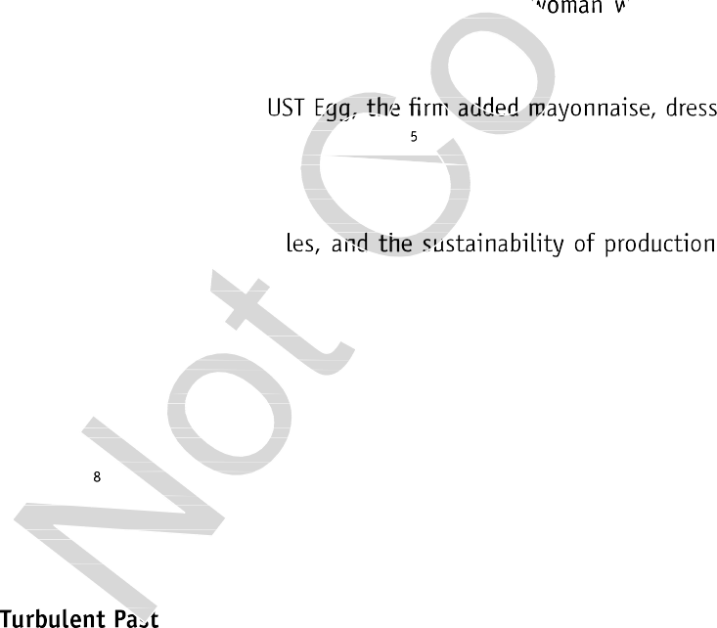
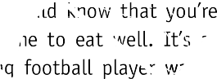
“Regardless of your motivation, you should know that you’re a part of something big: a mission to make it easier for everyone to eat well. It’s a story of meat lovers, egg lovers, and plant lovers. Of the young football player .. dNting protein before practice in Birmingham and the Beijing businessy. =•° ./anting a breakfast she can feel good about.

After the launch of 3 Ings, cookies, cookie dough, and other breakfast proteins to its product line. To develop these products, MUST utilized a proprietary machine- learning algorithm that predicted and tested viable plant proteins to replace animal proteins in food products.^ The algorithm systematically explored new ingredients and formulations, optimizing for human health benefits, taste profi . As of late 2017, 3UST’s products had saved over 361 million gallons of water, 1.46 million kg of C0„ and 2.5 million square meters of land.'

Much of flUST’s distribution network for MUST Egg relied on partnership agreements with major chicken egg suppliers who manufactured and distributed the Egg. For example, the Italian-headquartered Eurovo Group, a leading European producer and distributor of packaged eggs, received protein powder from MUST and mixed it with oils, gums, and seasonings before distributing the product to its retail and food service partners. Tetrick expected that as demand for this product grew, suppliers would build factory lines separate from where they processed real eggs.° Tetrick also aimed at expanding 3UST‘s partnerships to include a variety of food channels including grocery stores, restaurants, and school mess halls.'°

Tetrick was a risk-taker and visionary, determined to disrupt one of the world’s largest industries and change the way the world viewed and consumed food. However, he was dogged by 3UST’s controversial and
lent past.

In 2014 MUST, Inc., at the time known as Hampton Creek, was accused of conducting a product buyback scheme in which it paid employees to visit grocery stores, inquire about the company, and purchase its

Thank you for using www.freepdfconvert.com service!

Only two pages are converted. Please Sign Up to convert all pages. https://www.freepdfconvert.com/membership

