Reading One: Ahura Mazda and AngraMainyu
Introduction:
This text discusses the high God of Zoroastrianism, Ahura Mazda, as well as the “Mazdayasnians,” which is another name for Zoroastrians, as this word translates to the “mazda worshippers”. This passage introduces the goodness, eternal nature, and omniscience of Ahura Mazda. But it also introduces the “evil spirit” of Zoroastrianism, who is known as “AngraMainyu. ”
The text discusses the differences between Ahura Mazda, whose main characteristic is light and everything that symbolically goes along with light – revelation, purity, etc. AngraMainyu, on the other hand, is associated with darkness and everything that goes along with that quality – evil, temporality, emptiness, etc.
The passage wants to make very clear that Ahura Mazda and AngraMainyu are completely separate from each other, although Ahura Mazda is more powerful and actually created AngraMainyu.
Starting in Verse 8 the passage begins to tell part of the origin story of Zoroastrianism.
In Zoroastrian cosmology, it is believed that AngraMainyu was created by Ahura Mazda, then remained at bay, in a “spiritual state” as the text describes, for three thousand years. Afterwards, he escaped from this state, which we could call hell as that is a term we may be more familiar with. AngraMainyu and his creations, other evil spirits, are free to release evil and temptation on the world for a period of several thousand years, the time in which we are now living.
Ultimately, however, Zoroastrians believe that Ahura Mazda and his goodness will win out over AngraMainyu. It is the responsibility of every human being to choose good over evil in this world, which helps to bring closer the ultimate conquering of evil in the world, and the ushering in of a perfect future state free from any evil and temptation.
Zoroastrianism believes that our world is a battleground between good and evil – it is our responsibility to work for the good in order to help goodness ultimately win and usher in the “future state,” which will be an eternal paradise once AngraMainyu and his evil demons are defeated. Note the similarities between AngraMainyu and the Christian and Muslim conceptions of the devil/shaytan – many scholars believe that AngraMainyu influenced early Christian and Muslim conceptions of Satan.
It is important to note, however, that some Zoroastrians today see AngraMainyu as a literal devil-like figure, while some Zoroastrians understand it to be a symbol of evil and temptation, not a real being.

Access the reading here:
- https://holybooks-lichtenbergpress.netdna-ssl.com/wp-content/uploads/05.SacredBooksEast.VarOrSch.v5.Muller.Zor_.West_.PahlaviTxts.p1.Oxf_.1880..pdf (Links to an external site.)
  - Our passage is located on pages 3-6

The Bundahishn Chapter One

Verses 1-10

In the name of the creator Ahura Mazda
The Zand-akas (Zand-knowing or tradition informed, aka this passage), which is first about Ahura Mazda’s original creation and the antagonism of the evil spirit, and afterwards about the nature of the creatures from the original creation till the end, which is the future existence.
As revealed by the religion of the Mazdayasnians (Zoroastrians), so it is declared that Ahura Mazda is supreme in omniscience and goodness, and unrivaled in splendor; the region of light is the place of Ahura Mazda, which they call ‘endless light,’ and the omniscience and goodness of the unrivaled Ahura Mazda they call revelation.
Revelation is the explanation of both spirits together; one is he who is independent of unlimited time, because Ahura Mazda were and are and ever will be’ while AngraMainyu in darkness, with backward understanding and desire for destruction, was in the abyss, and it is he who will not be; and the place of that destruction, and also of that darkness, is what they call the ‘endlessly dark’.
And between them was empty space, that is, what they call ‘air,’ in which is now their meeting.
Both are limited and unlimited spirits, for the supreme is that which they call endless light, and the abyss that which is endlessly dark, so that between them is a void, and one is not connected with the other; and, again, both spirits are limited as to their own selves.
And, secondly, on account of the omniscience of Ahura Mazda, both things are in the creation of Ahura Mazda, the finite and the infinite; for this they know is that which is in the covenant of both spirits.
And, again, the complete sovereignty of the creatures of Ahura Mazda is in the future existence, and that also is unlimited for ever and everlasting; and the creatures of AngraMainyu will perish at the time when the future existence occurs, and that also is eternity.
Ahura Mazda, through omniscience, knew that AngraMainyu exists, and whatever he schemes he infuses with malice and greediness till the end; and because He accomplishes the end by many means, He also produced spiritually the creatures which were necessary for those means, and they remained three thousand years in a spiritual state, so that they were unthinking and unmoving, with intangible bodies.
The evil spirit, on account of backward knowledge, was not aware of the existence of Ahura Mazda; and, afterwards, he arose from the abyss, and came in unto the light which he saw. Desirous of destroying, and because of his malicious nature, he rushed in to destroy that light of Ahura Mazda and he saw its bravery and glory were greater than his own; so he fled back to the gloomy darkness, and formed many demons and fiends; and the creatures of the destroyer arose for violence.

Zoroastrian Confession of Faith

Zoroastrian Creed
This passage comes from the Yasnas, the oldest section of the Avesta, the most ancient and most sacred text in Zoroastrianism. This is basically a primer on the Zoroastrian faith - it introduces God, or Ahura Mazda, Zarathustra, the prophet of Zoroastrianism, and the ethical teachings of "good thoughts, good words, good deeds."
The passage also mentions the "ameshaspentas" and "devas" - when Zoroastrian came into the world, it emerged into a polytheistic culture. Instead of worshipping multiple equal gods, Zarathustra taught that Ahura Mazda was the high, creator God, and all the other "gods" were actually spirits. The good spirits were called the "ameshaspentas," and are basically spirits of the natural elements of the world that help keep balance in the natural world. But some of the "gods" were actually evil spirits, or "devas." These "devas" should not be worshipped, are helpers of AngraMainyu (or the "devil" figure) and try to cause mischief and chaos in this world.
This passage is routinely chanted by Zoroastrian priests as part of the Yasna ceremony and may have been used when someone converted to Zoroastrianism.

Yasnas, Chapter 12 (from the Avesta)
The good, righteous, right religion which the Lord has sent to the creatures is that which Zarathustra has brought. The religion is the religion of Zarathustra, the religion of Ahura-Mazda, given to Zarathustra.
I praise the well-thought, well-spoken, well-performed thoughts, words, and works.
I lay hold on all good thoughts, words, and works.
I abandon all evil thoughts, words, and works. I bring to you, O ameshaspentas.
Praise and adoration, with thoughts, words, and works, with heavenly mind, the vital strength of my own body.
I drive away the devas, I profess myself a Zarathrustrian, an expeller of the devas, a follower of the teachings of Ahura Mazda.
A hymn-singer of the ameshaspentas, a praiser of the ameshaspentas.
To Ahura-Mazda, the good, endued with good wisdom, I offer all good.

Access the original text here:
https://www.sacred-texts.com/zor/toz/toz05.htm#page_66

The Coming of Saoshyant

Reading Two: The Coming of Saoshyant

This passage discusses the events that will occur at the end of the current age, when the conquering of AngraMainyu will begin to take place. Zoroastrians believe that an individual, called the “Saoshyant,” will usher in this era and lead the battle against AngraMainyu. The Saoshyant is a savior-figure who will be born of a virgin, which the text calls “Gobakabu”. The text talks about her lineage and how she is a descendant of certain individuals. This is important for Zoroastrians because they believe that the Saoshyant will be a descendant of Zarathustra, the original prophet of Zoroastrianism. This text tells the story of how she will bathe in a lake and become impregnated with the seed of Zarathustra, which has been kept intact for thousands of years by angels. Then she will give birth to the Saoshyant.
The text continues to talk about the greatness of the Saoshyant, his goodness, his strength, and his abilities.
Then the text continues with discussing what will happen when the Saoshyant grows up, how he will destroy all the evil in the world and lead the true Mazda Worshippers to defeat AngraMainyu and usher in the future existence. When he is 30 years old there will be a cosmic sign in the sky announcing his identity and then when he is 57 years old he will vanquish all evil from the world. Humanity will be released from evil and temptation, which is shown in the changing diet of humanity – the passage states that humans will become vegetarian, then drink only water, and then eat only “spiritual food.” Zoroastrians are not vegetarians, but these diet changes symbolize the bettering of humanity – they will no longer need the things of this world as they grow closer to God.
Scholars have often pointed to the similarities between the idea of Saoshyant and that of the “Mashiach” or Messiah in Judaism, which strongly influenced the beliefs surrounding Jesus in Christianity. Furthermore, the idea of the final battle between Saoshyant and Agra Mainyu has been compared to the final battle between the Messiah Jesus and the Anti-Christ from both Christianity and Islam.

Denkard Book 7, Ch. 10 Verses 15-19, Book 7, Ch. 11, Verses 4-5

And when thirty winters of the tenth century are unelapsed, that maiden, who is Gobakabu (translates to ‘having a testifying father’), walks up to the water; she that is the mother of that testifying Saoshyant who is the guide to conveying away the opposition of the destroyer, and her former lineage is from VohurokoiFrahanyan in the family of Isadvastar, the son of Zaratust that is brought forth by Arang.
That maiden whose title is all-overpowerer is thus all-overpowering, because through giving birth she brings forth him who overpowers all, both the affliction owing to demons, and also that owing to mankind.
Then she sits in that water, when she is fifteen years old, and it introduces into the girl him ‘whose name is the Triumphant Benefiter, and his title is the Bodymaker; such a benefiter as benefits the whole embodied existence, and such a bodymaker, alike possessing body and possessing life, as petitions about the disturbance of the embodied existences and mankind.
Not before that has she associated with men; nor yet afterwards, when she becomes pregnant, has she done so before the time when she gives birth. When that man becomes thirty years old, the sun stands still in the zenith of the sky for the duration of thirty days and nights, and it arrives again at that place where it was appointed by allotment.
[Then when Saoshyant is] fifty-seven years old there occur the annihilation of the fiendishness of the two-legged race and others, and the subjugation of disease and decrepitude, of death and persecution, and of the original evil of tyranny, apostasy, and depravity; there arise a perpetual verdant growth of vegetation and the primitive gift of joyfulness; and there are seventeen years of vegetable-eating, thirty years of water-drinking, and ten years of spiritual food.
And all the splendor, glory, and power, which have arisen in all those possessing splendour, glory, and power, are in him on whom they arrive together and for those who are his, when many inferior human beings are aroused splendid and powerful; and through their power and glory all the troops of the fiend are smitten. And all mankind remain of one accord in the religion of Ahura Mazda, owing to the will of the creator, the command of that apostle, and the resources of his companions.

Access the reading here:
https://holybooks-lichtenbergpress.netdna-ssl.com/wp-content/uploads/47.SacredBooksEast.VarOrSch.V47.Muller.Zor_.West_.p5.MarvelsZoroast.Oxf_.1897..pdf

What do the Zoroastrian Scriptures look like?
Here is a picture of what the Avesta looks like. This is an image from a page of an early Avesta manuscript:

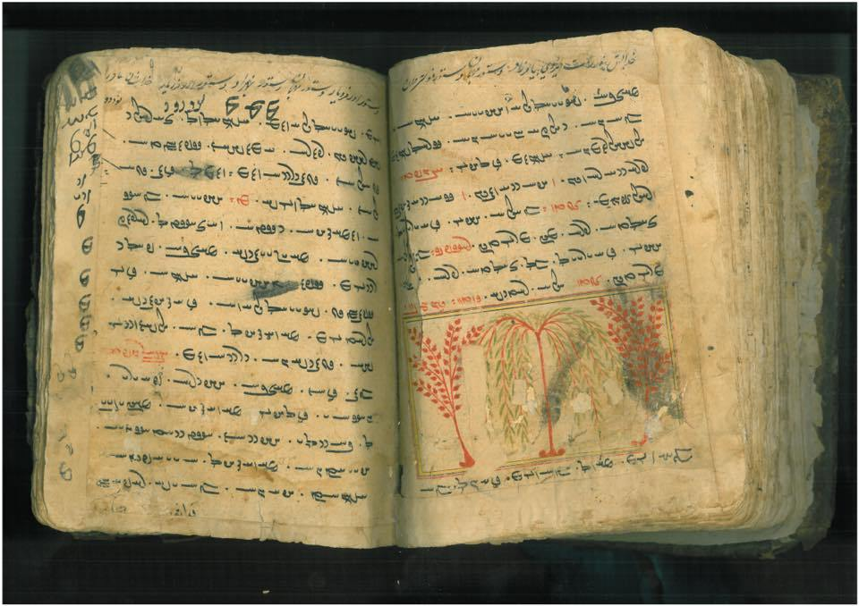
If you want to see more images of what the earliest Avestan manuscripts that we have look like you can access digitized manuscripts that are owned by the British Library here:
http://www.bl.uk/manuscripts/BriefDisplay.aspx (Links to an external site.)
They have a few early manuscripts that you can explore, most of which are written in the original Avestan. Just click on the link next to the text and you can scroll through the pages.

Zoroastrianism Youtube Playlist
Please watch the following video playlist to get a better idea of the Zoroastrian religion and the Yasna ceremony.
https://www.youtube.com/watch?v=eIabp3brgt8&feature=youtu.be&list=PLD2mGQI2teqsa1msJZKw9BveAje9fW8wc

The first video is a clip from a documentary series that Morgan Freeman did a few years ago about the religions of the world. He visits a Zoroastrian fire temple in Orange County and talks with the head of that temple about Zoroastrianism.
The second video is from an Australian news show (like the Australian equivalent of 60 minutes) about Zoroastrians in Iran. In this video you can see how Zoroastrians still practice in Iran today and how their numbers are dwindling there.
The last video is from a Zoroastrian community in Manchester, England (most likely these are descendants of Parsis) and it goes through the Yasna ceremony. You get to actually see what the Yasna ceremony looks like and how the Avestan texts are chanted in that ceremony.

