How Stress Impacts The Academic Performance of College Students
Towson University

Abstract 3
Chapter 1 (introduction) 3
Statement of Problem, Purpose and Scope of Research 3
Research Question(s) and Hypotheses 4
Delimitations and Limitations 5
Assumptions and Operational Terms 5
Chapter 2 (LITERATURE REVIEW AND BACKGROUND) 6
Topic, Specific Population, Recruitment of Participants 6
Gaps in Knowledge/ Need for Program and Research 8
Theory/Model- Constructs 9
Goals/Objectives/Outcomes 10
Proposed Program Intervention 11
Chapter 3 (METHODS) 11
Goals of Research, Goals and Objectives of Program, and Measurement 11
Research Question and Hypotheses (Alternative and Null) 12
Research Conducted and Study Design and Approval Process 12
Data Collection (Instrumentation, Q&R, Reliability/Validity, Citations 13
Study Design Analysis Proposal/Data Statistics Gathered 14
Reliability and Validity Concerns/Ethical Considerations 15
Limitations in the Study, Implications and Research for Future Studies 15
References 16

Abstract

Research studies have shown that behavioral and mental health correlates with students’ academic performance. This research study proposes that stress influences the academic performance of undergraduate students. The purpose of this research study is to promote health by increasing resilience skills and finding ways to decrease stress level amongst undergraduate students at Towson University, MD. Participants (N=600) will complete a survey derived from the ACHA-National College Health Assessment (NCHA) III by using three scales. The research study design is non-experimental, quantitative. Regression Analysis is used to analyze data. Future research implications on stress, health, and academic performance will be discussed.
Chapter 1 (INTRODUCTION)
Introduction and Statement of the Problem

There are 18 million college students in the US according to The American College Health Association (Upright, Esslinger, & Hays, 2014). Research studies have shown that health and academics amongst undergraduate students are correlated. Undergraduate students who develop and participate in unhealthy and risky health behaviors can result in negative repercussions in academics such as missed classes and lower grades (Henry, Cormier, Hebert, Naquin, & Wood, 2018). The survey data from the National Alliance of Mental Illness (NAMI) show that 64% of undergraduate students that do not complete their studies and withdraw enrollment from their institutions do so due to behavioral health related issues such as mental health diagnosis and substance abuse (De Luca, Franklin, Yueqi, Johnson, & Brownson, 2016). Therefore, in order for undergraduate students to continue, excel, and perform well in their academics, focusing on improving their health would be beneficial, with the support of student affairs administrators and personnel in higher education institutions (Henry et.al, 2018).

Purpose of the Research
There are several behavioral health-related reasons that could affect the academic performance of college students, such as anxiety, depression, and stress. The purpose of the research study is to advocate and promote behavioral health and increase resilience amongst undergraduate students at Towson University in Maryland, with a goal of enhancing academic performance and overall health and wellbeing. In promoting health amongst college students, focusing on research concerning the subject of increasing resilience would be more beneficial than eliminating health risks (Hartley, 2011).
Scope of the Research
Results of past research studies report that the level of stress amongst undergraduate students had been the highest since 2010 (Pedersen et.al, 2017). There is limited research concerning the source of stress, school spillover, and student health (Pedersen et.al, 2017). Therefore, further research concerning the relationship between stress and academic achievement needs to be conducted. Stress influences undergraduate students’ retention and graduation rates and act as a barrier to academic achievement (Pedersen et.al, 2017). This research study seeks to understand the sources of stress and to find ways such as skills and strategies to decrease stress and increase resilience amongst undergraduate students at Towson University.

Research Question
Will stress impact the academic performance of undergraduate students at Towson University in Maryland?
Hypotheses
Ha: Stress will have an impact on the academic performance of undergraduate students at Towson University in Maryland.
Ho: Stress will not have an impact on the academic performance of undergraduate students at Towson University in Maryland.

Delimitations and Limitations
Delimitations include deliberately limiting the scope of the study to a narrower size in regards to its research focus while Limitations include limiting the study not intentionally but due to “factors that are beyond control of the researchers” (Cottrell & McKenzie, 2011, p. 86-89). The delimitations of this research study are: Towson University full-time (12 credits and over) undergraduate students, excluding non-traditional students enrolled in Spring 2020 at the main campus. A sample (n=600) of undergraduate students will be recruited. The survey data will be collected during the first two weeks of the Spring 2020 semester. The limitations of this research study are: literature resources might not be up-to-date thus limiting access to current student data; error on sampling including variance and bias; inaccuracy of responses of participants; and the research study cannot be generalized as of the whole Towson University undergraduate student population.

Assumptions and Operational Terms
The assumptions in this research study include: all participants have a clear understanding of the purpose and goal of the research study; all participants understand the terms and words used in the survey to increase accuracy of responses; and all participants have experienced being in stressful situations while completing their undergraduate degrees. The operational terms used in this research study are as follows:
Stress
The brain and body’s response to any demand (National Institute of Mental Health, 2019).
Academic Grade Point Average (GPA)
The total average grade of a student
Spillover
“A form of stress carryover whereby experiences in one domain or context bleed into another through shared emotions or behaviors” (Pedersen et.al, 2017, p.524).
Resilience
The ability to cope and overcome adverse situations and environments (Turner et.al, 2017).
Chapter 2
Literature Review and Background Information

Topic: Background on Stress amongst College Students

Behavioral and psychological health issues such as anxiety, depression, and stress have been increasing amongst undergraduate students; negatively affecting their graduate point averages (Carton & Goodboy, 2015). Undergraduate students with behavioral and psychological health issues are faced with various barriers and hindrances such as: exhaustion and hopelessness, in relation to classroom involvement and participation, influencing their ability to perform well academically (Carton & Goodboy, 2015). One of the top impediments to undergraduate students’ academic performance is stress (Larson, Orr, & Warne, 2016). Stress acts as a barrier and has a significant effect on the overall life satisfaction of undergraduate students (Coccia & Darling, 2016).
Data Statistics on the Relationship Between Stress and Academic Performance
A 2012 survey conducted by the National Alliance on Mental Illness (NAMI) demonstrates that 73% of undergraduate students with behavioral and psychological health issues have encountered an on-campus mental health crisis (De Luca et. al, 2016). These behavioral and psychological health issues are related to the undergraduate students’ enrollment and graduation, with less than 50% of undergraduate students completing their college degree (De Luca et. al, 2016). Furthermore, data show that 75-80% of undergraduate students are moderately stressed, while 10-12% report that they are severely stressed, affecting academic achievement (Coccia & Darling, 2016).
Promotion of Behavioral Health (Decreased Stress) and Increased Resilience
According to the research study conducted by Upright et.al (2014), stress is the top ranked health factor affecting the academic performance of undergraduate students. The academic performance of one third of the undergraduate students is hindered due to stress (Hartley, 2011). One of the positive influences on health and wellbeing of undergraduate students is resilience (Vidic & Cherup, 2019). Resilience is important in helping undergraduate students overcome stress, especially students with “drug use and aggressive behaviors” (Yang, Li, & Lin, 2019, p. 908). Resilience helps people achieve a healthy lifestyle and overcome adverse environments (Yang et.al, 2019). Positive outcomes in academics and prospective employment can be attributed to increased resilience of undergraduate students (Turner, Scott-Young, & Holdsworth, 2017).
Developing resilience benefits undergraduate students by learning to effectively deal with stressful situations due to environmental factors; and thereby enhance their overall wellbeing (Turner et.al, 2017). The university setting can help usher undergraduate students to build their resilience skills through incorporating strategies within university curriculum (Turner et.al, 2017). University resources that can aide with the undergraduate students’ resilience development include mentoring, counseling, and stress management knowledge and skills (Turner et.al, 2017). To assist in the prevention of the severity of undergraduate students’ psychological problems, assessment and promotion of resilience is a key resource (Hartley, 2012).
Specific Population: Undergraduate Students at Towson University, Maryland
The specific population of this research study comprises of undergraduate students (n=600) pursuing a four-year degree at Towson University, Maryland.
Recruitment of Participants
The participants of the research study (i.e., undergraduate students at Towson University) will be recruited through the following means: firstly, the setting of the research study will be at the main campus of Towson University. As for the data collection methods, the researcher will seek the Institutional Review Board (IRB) approval at Towson University. Secondly, the recruitment will be carried through a convenience sample of 18 college professors from various departments within the institution who teach undergraduate courses. An electronic mail will be sent to these professors. Thirdly, the professors who would be willing to participate in the recruitment of participants (students) will be asked to announce the research study to their class; and the students who would be interested in participating will then be asked to complete a survey, to be administered in Spring 2020.

Gaps in Knowledge/Need for Program and Research
Even though the stressful environmental atmosphere undergraduate students are currently in affect their academic achievement, including burnout from juggling school and work, research studies on improving resilience to help manage stress are inadequate (Turner et.al, 2017). The altogether elimination of college stressors is a complex task but conducting research studies on helping students to improve ways to cope and overcome behavioral and mental health issues would be beneficial (Hartley, 2013). Although research studies have examined the risks of undergraduate students with mental health issues, conducting further studies on resilience and coping methods is just as crucial and necessary (Hartley, 2013).

Theory/Model-Constructs
The Ecological Model by Urie Bronfenbrenner (1979) will be used in this research study. The Ecological Model consists of five constructs/systems: microsystem, mesosystem, exosystem, macrosystem, and chronosystem (Bronfenbrenner, 1979). These five systems are “fundamentally linked” and are not independent of each other (Turner et.al, 2017). In each of these five systems, behaviors are shaped by roles, norms, and rules that could have an influence on other systems, as they are interrelated (Turner et.al, 2017). There are several factors that contribute to the behavioral and mental health of undergraduate students, internally and externally (Turner et. al, 2017). An example of the interrelatedness of these systems includes drawing social support from family as a tool to cope with the demands of the university (Turner et.al, 2017). These relationships amongst systems have an impact on the stress level and resilience level of undergraduate students (Turner et.al, 2017).
For the purposes of this research study, the Ecological Model will be used to delve into the factors contributing to stress (amongst systems) and how these factors impact the academic performance of undergraduate students. Specifically, the theory constructs that would be used for this research study are the microsystem (immediate environment) and the mesosystem (relations between microsystems) (Bronfenbrenner, 1979). The focus of studying these two constructs is to determine the interrelatedness of systems and to develop ways to decrease the stress level and increase the resilience level of undergraduate students at Towson University, Maryland.

Goals/Objectives/Outcomes
The development of health promotion programs in higher education institutions can help improve the academic performance of undergraduate students by gaining knowledge on the relationship between health-related factors and student success (Larson et.al, 2016). Although there have been research studies that focused on the relationship between stress and health, there is a lack in literature concerning school spillover and student health (Pedersen, Swenberger, & Moes, 2017). One form of school spillover is on stress, developing from academic demands, affecting the other areas of the lives of undergraduate students (Pedersen et.al, 2017).
The goal of this research study is to examine the relationship between undergraduate students’ stress and academic performance through measuring resilience level, psychological wellbeing, and social relationships; with an aim to promote health and enhance academic performance. There are two objectives on this research study. The first objective will be to determine the factors that contribute to undergraduate students’ stress and to educate them to find ways to cope and overcome these stressors. The second objective will be to help undergraduate students develop and increase their resilience level, to improve their behavioral and mental health and wellbeing and to enhance their academic performance. The outcomes of this research study are to gain knowledge, skills, and strategies to decrease stress levels and increase resilience amongst undergraduate students at Towson University through the utilization of the research literature.

Proposed Program Intervention
For this research study, the focus will be on how stress impacts the academic performance of undergraduate students. There will be no program intervention involved.
Chapter 3

Goals of Research, Goals and Objectives of Program, Measurement
The development of health promotion programs in higher education institutions can help improve the academic performance of undergraduate students by gaining knowledge on the relationship between health-related factors and student success (Larson et.al, 2016). Although there have been research studies that focused on the relationship between stress and health, there is a lack in literature concerning school spillover and student health (Pedersen, Swenberger, & Moes, 2017). One form of school spillover is on stress, developing from academic demands, affecting the other areas of the lives of undergraduate students (Pedersen et.al, 2017).
The goal of this research study is to examine the relationship between undergraduate students’ stress and academic performance through measuring resilience level, psychological wellbeing, and social relationships; with an aim to promote health and enhance academic performance. There are two objectives on this research study. The first objective will be to determine the factors that contribute to undergraduate students’ stress and to educate them to find ways to cope and overcome these stressors. The second objective will be to help undergraduate students develop and increase their resilience level, to improve their behavioral and mental health and wellbeing and to enhance their academic performance. The outcomes of this research study are to gain knowledge, skills, and strategies to decrease stress levels and increase resilience amongst undergraduate students at Towson University through the utilization of the research literature.
For the measurement of this research study, the instrument that will be used is derived from the ACHA-National College Health Assessment (NCHA) III Survey, using three scales: The Connor-Davison Resilience Scale, Diener Flourishing Scale- Psychological Well-Being, and the UCLA Three-Item Loneliness Scale.

Research Question and Hypotheses (Alternative and Null)
Research Question
Will stress impact the academic performance of undergraduate students at Towson University in Maryland?
Hypotheses
Ha: Stress will have an impact on the academic performance of undergraduate students at Towson University in Maryland.
Ho: Stress will not have an impact on the academic performance of undergraduate students at Towson University in Maryland.

Research Conducted and Study Design and Approval Process
The research study will be conducted at the main campus of Towson University, Maryland in Spring 2020. The research study design is non-experimental, quantitative. The research study will commence within the first two weeks of Spring 2020 semester. As for the approval process, the researcher will seek approval from the Institutional Review Board (IRB) at Towson University.

Data Collection (Instrumentation, Q&R, Reliability/Validity, Citations)
The instrument that will be used in this research study is derived from the ACHA-National College Health Assessment (NCHA) III Survey, using three scales: The Connor-Davison Resilience Scale, Diener Flourishing Scale- Psychological Well-Being, and the UCLA Three-Item Loneliness Scale. The Connor-Davison Resilience Scale (CD-RISC2) N3Q42- composes of two statements on a Likert Scale (ranging from 0-Not at all true through 4- True nearly all the time). For scoring, the higher the score, the greater level of resilience it indicates. To calculate the score, get the sum total of all items.
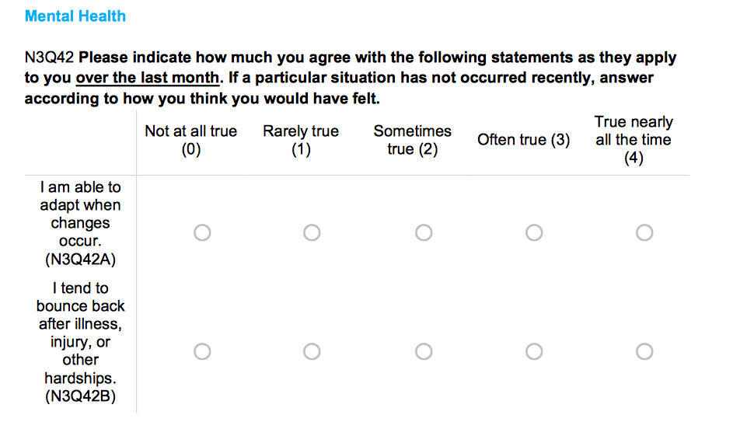
The Diener Flourishing Scale- Psychological Well-Being (PWB) N3Q41 composes of 8 statements on a Likert Scale (ranging from 1- Strongly disagree through 7- Strongly agree). For scoring, the higher the score, the greater psychological resources and strengths it indicates. To calculate the score, get the sum total of all items. The third scale that will be used in this research study is the UCLA Three-Item Loneliness Scale N3Q45 (Hughes, et.al. 2004), which composes of 3 statements on a Likert Scale (ranging from 1- Hardly ever through 3-Often). For scoring, the higher the score, the greater degree of loneliness it indicates; calculate the score by getting the sum total of all items.

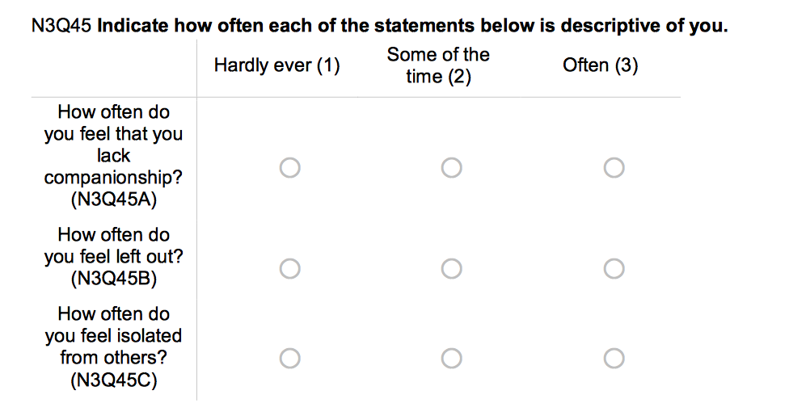
As for the reliability and validity measures, the Principal Components Factor Analysis (PCA) and Reliability Analysis using SPSS and test-retest (measurement validity) will be utilized. In performing PCA, the assumption is that “the total variance is equal to common variance” wherein a unique variance is nonexistent (UCLA Institute for Digital Research & Education, 2019). The link/rational to these measures is that it specifically measures resilience, psychological wellbeing, and loneliness of undergraduate students in relation to their academic performance.

Study Design Analysis Proposal/Data Statistics Gathered
The study design analysis that will be used is Regression Analysis. The link/rational to this is that it measures the difference between previous and revised surveys (for future changes in ACHA-NCHA Survey). Regression Analysis will be best suited to utilize in this research study as it can be used to determine the degree of relationship amongst health factors in relation to academic performance (Larson et. al, 2016). These health factors include stress, health, and academic performance.

Reliability and Validity Concerns/Ethical Considerations
There are advantages to this non-experimental research design including: providing solution to important research questions by health professionals and examines knowledge and behavior of people (Cottrell & McKenzie, 2011). However, there are also disadvantages to this non-experimental research study design such as the inability to prove associations and prone to bias (Thompson & Panacek, 2007). The reliability and validity concerns of this research study are: accuracy in students’ responses and maturation effect. The ethical considerations in this research study include: informed consent, beneficence, confidentiality, and privacy of Towson University undergraduate student participants.

Limitations in the Study, Implications and Research for Future Studies

The limitations of this research study are: literature resources might not be up-to-date thus limiting access to current student data; error on sampling including variance and bias; inaccuracy of responses of participants; and the research study cannot be generalized as of the whole Towson University undergraduate student population. The implications for future studies include: a larger sample size for increased generalizability; further research on knowledge concerning factors that contribute to stress, behavioral and mental health, and academic performance; and develop ways to help undergraduate students cope with the academic demands of higher education institutions and increase students’ resilience skills to enhance their academic performance and improve their overall health and well being.

References
Bronfenbrenner, U (1979). The ecology of human development. Cambridge, MA: Harvard University Press.
Carton, S. T., & Goodboy, A. K. (2015). College Students’ Psychological Well-Being and Interaction Involvement in Class. Communication Research Reports, 32(2), 180–184. https://doi.org/10.1080/08824096.2015.1016145
Coccia, C., & Darling, C. A. (2016). Having the Time of Their Life: College Student Stress, Dating and Satisfaction with Life. Stress & Health: Journal of the International Society for the Investigation of Stress, 32(1), 28–35. https://doi.org/10.1002/smi.2575
Cottrell, R. & McKenzie, J. (2011). Health Promotion and Education Research Methods: Using the Five- Chapter Thesis/Dissertation Model. (2nd ed.), Jones and Bartlett Publication. ISBN-13: 9780763775070.
De Luca, S., Franklin, C., Yueqi, Y., Johnson, S., & Brownson, C. (2016). The Relationship Between Suicide Ideation, Behavioral Health, and College Academic Performance. Community Mental Health Journal, 52(5), 534–540. https://doi.org/10.1007/s10597-016-9987-4
Hartley, M. T. (2012). Assessing and Promoting Resilience: An Additional Tool to Address the Increasing Number of College Students with Psychological Problems. Journal of College Counseling, 15(1), 37–51. http://dx.doi.org/10.1002/j.2161-1882.2012.00004.x
Hartley, M. T. (2011). Examining the Relationships Between Resilience, Mental Health, and Academic Persistence in Undergraduate College Students. Journal of American College Health, 59(7), 596–604. https://doi.org/10.1080/07448481.2010.515632
Hartley, M. T. (2013). Investigating the relationship of resilience to academic persistence in college students with mental health issues. Rehabilitation Counseling Bulletin, 56(4), 240–250. https://doi.org/10.1177/0034355213480527
Henry, B., Cormier, C., Hebert, E., Naquin, M., & Wood, R. (2018). Health and Health Care Issues among Upper- Level College Students and Relationships to Age, Race, Gender, and Living Arrangements. College Student Journal, 52(1), 7–20.
Larson, M., Orr, M., & Warne, D. (2016). Using Student Health Data to Understand and Promote Academic Success in Higher Education Settings. College Student Journal, 50(4), 590–602.
Meyer, S., & Larson, M. (2018). Physical Activity, Stress, and Academic Performance in College: Does Exposure to Stress Reduction Information Make a Difference? College Student Journal, 52(4), 452.
National Institute of Mental Health. (2019). 5 Things You Should Know About Stress. Retrieved from https://www.nimh.nih.gov/health/publications/stress/index.shtml
Pedersen, D. E., Swenberger, J., & Moes, K. E. (2017). School Spillover and College Student Health. Sociological Inquiry, 87(3), 524–546. https://doi.org/10.1111/soin.12161
Thompson, C.B., & Panacek, E.A. (2007). Research study designs: Non-experimental. Air Medical Journal, 26(1), 18-22. https://doi.org/10.1016/j.amj.2006.10.003
Turner, M., Scott-Young, C. M., & Holdsworth, S. (2017). Promoting wellbeing at university: the role of resilience for students of the built environment. Construction Management & Economics, 35(11/12), 707–718. https://doi.org/10.1080/01446193.2017.1353698
UCLA Institute for Digital Research & Education. (2019). Principal Components (PCA) and Exploratory Factor Analysis (EFA) with SPSS. Retrieved from https://stats.idre.ucla.edu/spss/seminars/efa-spss/
Upright, P., Esslinger, T., & Hays, W. (2014). Health Issues Affecting College Student’s Academic Performance. KAHPERD Journal, 51(2), 30–36.
Vidic, Z., & Cherup, N. (2019). Mindfulness in Classroom: Effect of a Mindfulness-Based Relaxation Class on College Students’ Stress, Resilience, Self-Efficacy and Perfectionism. College Student Journal, 53(1), 130–142.
Yang, Y., Li, M., & Lin, H. (2019). Parental Rejection, Resilience, and Health-risk Behavior in Emerging Adults. American Journal of Health Behavior, 43(5), 898–911. https://doi.org/10.5993/AJHB.43.5.3

Organizational Table
 | RQ | Hypothesis | Theory | Constructs | Instrument | Analysis
Component | Will stress impact the academic performance of undergraduate students at Towson University in Maryland? | Ho: Stress will not have an impact on the academic performance of undergraduate students at Towson University in Maryland.  Ha: Stress will have an impact on the academic performance of undergraduate students at Towson University in Maryland. | Ecological Model (Bronfenbrenner, 1977) | Individual (knowledge, attitude, skills)  Interpersonal (social network)  Organizational (environment, ethos)  Community (cultural values, norms)  Public Policy  Note: For the purposes of this class, I would use one construct- organizational. | ACHA-National College Health Assessment (NCHA) Survey  Scales that would be used from ACHA-NCHA III:  The Connor-Davison Resilience Scale (CD-RISC2) N3Q42 item numbers.  -2 statements; Likert Scale (with 0- Not at all true and 4- True nearly all the time).  Diener Flourishing Scale- Psychological Well-Being (PWB)  N3Q41  - 8 statements; Likert Scale (with 1- Strongly disagree and 7- Strongly agree).  UCLA Three-Item Loneliness Scale (Hughes, et.al. 2004) N3Q45  -3 statements; Likert Scale (with 1- Hardly ever and 3-Often).  Reliability & Validity: Principal Components Factor Analysis and Reliability Analysis using SPSS.  Test-retest (measurement validity). | Regression Analysis
Link/Rational |  | Focuses on enhancing academic performance as a result of better health (i.e., decreased stress and increased resiliency). | The intervention would increase academic performance of students by becoming more resilient and less stressed. | Specifically focuses on organizational (environment, ethos) as related to students’ stress and to improve resilience skills. | Specifically measures resilience, psychological well-being, and loneliness of college students in relation to their academic performance. | Measures difference between previous and revised surveys (for a change in ACHA-NCHA Survey).

