Make sure you consider the following:
- Compelling Introduction that hooks the reader. Engaging writing to sustain the reader’s interest throughout.
- The topic must be focused and narrowly enough for the scope of this assignment.
- A position thesis statement provides direction for the paper.
- The subtopics should flow together and not be all over the place. The ideas are arranged logically to support the central purpose. They are usually clearly linked to each other. For the most part, the reader can follow the line of reasoning.
- For each of your subheadings make sure your writing is clear and concise. It is important not to become sidetracked. Effective use of coordination, subordination, division and parallelism
- References are primarily peer reviewed professional journals or other approved sources (e.g., government documents, agency manuals, and organizations’ websites). The reader is confident that the information and ideas can be trusted.
- The evidence comes from a wide variety of valid sources. The bibliography is complete and reflects appropriate sources.
- Sources are exceptionally well integrated and they support claims argued in the paper very effectively.
Look at the types of thesis you could use.
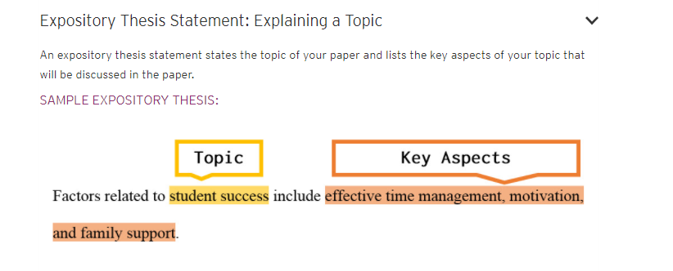
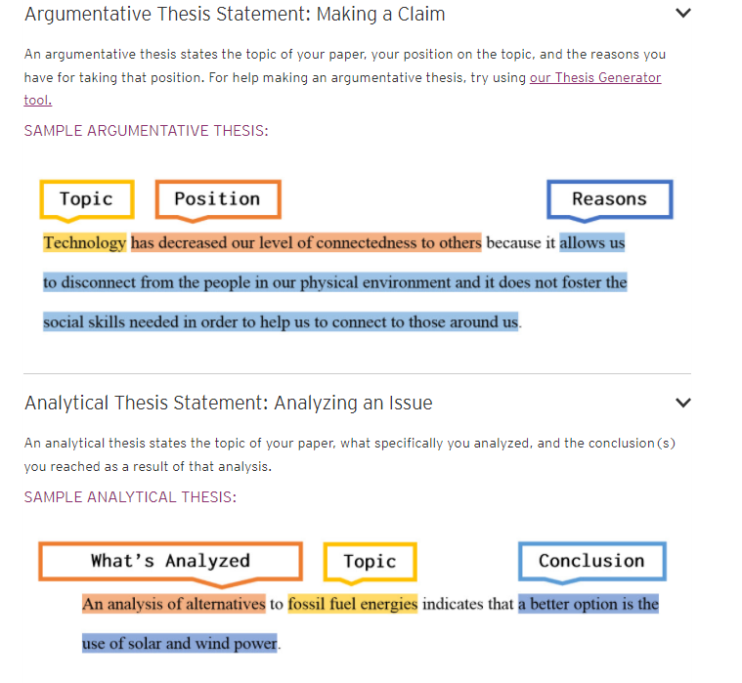

Here is what you should consider when writing an introduction. Final Paper:
c
