FIN464 Fall 2020 Homework #2

Instructions: please type your answers in the space provided, then upload the file in pdf format in Blackboard by the specified deadline.

Alternatively, you can print the file, handwrite the answers, then scan or take a clear picture of your work and upload it in Blackboard. My recommendation would be to use the app Scannable (or similar), which produces very high-quality PDF images of your homework assignments going forward. However, JPEG format is also acceptable.

Homework is individual effort. Suspected cheating and violations of the Academic Integrity Code will be immediately referred to the Office of the Dean.

You must show your calculations to receive full credit. If the homework is submitted after the specified deadline, the score will be zero on all answers – no exceptions. It is your responsibility to check that the submission is properly uploaded in Blackboard and the file is complete.

Name ________________________________________ Section ____________________

Problem #1

You are the manager of Felix Bank, and you worry because the income gap currently equals – $35 million and interest rates are expected to increase by 1.5%.
a) Determine the amount of rate-sensitive assets if rate sensitive liabilities are $467 million. [1 point]
b) Calculate the change in bank income ($ amount) if interest rates do increase by 1.5%. [1 point]

Problem #2

Felix Bank has the following rate sensitive assets:

Treasury bills $210 million;

Commercial loans $540 million;

and Consumer loans $200 million.

The duration of each type of asset is 0.65, 1.87 and 6.9 years, respectively.

Calculate Felix Bank´s average duration of the assets if physical assets equal $35 million and the bank holds $15 million in reserves. [1 point]

Problem #3

Compute the minimum average duration of assets a bank needs if it wants to tolerate a duration gap not lower than – 1.5 years, assuming the average duration of liabilities is 3 years, assets are currently valued at $300 million and liabilities are $280 million. [1 point]

Problem #4

- Calculate the duration of a $1,000 6% coupon bond with three years to maturity. Assume that all market interest rates are 7%. Show the computations in two different ways (Calculator inputs/Discounting by using the formula/Excel spreadsheet). [1 point for each way, 2 points max]
- Calculate the expected price change if interest rates drop to 6.75% using the duration approximation. [1 point]

Problem #5

a. Felix Bank started its first day of operations with $6 million in capital. $100 million in checkable deposits is received. The bank issues a $50 million in commercial loan. If required reserves are 8%, what does the bank balance sheets look like? Ignore any loan loss reserves. [1 point]
b. Felix Bank decides to invest $45 million in 30-day T-bills. What does the balance sheet look like? [1 point]
c. After a week, deposits fall by $5 million. What does the balance sheet look like? Are there any problems? [1 point]
d. Propose one solution to solve the problem identified in question c. What does the balance sheet look like after you implement your solution? [1 point]

To get full credit, you must DRAW THE BALANCE SHEET AND FILL IN THE ASSETS AND LIABILITIES ITEMS REPORTED IN THE QUESTION

Problem #6

Consider the following balance sheet:

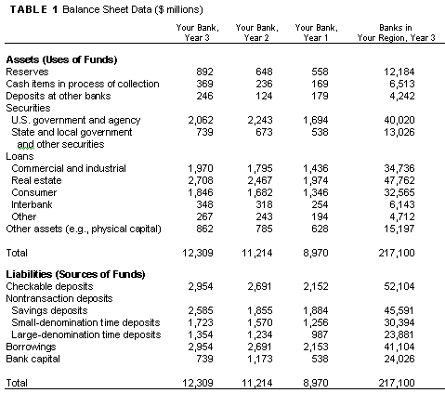

Examine the liquidity management practices of your bank over the last three years. Assume that the reserve requirement is 8% on all deposits.

- How has the liquidity position (in terms of required and excess reserves) of the bank changed over time? How does the liquidity position of your bank compare to the regional banks in year 3? Explain and show your computations. [2 points]
- Would your bank have sufficient reserves if deposits increased 40% in year 3? Explain and show your computations. [1 point]

Calculate the equity multiplier ratio for each year. How does the equity multiplier of your bank compare to the regional banks in year 3? Explain [1 point]

