- All in-text citations are listed in Works Cited by first combinations of unique word(s)
- In-text citations are listed in work cited and is organized nicely
- All Works Cited are used at least once in the body of the paper as an parenthetical in-text citation
- All works cited are used at least once in body
- All in-text citations have page or paragraph numbers noted
- All in text citations include page or paraph numbers
- Works Cite is properly formatted
- Work Cited is formatted properly
- Paper is 2,000 - 2,500 words long
- Excluding Work cited. The paper meets the 2,000 minimum requirement. 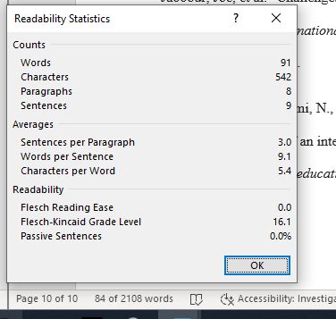
Though I do find it a bit funny Readability thinks there are only 91 words. In the entire paper
- Proposal is included
- Proposal is included
- Paper is written at the proper grade level in proper formal English proses
- According to the readability statistics the paper is written a proper higher education level. Although those are the same statistics that say there are 91 words in the paper.
- Paper has been grammar checked
- Microsoft spelling and grammar check came back with no errors (not counting last names)
- Research is done properly
- Research is done properly. Paper is organized and interesting to read about data security.
- Cultural & change management is addressed
- Paper is interesting
- (10&11) The paper topic is interesting. I have to say right off the bat…how happy I am to have graduated college a year before this pandemic. I don’t think I could survive more than 2 classes online. I can’t even image what its like for kids in public school. The paper brings up good points on the pros and cons of online learning
- Overall cohesiveness
- Paper is cohesive. The paper flows well and all ideas are clear and organized
- Quality introduction
- Good introduction that introduces the topic
- Quality conclusion
- Paper conclusion is good. There is hope that with time online education can be a great tool.

