South Africa is one of the most developed African states with a unique and fascinating history. Politically it was one of the last African states to get rid of colonialism and a very young republic since it gained its independence in 1993. Additionally, it was among the last nations to have a black president. One thing that makes South Africa's history unique is the political regime that classified people according to their race. Apartheid is one of the most open discriminative regimes ever when some races got privileges while others were oppressed because of being a different race. Understanding historical texts and ideas such as apartheid are easily tackled if historical criticism is applied. Historical criticism is a history that involves further investigation by looking at historical events from different spheres called a historical lens. The purpose of employing this technique when analysing historical texts is to better understand historical events while avoiding biasness in the process. It gives scholars a critical thinking process while analysing historical events.
There are various historical lenses we can look at when analysing texts and historical events. Some of these lenses include; the historical significance of an event, the cause and effect of that event, what ethical judgment can one draw from the event, and how we can look at the event from political, economic, and social lenses. Using historical lenses allows scholars to be objective and eliminates any form of biasness that may arise from analysing historical content. When looking into the South African apartheid system, the essay will employ the political, social, and economic lenses to explain the concept and create a deeper understanding of the historical event.
From the political lens, apartheid resulted from racial superiority in policymaking or any influence in the political scene. Apartheid in South Africa was long before 1948 before the National party made it a law. This form of racial segregation came during the scramble and partition of Africa, where white nations divided Africa into protectorates and used them to acquire raw materials and cheap labour to develop their states; this was after the World War II. After many African states gained independence and colonialists went back to their mother countries, South Africa was not among them, and it is arguable because of the strategic location of South Africa and its diverse wealth in minerals. Since the white race was the minority, they felt threatened and decided to develop laws that would give them power over the majority who were the black people, hence the apartheid's birth.
Though not written, apartheid did exist, but it became more pronounced when it was put in as a law after the National party won. In the year 1951, the government brought in the reestablishment of African settlements to create their sense of government through the Bantu self-government act that was under the white government and only had the power within these settlements, which was a way of excluding Africans from the national government(Gumede, 2017).
Socially, apartheid affected South Africa in many ways in that there were laws created to prevent races from marriage or any form of union. If a black person were found that he or she shared a child with a white person, you would go to prison.
There were places of leisure, schools, transport, and housing for only white people, and it was illegal for a black person to be seen. The only jobs Africans would get were minimal regardless of their education. To help prevent black people's encroachment in white places, they came up with laws that required Africans to carry documents that stated the reason they were traveling and how long they would stay in the place ("A history of Apartheid in South Africa | South African History Online", 2020).
Economically, there were acts like the land acts introduced in 1913 but became more stringent from the group's area acts of 1950 that made sure that there was the business established in each area for each race. It was prohibited to conduct business between different states. 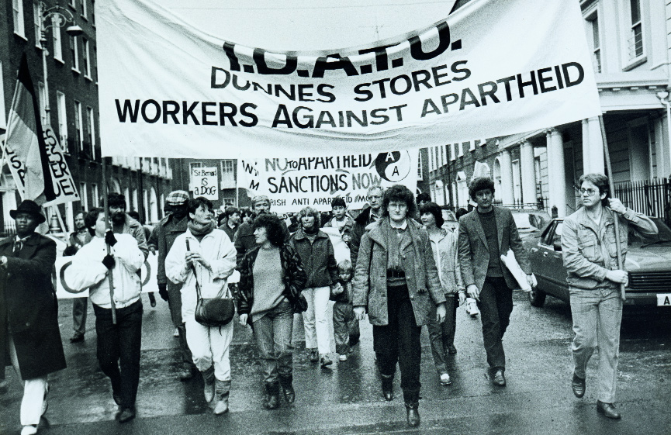
They also established the lands act between 1954 and 1955 that the minority race owned 80 percent of South African land. Africans were also given minimal jobs that did not help them develop their living areas, causing high poverty among the inferior races ("apartheid | Definition, Facts, Beginning, & End", 2020).
From the analysis of apartheid using the political, social, and economic lens, the political lens would give the impression that apartheid was not that bad hence earning a bit of leniency. Since the minority group acted out of fear of losing some of the things they had achieved to people, they empowered them with knowledge and skills.
It is natural to be defensive when someone is threatening to take what you have worked to establish with your sweat and blood hence the justification of this harsh policy. If a scholar chose to use this approach to explain apartheid, the course of history would have been quite different.
Though apartheid is painted in a bad picture by literature and other texts, one cannot ignore the biasness and motivation derived from the influences of their time. Using apartheid as an example, we can say that the authors of the literature behind it were motivated by the post-colonial era since it was a time of African nationalism and there was a lot of political influence of making things African hence painting apartheid as a form of oppression rather than a period of enlightenment since there were also positive effects of the system such as economic development, better infrastructure, education and unity as opposed to the leadership of African leaders who are mainly categorized by dictatorship and corrupt political regimes.
Apartheid does help in further understanding contemporary issues such as leadership and equality. These are concepts that are still dominant in our current times. For instance, leadership does have some form of oppression, especially if it is authoritarian, which is no different from the apartheid rule. On the other hand, equality is something we are still fighting for, even in our current regimes.
From the above analysis of contemporary issues, it is in accord to say that history does repeat itself. Oppression and equality are products of every political regime that every country is trying to fight. There is always a group of minority citizens who do not feel the assistance or the effect of any political leadership.
In conclusion, the history lesson on historical criticism is vital, especially in understanding issues that may arise during our day to day life. Approaching issues with an open mind free from bias can go a long way in assisting the public in understanding issues objectively and becoming a public change agent that can institute change using a liberal mind.

References
Apartheid | Definition, Facts, Beginning, & End. (2020). Retrieved 16 October 2020, from https://www.britannica.com/topic/apartheid
A history of Apartheid in South Africa | South African History Online. (2020). Retrieved 16 October 2020, from https://www.sahistory.org.za/article/history-apartheid-south-africa
Gumede, V. (2017). Political economy of post-apartheid South Africa. CODESRIA.

