HUS 2428 LESSON 11
Required material: There are two required texts for this course.
Study Guide for the Florida MCAP, CAP, Certification Exam (2016)
This comprehensive review is published by the Florida Certification Board (FCB)
Comprehensive Education Services. It should be available from the St.
Petersburg College Health Education Campus (HEC) bookstore. But it may also
be ordered directly from FCB. ( https://flcertificationboard.org/products/ )
•
CSAT Technical Assistance Publication (TAP) 21 - Addiction Counseling
Competencies: The Knowledge, Skills, and Attitudes of Professional Practice
The TAP-21 can be viewed online at https://store.samhsa.gov/sites/default/files/d7/priv/sma12-4171.pdf
or a hard-copy can be ordered free of charge from the US Dept. of Health and Human
Services and SAMHSA's National Clearinghouse for Alcohol & Drug Information

Lesson 11
Print
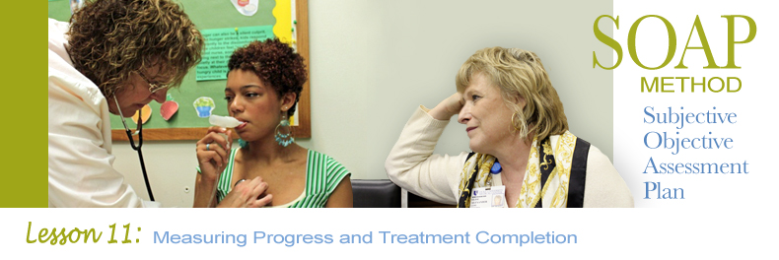
Please read the topics below. Then follow the directions under lesson 11 discussion question.

Professional Responsibility

Carefully read pages 131-160 in the FCB text. This material is presented in a very comprehensive manner in the text.

Please review these two ethics codes:
- Florida Certification Board Code of Ethics
- The Association for Addiction Professionals (NAADAC) Ethical Standards for Counselors

Ethics = Right or good behavior. It is a system of moral principles and values. Substance Abuse Counseling is a profession which has defined standards of conduct (See the links to two prominent ethical codes associated with our profession, provided above). Substance abuse professionals are held accountable for ethical conduct. Adherence to a recognized code of ethics, lends credibility to substance abuse professionalism as a field.
General Core Moral Values:
- Autonomy - Enhance freedom of personal destiny
- Obedience - Obey legal and ethical directives
- Conscientious Refusal - Disobey illegal or unethical directives
- Beneficence - Help others
- Gratitude - Pass good along to others
- Competence - Be knowledgeable and skilled
- Justice - Be fair; Distribute by merit
- Stewardship - Use resources judiciously
- Honesty and Candor - Tell the truth
- Fidelity - Don't break promises
- Loyality - Don't abandon
- Diligence - Work hard
- Discretion - Respect confidentiality and privacy
- Self-Improvement - Be the best you can be
- Nonmaleficence - Do no harm. Don't hurt anyone.
- Restitution - Make amends to persons injured
- Self-Interest - Protect yourself

Consumer/Client Rights
- Right to individual dignity
- Right to non-discriminatory services
- Right to quality services
- Right to communication
- Right to personal effects
- Right of minors to be educated
- Right to confidentiality
- Right to counsel (legal representation)
- Right to Habeas Corpus (Right to be told why one is in treatment)
- Liability and Immunity

Unethical Relationships
Counselors should avoid dual relationships with clients. Dual relationships are relationships in addition to the therapeutic counseling relationship. For instance, a counselor should not also be a client's AA sponsor. A counselor should not hire a client, maintain a social relationship with a client, or date a client.
- Bartering - Trading goods for services (instead of money), is discouraged.
- Social Relationships
- Sexual Relationships
- Business Relationships
Responsibility for inappropriate relationships is ALWAYS assumed to be the counselor's responsibility, even if the client was the person who initially pursued the inappropriate relationship.
Discharge Summaries

Purpose of a discharge summary:
- Summarize the client's initial treatment needs
- Summarize the course of treatment that met those needs
- Report treatment progress
- Report the client's alcohol/drug status and further treatment needs at the termination of his/her current treatment
- To identify aftercare
- To provide information for continuity of care
The discharge summary:
- Is written in the past tense
- Developed with the client's assistance
- Disclosed only with the client's approval
- Completed in a timely manner to allow for continuity of care
Components of a discharge summary:
- Initial presenting problem
- Diagnostic impression (diagnosis)
- Treatment problems and goals
- Course of treatment
- Evaluation of progress
- Final assessment of needs
- Substance status at discharge
- Referrals for further treatment
- Aftercare plans
- Final prognosis

Lesson 11 Discussion Question

Discharge Summaries
Why are Discharge Summaries so important? What types of information would you include in a thorough discharge summary? What should a discharge summary tell you about a client? Please answer these questions and respond to two other students' posts.

