WHO SHOULD BE INVOLVED?
If the internal structure’s purpose is to aid managers—and if ensuring high involvement and commitment from employees is important—those managers and employees with a stake in the results should be involved in the process of designing it. A common approach is to use committees, task forces, or teams that include representatives from key operating functions, including nonmanagerial employees. In some cases, the group’s role is only advisory; in others, the group designs the evaluation approach, chooses compensable factors, and approves all major changes. Organizations with unions often find that including union representatives helps gain acceptance of the results. Task forces involving both unions and management participated in the design of a new evaluation system for the federal government. However, other union leaders believe that philosophical differences prevent their active participation. They take the position that collective bargaining yields more equitable results. So the extent of union participation varies. No single perspective exists on the value of active participation in the process, just as no single management perspective exists.
Exhibit 5.14 shows further results from the survey of WorldatWork members discussed earlier. We see that compensation professionals (i.e., usually compensation analysts, sometimes also those at higher levels such as the compensation manager) are primarily responsible for most job evaluations for most jobs. Although that holds true for senior management jobs as well, we see that the higher level compensation manager is more likely to be charged with the job evaluation in this case and that consultants also play a much larger role here.
EXHIBIT 5.14 Who Typically Conducts the Job Evaluation?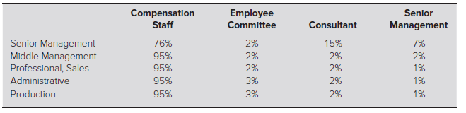
Source: WorldatWork, “Job Evaluation and Market-Pricing Practices,” November 2015.
Note: Number of respondents ranged from 535 to 621 organizations.

