Content

1. Executive summary (Task 2-5)………………………………….……………3
2. Managerial Report…….……………………………………..………………...4
2.2 Expected Monetary Value............................................................................4
2.3 Sensitivity Analysis…………………………………………………………5
3. Appendices............................................................................................................6

Executive Summary
The analysis of a scenario for any investment opportunity is a difficult task to engage in. The development of treemaps and calculation of probability necessitate the making of decisions in the most uncertain states. In our scenario, the real estate agent is considering building an apartment, offices, or a warehouse. There are predictions of three conditions of nature; optimistic, pessimistic, and realistic. The three personalities are all associated with each alternative and valued at specific amounts. Calculating the EMV will allow the company management to decide which choice is the best based on net returns. The probabilities in the excel file are from the current market status employed to determine whether the company show hire an analyst to evaluate their venture or not. This managerial report considers all the necessary steps to ensure that the management of the real estate company makes an informed decision based on the best-case scenario. The calculation for the study is done in an excel file together with the treemaps.

Managerial Report
A real estate agent is considering either build an apartment, offices, or a warehouse. There are predictions of three states of nature; optimistic, pessimistic, and realistic. The three characters are all associated with each option and valued at specific amounts. Calculating the EMV will allow the company management to decide which alternative is the best based on net returns. The company is evaluating the risks associated with hiring a business analyst and its effect on the project's returns. They want to compare the chances of getting into the market using their market predictions and the available data and the value of hiring a business analyst. The calculation for each case considered is then compared and critically analyzed to evaluate the path with the highest returns on investment.
2-2.
EMV for Not Hiring and Hiring a Business Analyst
The EMV for hiring not hiring a business analyst is $300,600, while the EMV for hiring a business analyst is $173,300.
My recommendation: to hire or not to hire a business analyst
My recommendation is that the company should not hire a business analyst. When carried down into the payoff table off the table, the cost of hiring a business analytic reduces the investment amount by the hiring amount of the analyst. The positive analysis report indicates that there will be a difference of 332,000-300,600 = $32,000 between not hiring an analyst category of the Apartment building, which is the best alternative of the three. However, considering the worst-case scenario, the apartment building difference between the not hiring and negative report analysis is 300,600 – 67,450 = 2333,150. The last case's loss will be too huge a risk to undertake, considering the uncertainties of the analysis report. The possibility of a win-win situation is located in the not hiring of an analyst who will reduce cost and timesaving.
2-3.
The sensitivity analysis is an essential tool used to define the probability range concerning the survey results. The survey results are useful to evaluate the decision to hire or not to hire a business analyst. This analysis positively affected the decision as it sensitizes the possible risk factors associated with the survey probabilities. By drawing the sensitivity chart and finding the possibility for their cross point, it is evidenced that hiring a business analyst will cost the company more and have reduced return on investment.
From the sensitivity evaluation, we can set the line for not hiring the business analyst at a fixed price of $300,600. Let's assume that the probability variation line depicts a positive value (P). Going with the given concern, it is heeded that the probability of reporting negative results is 1-P. If we presume that the probability is 0, then the point will eat $173,300. However, if we assume that the probability is equal to 1, then the point will be $300,600.From the two obtained points, we can come up with a line such that $173,300+185800p=$300,600
185800p=300,600-173,300
185800p=127,300
P=0.6851
The implication here is that when the probability is 0.6851, the not hire and hire outcomes have a value of $300,600. When the probability is below the value of 0.6851 then the outcomes will be lower than $300,600. However, a probability above 0.6851 is an indication that the results are above $300,600.
In conclusion, when the probability is lower than positive 0.6851, the company should not hire the analyst. However, when the probability is above 0.6851 then a business analyst should be hired. The company should aim at attaining a probability of over $300,600.
3. Appendices

References
Olivas, R. (2007). Decision Trees. A Primer for Decision-making Professionals.
Saltelli, A., Tarantola, S., Campolongo, F., & Ratto, M. (2004). Sensitivity analysis in practice: a guide to assessing scientific models (Vol. 1). New York: Wiley.

Payoff Table:
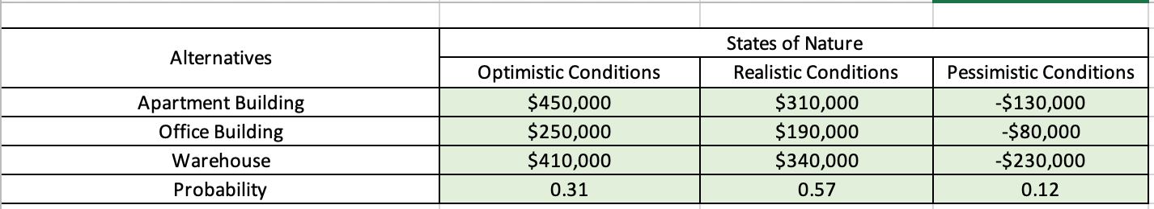

EMV Table: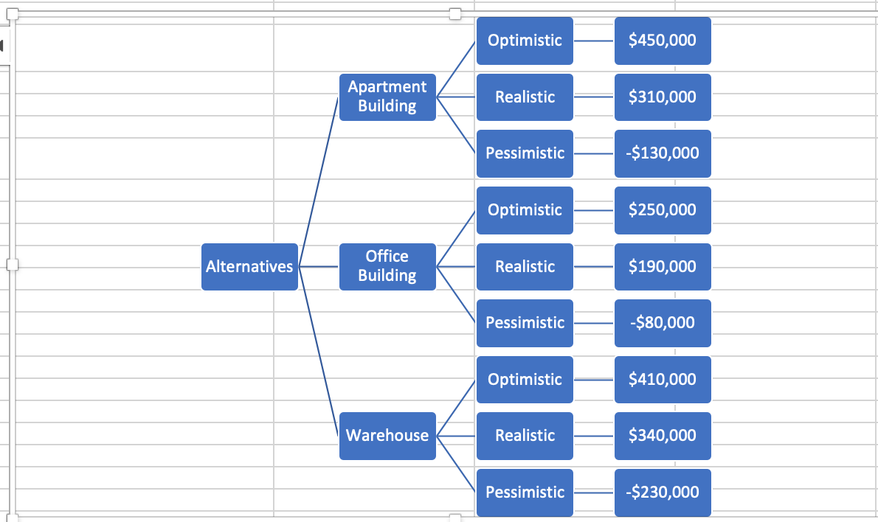
Sensitivity Analysis:
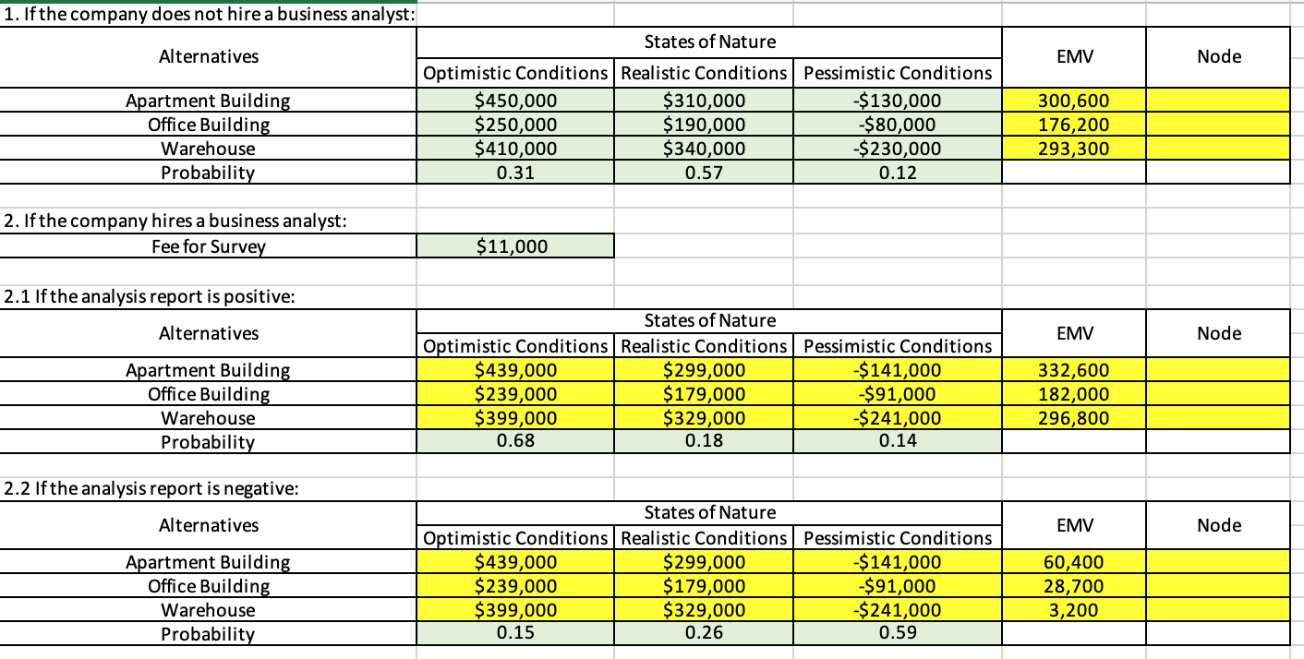
Sensitivity Analysis Diagram:
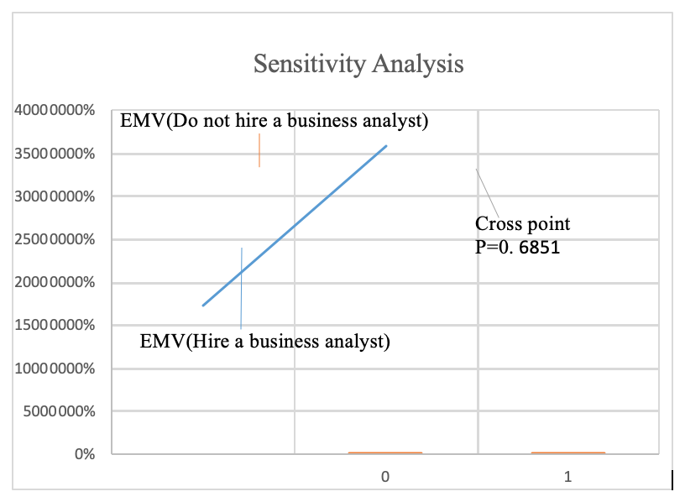

TreePlan Diagram of the Decision Tree:
