Compensation Analysis for Amazon
Part I
Six factors affect a working individual's compensation, including location, years of experience, education, direct reports, performance, and reports to superiors. Companies compensate individuals according to the location of the company. For example, Amazon, located in San Francisco, compensations average range is $101 148, while the least goes at $ 90,268(25%) and maximum compensations at $113,507(75%). At Washington DC, has its average wage at $ 90 820 while its minimum wage is at $ 62,776 and maximum wage at $401 000. San Francisco is proving to be on average on its wages, and Washington to have the largest maximum wage payment.
Education is another factor which indicates that most companies employ individuals with a bachelor's degree and compensate them well. Most companies moreover prefer individuals who have work experience between 3- 10 years. Amazon recommends three while the rest range from five to ten years. Work performance is another factor that most employees regard before employment and compensation negotiations. An individual with excellent work performance is likely to be employed than an average or below-average work performance. In the Amazon requirements, it states clearly that individuals should know what the company requires of them.
Reports are also an important perspective on employment opportunities. For example, a report that the HR recommends will influence which rank the company will locate an individual (Grace, 2020)

Part II
Source: https://www1.salary.com/Salary-Ranges.html.
The market data research for a position as Learning and Development (L&D) Project Manager in Boston MA, with an average of years of experience of 5 – 10 and with a bachelor’s degree is offering a base salary average of $86,800 (50%) with bonus and legal benefits
Salary: $75,600 (25%) - $86,800 (50%), $99,600 (75%)
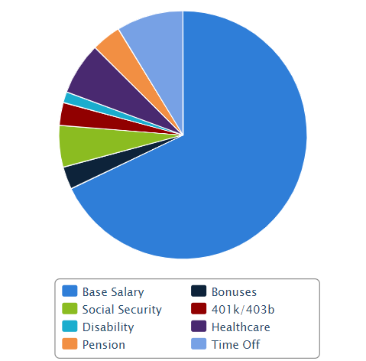
Core Compensation
 | Median | % of Total
Base Salary | $83,200 | 67.9%
Bonus | $3,600 | 2.9%
Value of Benefits
 | Median | % of Total
Social Security | $6,640 | 5.4%
401K/403B | $3,646 | 3.0%
Disability | $1,736 | 1.4%
Healthcare | $8,352 | 6.8%
Pension | $4,687 | 3.8%
Time Off | $10,683 | 8.7%
Total Compensation | $122,544 | 100%

References
Grace, A. (2020). Amazon.com: Online Shopping for Electronics, Apparel, Computers, Books, DVDs & more. Amazon.com. Retrieved 21 November 2020, from https://www.amazon.com/.
Salary.com, S. (2020). Browse Jobs by Salary Ranges | Salary.com. Salary.com. Retrieved 21 November 2020, from https://www1.salary.com/Salary-Ranges.html.

