No Plagiarism​

Welcome to your first Digital Marketing project!
It is time to apply your digital marketing foundations and get some hands-on experience! Please note that you must use the same product throughout the program.
In this and each of the following projects, you have two product options:
1) The Sandbox Project: you will take on the role of a marketing consultant for an organization you should be somewhat familiar with already: Udacity. In addition to the Digital Marketing Nanodegree program, Udacity offers a wide range of free and paid online courses, many focusing on technology. Udacity also offers training programs for companies, as well as recruiting services.

Marketing Challenge #1: Digital Marketing Nanodegree Program
You are tasked with attracting future fellow students for this Digital Marketing Nanodegree Program. More specifically, your objective is to collect leads of potential students, who could be interested in taking this course. In order to do this, we have created a landing page, where prospective students can download a free eBook if they provide us with their email address. The eBook – a Social Media Advertising Guide – is a short excerpt from the Digital Marketing Nanodegree Program, content that you will see in the Social Advertising course.
For the purpose of the projects, assume costs of $0 for the eBook and a conversion value (revenue) of $15 per collected email address.

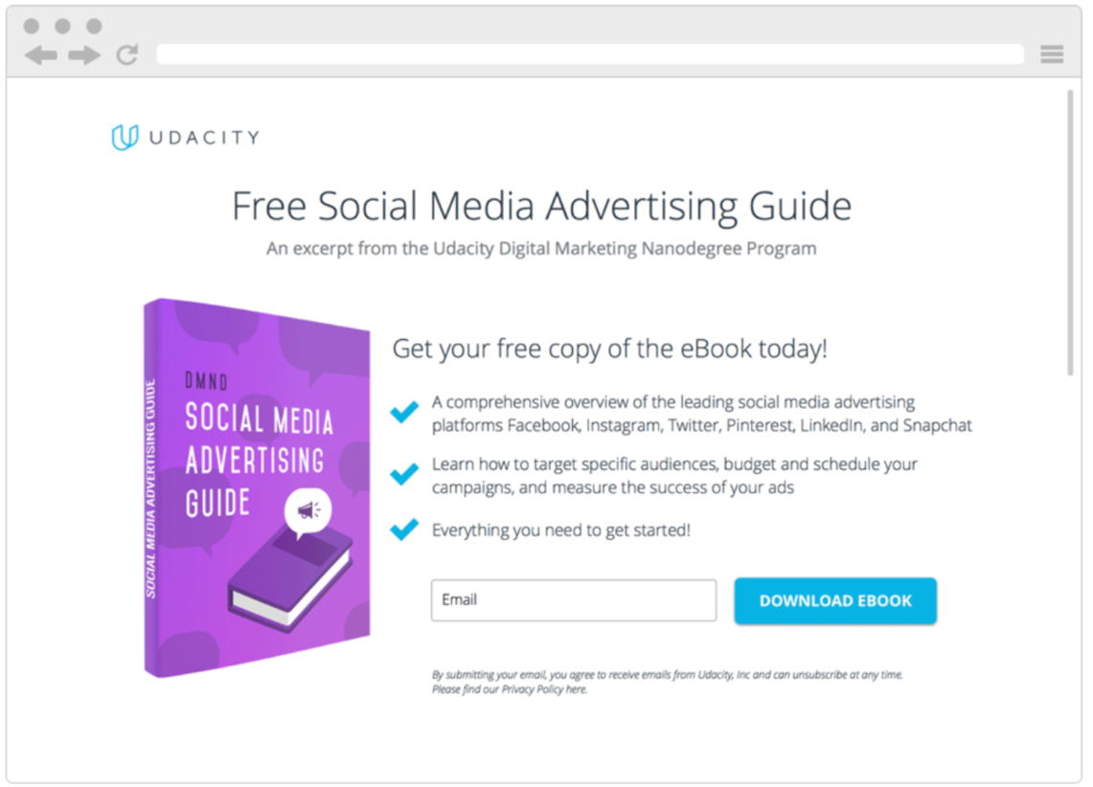

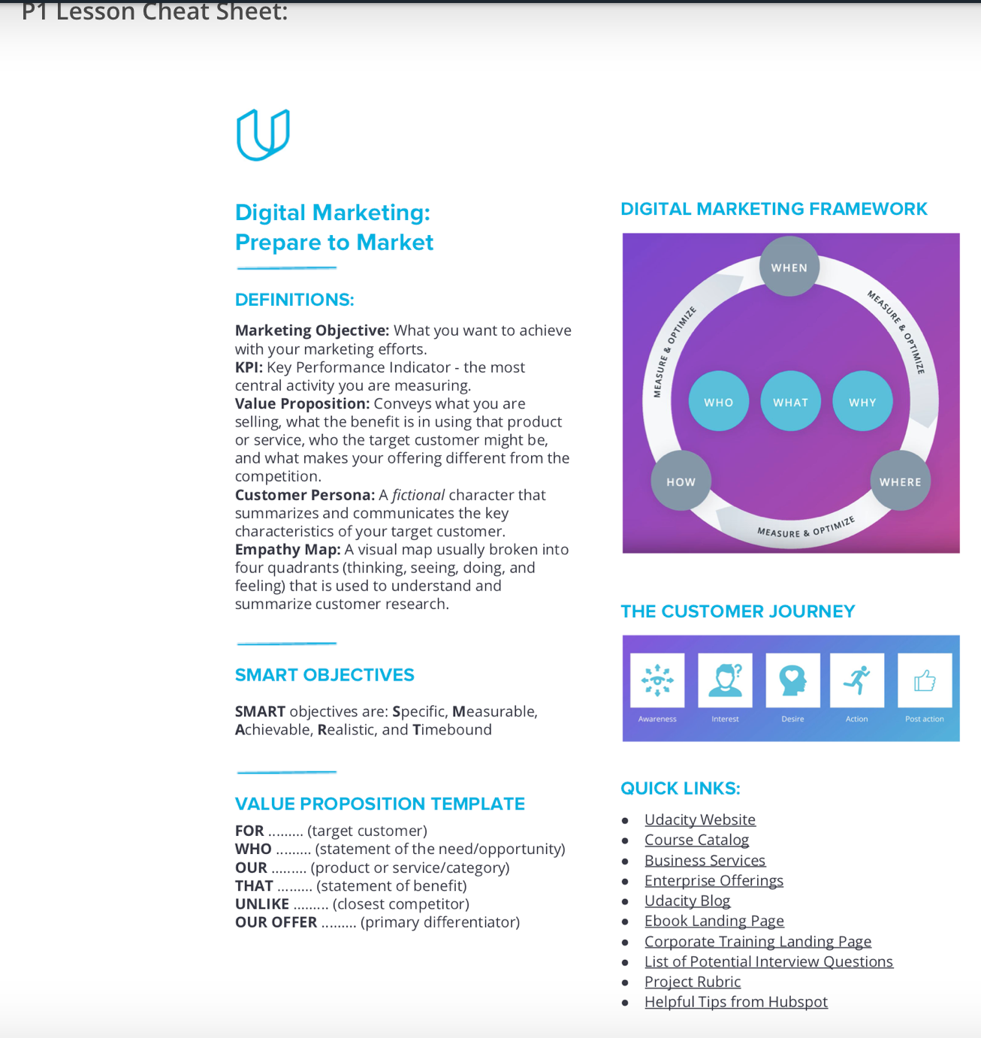

Project 1: Get Ready to Market

Step 1: Getting Started
Option 1: Imagine that Udacity has tasked you with creating a campaign for either the DMND Program. To get started you will first need to decide which product you will be marketing. Friendly reminder: Students must use the same product throughout the program.

Option 2: Define your company’s marketing and sales goals this year. Where are you currently in pursuing those goals? You will create a campaign in order to get closer to your marketing goals. Friendly reminder: Students must use the same product throughout the program.

Next, you will need to articulate the marketing objective and KPI for your pretend campaign. Since you will not be creating an actual campaign you can make your marketing objective as lofty as you like, just remember to make your objective is SMART.
SMART objectives are: Specific, Measurable, Achievable, Realistic, and Timebound.
You will be providing your answers in the template for this project to help you get comfortable using slides for presentations. It is a great opportunity for you to get familiar with this now, as you will be using this tool further on in the course.

Step 2: Value Proposition
Now that you’ve chosen a marketing challenge, you need to articulate the value proposition for the product you’ve chosen. This will help to ensure that you and your pretend client, Udacity, are aligned on potential customers, product/service value, along with the competitive landscape and differentiator. For this section, you will be using Geoffrey Moore’s template as a guide to create your value proposition.

Step 3: Customer Persona
Throughout the course you will be using the customer persona you are creating now to keep you focused on who your customer is while you are writing content, building campaigns, and auditing sites.
Create an Empathy Map To create your customer persona you will first need to interview potential customers and create an empathy map. As you’ve learned in this course, an empathy map is used to understand and summarize customer research. Most empathy maps have four quadrants broken into Thinking, Seeing, Doing, and Feeling.

Interview Potential Customers You will be interviewing a minimum of three potential customers to collect information for your empathy map. After you interview your potential customers, you’ll prepare all of the information you gathered onto sticky notes and place them in one of the four quadrants: Thinking, Seeing, Doing, and Feeling.
- List of potential questions
- As much as possible, list the actual words and phrases your customers say, the applications they use, and the websites they visit.
- Once you have your empathy maps, you’re ready to create a persona.

Construct Customer Persona
The customer persona is a fictional character that summarizes and communicates the key characteristics of your target customer. When creating the persona, you will use the information from the empathy maps to inform what characteristics your fictional person will have.
To describe your persona, you will use the template provided in the deck. First describe the background and demographics, then the hobbies, then the needs and barriers they face, and finally, lay out the goals of your persona. It is a good idea to give your persona a descriptive name and add a picture of what he or she may look like.

Rubric

PROJECT SPECIFICATION

Prepare to Market

Getting Started

CRITERIA
Is the student able to articulate a marketing objective and KPI for their pretend campaign?

MEETS SPECIFICATIONS
- Selected one of the three products: DMND Program
- Listed one marketing objective for the product selected.
- Stated your primary KPI.
- All answers should contain sufficient detail to convey an understanding of the material and have a clear focus on the product chosen.
Value Proposition

CRITERIA
Does the student understand how to craft a value proposition?

MEETS SPECIFICATIONS
Your value proposition should relate to the product chosen and include:
- Your answer must use the Geoffrey Moore’s template for the product you chose
- What is being sold
- The benefit of the product
- The target customer
- What makes the offering different from competitors - what makes you unique
Customer Persona

CRITERIA
Does the student know how to create a customer persona?

MEETS SPECIFICATIONS
Your submission should relate to
the product chosen and include:
- List of questions and answers from your interviews
- Screenshot of your Empathy Map
- A single Customer Persona that includes: Name, Background and Demographics, Needs, Hobbies, Goals, Barriers for your customer

Empathy Map: Potential Interview Questions

As a marketer, you will want to cater your interview questions to the product/service you will be marketing. If you have chosen to market Enterprise you’ll want to use questions like the ones outlined in this blog post by Hubspot: 20 Questions to Ask When Creating Buyer Personas

If you’ve chosen to market the Digital Marketing Nanodegree we’ve provided a list of potential questions below:

Personal Background
1. Describe your personal demographics.
Are they married?
What's their annual household income?
Where do they live?
How old are they?
Do they have children?
2. Describe your educational background.
What level of education did they complete?
Which schools did they attend?
What did they study? Get specific here. "Boston University" is better than "liberal arts college."
3. What is your job role? Your title?

4. How long have you had this role and title?

Hobbies

1. What do you like to do in your free time?

2. What are you interested in?
Challenges/Barriers
1. What are your biggest challenges professionally/personally?

2. Is price or time a concern for the goals you want to achieve?

3. What setbacks prevent you from achieving your goals?
Do you feel like you don’t have enough information?
Are you not sure where to start?
Have you started researching at all?

Goals
1. What are your professional/personal goals?
How is your work/life balance?

2. Where do you see yourself in the next five years?
A new role in the same industry?
A completely new role in an entirely different industry?

3. How have your goals changed in the past 3 years?

This example of the project BUT DO NOT COPY,

https://kupdf.net/download/udacity-dmnd-project-1-get-ready-to-market-_59ba818e08bbc57f21894d34_pdf

https://fliphtml5.com/gojhs/pxbd/basic

