Extended Definition
Student’s Name:
Institution:
Lecturer:

Subject / Topic: Conflict Resolution
The genre for this extended definition is a report format on conflict resolution. Conflict resolution concerns various ways of establishing of solutions to disagreements between differing parties (Elena Losa Iglesias & Becerro de Bengoa Vallejo, 2012). Its target audience is the human resource managers, since the employees are in constant conflict with each other and against the management. Therefore, it demands for an intervention of an assertive mediator that’s listens to, and unites the opposing parties. Besides, it integrates various concepts such as conflict resolution strategies and mantras, to attain success. In this case, an individual may choose to either employ the accommodating, compromising, avoiding, competing, or collaborating strategies, to handle different conflicting situations. The conflict resolution mantras are internal chants that are vital for self-management of anger and emotions during a disagreement. They assist in effective decision making, and help in finding amicable solutions for the situation at hand.
Content Requirements:
Conflict Resolution Strategies
The conflict resolution strategies concerns various approaches adopted to limit and mitigate, or to handle situations of disagreements. Thomas-Kilmann identifies five strategies for managing confliction situation between two parties. First, the avoidance approach allows an individual to ignore situations that would result to disagreements (Elena Losa Iglesias & Becerro de Bengoa Vallejo, 2012). In such scenarios, one hopes that the conflict will naturally dissipate. Secondly, the accommodating strategy entails the submission to the demands and desires of the other party, to prevent the escalation of a dispute. As a result, a person works to please the concerns of the other group. Thirdly, the compromising approach concerns finding solutions that partially meet the desires of each party involved in a conflict. Fourthly, the competing strategy occurs when one party seeks to dominate and to gain from the situation of conflict. Finally, Thomas-Kilmann highlights that the accommodating approach enables individuals to establish amicable solutions that satisfy the desires of each conflicting party.
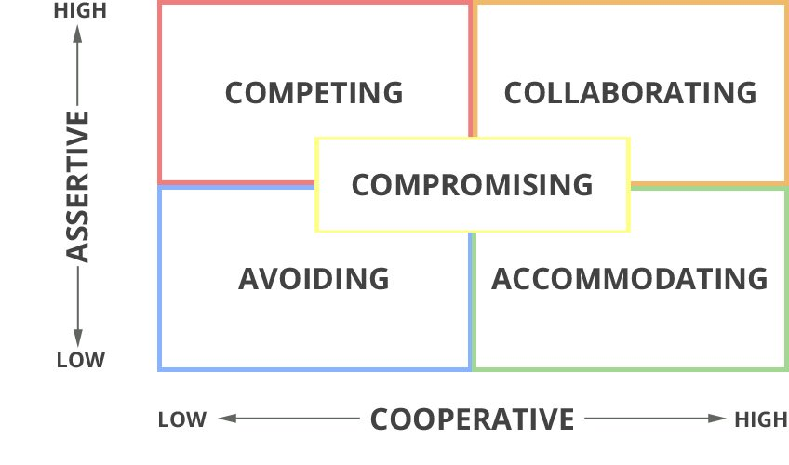
Conflict Resolution Mantras
The conflict resolution mantras are internal chants that regulate emotions and behaviors when handling a heated disagreement (Lynch, 2018). It concerns active listening to determine the argument positions for both parties, and a calm approach to decision making. For instance the mantra on “Breath in, Breath out” helps in anger management and allows individuals to develop clear thoughts regarding the conflicting situation. Research indicates that anger regulation is the most essential aspect when resolving a disagreement, and can be attained by taking a deep breath (Lynch, 2018). Besides, one can adopt the mantra on “Do Not Compete” that enables people to understand that managing conflicts is not a contest between the disagreeing parties. Similarly, this mantra helps individuals to remain calm, and to actively listen to the position of the other party. As a result, one understands that disagreements are resolved with an accommodating approach, where the desires and demands of each party are met.
Mistakes to Avoid During Conflict Resolution
Furthermore, some conflict situations keep recurring because individuals make mistakes during the resolution process. For instance, both parties may choose to avoid the conflict all together; hence, escalating the tension and frustrations without establishing solutions. Such scenarios result to anger and distress among the individuals involved in a disagreement. Besides, the mistake of “being right” limits an individual from listening and understanding the argument position of the other party. For this reason, it is difficult to establish solutions, since one considers his/her ideas as better than that of the other individual. Additionally, people make the mistake of forgetting to listen, which underestimates the other person’s point of view. Therefore, individuals must such mistakes to effectively resolve conflicts.

References
Elena Losa Iglesias, M., & Becerro de Bengoa Vallejo, R. (2012). Conflict resolution styles in the nursing profession. Contemporary Nurse, 43(1), 73-80. https://doi.org/10.5172/conu.2012.43.1.73
Lynch, M. (2018). Conflict-resolution mantras for the workplace and everyday life [infographic]
| OUPblog. OUPblog. Retrieved 17 February 2021, from https://blog.oup.com/2018/04/conflict-resolution-mantras-workplace-everyday-life-infographic/.

