NSG110 Math Homework (Math Quiz Practice) #6
1)
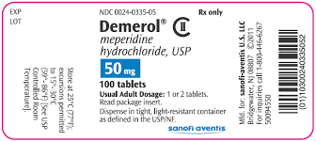
What is the brand name? ____________________________________
What is the generic name? ___________________________________
How many pills are in the bottle? ______________________________
How many milligrams are each pill? ____________________________

2) The doctor prescribes 750 micrograms of a medication. The pharmacy sends 0.5milligrams pills of the medication. How many pills will you give the patient? ____________________________________

3) Total your patient’s intake and output for your 12 hour shift.
At 08:00 the patient consumed 1 cup of coffee, 1 pint of milk and 6 ounces of orange juice. At 08:30 he voided 200mL of urine and vomited 150 ounces of emesis. At 11:45 he vomited 100 mLs of emesis and states he is very nauseated. You notify the health care provider who orders normal saline 100ml/hr IV, which is started at 12:00. The patient consumed ½ cup of ice chips. For dinner the health care provider ordered clear liquids. 14:00 the patient voided 225 mL of urine. At dinner the patient took 1 cup of chicken broth, ½ cup of jello and 8 ounces of tea. At 18:00, the patient voided 100ml of urine. Your shift ends. What is the intake and the output of this patient?

4) A parent brings in their infant for fever and ear infection. The physician orders 300mg of Amoxicillin. The pharmacy sends you this 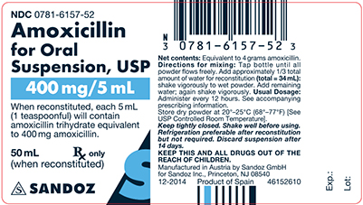
How many mL do you give your patient? Round to the nearest tenth.

5) The physician has ordered 500 mg of XX medication. The pharmacy sends 0.25 g pills of XX medication. How many pills should you give?

6) The OR calls and tells you to have your patient ready for surgery at 13:00 today. What time is this in standard time? (Be sure to include am/pm)

7) The physician orders Doxycycline 10 mL for a child with a sore throat.
The pharmacy sends this medication 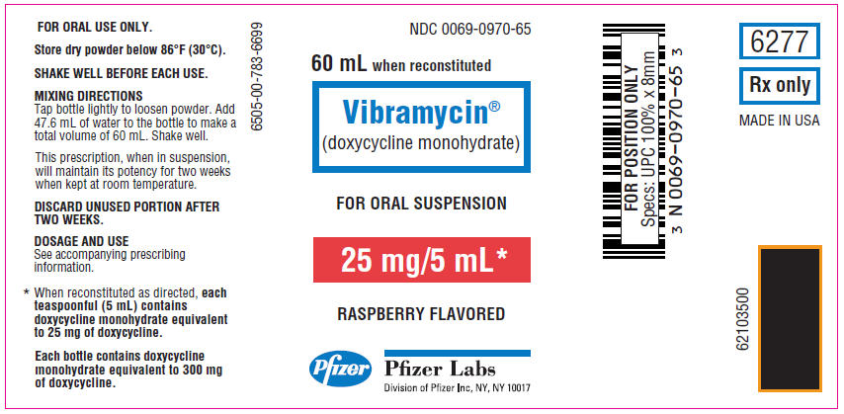
The mother complains that you gave Vibramycin and that is not what the doctor ordered. What do you tell her? ______________________
8) The physician orders 250 mcq of digoxin po daily for your patient. The pharmacy sends digoxin 0.25mg per mL. How many mL do you administer? ____________________________________________

9) Your patient is to receive 6 mg of Ketorolac every 6 hours as needed for postoperative pain. How many mL’s will you give per dose?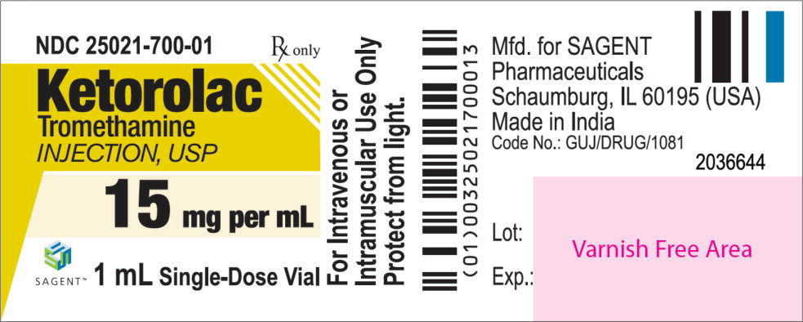

10) Your patient’s IV is infusing at 100mL/hr. Halfway through your 12 hour shift the IV infiltrates, you stop the infusion and cannot restart a new IV. How many mL’s did your patient receive for your shift?

