The book use in this assignment:
Laursen, G. and Thorlund, J. (2017) Business analytics for managers: Taking business intelligence beyond reporting (2nd ed). Hoboken, NJ: Wiley (page 49- 57)

Read the summerhouse scenario in Chapter 3 of the textbook, then write a three -page paper that discusses how this scenario would be different if it was tracking the time needed for a nurse to complete their rounds in a hospital. Be creative in applying the same methodology from the scenario and in the number of rooms the nurse needs to visit.

CASE STUDY: A TRIP TO THE SUMMERHOUSE

We will draw on this example throughout this chapter, introducing concepts such as KPIs, performance management (also called corporate performance management [CPM] and business performance management [BPM]), lead information (information for business process reengineering), lag information (information for monitoring and controlling processes), and the definition of information requirements based on critical success factors (lead and lag information combined) and dashboards (a tool for monitoring the organization's processes). So lean back—we're going on a trip to the summerhouse. The route we're taking is 60 miles long and is expected to take 60 minutes. As we continue, we will monitor and measure the operational process required to take this trip. From a business perspective, we are looking for answers to three questions; our BA function must answer them.
- Status: “Have we gone far enough in relation to how long we've been on the road?”
- Trend: “Are we accelerating up or down, or is our speed constant?”
- Projection: “Given our speed and how far we've gone, will we reach the summerhouse at the expected time?”

Specification of Requirements We can now start making our specification of requirements for the performance management dashboard. The goal is to drive 60 miles in 60 minutes. We can now place in our budget a goal line, as shown in Exhibit 3.2, which is a straight line and a function of time. In other words, we choose a goal that is to drive with the same speed all the way. To do that, we must be halfway through after 30 minutes.

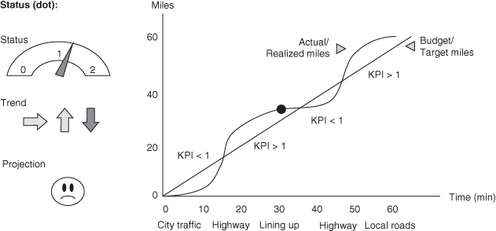
Exhibit 3.2 Example of a Performance Management Dashboard for the Trip Our KPI must specify key elements of the performance and give us an idea of the degree of success with the project. An obvious choice for KPI will therefore be the relationship between what we have achieved and what we plan to achieve.
Visually, this means that the graph with actual miles is lying above the target curve, when our KPI is more than 1 (see Exhibit 3.2).
In addition to the graph, we could set up a “cockpit” or performance management dashboard, consisting of a number of simple indicators for the process. Here we have made a status indicator showing our current KPI, and this is more than 1 when the status line is over our target line.
We have also added a trend meter, which points downward if the speed in the current period is lower than the speed in the previous period. The situation at the black dot in Exhibit 3.2 is therefore that we are doing well overall, but that we should be aware that we are losing speed. Further, we have added a smiley face on this dashboard with information about whether the summerhouse will be reached on time given the current location and acceleration. This last KPI is illustrated by a smiley that is happy, neutral or unhappy, depending on a projection of whether we will reach our destination on time, might reach our destination on time, or won't reach our destination on time, based on current statuses. At an overall level, we just have to keep an eye on the smiley.

Technical Support So what do we need in terms of technical support to realize this specification of requirements? Exhibit 3.3 shows a section of our base table.

