Group 1: Josefina Avalos, Aditya Bala, Yin Chang, Jiaqi Jiang, Jared Fisher
MGMT 567: International Entrepreneurship
Dr. Annaleena Parhankangas
March 8, 2021
International Business Plan Report
Introduction:
One thing that has become apparent over the past year is that technology and innovation are becoming increasingly more available around the world. This has caused the dispersing of technology through a vast amount of new and recent markets around the globe. With technology being so essential and readily available, technological services have also spiked over the past years. Some of them include everything from delivery to pick-up services. Our focus is to understand the traction of how grocery shopping and delivery services will continue to grow and how our delivery grocery service app in India will expand around the world.
The delivery and pick-up services are highly utilized by those who have a busy lifestyle, elderly individuals, everyday individuals, and those who are doing everything to stay safe from the pandemic. Due to the sheer size of the market, we hope to develop a product that services this industry and an app and web platform that can determine the most efficient route to deliver the most product.
Overview - Product and Market Potential:
Our service will provide a delivery and pick-up service with shopping being done by a personal shopper for India's customers. The organization will partner with the most popular and regional retailers such as 7-Eleven, Easyday, Big Bazar, D-Mart, Food-world, Hypercity, Lulu Hypermarket, Maveli stores, street vendors, and small markets to list their goods on the service's app where consumers can select and shop. It will offer over 100 trusted retailers and popular local grocery stores that consumers in India will enjoy.
The service will be an app and a website that can be downloaded or accessed on a computer or cell phone. The app will ask for information about the customer and their zip code to unlock the best retail and grocery stores around their area, available items, and prices of the items. The customer will start the shopping experience by adding grocery items to the app/website cart and then pay when they click on the checkout button. Once the items are bought from the app, a local shopper will hand-pick them according to the order. Then the local shopper will deliver the address provided by the customer at the assigned time selected by the customer.
The service will allow the customer to access the goods they need without visiting the stores themselves. It will be accessible to all customers ages 18 and older with all income backgrounds. The app will connect them to local shoppers in their area to shop and deliver groceries and other items from their favorite stores. The delivery or pick-up time will be as fast as one hour, later in the day, or depending on the customer's schedule. Shoppers will get paid through delivery fees and tips at the customer’s discretion presented in the app and added in the final amount at checkout. It is important to note that our company employees will utilize their own mode of transportation to make deliveries and will be compensated for in that way as well.
One of the app's critical features is to enhance our mobile shoppers' efficiency by pairing orders together that are received within the same period of time. Additionally, this is done because it will cut travel time and drop off on the orders. Therefore, if we can develop the software necessary to have our employees deliver two or three per trip efficiently, it would save us delivery costs and time. To help take advantage of this fast delivery option, rushed deliveries that need to be fulfilled in a short amount of time will be an extra fee to compensate the shopper.
The current location we have chosen to be located in is India. We believe India is the best country for the business to operate the app because of our customers' and shoppers' availability, India’s un-captured market potential, and India is currently the second most populated and seventh-largest country in the world. With a population of 1.3 billion, it has a large labor pool available for delivery services to both customers and shoppers. According to Plecher (2020), India's unemployment rate among the youths in 2020 was 23.75%.
With such a large unemployed youth population, we believe our app will help create jobs and boost the economy. Besides, a lot of the youth population uses a smartphone already, that it will be easy for them to access our app.
This will allow our company to employ many shoppers to make deliveries and help the youth earn money.
Based on their culture and norms, grocery shopping in India is mostly done by small markets and street vendors, while the people are familiar with delivery services. Our company will partner with popular vendors and markets and include them as grocery stores that customers can select. People in India are also very familiar with delivery apps that local restaurants and cafes use. This will allow our company to have a quicker entry into the service delivery sector. Our service is also focused on grocery shopping, and India is yet to have a major delivery service in the market due to the newness of the market. Our company's service will be one of the first to capitalize in that industry, providing an opportunity for growth, limited competition, and success in the long-term.
Apart from the large population that creates a market and employees for our business, India's government creates a suitable international business environment. For example, the country offers low taxes for foreign businesses, timely company clearances from different departments and ministries, ease of doing business, and strong infrastructures, including transport and communication systems (Rai, 2020). The Indian government has set up a group of secretaries headed by a cabinet secretary to engage foreign investors and provide possible facilities to ease setting up a business.
India also has a strong GDP growth rate currently at 8-9%, second to China, which provides an opportunity for business growth (Pettinger, 2016). Such measures make it ideal for the company to expand its business and invest in India for both local and international economic growth and organizational success. The growth that we see in GDP will hopefully translate into more people having the ability to purchase groceries through our services as GDP grows.
We are looking to locate it in either New Delhi, Bengaluru, or Mumbai to start the company. The reason for targeting these markets is due to their recent success and notable startup business location ranking among other top world cities. According to Edmund Ingham of Forbes.com, "Bengaluru's infrastructure lends itself to nurturing entrepreneurship having built on its I.T. services legacy to create an ecosystem that contains talent, investors, R&D grants and plenty of competition as well as excellent weather." (Ingham) The article discusses all these cities and how they are all well known for their I.T. and technological development.
In terms of population, Mumbai is the largest city, followed by New Delhi and then Bengaluru. The population is important to the industry that we will be entering as it will be key to ensure that there is a large enough population to both hire employees and add potential customers.
Country Analysis:
India is one of the fastest-growing countries in the world. Just like China, India started growing in the 1970s and 80s. India accounts for about 2.4% of the world's landmass, but the population accounts for almost 18% of the global population. Although China has already established itself as one of the major economies in the world, India is also making its way up there at a significant pace.
Economic-Geographic Environment:
Geographic Influences
Being the seventh-largest country in the world, India has a variety of geographic features, including flatlands, mountain ranges, rivers, valleys, and dessert. Due to the various geographic spectacles, India has a variety of natural resources such as coal, iron, and natural gas. The country is surrounded by water on three sides, forming a peninsula and making transportation of goods and materials through water accessible and trouble-free. According to Hietzman in the book titled India: A Country Study, “India has 7,000 kilometers of seacoast and shares 14,000 kilometers of land frontier with six nations: Pakistan, China, Nepal, Bhutan, Bangladesh, and Burma.” However, a vast majority of India's social and economic activity happens in what is called the Indo-Gangetic Plain. The plain consists of alluvial soil that the northern part of India and is home to roughly 400 million people.
Infrastructure
India's infrastructure sector has a huge role to play in India's economic growth and development. Due to its large population, transportation and communication services have been developed over the years. India has the fourth-largest rail network in the world, according to Railway Technology. It spans more than 120,000km of the country, covering small towns and villages.
Although India has a large railway system, road transport is still the chosen and largely used transportation and has the biggest share in the infrastructure sector. Highways, overpasses, and bridges are being built throughout the country for interstate connectivity. According to India Brand Equity Foundation, “The infrastructure sector has become the biggest focus area for the Government of India. India plans to spend US$ 1.4 trillion on infrastructure during 2019-23 to have a sustainable development of the country.” (Infrastructure Sector in India). This will significantly help traveling in India, as well as the dispersion of technology throughout India as well.
As a market that is competing globally, India’s technology sector has boomed over the last two decades. Bangalore is considered the “Silicon Valley of India” as it has a high-tech industry and is one of Asia's fastest-growing startup ecosystems. The digital growth in India makes it one of the most attractive markets for expansion.
Social-Cultural Environment:
Demographic Trends
India is the second most populated country in the world, with a population of 1.3
billion. The population is growing at a rapid two-to-one rate. Currently, India has a working population (people between 15-64 years) of almost 65%. By 2030, it is expected to grow to 68% of the country’s population.
The life expectancy of females (71.8 years) in India is greater than males' life expectancy (69.2 years). India currently has an urban population of 34.5%, which is on the rise and is expected to increase in the future. Having a predominantly young population, India has a substantial number and unemployed youth, making it a large consumer base for any product or service.
Cultural Analysis
One of the most diverse countries in the world, India has more than 15 major languages, 28 states, and eight union territories. Due to its diverse population, almost every state has its own language, cultural competencies, and social structure. The top practiced religions are Hinduism, Islam, and Christianity, followed by Sikhism, Buddhism, and Jainism.
One of the best ways to analyze a country’s cultural competencies is by using Hofstede’s cultural dimensions theory. By using the framework for cross-cultural communication, we can analyze and compare different dimensions with various countries. Below are the scores for each dimension for India-
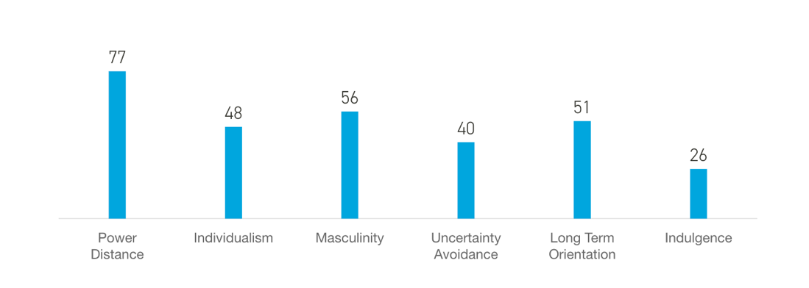
As we can see in the model above, Power Distance has a high score of 77, which shows us how power is distributed unequally throughout society and business. It is a collectivist culture, which respects values and relationships developed over the years. Although it has a relatively conservative culture, India's young population is quickly adapting to western culture and values. This is a positive sign as we seek to develop and grow IndiaKart around the country.
Political-Legal Environment:
Government and Politics
India is considered a parliamentary democratic operating country that uses a constitution to guide decision-making. The president is the head of the state, while the prime minister is the head of the government. They currently utilize the electoral college system that we see here in the United States to determine the next elected officials. This is largely due to England's previous ruling over India, as it was considered a colony of England until 1947.
India also operated with a court system, with the highest court in the land being the Supreme Court. The Supreme Court handles high-profile court cases and cases that come up through the lower courts. With that being said, there is still a high amount of government corruption that takes place. According to Roger Darlington, "Politics in India is much rougher and much more corrupt than the democracies of Europe and North America." However, not all is lost as India is still a young democracy and gaining a lot of traction and poised to see a lot of growth in the coming years.
Promoting Global Business
India has comparative advantages such as burgeoning middle class, low labor rates between $0.92 and $1.45 per hour. In addition, India has around 80 million people who speak basic English, 2,000-year history of international commerce and technology, and business opportunities. Furthermore, India occupies leadership roles in important companies, academia, and professions in both U.S. and Europe.
Target Market:
- What does the market need for the product/service?
India has an expansiveness in landscape and high traveling cost. As a result, people in India are more willing to save the time value by just a few clicks on the device to receive their groceries and items of choice on their doorstep at their preferred time. Our market segment in India is targeted at people who don't want to make one trip to the grocery store but instead want to save on those consuming trips to the grocery store with our user-friendly application. Furthermore, companies that collaborate with us can have more access and loyal customers to increase their sales. With technological advancement and innovation of 5G, it will bring the world to a new era, and the market will be faster and easier for people and replace old traditional services.
- What is the profile of your typical customers:
Our customer's profiles are split between two main categories: a household family and a repetition buyer. A household family will be purchasing bulk groceries around a week or twice. The age range of this type of customer will be around 25 to 60. We will utilize notifications for customers that fall in this range and send them things such as a weekly deal or sale that might be going on. The other type of customer will be a repetitive buyer. This type of customer will always buy the same amount and same type of product once a month for six weeks (about one and a half months). Usually, they stick with the same product, such as shampoo, supplement, and toilet paper. This customer type is usually younger than 21 or college students who have a limit of purchasing and are loyal to specific brands on certain products. An effective way to market them is using bundle offers and discounts to keep them as a customer.
- What consumer segment(s) are targeted:
The consumer segments are targeted at people who are willing to pay a delivery fee for a shopper to do their groceries to save time. Our customers' segmentation is split into four categories geographic, demographic, behavioral, and psychographic. In terms of geography, our customer location will be in the Urban areas. Within these urban areas, we will be targeting a vast number of people, from those who are very busy to those who might just not want to go to the grocery store. In behavioral terms, our product services will be more likely to be used by people that seek a new living style or something new in the market. As we mentioned, our services help our customers to save up more time on grocery purchases. The last has to do with psychographics of our customers will be. Many prefer to buy groceries online and would be able to wait for the food to come within a day to receive their product, which is customer likes to plan its future.
- What type of strategy (e.g., differentiation, focus, low-cost, etc.) would be most appropriate in this case, etc.?
The type of strategy or differentiation that our service provides that will set us apart from others will be our partnership with the well-known grocery companies and partnering with local/street vendors for more ordering. In addition, we will also personalize orders for our customers and be on all social platforms. Furthermore, we will be part of helping build new job opportunities for our youth employment in India.
- What are the unique selling propositions of this product/service?
Our customers will have access to rewards in our application and website. They will receive one reward every time they choose our service, and once they reach the 10th reward, they will receive one free pick-up or delivery service. This service targets folks of a low to high income; therefore, our pick-up and delivery fee will be affordable for all. Furthermore, our service offers various products and delivers right to your doorstep to be part of our application loyalty and value.

- What are total industry sales for this product/service in your target country over the past five years?
The total industry sales for this service in India are about one hundred billion Rupees. According to Sandhya Keelery, “As of 2019, Bigbasket - the online grocery store had the highest market share among online groceries in India at over 35 percent. The other competitors Amazon and Grofers, were not far behind. The market value of online groceries was about 100.7 billion Indian rupees that same year.” The industry has been growing very rapidly in recent years. Our application service has also had a rapid spread around India’s surrounding areas and countries.
- What is the future potential of this market in terms of its size and growth?
The future market potential and growth are both very promising and encouraging to see. We expect that the grocery delivery service will be one of India's most popular services, which will grow into the surrounding areas. It will continue to innovate over the years to adapt to the times and customers. It is a quality service that India has been waiting for, and with the popularity of our service, our service will continue to expand in other countries that will then generate more sales and consumers.

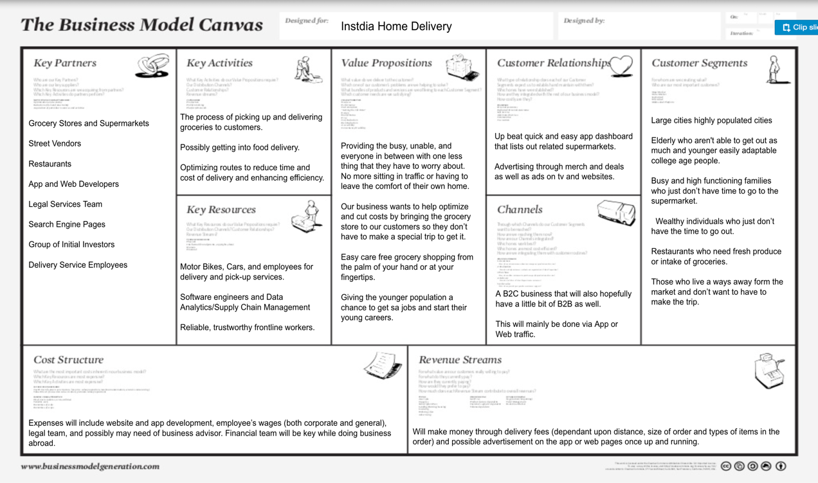
References
Barhate, P. (2018). 17 Popular Grocery Apps in India to Order Your Daily Needs On-demand. Retrieved February 24, 2021, from https://mobisoftinfotech.com/resources/blog/why-on-demand-grocery-apps-are-gaining-huge-popularity-in-india/
Contractor. Farok. "India and its role in International business: The sleeping giant is still waking from its over-regulated past." Retrieved July 27, 2020, from https://globalbusiness.blog/2020/08/12/india-and-its-role-in-international-business/
Hietzman, James, and Robert L. Worden. “India.” India: A Country Study, U.S. Library of Congress, countrystudies.us/india/.
“Infrastructure Sector in India.” IBEF, www.ibef.org/industry/infrastructure-sector-india.aspx.
“India Demographics” https://www.worldometers.info/demographics/india-demographics/
Ingham, Edmund. “Top Cities for Starting Up in India.” Forbes, Forbes Magazine, December 10, 2015, www.forbes.com/sites/edmundingham/2015/12/06/indias-top-start-up-cities/?sh=6f40aa6370d5.
Keelery, Sandhya. “India - Online Grocery Market Share by Company 2019.” Statista, 22 Jan. 2021, www.statista.com/statistics/1118621/india-online-grocery-market-share-by-company/.
Luthra, Sonia "India's Demographic Outlook" December 29, 2011, https://www.nbr.org/publication/indias-demographic-outlook-implications-and-trends/
Pettinger, T. (2016). Strengths of Indian economy. Economics Help. https://www.economicshelp.org/india-2/strengths-indian-economy/
Plecher, H. (2020). India: Youth unemployment rate from 1999 to 2020. Statista. https://www.statista.com/statistics/812106/youth-unemployment-rate-in-india/
Rai, V. (2020). Attracting foreign investment into India: Key initiatives by the government. ISAS. https://www.isas.nus.edu.sg/papers/attracting-foreign-investment-into-india-key-initiatives-by-the-government/
"Timeline: 165 years of history on Indian Railways" June 12, 2018, https://www.railway-technology.com/features/timeline-165-years-history-indian-railways/
UKEssays. (November 2018). Country Analysis of India. Retrieved from https://www.ukessays.com/essays/international-studies/country-analysis-of-india.php?vref=1

