Ashley P Post to week 6 discussion 1

The video posed many insightful questions and rationales. It began by suggesting that selfish activity and self-centered activity is the origin of all disorders. This argument is made by the example of when the patient comes in, he is concerned about his depression, his joy, his anxiety, his happiness…therefore, the self is the beginning of all disorder, his salvation, his fulfilment and so on. Psychologists may not see this as the problem, however. They see each individual’s goal is to have an adequate self.
There are conflicts in the animal world and plant world as well. Animals compete to survive and plants compete for light. There are natural disasters such as earthquakes. The difference would result in consciousness. There is consciousness in the disorder in human human interaction. It is natural for nature as well as humans to suffer and live in disorder. The example used was a cheetah chasing a deer. Everyone suffers but some people suffer more than others and some are more fortunate, for example in their upbringing or heredity.
Physical suffering is inevitable such as sickness, disease, health, etc. We increase the physical suffering through psychological problems. An example was used here where women will have multiple children, forgetting the pain of bearing the first child. They later discuss the self-centeredness of raising a child and how the mother raises the child to suit her own selfish needs. The child is described as a victim of circumstance and this is passed on from generation to generation. This selfishness trait is believed to be inherited from our animal parts and has always been so always will be.
Humans are a product of society and selfishness made be modified. Depression is a self-centered issue. We can change this. It is important to break down the barriers that we have at the beginning of life, during childhood and not at the end. Once we can do that, we experience freedom and more doors will open. It is then we can live in this world without conflict. The conversation is ended between the psychologists with trying to help people depend on themselves only and not on other people for answers or happiness. There is more fear and anxiety in attachments. Help the individual find out what would make them more secure within himself.
The nature of the mind is the conscious awareness of one’s thoughts, emotions, desires, purpose, sensations, morals, etc. Societal and environmental influences develop and change this nature. Healthy mental functioning occurs when an individual is able to understand, express and maintain his emotions, thoughts, concerns, and motivations. The individual is able to learn new material and gain knowledge from experiences. A healthy mind can be described as the mind and spirit being in harmony. A healthy mind realizes when it is thinking irrationally and will be able to redirect thoughts and patterns of behavior without reacting impulsively. In order for unhealthy mental functioning to occur, the individual will be in a destructive or irrational mental state. This may occur will an individual cannot process his emotions or set aside a persistent worry or thought. This could lead to undesired behavior and psychopathology (Maj, 2018). Overall health and the quality of life are defined by the relationship between the body, personality, spirit, family, community, society, etc. A healthy individual will have positive connections with his community, be productive in society, and have a defined, pleasant personality with a good spirit about him. He could have inherited these traits from his family or had a positive support system. Individuals that have grown up in poverty or were not taught self-care or experienced childhood trauma may be at risk for unhealthy mental functioning and psychopathology later in life (Murphy et al., 2019).
PICTURE

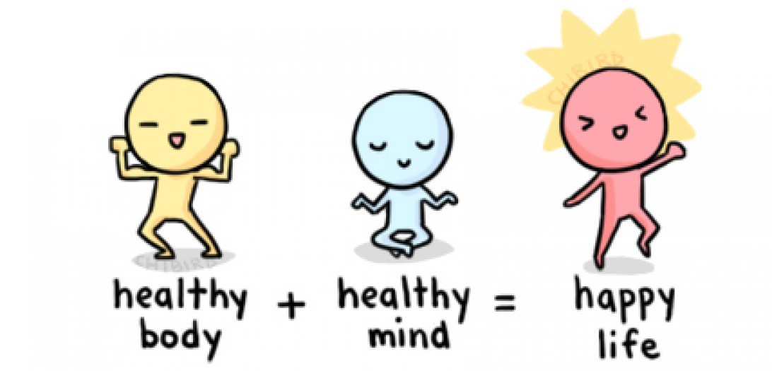
Some cultures consider mental illness as a sign of weakness and are discouraged to talk about their problems. In many cultures, there is a stigma around mental health and many choose to hide mental illness. This makes it harder to ask for help. Minority cultures are more likely to seek mental health treatment alone and get less support from their families. It is important for various cultures to confide in those that can provide unbiased resources and treatment options. Education has been referenced to in some cultures as a reflection of mental health and some cultures put great emphasis on academic achievement. Handbooks may limit our understanding of psychopathology by generalizing mental illnesses. These generalizations made can lead to misdiagnosis and overdiagnosis through similar symptoms. The possibility of a dual diagnosis will less likely be considered here if it is not specifically defined in the handbook. Also, exploration and observations of rare case studies will be less likely when commonalities are being sought (Lumpkins, 2018).
Reference
Agnieszka Maj. (2018). A Healthy Mind in a Healthy Body—Recipes for a Healthy Living as Seen in Polish Vlogs. Qualitative Sociology Review, 14(2), 116–129. https://doi-org.proxy-library.ashford.edu/10.18778/1733-8077.14.2.07
Jenifer A. Murphy, Georgina Oliver, Chee H. Ng, Clinton Wain, Jennifer Magennis, Rachelle S. Opie, Amy Bannatyne, & Jerome Sarris. (2019). Pilot-Testing of “Healthy Body Healthy Mind”: An Integrative Lifestyle Program for Patients With a Mental Illness and Co-morbid Metabolic Syndrome. Frontiers in Psychiatry, 10. https://doi-org.proxy-library.ashford.edu/10.3389/fpsyt.2019.00091
Lumpkins Crystal Y., Vanchy Priya, Baker Tamara A., Daley Christine, Ndikum-Moffer Florence, & Greiner K. Allen. (2016). Marketing a Healthy Mind, Body, and Soul : An Analysis of How African American Men View the Church as a Social Marketer and Health Promoter of Colorectal Cancer Risk and Prevention. Health Education & Behavior, 43(4), 452–460.

