WOMEN'S VOICES AND SOCIAL CHANGE
In the United States, as in many other nations, the struggle for women to achieve equal status under the law has been a difficult and ongoing effort. The Women's Rights Movement in the United States grew out of the Abolitionist Movement—the drive to end chattel slavery, in which human beings were defined as commodities to be bought and sold. Women who became politicized in that movement began to actively strive for achieving equal rights for themselves. Throughout these struggles, women’s voices and writings have given direction to their cause.
This timeline intersperses key events in women’s history with brief profiles of key women writers. Consider each writer within the context of her times and within the continuum of change.
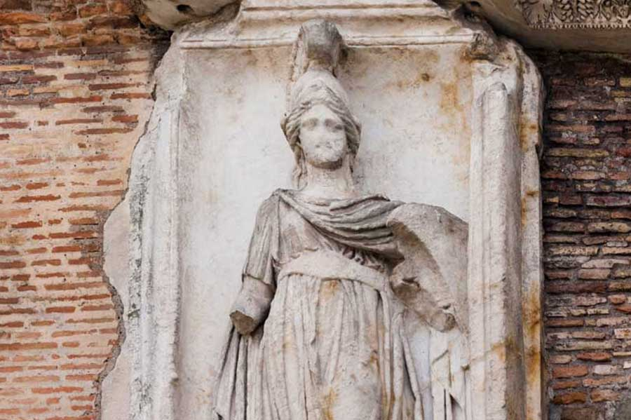
Minerva has been known since ancient times as the Roman goddess of wisdom and sponsor of the arts, trade, and strategy.
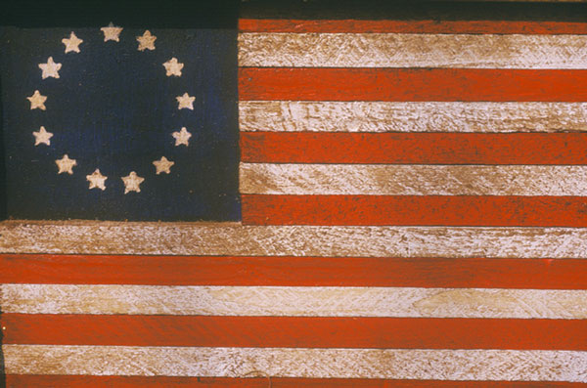

1770s

1776
Before the U.S. Constitution was written, Abigail Adams wrote to John Adams: "In the new code of laws, remember the ladies and do not put such unlimited power into the hands of the husbands."

1777
The original 13 U.S. states pass laws that prohibit women from voting.
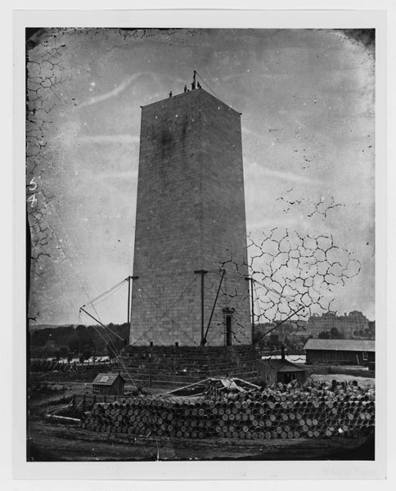
Washington Monument foundation construction.

1840s – 1860s

1848
The Seneca Falls Convention in New York is the first American convention focused on the rights of women.

Elizabeth Cady Stanton
Elizabeth Cady Stanton (1815–1902)
Declaration of Sentiments
Born in 1815 in New York, Elizabeth Cady Stanton was an ardent abolitionist and early leader of the women’s rights movement. She was one of the organizers of the Seneca Falls Convention. The Declaration of Sentiments, drafted by Stanton and Lucretia Mott and presented at the convention, was a passionate statement in opposition to the constitutional disenfranchisement of women. The Seneca Falls Convention—and this declaration—are widely recognized as the beginning of the Women’s Movement in the United States and served to set an agenda for the efforts that followed.

Sojourner Truth
Sojourner Truth (c.1797-1883)
“Look at me. Ain’t I a Woman?”
A chattel slave until she was 29 years old, Sojourner Truth became one of the most prominent abolitionists in the United States. As an outspoken proponent of civil rights for black women Truth brought to the abolitionist movement the radical stance that black women too required the equal status being sought for black men—just as white women were advocating for themselves. Her speech, “Look at me, Ain’t I a Woman?, delivered at the 1851 Women’s Rights Convention in Akron, OH, is an extraordinary feminist statement.

Emily Dickinson
Emily Dickinson (1830-1886)
“The Soul selects her own Society”
Emily Dickinson was born in Amherst, MA. While widely read and studied today, she was not publicly recognized during her own lifetime. Dickinson led a fairly reclusive life. Nevertheless, she wrote prolifically and has become widely acknowledged as an innovative, pre-modernist poet and today is an inspiration to feminist writers.

1850
Women are guaranteed the right to own land in the state of Oregon, without respect to marital status.
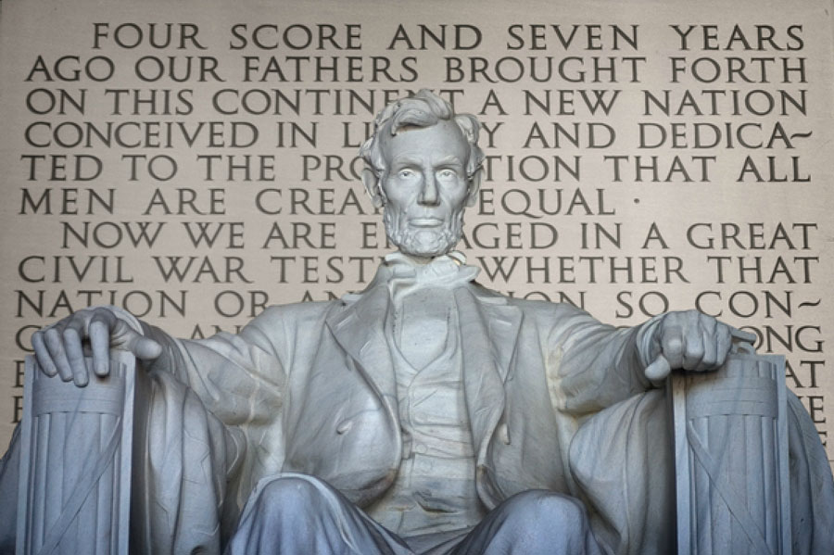

1860s

1865
The 13th Amendment to the US Constitution is ratified and abolishes chattel slavery in the United States.

1865
The University of Zürich becomes the first European university to admit women.

1867
Polish-born French physicist Marie Curie becomes the first woman to win a Nobel Prize and the only woman to win the award in two different fields (physics and chemistry).

1869
Susan B. Anthony and Elizabeth Cady Stanton form the National Woman Suffrage Association. The goal of the organization is to gain voting rights for women via a Congressional amendment to the U.S. Constitution. This would not be achieved for another 50 years.

Kate Chopin
Kate Chopin (1850-1904)
“The Story of an Hour”
Missouri-born Kate Chopin was an author of short stories and novels who today is recognized as a leading and progressive writer of her time. Her second novel and her best-known work, The Awakening, shocked readers with its themes of female sexuality when it was published in 1899. Today, this story of a woman trapped and oppressed by the society in which she lives is a highly regarded piece of feminist literature.
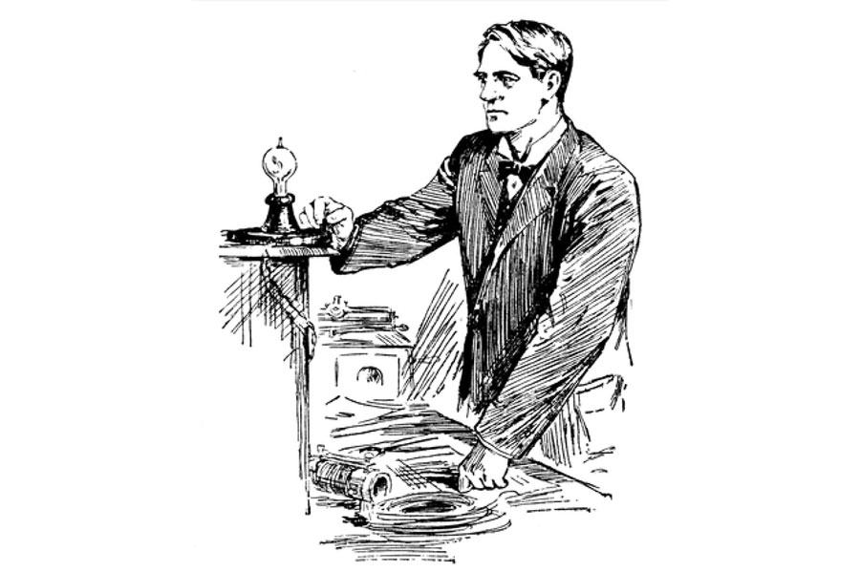

1870s

1874
The US Supreme Court rules that suffrage is not a constitutionally guaranteed right. Rather, it was up to individual states to grant or deny the right to vote.

Charlotte Perkins Gilman
Charlotte Perkins Gilman (1860-1935)
“The Yellow Wall-Paper”
When Charlotte Perkins Gilman, a writer and social activist from Connecticut, wrote the short story, “The Yellow Wall-Paper” in 1892, very little had changed in the United States regarding women’s legal rights. Gilman’s work often focused on the importance of women gaining economic independence. To this end, she founded The Forerunner, a magazine that targeted women's issues and social reform. Gilman’s voice, through these various outlets, continued to build the momentum for social change and women’s rights.

1893
Colorado is the first state in the United States to adopt an amendment granting women the right to vote. Utah and Idaho soon follow.
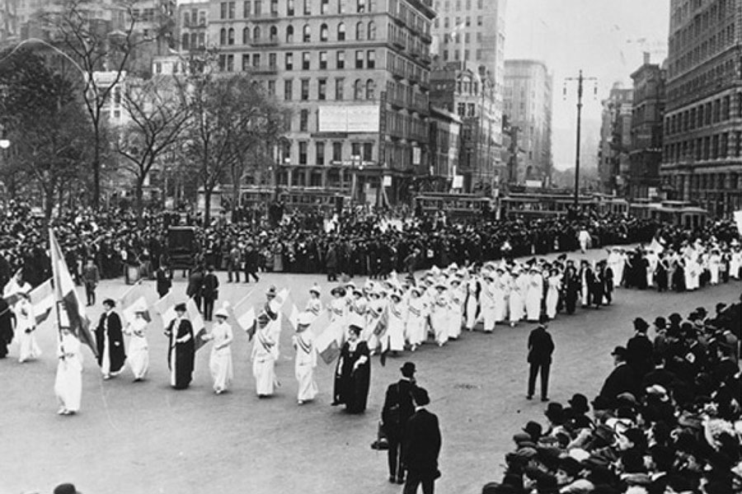
New York, 1913

1900s - 1960s

1918
Canadian and British women are granted the right to vote; in Great Britain a woman must be over age 30.

1920
The 19th Amendment to the U.S. Constitution is ratified, giving American women in every state the right to vote.

1923
The first Equal Rights Amendment, written by Alice Paul, is introduced into the United States Congress. The amendment dies in 1982 when it fails to achieve ratification by a minimum of 38 states. It has been reintroduced into every Congress since.

Katherine Anne Porter
Katherine Anne Porter (1890-1980)
“Rope”
Katherine Anne Porter was a key voice in American literature of the 20th century. A Pulitzer Prize-winning journalist, novelist, essayist, and short-story writer, she critiqued her times as well as the greater society. Her works were informed by the many places she lived, both in the United States and abroad. She often addressed issues of women’s rights and social injustice in her writings.
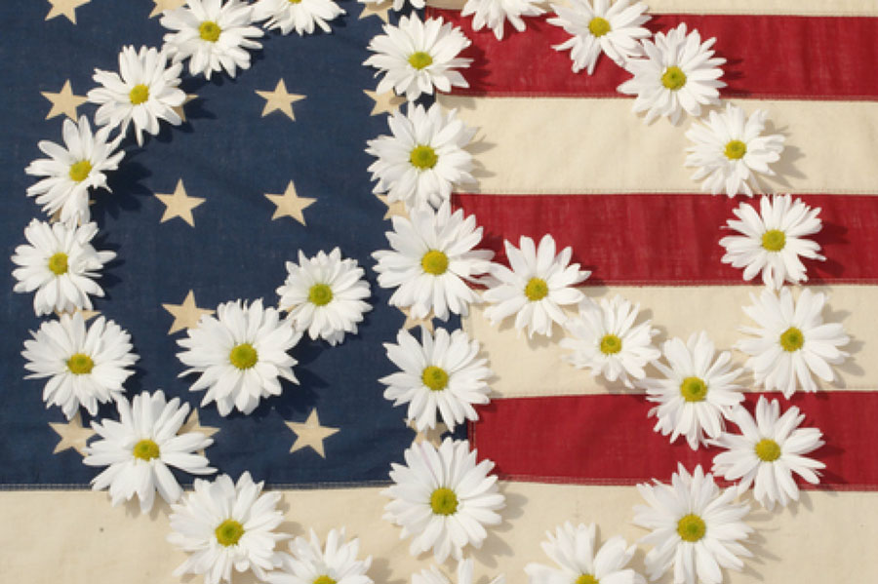

1960s

1960
Sirimavo Bandaranaike of Sri Lanka, becomes the world’s first elected woman prime minister.

1962
U.S. scientist and ecologist Rachel Carson publishes Silent Spring, helping to create global awareness about environmental concerns.

1963
The Equal Pay Act becomes federal law in the United States, requiring employers to provide equal pay for men and women performing the same job duties regardless of the race, color, religion, national origin or sex of the worker.

1964
Title VII of the Civil Rights Act of 1964 is passed in the United States, barring employment discrimination by private employers, employment agencies and unions based on race, sex, and other grounds.

1966
Indira Gandhi becomes the first woman Prime Minister of India.

1967
U.S. President Lyndon B. Johnson issues Executive Order 11375, which expands affirmative action policies to cover discrimination based on sex. As a result, federal agencies and contractors must take active measures to ensure that women, as well as minorities, have the same employment and educational opportunities as men.

1969
Zionist activist Golda Meir is appointed the fourth Prime Minister of Israel, and the world’s third woman to hold the title.
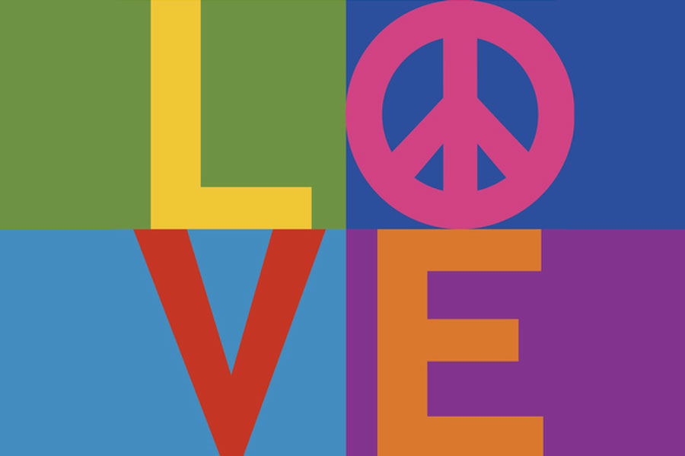

1970s

1970
Walden University is founded by Bernie and Rita Turner. Walden’s mission of positive social change is reflected throughout the programs, research, professional activities, and products created by the Walden academic community.

Maya Angelou
Maya Angelou (1928-2014)
I Know Why the Caged Bird Sings
Famed author, actress, screenwriter, dancer, poet, and civil rights activist Maya Angelou survived a painful childhood in the segregated South to become a worldwide model of resiliency and triumph over adversity. Her memoir, I Know Why the Caged Bird Sings, was a bestseller and is considered by many to be imperative reading for students in high school and college. In 1993, Angelou recited her poem “On the Pulse of Morning” at President Bill Clinton’s inauguration.

Judy Brady
Judy Brady (1937–)
“I Want a Wife”

Fifty years after women in the United States gained the right to vote, Judy (Syfers) Brady read her tongue-in-cheek piece, “I Want a Wife,” at a 1970 rally in San Francisco. In spite of constitutional changes, in 1970, women were still subject to many legal inequalities and were still denied many of the rights accorded to men. The first issue of Ms. Magazine subsequently featured this iconic piece and it has remained a key piece of feminist writing.

Alice Walker
Alice Walker (1944-)
“Everyday Use”
Novelist, short-story author, poet, civil rights activist and feminist Alice Walker grew up in the segregated South. Active in the Civil Rights Movement, she poured her experiences into her writing. Walker is most well known for her novel The Color Purple, which became both an acclaimed movie as well as a Broadway musical. Walker has long been a prominent voice in the black feminist movement.

Ntozake Shange
Ntozake Shange (1948-)
For colored girls who have considered suicide / when the rainbow is enuf
Ntozake Shange chose her own African name, which means “she who comes with her own things” and she “who walks like a lion.” Shange, an educator, performer/director, and a writer, focuses her work on her experiences of being a black woman in America.

1973
In Roe v. Wade, the Supreme Court of the United States establishes a woman's right to safe and legal abortion, overriding the anti-abortion laws of many states.

1974
The Equal Credit Opportunity Act in the United States bans racial or sexual discrimination in the credit industry.

1978
The passage of the Pregnancy Discrimination Act in 1978 makes it illegal for U.S. employers to discriminate against women based on their plans to have children.

Rita Dove
Rita Dove (1952-)
"After Reading Mickey in the Night Kitchen for the Third Time Before Bed"
Rita Dove’s work has been greatly praised for both its lyricism as well as its historical and political breadth. It has noted that “Dove is a master at transforming a public or historic element—re-envisioning a spectacle and unearthing the heartfelt, wildly original private thoughts such historic moments always contain.” Highly acclaimed, Dove was named U.S. Poet Laureate in 1993.
(Shaughnessy, B.) Retrieved from http://www.poetryfoundation.org/bio/rita-dove.

Eve Ensler
Eve Ensler (1953-)
In the Body of the World
Eve Ensler is an internationally bestselling author and an award-winning playwright whose works include The Vagina Monologues. She is the founder of V-Day, the global movement to end violence against women and girls, which has raised more than $90 million for local groups and activists, and inspired the global action One Billion Rising. Retrieved from http://inthebodyoftheworld.com/.

1990s

1990
Violeta Barrios de Chamorro is elected president of Nicaragua, becoming Central America’s first woman president.

1990
The first web page is served on the open Internet, opening the door to unparalleled connectivity and the opportunity for shared information by all. Many people around he world embrace this powerful platform for change.

1993
The Family and Medical Leave Act gives U.S. men and women protected unpaid leave to deal with family emergencies, including the birth of a child.

Fannie Lou Hamer (1917–1977)
Fannie Lou Hamer (1917–1977); Janice D. Hamlet (1955-)
“Fannie Lou Hamer: The Unquenchable Spirit of the Civil Rights Movement”
Fannie Lou Hamer was born into rural poverty in Mississippi and was working the fields at age 6. When Hamer was 45 years old she began an extraordinary journey as a civil rights activist. Until her death in 1977, Hamer worked tirelessly on civil rights issues: registering African Americans to vote, working for the Student Nonviolent Coordinating Committee, and founding the Mississippi Freedom Democratic Party. In 1971 she helped establish the National Women’s Political Caucus. On her tombstone is written one of her most famous quotes: "I am sick and tired of being sick and tired."
Dr. Janice D. Hamlet who authored the journal article, “Fannie Lou Hamer: The Unquenchable Spirit of the Civil Rights Movement,” is a professor at Northern Illinois University. Her current research interests include African American history, culture and communication and womanist epistemology and methodology.
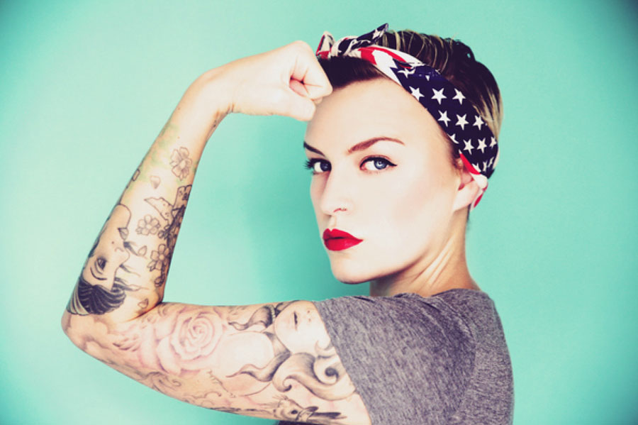

2000s

2004
The March for Women’s Lives in Washington, D.C., protests President Bush’s policies on abortion and women’s healthcare.

2004
Kenyan environmental activist, feminist, and human rights advocate Wangari Maathai is awarded the Nobel Prize for Peace, becoming the first black African woman to win a Nobel Prize.

2009
The Lilly Ledbetter Fair Pay Act is signed into U.S. law, expanding workers’ rights to sue for pay discrimination.

Natasha Campo
Natasha Campo
“Feminism Failed Me: Childcare, Maternity Leave and the Denigration of Motherhood.”
Natasha Campo holds a PhD from the History Program at La Trobe University in Australia. She has published and presented widely in academic forums as well as in the mainstream press on Australian feminist history, and has a particular interest in the way feminism has been represented and remembered in the popular media. Retrieved from http://arts.monash.edu.au/jas/staff/natasha-campo.php

Pnina Ron
Pnina Ron
“Daughters as Caregivers of Aging Parents: The Shattering Myth”
Dr. Pnina Ron is a lecturer at the School of Social Work at the University of Haifa, Israel. Her research subjects focus on mental health among the elderly, gender and sex-role orientation among the elderly, and intergenerational relationships.

Tracy Carpenter-Aeby
Tracy Carpenter-Aeby
“Rewriting Family Stories During Successful Transition From an Alternative School: One Student’s Story of ‘Violent Female’ to 'Phenomenal Woman'”
Dr. Carpenter-Aeby is an Associate Professor in the School of Social Work, College of Human Ecology, at East Carolina University. Her research interests include: program evaluation, alternative schools, bullying-harassment, interventions with disruptive students and families, service learning, social work pedagogy, and technology.

Cherrie Moraga
Cherrie Moraga
“The Welder”
Cherrie L. Moraga is a Chicana playwright, poet, essayist, and feminist activist whose plays and publications have received national recognition. She is Artist in Residence in the Department of Drama at Stanford University. The focus of much of Moraga’s work is the impact of gender, sexuality and race in the lives of women of color.

Women’s Voices Today
In spite of progress that has been made, there is much more yet to be achieved. Around the world, women today continue to speak out and write about women’s rights issues that include:
- Reproductive rights and justice
- Reproductive and maternal health
- Economic justice
- Gender discrimination
- Educational equity
- Human trafficking
- Child marriage
- Ending violence against women
- Racial justice
- LGBT rights

2014
Malala Yousafzai, age 17, is the youngest person to receive the Nobel Peace Prize. As a child in Pakistan, she was an advocate for girls' education, which resulted in the Taliban issuing a death threat against her. In 2012, she was shot on her way home from school. She survived, and continues to speak out, write, and advocate the importance of education for girls and women. United Nations Secretary-General Ban Ki-moon described her as "a brave and gentle advocate of peace who through the simple act of going to school became a global teacher.” Retrieved from http://www.un.org/sg/statements/index.asp?nid=8095

2015
From the National Organization for Women (NOW):
“Equality in pay, job opportunities, political structure, social security and education will remain elusive without a guarantee of equality in the U.S. Constitution.” Retrieved from http://now.org/issues/
Social change is a global concern. In communities around the world, women’s voices continue to drive the momentum of change.

