Eating Disorder During COVID-19
Critique of Health Information Resources
GCH 350

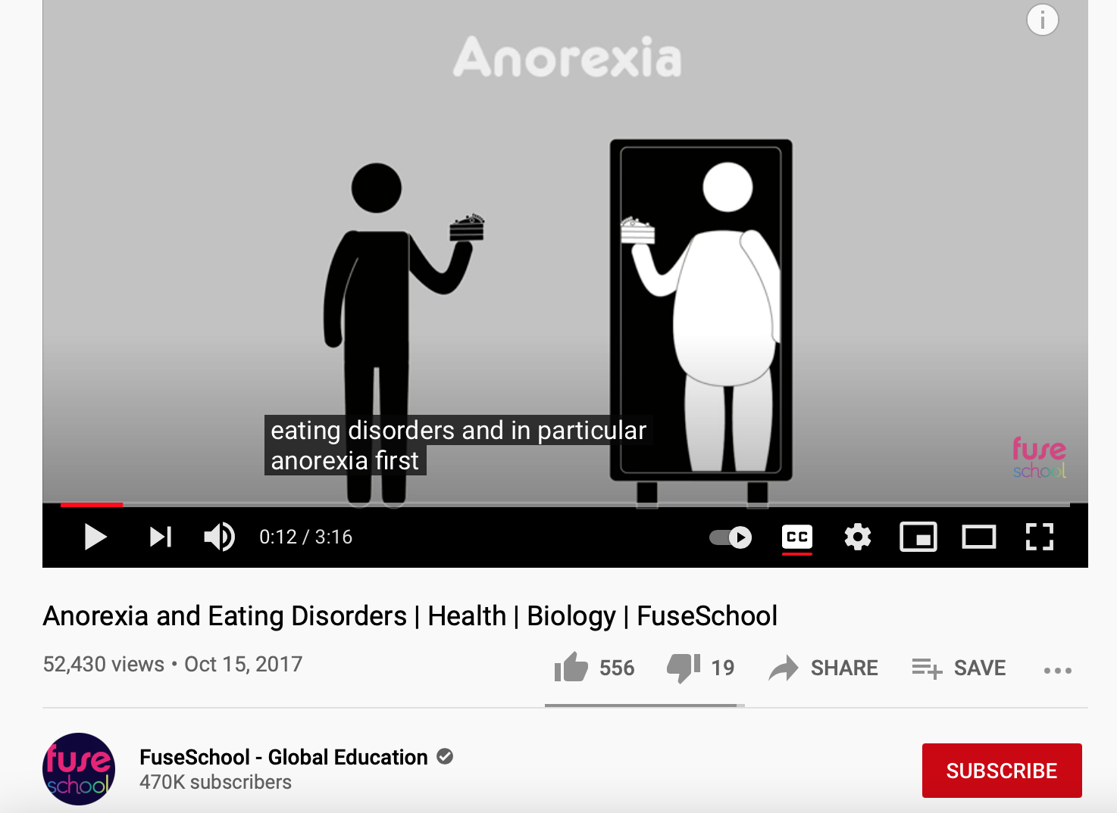

Video Critique
- Brief summary
In this health education video titled, “Anorexia and Eating Disorders | Health | Biology | FuseSchool” and uploaded by FuseSchool, the viewer is able to grasp an understanding on eating disorders and what they mean from a psychological standpoint. This animated video depicts the seriousness of eating disorders and the possible outcomes. The purpose of this video is to educate the audience on eating disorders and it focuses primarily on Anorexia Nervosa. The video content explains what Anorexia is, how common it is, and the unfortunate grim outcomes that serious cases would reach such as organ failure and suicide.
- Critique of Material
- Intended Audience
This video has an intended audience aged approximately 14 and over. The education level of this audience would be eighth or ninth grade. The video does not specify that it is targeted towards a specific gender, race, ethnicity, occupation or socioeconomic level. However, it does note that eating disorders are most prominent among women, and likely start at an average age of sixteen years old. The video also states that eating disorders do not discriminate against any one country or ethnicity and can affect anyone.
- Evaluation of Source
The use of simple animation is appropriate for an adolescent audience with a serious topic. The source is somewhat outdated as it was published in 2017, but most the information remains relevant. The source was easy to follow in terms of animation, however, it was a bit dull as it lacked color and a clear storyline. I would say that the source’s credibility and reliability cannot be verified as they did not reference the information presented in the video. The Youtube channel states that it is created by a group of teachers and animators who come together to make fun and easy to understand information on a number of subjects, but fails to offer the audience any further credentials for these creators.
- Personal Reaction
I think this source is good as a starting point for educating youth on eating disorders, specifically Anorexia Nervosa. I liked that it was simple and to the point as to not lose the interest or short attention span of the intended audience. I also enjoyed the inclusion of the statistic that at least 4 out 10 people have personally experienced an eating disorder or know someone who has. However, I did not like the general depiction that Anorexia Nervosa makes the individual unable to see the reality of their body and gives a false image of oneself. While that may be true in some cases, anorexics are often completely aware that they are underweight and look unhealthy. In fact, it is a way to show and see the disease they feel on the inside in a physical form. Overall, this is a good source for background information, but I do not think I would use it in my health education and promotion plan because it is somewhat outdated and lacks credibility.

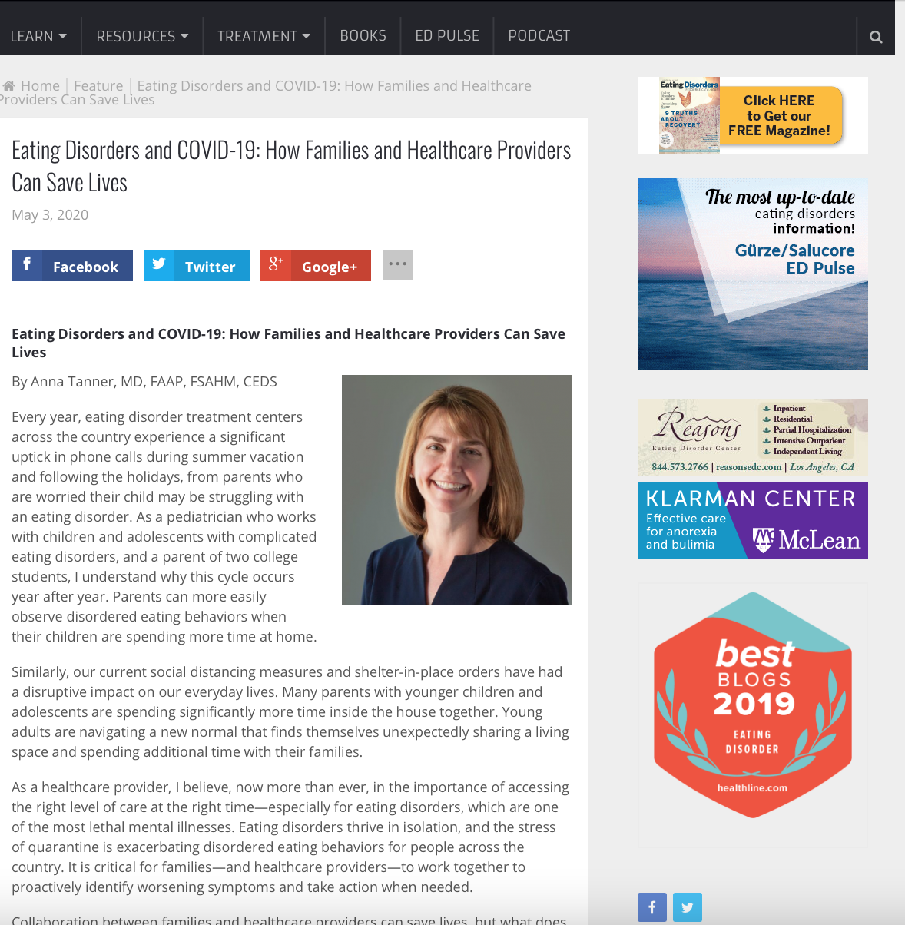
Website Critique
- Brief summary
The health information resource for this critique is a website owned by Lindsey Hall and Leigh Cohn who the authors of the first book written solely about bulimia called Bulimia: A Guide to Recovery. This website’s publishing company is LLC, which is a publishing company that has specialized eating disorders since 1980. The author of this resource is Anna Tanner who has a Masters degree in health and is the vice president of medical services for a national healthcare system that treats eating disorders. The purpose of this health resource is to provide people with information on eating disorders, COVID-19’s impact on eating disorders, and how families and health providers can help those struggling during the pandemic. The website states that isolation is what eating disorders thrive on, and that the stress of quarantine is intensifying eating disorders everywhere. It also notes that intervention from family and health care providers has the potential of saving the lives of those affected.
- Critique of Material
- Intended Audience
The indented audience for this website is the families of those struggling with eating disorders and healthcare providers which would set the age range somewhere between 18 and 65 years old. The audience will most likely have post-high school education as indicated by the SMOG test. Also, the targeted audience could be either male or female as there was no obvious gender indicated by the language used or pictures. The target audience would likely have an occupation of healthcare provider or parent, may be middle to upper income, and can be of any race or ethnicity.
- Evaluation of Source
The source is appropriate for the intended audience because it was created by graduate from a Master’s program and is the vice president of medical services for Veritas Collaborative, which is a national healthcare system for treatment of eating disorders. The creator, Anna, is also a board-certified pediatrician and certified eating disorder specialist who has over 20 years of experience. Additionally, Dr. Tanner oversees the programming at the Veritas Collaborative Multidisciplinary Eating Disorder Assessment Clinics in multiple East Coast states such as North Carolina, Virginia, and Georgia. The information is very recent as it was posted less than a year ago in May 2020 and is up to date in terms of the recent global pandemic. The website in itself is not visually appealing, it lacks the general graphic designs that would make it stand out, there are advertisements to the right that can be somewhat distracting, and there are no photos or illustrations other than the author’s photo. The reading level is appropriate for the audience as the SMOG test results indicated an age of 17 and above which matches that of the intended audience. The data for the website was gathered by the author herself and given the qualifications above and her experience in this field, the information presented is credible.
- Personal Reaction
Personally, I thought this website was a great source because it provided educational information based on expertise. I liked that the headlines for each part were clear, the format was easy to navigate, the author’s qualifications were included, and the source explained all the information while providing ways to help those who are suffering from an eating disorder. However, something I didn’t like was that there were no statistics or visual aids. The design of the website is a bit dull which can deter potential readers but overall, the source is exteremly informative. I would most likely use it in my health education and promotion efforts because it directly relates to the promotion of awareness about eating disorders during COVID-19 and it provides insight on how to help.
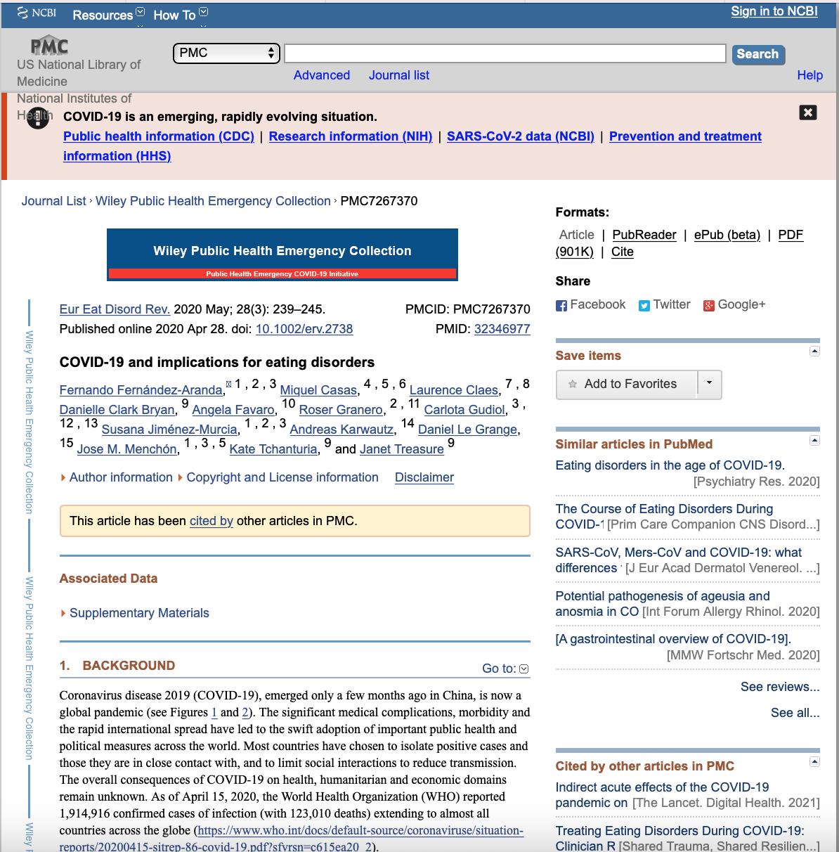
Government Document Critique
- Brief summary
The National Center for Biotechnology Information (NCBI) is part of the United States National Library of Medicine which is a branch of the National Institutes of Health (NIH). This center of information is funded and approved by the government of the United States. This source posted COVID-19 implications for eating disorders. The purpose of this document is to shed light on the fact that COVID-19 has increased the physical risk in patients with eating disorder due to isolation and reduced professional support. This document also emphasizes the challenges presented by COVID-19 and provides information on balancing the needs of eating disorders through the pandemic.
- Critique of Material
- Intended Audience
The indented audience for this government document is adolescents and their families which sets the age approximation at 14 years old and above. The content can be easily understood by those with nineth grade education level or higher. The document’s audience does not clearly target a single gender in the language used and does not provide any pictures to further identify the targeted gender, which mean that they could either be male or female. Furthermore, they would likely have the occupation of student in middle school, high school, or college students as well as their parents. And they may be of middle income and their ethnicity is not reflected in the government document.

- Evaluation of Source
The source is appropriate for the intended audience as it addresses general implications for eating disorders, family concerns about eating disorders, explains how to connect during isolation for those suffering from eating disorders, ways to help yourself and others, the challenges associated with reduced professional support during the pandemic, and balancing the needs of an individual suffering with eating disorders within the family. The reading level indicating by the SMOG test matches that of the target audience’s age. The government document is current and relevant as it was published in April of 2020 and revised in May 2020. I found the document to be visually appealing as it contains multiple figures that serve as visual aids and is generally well formatted with appropriate headings and organization which makes it easy to follow. The document is a credible resource that contains a good amount of helpful information for dealing with eating disorders during the COVID-19 pandemic.
- Personal Reaction
Personally, I believe that the material in this government document is useful, well expressed, and great resource to have for those suffering with eating disorders or their loved ones who want to help but are unsure of how to do so. I liked that the headings were provided for easier navigation through the material and that figures were present for further visualization of the material and emphasized the significance of the resource. I also enjoyed the fact that there was a table providing specific examples on conversations between those suffering from eating disorders and their caregivers as it plays a big role in understanding the mindsets. I would use this recourse in my health education lesson plan as it has proven credible and informative. It is also directly related to my specific health topic.
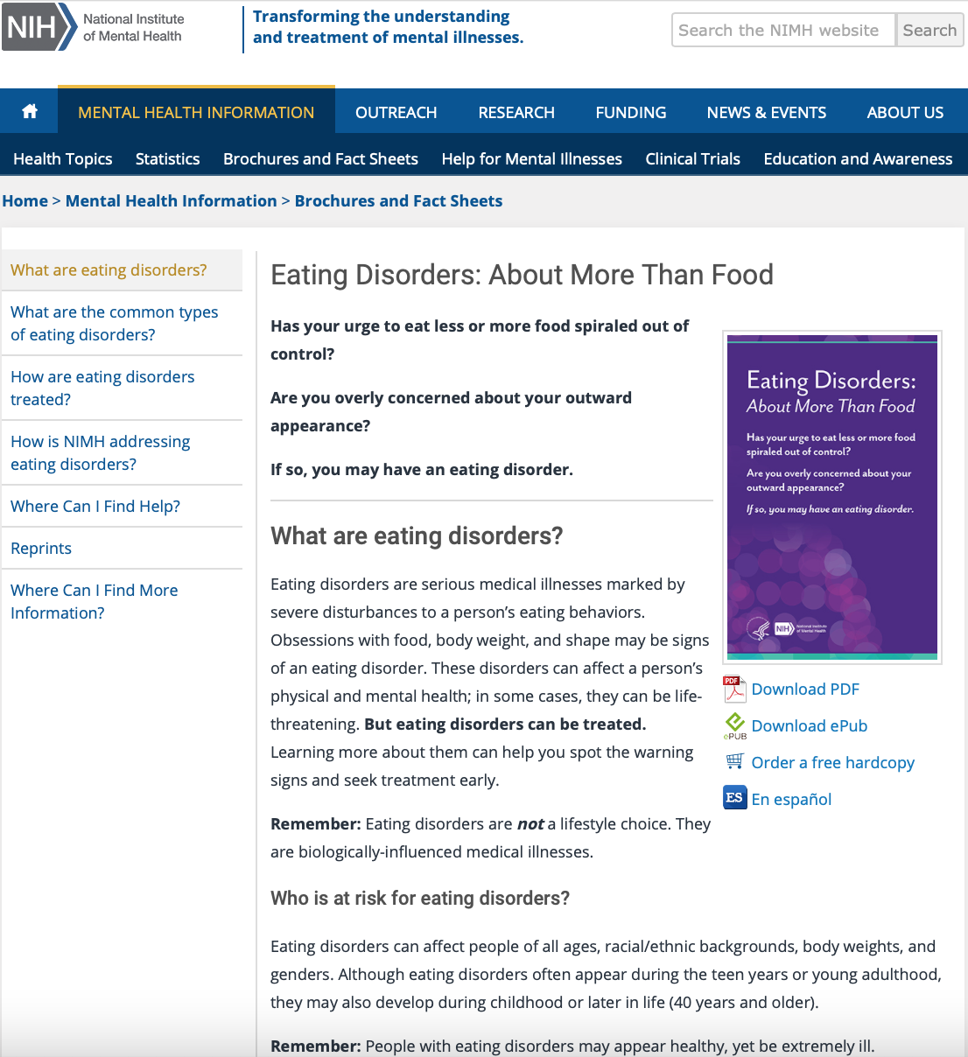
Educational Brochure/Fact Sheet Critique
- Brief summary
This resource is an educational fact sheet that provides its audience with a summary of what eating disorders are and many other additional facts. This fact sheet has information explaining what eating disorders are, the population at risk of eating disorders, the common types of eating disorders, symptoms of the three major eating disorders, treatment plans for eating disorders, how the National Institute of Mental Health (NIMH) is addressing eating disorders, how to participate in research, and how to find help for eating disorders. The purpose of this source is to educate the target audience by providing them with crucial information about eating disorders as well as promoting the treatment of eating disorders.
- Critique of Material
- Intended Audience
I believe that the intended audience for this fact sheet are 15 years old and above. The SMOG reading level test indicated that the vocabulary used is intended for education levels of tenth grade and higher. According to the fact sheet, it is intended for all genders and ethnicities as eating disorders can affect people from all genders and ethnicities. This fact sheet is meant to educate anyone who is willing to learn about eating disorders. The fact sheet is not aimed at people with a specific occupation or socioeconomic level.
- Evaluation of Source
I believe that this source was appropriate for the intended age group as it simply put but entirely based upon facts. The content of this fact sheet was last revised in 2018 so it is not very current, however, the information is up to date. I found the source visually appealing as the format was easy to go through, the points were clear and well organized. The source’s reading level is appropriate for the intended audience. This fact sheet is a credible and reliable resource as it was created by the National Institute of Mental Health which is a federal research agency.
- Personal Reaction
I think this is a really good source. I liked that it was simply stating the facts as fact sheets should. I also liked that it provides the reader with a multitude of resources for help and treatment, such as how to participate in a clinical study and number to reach help. There are not factors that I dislike about this source as it serves its purpose as a fact sheet and presents relevant information. However, I do think that photos or other visual aids would have made it more intriguing to a reader, especially for adolescents which seem to be the intended audience. I think this source would be valuable for my health education and promotion lesson plan. I would be able to obtain facts and other helpful recourses on eating disorders by including it. It could serve as background information to educate the audience and present them with an overview on eating disorders.
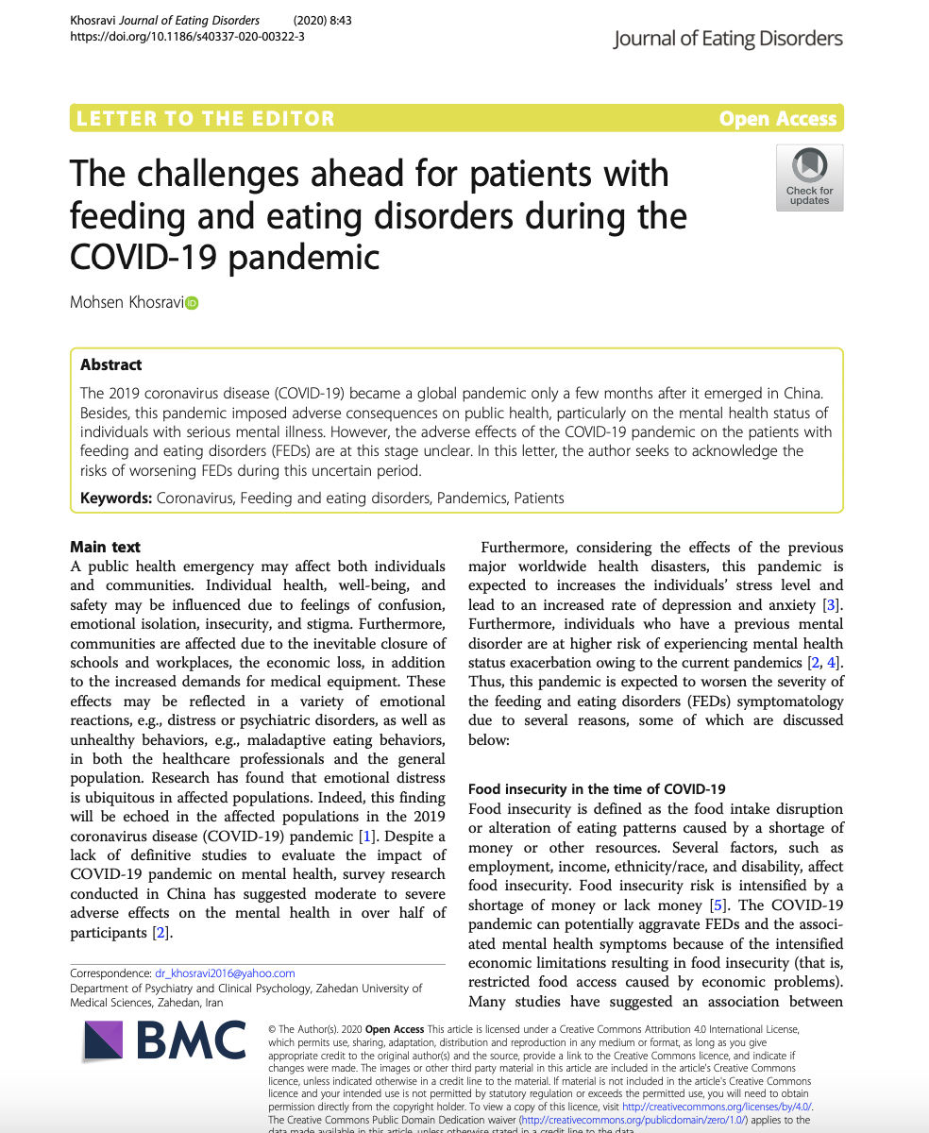
Peer-Reviewed Journal Article Critique
- Brief summary
This peer-reviewed journal article was published by BMC and created by Mohsen Khosravi who is who a Master’s degree obtained in 2012 from Isfahan University of Medical Sciences. The creator also completed psychiatry residency at Zahedan University of Medical Sciences, Iran in 2016. Afterwards he become an assistant professor and clinical psychiatrist as the same university he completed his residency at. The purpose of this journal article is to acknowledge the risks of worsening feeding and eating disorders during this uncertain period of COVID-19, as well as highlighting the food insecurity public health emergency occurring alongside the pandemic. As a scientific research paper, the article included multiple sections. Each section touches on a specific effect of COVID-19 on the individuals at risk. These sections highlight food insecurity in the time of COVID-19, the stressful effects of daily news, and the disruption of access to professional support caused by the pandemic.
- Critique of Material
- Intended Audience
The intended audience are individuals aged 21 and above. The material is catered towards those who may suffer the outcomes associated with food insecurity, eating disorders, and those who would like to educate themselves on the problems stemming from the pandemic. The education level of the readers would be high school and above. This article is not targeting one specific gender within its language and is open to all races and ethnicities. I believe that this journal article is aimed at a target audience of community organizers, local government officials, social workers, healthcare professionals, and care providers. Due to the mention of food insecurity as a main objective of this journal during an emergency, I would say that the socioeconomic level of those affected would be low-income, and middle-income for those within the targeted audience.
- Evaluation of Source
The source is appropriate for intended audience as it features and highlights the issues at hand. The author also explains the information in a way that the audience can understand. This source is current as it was received by the publisher in July of 2020 and then published in September of 2020. This source is relevant because it focuses on issues that remain in full effect to this day as the pandemic persists. The reading level is appropriate for the intended audience as anyone aged 14 or above should be able to read and comprehend it with no issues. This is a credible and reliable source, not only is it peer-reviewed, but the author is educated on the matter, uses facts, and references other peer-reviewed work.
- Personal Reaction
I think this was a really good journal article. It was informative and touched on issues that the other sources I have read did not. It was very informative as to how COVID-19 could play a role in increasing the risk of feeding and eating disorders. I liked that it emphasized the outcomes of food insecurity due to the economic limitations associated with the pandemic. If I had one suggestion to better this journal article, I would say that because the author has expertise within this area, he could have included a section of recommendations on how to reduce the prominent effects of COVID-19 on individuals with higher risks of feeding and eating disorders. I believe that this article has important information that could be useful in my health education and promotion plan.

References
Fernández-Aranda, F., Casas, M., Claes, L., Bryan, D. C., Favaro, A., Granero, R., Gudiol, C., Jiménez-Murcia, S., Karwautz, A., Le Grange, D., Menchón, J. M., Tchanturia, K., & Treasure, J. (2020). COVID-19 and implications for eating disorders. European eating disorders review : the journal of the Eating Disorders Association, 28(3), 239–245. https://doi.org/10.1002/erv.2738
FuseSchool – Global Education. (2017, Oct 15). Anorexia and Eating Disorders | Health | Biology | FuseSchool [Video]. YouTube. https://www.youtube.com/watch?v=jgjzUxosZ9o
Khosravi, M. The challenges ahead for patients with feeding and eating disorders during the COVID-19 pandemic. J Eat Disord 8, 43 (2020). https://doi.org/10.1186/s40337-020-00322-3
National Institute of Mental Health. (2018). Eating disorders: About more than food [Fact Sheet]. https://www.nimh.nih.gov/health/publications/eating-disorders/index.shtml
Tanner, A. (2020, May 03). Eating disorders and covid-19: How families and healthcare providers can save lives. Gürze Books LLC. Retrieved from https://www.edcatalogue.com/eating-disorders-covid-19-families-healthcare-providers-can-save-lives/

