Module 4 - SLP

PRIVATE SECTOR PARTNERSHIPS

Assess Crisis Management for Selected Organization
Private Sector Partnerships: Natural/Man-Made Disasters
Below are examples of private sector partners that should be covered in an emergency response plan for a town or city. Each are dependent upon the other and must work together:
- Transportation (e.g., trains, planes, emergency vehicles)
- Telecommunication systems
- Utilities (e.g., water, electricity, waste disposal)
- Banking (responding to local credit demands)
- Hospitals
- Retail (e.g., lumber outlet, supermarket)
This assignment required you to utilize an Excel (or any other) electronic data sheet. If you need assistance you can use the Excel Help options or see your Readings.
Scenario: A strong earthquake 50 miles west of the Southern California coastline created a tsunami wave that hit the beach cities of San Clemente, Dana Point, Laguna Beach, and Newport Beach. First responders are reporting continuously on human casualties: dead and injured, and structure damage: damaged and destroyed. You are at the County ICS command post, and receiving said reports from the field, compiling them within an Excel file. You are required to provide an updated and aggregate report to the incident commander.
Your assignment
Create a Bar Chart from the data compiled below. Hint: Cut and Paste the table onto Excel spreadsheet. Click “Insert” on Excel sheet; Left-click, hold down, and shade the entire table; scroll up and click “Recommended Charts;” and, click on a chart of your choice.
Submit your work to include:
- Your report table and chart.
- Point out the major findings of your report.
- Name the private sectors that will be involved in responding to the devastation. Comment on the private sectors that will be involved in responding to the devastation.

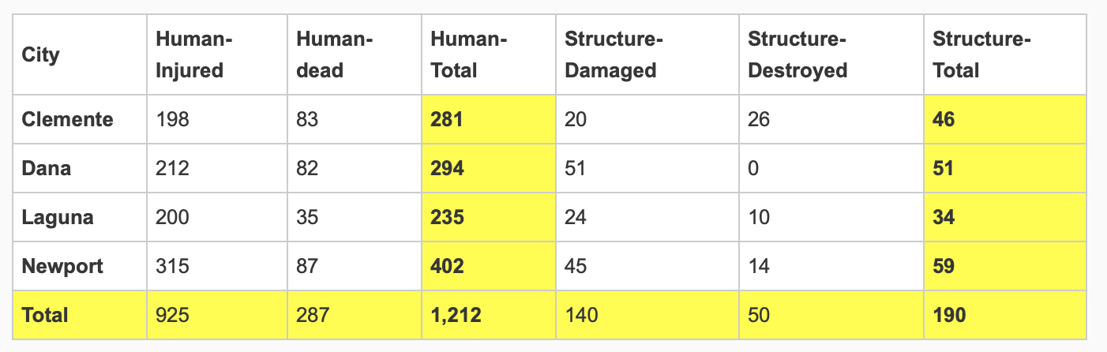

SLP Assignment Expectations
Length: This SLP should be 4-6 pages, not counting the title page and references.
References: At least two references should be included from academic sources (e.g., peer-reviewed journal articles). Required readings are included. Quoted material should not exceed 10% of the total paper (since the focus of these assignments is critical thinking). Use your own words and build on the ideas of others. When material is copied verbatim from external sources, it MUST be enclosed in quotes. The references should be cited within the text and listed at the end of the assignment in the References section (preferably in APA format).
Organization: Subheadings should be used to organize your paper according to question.
Grammar and Spelling: While no points are deducted for minor errors, assignments are expected to adhere to standard guidelines of grammar, spelling, punctuation, and sentence syntax. Points may be deducted if grammar and spelling impact clarity.

