Audience Profile

Audience and Purpose
Primary Audience: Sabrina Goodwin, Engineering Manager
Secondary Audience: Phillip Mitank, Plant Manager
Relationship with Audience: Supervisor
Purpose of Document: To propose an office redesign and assure employee and company benefits outweigh costs
Intended Use of Document: Persuade audience to approve a redesign of office space
Technical Background: None required
Prior Knowledge: May not know psychological benefits of spatial and physical environment factors
Information Needs: Needs to understand benefits of changes, time and money to implement
Cultural Considerations: USA Office
Probable Questions: How long will these changes take to implement, and will they be disruptive? Are these changes worth the cost?

Audience’s Probably Attitude and Personality
Attitude Towards Topic: Ambivalent and likely skeptical
Probable Objections: Initial time and monetary costs might outweigh any benefits. Might be too costly or disruptive to implement practically.
Probable Attitude Toward Writer: Open
Organizational Climate: Technical
Persons Most Affected by This Document: Engineers working in the office space
Temperament: Neutral
Probable Reaction to Document: Interest should be piqued. Reader should be reassured of costs

Audience Expectation About the Document
Reason Document Originated: My own idea
Material Important to Audience: Cost-efficiency
Potential Problems: Reader may require more justification, depending on the extent of changes proposed
Length and Detail: Concise but meaningful information
Tone: Business
Due Date: December 23, 2017

Determining a Cost-Efficient Renovation to Improve Employee Productivity and Welfare

Prepared for
Sabrina Goodwin
KMN Enterprises

By
Holly Hunter

December 19, 2018
The Letter of Transmittal will go on this page.

The Table of Contents will go on this page.

Introduction

Employee efficiency directly correlates with a company’s production capabilities. Productive employees will accomplish more in a given time frame, which translates to an increased work output without an associated increase in wages or work hours. Additionally, employee welfare indirectly influences a company’s value. Employees that enjoy their work environment will give positive employment reviews of the company. These ratings will attract future employees and ensure the growth of the company. Making changes to improve the quality of work life for employees would provide both short and long-term benefits to our company.

Among other factors, one way to improve employee productivity and welfare is through physical environmental changes. Studies by the American Society of Interior Designers show that the design of an office space can positively influence employee productivity and emotional state (ASID), though relationships between poor work environments and negative employee mental health have not been established (Shea, Pettit and De Cieri). Therefore, a cost-efficient renovation of the engineering office spaces is proposed. This redesign will improve the productivity and mental outlook of our engineers and has the added benefit of providing a case study for future office renovations at our company.

This report will explore the various influences on employees of different workplace environmental factors. It begins with a summary of daily functions specific to engineers and discusses means of improving the productivity of these functions by adjusting the office environment. Following this, the scope is expanded to generate design ideas for improving productivity and wellbeing across a variety of industries. Finally, the time and budget costs for making these changes will be evaluated, resulting in a final renovation plan that improves quality of work in a cost-efficient manner.

Data Section

Daily Functions of Engineers

KMN Enterprises employs a variety of engineers with different backgrounds, primarily mechanical and electrical engineering. Our engineers work in manufacturing as well as research and development. Engineers balance technical and creative work; they must generate innovative ideas to solve design problems, but must also run calculations and synthesize data. Any design changes made should facilitate both creative thinking and technical data processing. Engineers also work in collaborative and solitary capacities. Our employees often take on projects that span multiple disciplines or require teams of engineers working together. However, a number of our projects are run on individual bases; This, along with the range of introverted and extroverted personalities of our engineers, demonstrates the importance of individual work environments. Accommodations for private and collaborative work spaces should be incorporated into renovations. This is not an exhaustive list of functions our engineers perform, but these two functions can be promoted using two methods detailed in the next section.

Methods for Improving Productivity of Daily Functions of Engineers

Two spatial design methods are employed to facilitate the efficiency of our engineers. A study by the University of Minnesota demonstrates that ceiling height affects how information is processed (Meyers-Levy and Zhu). High ceilings (ten feet, in the study) promote abstract processing, while low ceilings (eight feet) facilitate concentrated thinking. The experiment was designed to study the effects of priming on consumer responses, but can reasonably be applied to the decision-making process utilized by engineers at KMN Enterprises. A nested cubicle design with variable ceiling height would spatially promote both processing methods for individuals. The high ceilings already found in the engineering offices would be offset by a portion of the cubicle covered at a shorter height. Engineers could adjust to work in either the high or low ceiling environment, depending on their work throughout the day.

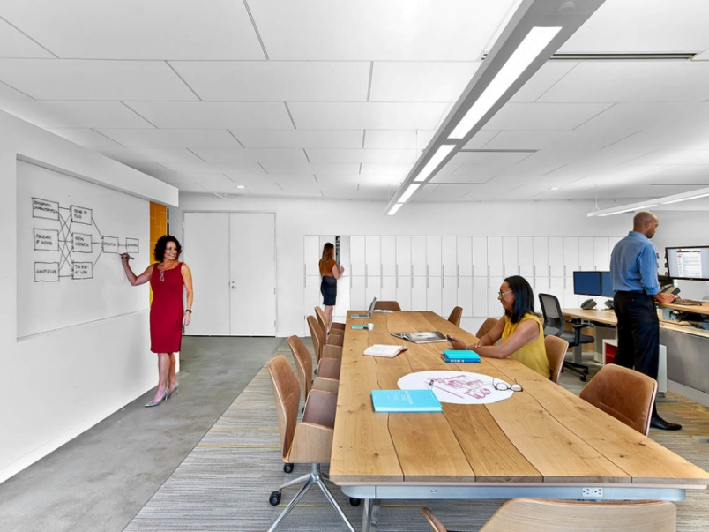
This method addresses the different kinds of thinking employed by engineers, but only accounts for individual work. In addition to cubicles, a portion of the office space should be dedicated specifically to group work, along with our existing meeting rooms. A large and inviting congregation area will encourage engineers to work together rather than in their own cubicles. Like the ASID office design shown in Figure 1, this area would have large tables where teams could sit and work together, in addition to dry erase boards or walls for collaborative brainstorming. No ceiling height changes would be employed; the existing high ceilings would promote the creative thinking needed for team projects. Both of these design changes should lead to increased productivity by promoting general functions of our engineering team (ASID).
Figure : Collaborative Team Work Room (ASID)X

Additional Methods for Improving Productivity and Employee Welfare

The previous discussion can be expanded to determine design improvements for productivity and employee wellbeing across all industries. Again, this is not an exhaustive list of enhancement measures, but provides several changes that could prove beneficial to our work environment. Both general concepts and specific products will be explored.

The first concept to be explored is that of biophilia. Biophilic design focuses on intentionally adding elements of nature to a solution. Grinde et al. demonstrates the emotional and health detriments associated with a lack of nature in everyday life, and surmises that an inclusion of nature can reduce stress and improve emotional states (Grinde and Patil). ASID’s design supports this idea by including potted plants in their office space (ASID). Plants also promote health by improving air quality and humidity (OEG Interiors). KMN Enterprises could use this information and incorporate elements of nature in the engineering offices. Planter boxes by windows or small potted plants at employees’ desks or in congregation areas would introduce biophilia to the office and contribute to the overall mental health of our engineers.
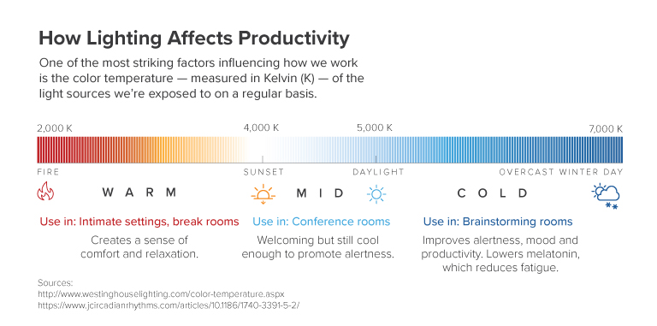
The second concept discussed is lighting in the workplace. Proper lighting in the workplace can improve productivity and mental health. Ergonomic lighting should be a balance of variables: warm and cool, natural and artificial, direct and indirect (deluxe lighting). The temperature of light can affect productivity, supported in Figure 2. Medium temperature lights are recommended for general use, with cooler temperature lights employed in brainstorming areas like the collaborative teamwork room.
Figure 2: Lighting Temperature Spectrum and Uses (MBA@UNC Staff)

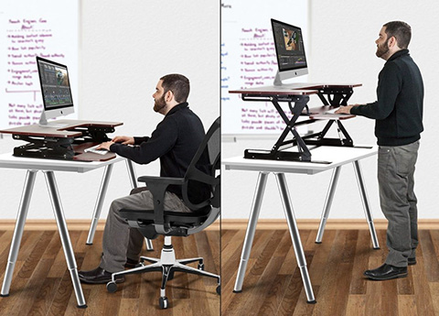
The windows already in the office provide excellent natural light, which could be paired with interior light fixtures to balance light sources. Fixtures should also be selected to reduce glare on computer screens and workspaces by providing indirect lighting. Work requiring more light would be accommodated by the addition of local light fixtures at employee workspaces. These fixtures would be flexible so light levels and incident angles could be adjusted by employees. Integration of some or all of these measures would improve the lighting in the offices and lead to increased performance and employee wellbeing.

Finally, a specific product will be discussed: the standing desk (shown in Figure 3). The standing desk advertises improved health by reducing the sedentary time spent in the workplace. It also claims to improve mental health, which may affect productivity (Leech). There is some disagreement on the true psychological and physiological advantages to standing desks (MacEwen, MacDonald and Burr) (Shmerling), but sources generally indicate some health benefits without a decrease in productivity (Chau, Sukala and Fedel).
Figure 3: Sit-Stand Desk

With this in mind, engineers in our group could be presented the option of exchanging their desk for a standing desk, or a sit-stand desk that can be converted between the two modes. This exchange could provide health benefits and factor into overall improvement in employee wellbeing.

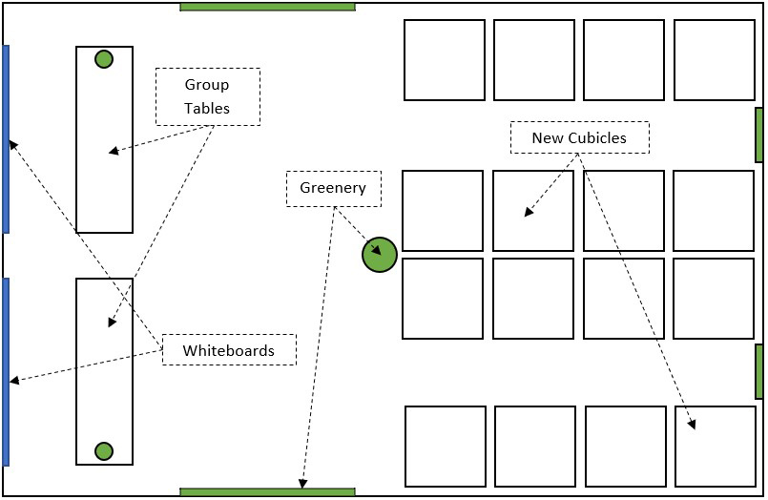
Figure 4: Potential New Floorplan for Engineering Offices

Time and Monetary Considerations

To summarize the previous sections, five major categories of renovations are proposed as follows.

- Convert cubicles to promote abstract and concrete processing of information.
- Create a welcoming team workspace that encourages employees to collaborate without compromising individual office areas.
- Introduce biophilic elements such as potted plants or window boxes to improve office atmosphere and employee wellbeing.
- Design a balanced and adaptive lighting scheme that promotes productivity while reducing employee strain.
- Provide employees the option of a standing or stand-sit desk to improve physical health, which may lead to improved emotional health and productivity.

Of these design changes, the third and fifth could be easily implemented in the quickest amount of time. Planting could take place over the course of a workday, after hours, or on a weekend with little interference in office workings. The desk replacements could be initially disruptive but could also be accomplished during off hours or over a weekend or series of weekends. After the initial replacements, the process would be significantly less of a hassle, as new employees could be given the option of a sitting or standing desk at their hiring date. Installation of the cubicle conversion could be accomplished on a similar time frame as the desk replacements.

However, the cubicle conversion (assuming our existing cubicles were used rather than purchasing new ones) would require either research into purchasing the ceiling modifier or designing and fabricating a custom component to meet the need. The collaborative work area would require a minimum of a week to refurbish the office space, relocate cubicles, and purchase and place new furniture. The timeline for lighting renovations is the most tenuous due it its multifaceted nature and is dependent on the extent of renovation desired.

The third design change would be the most cost-efficient; personal plants are relatively cheap, and the small scale of our office would reduce costs associated with planter boxes and other plants. The fifth design change would require the initial cost of the new desks, but their quick construction time and optional implementation would reduce costs. The second and fourth design changes are ranked next in cost-efficiency; these require purchased components and time to implement. The lighting adaptation could be designed to save energy and reduce cost of utilities to mitigate the cost. Finally, in the event of a custom designed part, the first design change would prove the most expensive to implement, requiring the time of an engineer or contractor to design and the cost of fabrication. Each of these design changes would improve productivity or employee wellbeing but must be weighed with their respective costs and time to implement.

With these considerations in mind, I have ranked the proposed design changes by a qualitative analysis of the time and monetary costs. These suggestions are independent and can be accomplished in any order or can be combined for greater changes. Executing these design changes in the engineering offices and analyzing employee outlooks and production abilities will provide a valuable case study for office renovations and employee work quality that can be applied to all departments in KMN Enterprises.

- Introduce biophilic elements such as potted plants or window boxes to improve office atmosphere and employee wellbeing.
- Provide employees the option of a standing or stand-sit desk to improve physical health, which may lead to improved emotional health and productivity.
- Create a welcoming team workspace that encourages employees to collaborate without compromising individual office areas.
- Design a balanced and adaptive lighting scheme that promotes productivity while reducing employee strain.
- Convert cubicles to promote abstract and concrete processing of information.

Conclusions

Implementation of some simple interior design modifications can have positive impacts on the productivity and welfare of employees. Varying work environments spatially promotes productivity by encouraging collaboration and facilitating left and right-brained thinking. Introducing biophilic design elements improves employee outlooks and mental health. Balancing variables associated with lighting can promote productivity and ergonomics. Finally, use of popular products like the standing desk can improve health at the very least, if not benefit employees in other areas.

Cursory thoughts indicate that biophilic design elements would be the most cost-efficient to implement, while the cubicle conversion would be the least. A more in-depth study could be performed as to the exact material and labor costs associated with these renovations. I recommend implementing the first two design changes as ranked above due to their low-risk natures. The remaining three should be analyzed further to determine their true cost-effectiveness for long term improvement in employee productivity and welfare.

Works Cited

(ASID: , (ASID),
Shea, Pettit and De Cieri: , (Shea, Pettit and De Cieri),
Meyers-Levy and Zhu: , (Meyers-Levy and Zhu),
ASID: , (ASID),
Grinde and Patil: , (Grinde and Patil),
OEG Interiors: , (OEG Interiors),
MBA@UNC Staff: , (MBA@UNC Staff),
deluxe lighting: , (deluxe lighting),
Leech: , (Leech),
MacEwen, MacDonald and Burr: , (MacEwen, MacDonald and Burr),
Shmerling: , (Shmerling),
Chau, Sukala and Fedel: , (Chau, Sukala and Fedel),

