Answered step-by-step
Juntional & Heart Block Rhythms: Find your assigned question and strip. Assume strip is from lead II. Most strips are 6 seconds in duration. For the strip in question #5, see note about duration. For your question, answer the following items based on the associated strip. •
State the interpretation of the rhythm and describe the characteristics listed below.
State which, if any, characteristics cannot be determined.
o Interpretation
o Regularity: atrial and ventricular
o Rate: state method used and rate (round to nearest whole number). If rhythm is irregular, state lower and upper range of the rate.
o P wave
o PR interval
o QRS complex
o QT interval
o ST segment
o T wave
• For the identified rhythm; discuss possible causes, nursing implications, and potential management strategies.
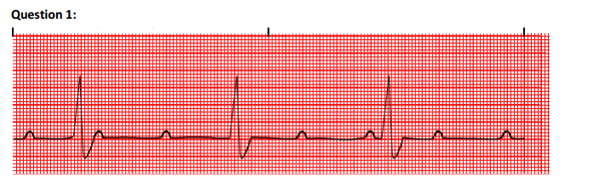
Health ScienceScienceNursingNUR 3276
Share Question
Answer & Explanation
Solved by verified expert
This is a 3rd degree AV block
Step-by-step explanation
Interpretation: 3rd degree AV block
Regular rhythm with Atria and Ventricle asynchrony where p waves are marching through the qrs complex
Rate is 33bpm with 45 small squares in between QRS 1500/45 = 33
P wave is upright and unremarkable at regular interval
Pr interval is prolonged
QRS complex is narrow 0.08s
QT segment cannot be measured

The cause for this would be an inferior myocardial infarction
This may lead to cardiac arrest if not managed as soon as possible
Management includes transvenous pacemaker especiall for people who cannot receive atropine
Transcutaneous permanent pacemaker should be given to allow synchrony of the atria and valves
ReplyForward

