1. Which do you find more enjoyable?
Dealing with real-life, concrete situations, such as closing deals, winning new clients and reviewing data.
Imagining new products that don't yet exist and daydream about how you might be able to develop them.
2. Which description best fits you?
I'm not terribly absorbed by natural or artistic beauty; I relate more to people, things, and information.
I respond powerfully to beauty and often find it in things others don't, whether in the arts or nature.
3. Which statement is most true of you?
I am very aware of how my behavior and decisions are influenced by what I feel.
I make sure I keep my emotions from affecting my business decisions.
4. When you hit an obstacle in reaching a goal, which are you more likely to say to yourself?
"If I just stick to my game plan and persevere, I'll get there; I've done it before."
"Maybe there's another way to reach my goal; besides, I'd rather try something new anyway"?
5. When a conversation at a business gathering turns to abstract ideas such as philosophy or a discussion of aesthetics, which would you tend to do?
Find yourself interested in hearing various ideas and opinions, and perhaps even join in the conversation?
Find another conversation; you can't be bothered with all that irrelevant debating.
6. Which concept appeals to you most?
"Think different"
"A tradition of excellence"
7. Which statement has been more applicable to your career?
"If I can believe it, I can achieve it."
"The only believable victories are probably the temporary and partial ones."
8. If you had to organize your own daily schedule and calendar, you would
miss or be late for a lot of meetings.
be fine; you're highly organized about most things.
9. If you're forced to break a promise to your best friend, which would you be more likely to say to yourself?
"Well, we're good friends; he'll understand."
"I'll either find a way to keep my promise eventually or make it up to him somehow."
10. What you accomplish in your life defines who you are.
I agree.
I disagree.
11. Which statement best describes what you do when faced with a task you dislike?
"The sooner I get this out of the way, the sooner I won't have to think about it anymore."
"I know I've got to do it sometime -- just not now."
12. When you use your intuition in making a decision, which do you typically do?
Rely on your initial gut reaction, which usually proves to be the right one anyway.
Consult your intuition only after you've spent some time thinking through all the issues first.
13. When you meet someone whose company you enjoy, which are you more apt to do?
Wait for them to indicate an interest in getting together.
Invite them over to your house for a social engagement.
14. After you've been to a party with a lot of other people, which are you more likely to feel?
Energized, maybe even sorry to leave the party.
Tired and ready for some quiet time alone?
15. When a meeting you're involved in but not responsible for seems to be drifting and ineffective, how do you react?
I try to take charge and focus the discussion.
I wait to see if the discussion becomes more productive and something valuable will emerge.
16. On vacation, how would you prefer to spend most of your time?
Going, doing, and seeing as much as possible.
Relaxing, reading, and kicking back.
17. If you were a car, which would you prefer to be?
A classic Bugatti, carefully tended and pampered by your owner.
A Ferrari Modena, racing from Paris to Dakar.
18. Do people often comment on your ability to create an atmosphere of joy and cheerfulness?
Yes
No
19. When working with a new client, which would you be more likely to do?
Go ahead and get started on the work based on a handshake.
Start work only after all contracts have been finalized and signed?
20. If you had to reschedule a client meeting because something more important came up, which would you be more likely to do?
Give the client a flattering reason, even if it's only partly true.
Be straightforward about why you have to cancel.
21. When colleagues come to you with a problem not of their own making, how are you more likely to feel?
Secretly resent helping because "He should be able to handle his own problems."
Happy to do what you can to help because "We've all been there."
22. If a group of your colleagues insisted on pursuing a plan you absolutely knew would create problems for your company, how would you handle it?
Fight for your idea, even if it means some serious confrontation.
Quietly point out the problems but agree in advance that you'll do whatever everyone else wants.
23. When you've been successful at something, you feel it's been mostly because
You've had a lot of help from others, great opportunities, and a little luck.
You've worked harder and smarter than a lot of other people.
24. When you watch a presenter stumble through harsh questioning from an audience, which would best describe your mental attitude?
Critical of the person's lack of preparation.
Sympathetic for the person's discomfort
25. When you make a decision, which do you tend to do?
Worry a lot about the worst-case scenario so you'll be prepared if it happens, and worry afterwards about the consequences.
Make it quickly and move on.
26. If you lost a competitive bid and found out that the client had given the winner inside information that wasn't available to you, how would you be more likely to feel?
Angry and resentful that the bidding was unfair.
Glad you aren't going to do business with a dishonest client.
27. When it comes to having "the blues," which do you tend to do?
Lose energy, get discouraged, and have trouble getting yourself motivated again.
Shake them off easily when they happen, which isn't often.
28. When you're in social situations, you are
Rarely nervous; you're not generally worried about the impression you make on others.
Very aware of what other people think about you, and conscious that others watch and evaluate you constantly.
29. If you see something you love but can't afford, which are you more likely to do?
Resist the craving until you're sure the purchase won't affect your other financial plans and dreams.
Go ahead and get it; you'll figure out later how you'll pay for it.
30. When you're under stress, how do you react?
You battle to fight off feelings of panic, confusion and helplessness.
You feel a weird sort of clarity and resolve; pressure often brings out the best in you.
31. Have you ever started your own business?
Yes.
No.

***FEEL FREE TO TAKE THE QUIZ AND SUBMIT YOUR ON ANSWERS. I HAD TO ANSWER THE QUIZ TO GET TO THE NEXT PAGE. THANKS****
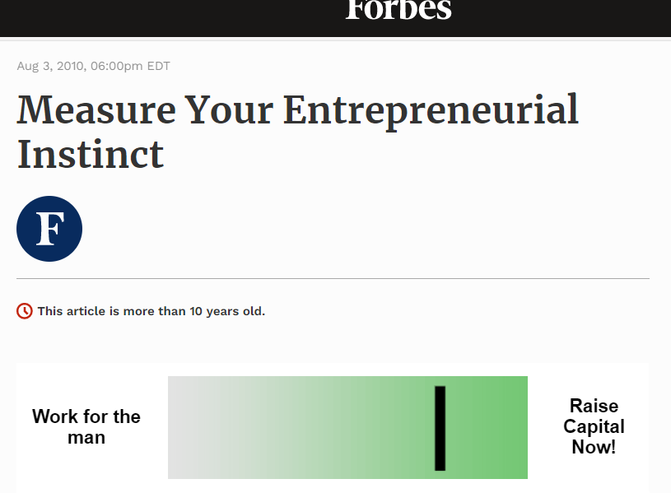

This is the website where I took the quiz: (You may need to add this site to your references as well)
https://www.forbes.com/2010/08/02/entrepreneur-personality-quiz-thomas-harrison-entrepreneurs-management-serial-startups-10-quiz.html?sh=f57bbbc488b1

