Emergency Operations and Disaster Management

Student’s Name
Institutional Affiliation
Course Name
Professor's Name
Date

Emergency Response Plan
Wildfires
For my Session Long Project, I select San Francisco, California, as my community. One disaster I intend to plan for in my Emergency Response Plan (ERP) is wildfire. I selected this disaster since California is facing an increasing forest and wildfire crisis. In this regard, about forty million acres of land inside California are in danger of wildfire, with approximately twenty million acres in great jeopardy. Furthermore, approximately eight million acres of land in California is established with housing unit densities considered to meet the Wildland-Urban Interface ideals (WUI), with about fifteen million families located in the WUI. Additionally, previous wildfire incidents have resulted in about two thousand injuries, claimed approximately a hundred lives, and cost the governor’s office about two billion dollars due to emergency services (Brown & Ghilarducci, 2017).
The other reason for selecting this disaster is that the growing impacts of climate change and fire suppression have naturally augmented wildfires’ intensity in the state. In addition, California faces many years of severe drought conditions due to its fire threat that results in unprecedented activity changes and fire behavior. For instance, the 2020 fire season broke many records. Five of the state’s six major fires in recent history scorched all at once, forcing thousands of individuals to flee their homes, destroying thousands of buildings, and exposing millions to dangerous, unhealthy air. From this viewpoint, more than four million acres of land burned across the state. On another matter, I intend to plan for this disaster since it will help restore the health of our diverse landscapes and forests across the state by strengthening wildfire preparation.

Figure 1
Mt. San Miguel is on fire. San Diego County wildfire.
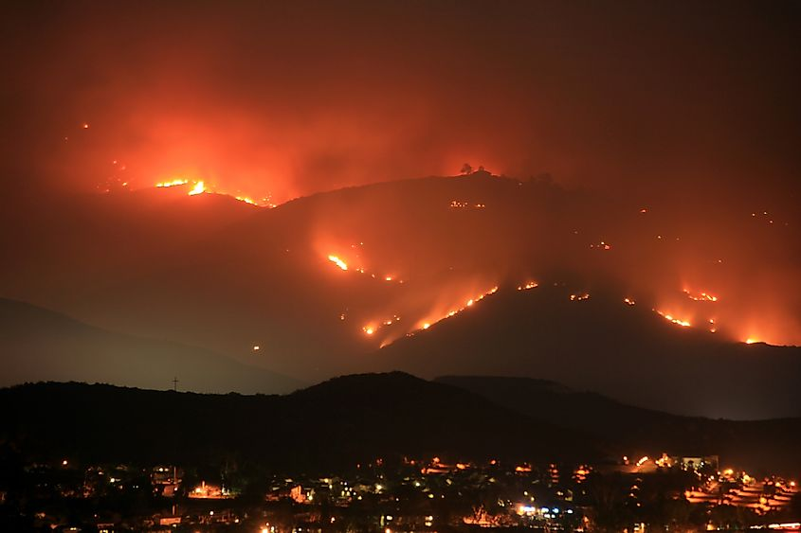
Note. This is Mt. San Miguel in San Diego County where wildfire can be seen raging on the mountains in the middle of the night. From “The US States Most Prone to Natural Disasters,” by K. Key, 2021 (https://www.worldatlas.com/articles/the-10-states-most-prone-to-natural-disasters.html). Copyright 2021 by World Atlas.

Figure 2
Top 20 Largest California Wildfires.
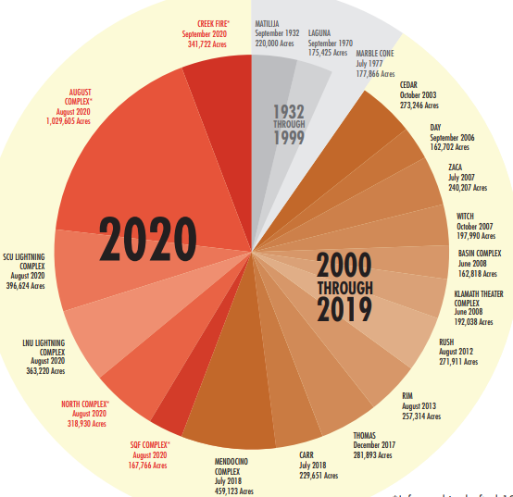

Note. The year 2020 takes up a huge potion while a decade ago. From Top 20 Largest California Wildfires, by Force Management Task Force, 2021, California Wildfire and Forest Resilient Action Plan. (https://www.fire.ca.gov/media/ps4p2vck/californiawildfireandforestresilienceactionplan.pdf). Copyright 2021 by Force Management Task Force.

Flooding
The other disaster I intend to plan for in my ERP is flooding. I selected this disaster since California has experienced destructive flood events throughout history. Despite federal, state, and local management agencies' continuous investments and action, flood risks exist in every county in California. Throughout California’s history, floods have caused extensive damages. For instance, the impacts of floods between 1954 and 2015 claimed about three hundred lives and a thousand injuries. More than seven million people and over six hundred billion dollar’s worth of assets are exposed to the dangers of flooding within the five-hundred-year floodplains. From this consideration, flooding can affect the state at different times and in diverse ways based on the climate, land, or hydrology complexities. The other reason for choosing this disaster is that its highly populated counties are susceptible to floods and have a high number of people with disabilities. Therefore, developing an emergency response plan for this community would help in saving money and lives.
Furthermore, I selected this disaster since the state faces various significant flood management challenges. California’s extensive flood management infrastructure was not designed to account for evolving statewide objectives, conditions, and scientific knowledge (Ehlers, 2017). Most urban and rural regions are not secured by barriers and are subject to repeated, periodic flooding by local streams or rivers.

Figure 3
List of flood-related events in California
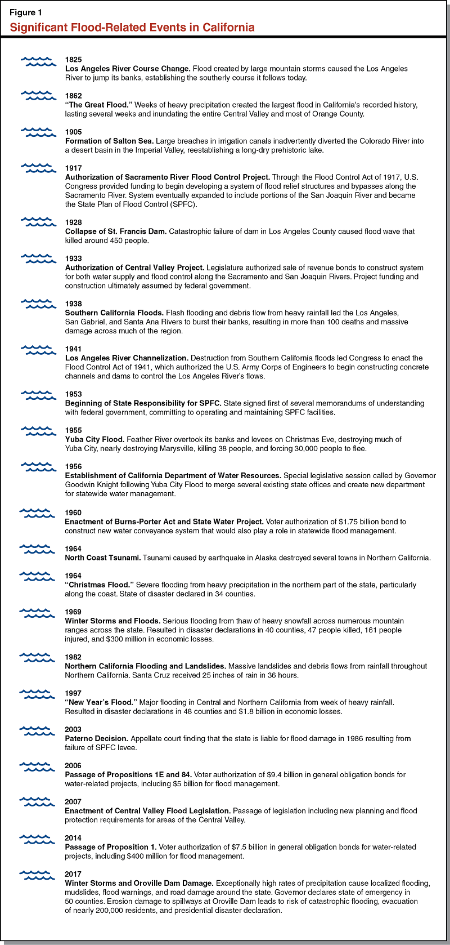
Note: A list of flood-related events that have occurred in California over the years. From Legislative Analyst’s Office, by R. Ehlers, 2017, Significant flood-related events in California (https://lao.ca.gov/Publications/Report/3571). Copyright 2017 by R. Ehlers.

Earthquakes
The other disaster I intend to plan for is earthquakes. I selected this disaster since California has the most extensive seismic risk exposure compared to any other state in the country. Conferring to the Federal Emergency Management Agency (FEMA), the average annual projected losses to the building stock are about four billion dollars in California or seventy-five percent of all the country's annualized risk. This is due to the combination of high concentration and seismicity of population and associated industries in seismically actives areas. Additionally, California lies on the boundary of two major tectonic plates that move past each other at a rate of two inches per year. In this regard, much motion is billeted sporadically by a sudden slip along the faults and boundary nearby, thus producing seismic activity. On another matter, more than seventy percent of California’s inhabitants dwell within thirty miles of a fault, where sturdy ground quaking could happen in the coming years. From this regard, planning for earthquakes will aid in saving lives and enhance the consistency of electricity as well as transportation lifelines through careful research and implementation activities (Brown & Ghilarducci, 2017). In conclusion, planning for this disaster will assist those accountable for public safety in deciding where actions to minimize forthcoming earthquake damages will be operational.

Figure 4
Southern Californians Cope with Earthquakes
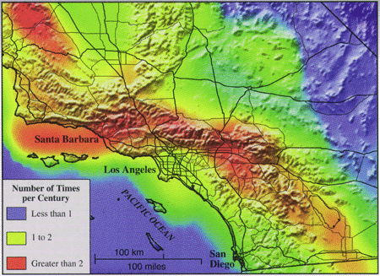
Note: Shows the rate of earthquakes in Southern California. From US Geological Survey, by W. Prescott, and M. Diggles, 2005, (https://pubs.usgs.gov/fs/1995/fs225-95/). Copyright 2005 by US Geological Survey.

References
Brown, E. G., & Ghilarducci, M. S. (2017). State of California: Emergency Plan. Retrieved from The Great Seal of the State of California: https://www.caloes.ca.gov/PlanningPreparednessSite/Documents/California_State_Emergency_Plan_2017.pdf
Ehlers, R. (2017). Significant Flood-Related Events in California. Retrieved from Managing Floods in California: Legislative Analyst's Office LAO: https://lao.ca.gov/Publications/Report/3571
Force Management Task Force. (2021). TOP 20 LARGEST CALIFORNIA WILDFIRES. Retrieved from California's Wildfire and Forest Resilience Action Plan: https://www.fire.ca.gov/media/ps4p2vck/californiawildfireandforestresilienceactionplan.pdf
Key, K. (2021). The US States Most Prone To Natural Disasters. Retrieved from WorldAtlas: https://www.worldatlas.com/articles/the-10-states-most-prone-to-natural-disasters.html
Legislative Analyst's Office LAO. (2017). Significant Flood-Related Events in California. Retrieved from Managing Floods in California: https://lao.ca.gov/Publications/Report/3571
Prescott, W., & Diggles, M. (2005). Southern Californians Cope With Earthquakes. Retrieved from USGS: https://pubs.usgs.gov/fs/1995/fs225-95/

