5.2 Discussion: Literature Review
INSTRUCTIONS
Getting Started
A literature review serves three significant purposes. First, the literature review helps the researcher better understand the topic. Second, the literature review demonstrates knowledge of the research field. Third, the literature review provides focus for readers to understand the information related to the topic. This assignment will help you develop your literature review in your program evaluation in the SWK-661 course.
Upon successful completion of this discussion, you will be able to:
- Analyze research literature for examples of research theory in clinical practice.

Background Information
As stated, there are three main purposes of a literature review:
- Probably the most important purpose is to develop the researcher’s understanding of the topic. For example, the researcher will understand what has been done in relation to the topic, understand the different methodologies that have been used, enhance his or her understanding of the vocabulary used with the topic, and identify any specific gaps in the research.
- Another important purpose is to demonstrate knowledge of the research field. This exhibits proficiency with the research area, improves the credibility of the research study, and generates interest in the study.
- A third important purpose is to help readers understand the information related to the topic. This is accomplished by developing the background for the research, updating the reader’s knowledge of the field/topic, and improving the reader’s overall understanding of the problem.
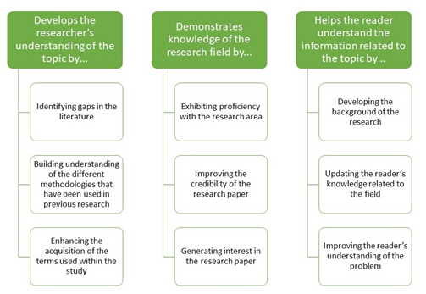

Instructions
- Review the rubric to make sure you understand the criteria for earning your grade.
- Read Chapter 4, “Literature Review” from the textbook Research Methods for Social Workers: A Practice-Based Approach.
- View the following resources:
  - PDF File: What is a Literature Review?(new tab)
  - Video: Interview on the Purpose of a Literature Review(new tab)
https://www.youtube.com/watch?v=rtPkCfbQWLk
- Respond to the following prompts:
  - Identify and discuss the three purposes of the literature review.
  - Give at least two examples of each purpose.
- Your initial post of at least 250 words is due by the end of the third day of the workshop.

