1. Consider the animal imagery of the Minoans and the Myceneans. How does it compare and contrast? What do the animals symbolize for each respective civilization?

Identify and include the four works below in your three-paragraph analysis and bring in an additional example from modern day addressing how an image of an animal represents a particular message. Your analysis should address the points put above, supported by at least one scholarly source.
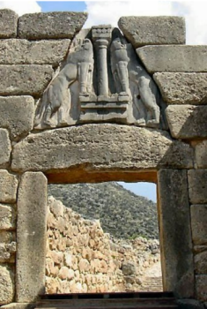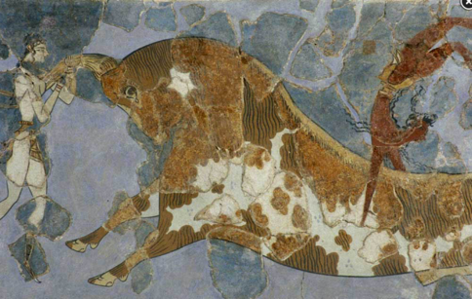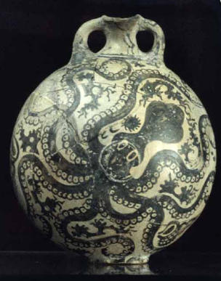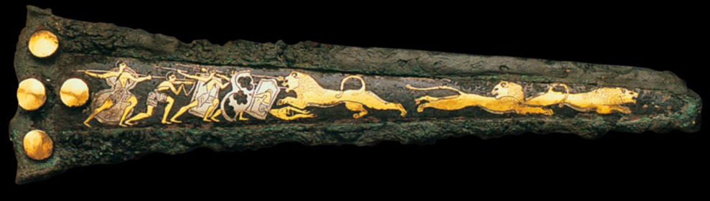

2. What do the Minoan paintings tell us of their relationships with the animals that inhabited the land and water they shared?
Be sure to cite examples to illustrate your points.

