NUR 335 Practicum Assignment 5.1
Health Promotion Assessment Worksheet
A health promotion assessment is a targeted assessment where the nurse assesses for health risks and education gaps that can be improved through health promotion interventions
Use this worksheet to interview an individual. There is a section at the bottom for you to add additional assessment information. Document your findings on the worksheet

Demographics
Initials: K.G.______________  Age: _16_________________  Sex: _Female__________________ | Primary Language Spoken: English____________  Cultural Background: Asian  ___________________  ______________________________________
General Health
How would you rate your general health? | Moderate
Have you had a wellness checkup with a healthcare provider in the past year? | Yes
Have you ever been told by a health care provider that you have a chronic disease such as hypertension, diabetes, heart disease, stroke, arthritis or kidney disease? | Yes
In the past month, have you had pain on more than three days that impacted your ability to perform your normal daily activities?  If yes:  - Where was the pain located?  - What have you tried to relieve the pain? | Yes  Joints  Physical exercise
How would you rate the quality of your sleep?  - How many hours do you regularly sleep in a night?  - Do you ever wake up before you wanted to?  - Do you have problems falling asleep? | Moderate  6 hours  Yes  Yes
Medications
Are you currently taking medicine for any chronic condition?  - Do you know what the medication is used to treat?  - Have you missed doses of your medication in the last week? | Yes  Arthritis  Yes
Women Only:
Are you pregnant or planning on becoming pregnant in the next year? | No
A mammogram is an x-ray of each breast to look for breast cancer. Have you ever had a mammogram?  - If yes, when was your last mammogram? | No
A Pap test is a test for cancer of the cervix. Have you ever had a Pap test?  - If yes, when was your last Pap test? | No
Men Only:
A PSA test is a test for cancer of the prostate. Have you ever had a PSA test?  - If yes, when was your last PSA test? | N/A
Lifestyle
Do you now smoke cigarettes every day, some days or not at all?  - If you are currently smoking, have you tried to quit?  - If yes, what methods have you used to quit smoking?  - Were the methods successful? | Not at all  N/A  N/A
For the questions below consider the past week in your answer:
How many times did you take part in physical activity of at least 30 minutes during the past week?  - If yes, what type of physical activity?  - If no, why?  - Was the past week representative of your normal level of physical activity? | Twice a day  Stretching  Yes
How many hours a day in the past week do you think you spent on sedentary activities where you remained sitting for extended periods of time?  - What activities were you doing during these times? | 4 hours  Computer use
To the best of your recollection, what food items have you eaten for breakfast in the past week? | Legumes, baked foods and dairy products
To the best of your recollection, what food items have you eaten for lunch in the past week? | Vegetables, meat and cereals
To the best of your recollection, what food items have you eaten for dinner in the past week? | Vegetables, sweet potatoes and fruits
What beverages do you routinely drink?  - How many times per week did you drink soda or pop?  - How many glasses of water do you drink in a day? | Plain water, tea, soda  2  8
Do you eat snacks throughout the day?  - If yes, what snacks do you routinely eat?  - What time in the day do you regularly eat snacks? | Yes  Salted chips and candy  3pm
How many times per week have you skipped meals? | 3
For the questions below consider the past 30 days in your answer:
What is the largest number of alcoholic drinks you had on any occasion in the past 30 days? | N/A
Have you used any drugs or other substances, other than those that are prescribed for medical reasons?  - If yes, what substance(s) did you take?  - How many times have you used this substance in the past 30 days? | NO
In the past 30 days, how many times have you eaten a meal outside of the home; at a restaurant or other venue? | 15
For the question below, consider all lifestyle behaviors (combined) in your answer:
Do you believe you lead a healthy lifestyle?  Please explain your answer? | Yes  I try to exercise and eat healthy diet as advised by my doctor.
Mental Well-Being
How often do you experience stress that exceeds your ability to cope?  - What strategies do you use to control stress? | 2 times a week  Sharing my challenges with family members
How often do you get the emotional and social support you need?  - Who would you describe as your support system? | In most cases  My mom
Over the last two weeks, how many days have you felt down, depressed or hopeless?  - If you have felt these feelings, what actions did you take to make yourself feel better? | 2 times  I shared with family members
Access to Preventative Services
Do you feel you have access to preventative health screenings and education?  - Do you have health insurance?  - Have you ever skipped care (Prescriptions, therapy, specialist visits etc.) that was recommended to you because of concerns regarding the cost of the care? | Yes  Yes  Yes
Education
Where do you normally receive health information? Examples could be the internet, health care provider, family or friends, etc. | Health care provider
What health topic(s) would you like to have more information on, if available? | Arthritis control, management and treatment
Other Assessment Information
Are you married?  Do you find those who are assisting you in managing your health condition reliable? | No  Yes

To be filled out by the participant:
Which of the following describes you, regarding each of these activities?

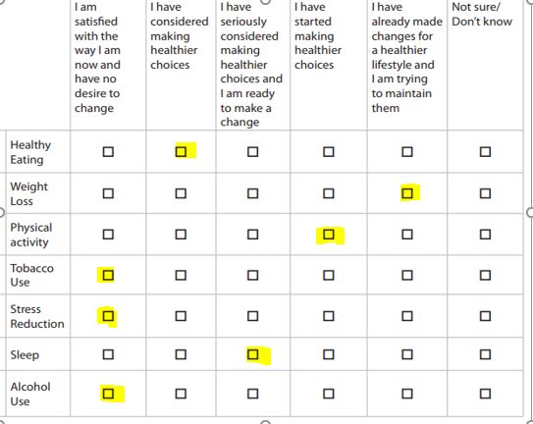
Adapted from the CDC National Healthy Worksite Program (NHWP) Employee Health Assessment (CAPTURETM)
Copyright 2005, Institute for Community Health Promotion, Brown University, Providence, RI. All Rights Reserved.

