Read CASE: Parts Emporium at the end of Ch. 9 (pp. 794).
Put yourself in Sue McCaskey's position and prepare a detailed report to Dan Block and Ed Spriggs on managing the inventory of the EG151 exhaust gasket and the DB032 drive belt.

Write a 1,050- to 1,400-word report.

Discuss Parts Emporium supply chain and possible remedies for its supply chain problems.

Present a proper inventory system and recognize all relevant costs. This should be a type of inventory system that a company would implement and then identify related costs. Also, provide an actual software system that could be purchased to manage an inventory system. Explain the benefits that would be relevant to the case scenario.

Discuss how your recommendations for these two items will reduce the annual cycle inventory, stock-out, and order costs. Be sure to include specific costs as a result.

Include strategic and tactical changes that might improve the company's inventory performance, reduce variability, and improve customer service. There should be at least two strategic and two tactical changes presented and identified as either strategic or tactical.

Format your paper consistent with APA guidelines.

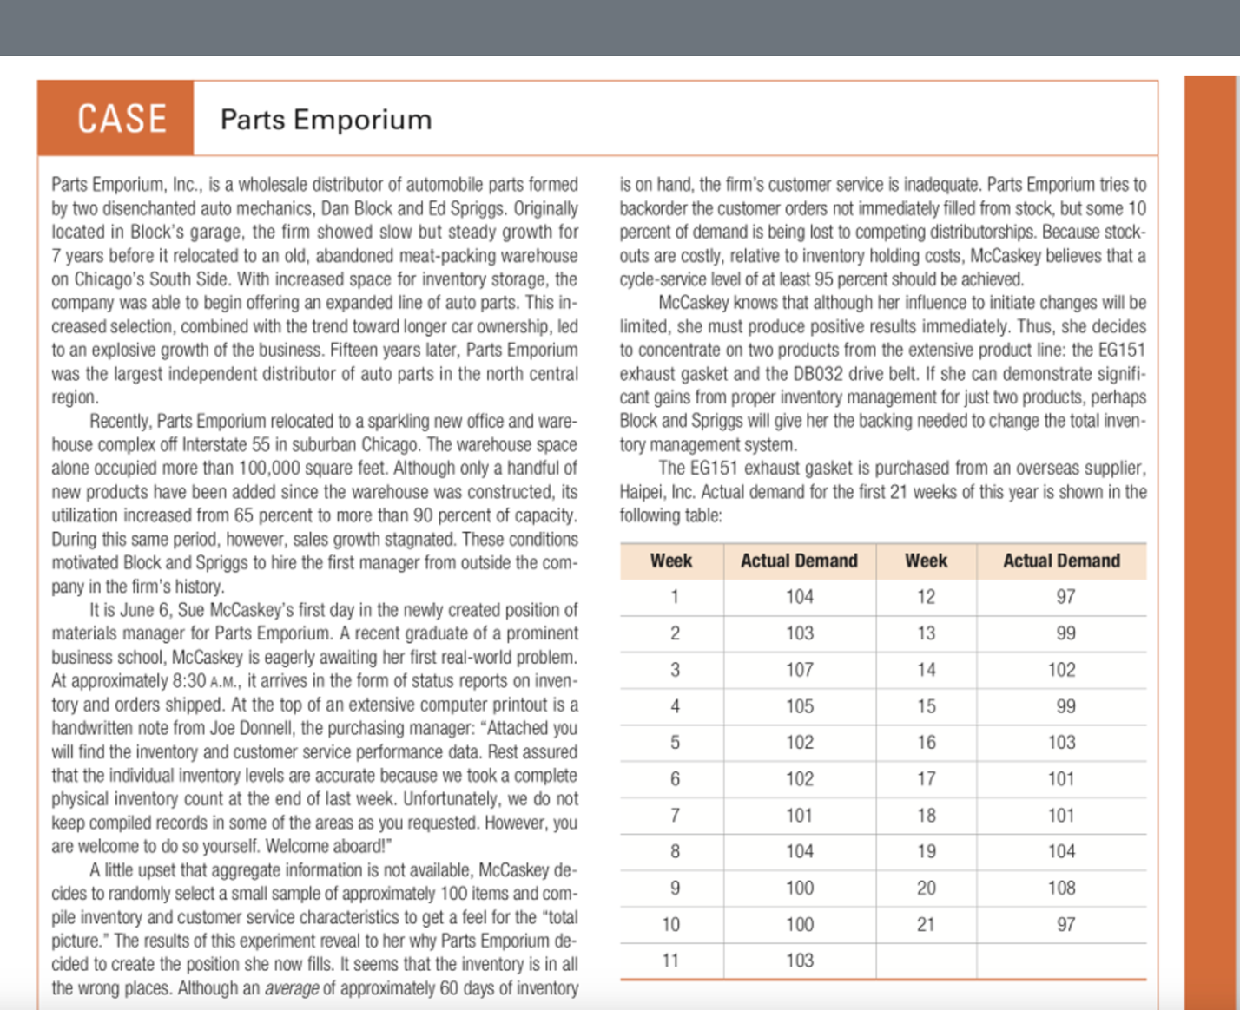Be sure to include sources with the course text at a minimum.

